"BoredGoWhereSG" App

Requirements document

Contents

1. Introduction 2

2. Project Overview 2

3. Design Elements 2

3.1 User Interface (UI) Design 2

4. Functional Requirements 2

4.1 User Input and Preferences 2

4.2 AI-Driven Recommendations 3

4.3 Map and Navigation 3

4.4 Conversation Panel 3

4.5 Integration with Third-Party Services 3

5. Non-Functional Requirements 3

5.1 Performance 3

5.2 Security 3

5.3 Usability 3

6. Constraints and Assumptions 3

7. Conclusion 4

8. Mockup Design 4

9. Milestones 6

# 1. Introduction

This document outlines the design and functional requirements for 'BoredGoWhereSG,' a mobile application that uses AI to help users find interesting activities and plan itineraries specifically in Singapore. The app will provide personalized suggestions, a visually appealing map interface, and interactive navigation features, making it easy for users to explore Singapore based on their preferences and current location.

# 2. Project Overview

'BoredGoWhereSG' aims to serve as an AI-powered travel companion for Singaporeans and tourists alike. By understanding the user's preferences, the app will suggest various attractions, dining options, and activities across Singapore. Key features will include a cartoon-style map, interactive walking routes, and a conversation panel that acts like a virtual travel assistant.

# 3. Design Elements

## 3.1 User Interface (UI) Design

- **Header and Search Bar:** The app features a prominent header with the name 'BoredGoWhereSG.' Below the header is a search bar with prompts such as 'Where would you like to go?' for easy user interaction.

- **Main Interface (Map View):** The map of Singapore is designed in a bright, cartoonish style, featuring iconic landmarks. Locations are marked with numbered pins. An animated walking icon will follow a dotted line to show the route from the user's current location to the selected destination. The map will allow zooming and panning.

- **Conversation Panel:** Located at the lower part of the screen, this panel provides personalized suggestions and can be swiped up for more details. This panel will have a chat-like interface to simulate a conversation with a virtual travel assistant.

- **Bottom Navigation Bar:** Icons for 'Home,' 'Explore,' 'Saved,' and 'Profile' will be present at the bottom of the screen for easy navigation.

- **Color Scheme:** A bright and playful palette will be used, with dominant colors like blue and orange to create an inviting atmosphere.

# 4. Functional Requirements

## 4.1 User Input and Preferences

- Users should be able to input preferences such as activity type, budget constraints, preferred travel times and duration, and group size.

## 4.2 AI-Driven Recommendations

- The AI system will generate recommendations based on user preferences, current location, and real-time data such as weather, traffic, and popularity trends.

## 4.3 Map and Navigation

- Numbered Pins: Each location will have an interactive pin on the map.  
- Walking Route Animation: The app will display a walking route with an animated icon moving along a dotted line.  
- Directions and Travel Time: The app will provide estimated travel times and directions.

## 4.4 Conversation Panel

- The panel will simulate a conversation, suggesting activities, restaurants, and sights based on user input. Users can interact with the panel to receive more personalized recommendations.

## 4.5 Integration with Third-Party Services

- Integration with services like Google Maps for accurate navigation, booking services for restaurants and attractions, and review platforms for additional information.

# 5. Non-Functional Requirements

## 5.1 Performance

- The app should be responsive and handle multiple users simultaneously without lag.  
- AI recommendations and map loading should occur within 2-3 seconds.

## 5.2 Security

- User data must be securely stored and comply with privacy regulations such as GDPR.  
- Authentication measures (e.g., OAuth, biometric login) should be implemented for account security.

## 5.3 Usability

- The UI should be intuitive, with clear navigation and easily accessible features.  
- The map should be easy to interact with, and all interactive elements should provide clear feedback (e.g., animations, haptic feedback).

# 6. Constraints and Assumptions

- Geographical Focus: The app will initially focus on Singapore only.  
- Data Dependency: The accuracy and relevance of recommendations will depend on real-time data sources (e.g., weather, traffic, event data).  
- Platform Support: The app will be developed for both iOS and Android platforms.  
- Budget and Timeline: The scope of features may be adjusted based on available budget and timeline constraints.

# 7. Conclusion

'BoredGoWhereSG' will offer users an engaging and interactive way to explore Singapore. The combination of AI-driven recommendations, a playful map interface, and intuitive navigation ensures a seamless and enjoyable user experience. This document serves as a blueprint for the development team, outlining the necessary features and design elements.

# 8. Mockup Design

Below is a mockup of the 'BoredGoWhereSG' app's user interface.

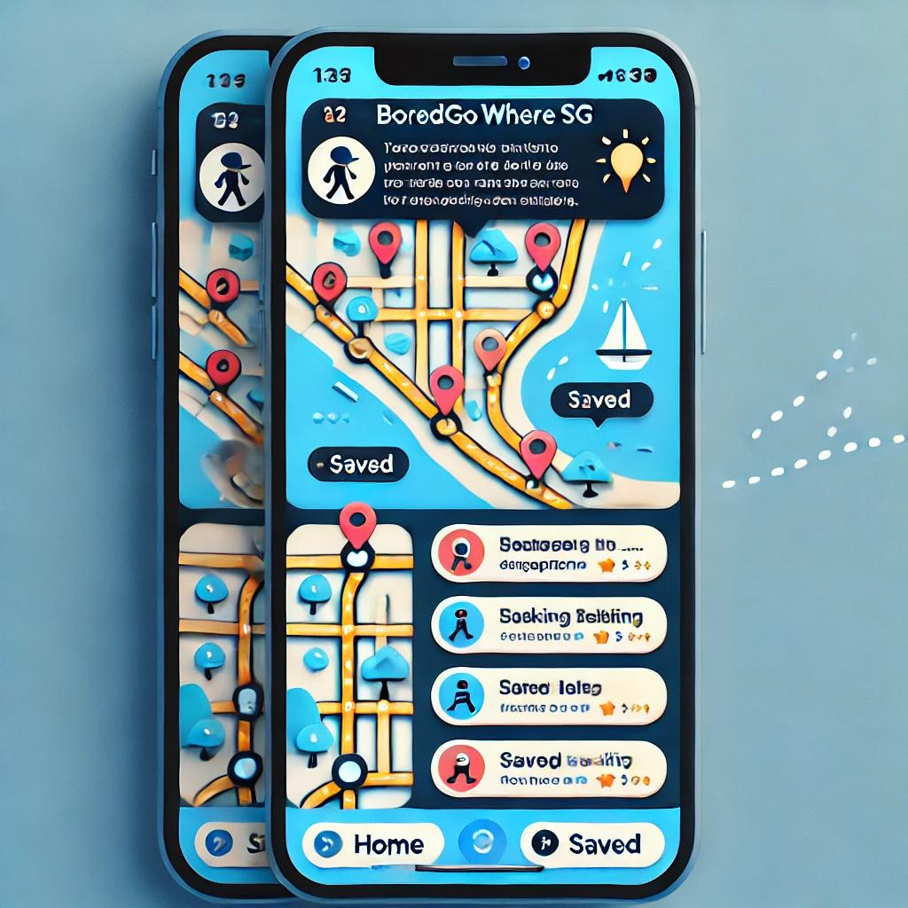

# 9. Milestones

|  |  |  |
| --- | --- | --- |
| Milestone | Task | Completion Status |
| Project Initialization | Define project scope | Started |
| Identify stakeholders | Not Started |
| Set up project management tools | NA |
| Design Phase | UI/UX design mockups | Not Started |
| User feedback and revisions | Not Started |
| Finalize design | Not Started |
| Development Phase | Backend development | Not Started |
| Frontend development | Not Started |
| AI integration | Not Started |
| Development Phase | Third-party API integration | Not Started |
| Testing Phase | Unit testing | Not Started |
| Integration testing | Not Started |
| User acceptance testing | Not Started |
| Deployment Phase | Deploy app to iOS/Android stores | Not Started |
| Launch marketing campaign | Not Started |
| Post-Deployment Support | Ongoing support and updates | Not Started |