

**The Experiment Report of**

***Machine Learning***

**College Software College**

**Subject Software Engineering**

**Members**

**Student ID** 201530613207

**E-mail 978163495@qq.com**

**Tutor**   **mingkui Tan**

**Date submitted** **2017.12 .3**

**1. Topic:** LogisticRegression& Linear Classification & Stochastic Gradient Descent

**2. Time:** 2017.12.2 PM 14:00-17:00

**3. Reporter:** peizhuoXie

**4. Purposes:**

* Further understand the principle of Logistic Regression& Linear Classification & Stochastic Gradient Descent method.
* Practicing on a small data set
* Understand the process of optimizing the super parameters

**5. Data sets and data analysis:**

In both Logistic Regression& Linear Classification, we use a1a and a1a.t dataset, including 32561 / 16281 samples and 123 / 123 features respectively.

**6. Experimental steps:**

* Using the function load_svmlignt_file from sklearn read the data set.
* Initializing the parameters randomly.
* Using Cross-entropy loss / Hinge loss and compute all the samples’ loss.
* Update the loss function by methods = ['SGD', 'NAG', 'RMSProp', 'Adadelta', 'ADAM']  
  Repeat the above steps for some times and draw the figure of loss-iteration.

**7. Code:**

def sigmoid(input_):  
 return 1 / (1 + np.exp(-1.0 * input_))  
  
  
def compute_loss(x, y, w):  
 # x.shape = [batch_size, feature_size + 1], y.shape = [batch_size, 1], w.shape = [feature_size + 1, 1]  
 logits = np.matmul(x, w)  
 loss = -np.mean(y * np.log(sigmoid(logits)) + (1 - y) * np.log(1 - sigmoid(logits)))  
 return loss  
  
  
def compute_gradient(x, y, w):  
 # x.shape = [batch_size, feature_size + 1], y.shape = [batch_size, 1], w.shape = [feature_size + 1, 1]  
 logits = np.matmul(x, w)  
 output = sigmoid(logits)  
 error = output - y  
 gradient = np.matmul(x.transpose(), error) / len(y)  
 return gradient # gradient.shape = [feature_size + 1, 1], the same as w  
  
  
global_list = {'NAG_momentum': np.zeros([feature_size + 1, 1]), 'RMS_expectation': 1, 'ADAM_s': 0, 'ADAM_r': 0,  
 'ADADELDA_r': 0, 'ADADELDA_e': 0}  
  
  
def optimizer(method, parameter_list, x, y, w):  
 global global_list  
 if method == 'SGD':  
 # sgd_para_list = {'learning_rate':0.01}  
 lr = parameter_list['learning_rate']  
 w -= lr * compute_gradient(x, y, w)  
 if method == 'NAG':  
 # nag_para_list = {'miu':0.9, 'learning_rate':0.01}  
 lr = parameter_list['learning_rate']  
 miu = parameter_list['miu']  
 momentum = global_list['NAG_momentum']  
 gradient = compute_gradient(x, y, w - momentum * lr * miu)  
 momentum = momentum * lr + gradient  
 w -= lr * momentum  
 if method == 'RMSProp':  
 # rmsprop_para_list = {'delta':10e-7, 'rho':0.95, 'learning_rate':0.1}  
 lr = parameter_list['learning_rate']  
 expectation = global_list['RMS_expectation']  
 rho = parameter_list['rho']  
 delta = parameter_list['delta']  
 gradient = compute_gradient(x, y, w)  
 norm = np.sum(gradient**2)  
 expectation = rho * expectation + (1 - rho) * norm  
 global_list['RMS_expectation'] = expectation  
 w -= lr * gradient / (np.sqrt(expectation) + delta)  
 if method == 'ADAM':  
 # adam_para_list = {'delta':10e-8, 'rho1':0.9, 'rho2':0.999, 'learning_rate':0.1}  
 delta = parameter_list['delta']  
 rho1 = parameter_list['rho1']  
 rho2 = parameter_list['rho2']  
 lr = parameter_list['learning_rate']  
 s = global_list['ADAM_s']  
 r = global_list['ADAM_r']  
 gradient = compute_gradient(x, y, w)  
 s = rho1 * s + (1 - rho1) * gradient  
 r = rho2 * r + (1 - rho2) * gradient * gradient  
 s_hat = s / (1 - rho1)  
 r_hat = r / (1 - rho2)  
 w -= (lr * s_hat) / (np.sqrt(r_hat) + delta)  
 global_list['ADAM_s'] = s  
 global_list['ADAM_r'] = r  
 if method == 'Adadelta':  
 # adadelta_para_list = {'delta':10e-7, 'miu':0.9, 'learning_rate':10}  
 r = global_list['ADADELDA_r']  
 e = global_list['ADADELDA_e']  
 miu = parameter_list['miu']  
 delta = parameter_list['delta']  
 lr = parameter_list['learning_rate']  
 grad = compute_gradient(x, y, w)  
 r = miu * r + (1 - miu) * grad * grad  
 w -= (lr * grad * np.sqrt(e + delta)) / (np.sqrt(r + delta))  
 e = miu * e + (1 - miu) * e * e  
 global_list['ADADELDA_r'] = r  
 global_list['ADADELDA_e'] = e  
 def shuffle_train():  
 global x_train, y_train  
 rng_state = np.random.get_state()  
 np.random.shuffle(x_train)  
 np.random.set_state(rng_state)  
 np.random.shuffle(y_train)  
  
 batch_size = 128  
 data_size = num_samples  
 def feed_data(batch_count):  
 if (1 + batch_count) * batch_size <= data_size:  
 feed_dict = {'x': x_train[batch_count * batch_size:(batch_count + 1) * batch_size],  
 'y': y_train[batch_count * batch_size:(batch_count + 1) * batch_size]}  
 else:  
 feed_dict = {'x': x_train[batch_count * batch_size:data_size],  
 'y': y_train[batch_count * batch_size:data_size]}  
 return feed_dict  
  
 methods = ['SGD', 'NAG', 'RMSProp', 'Adadelta', 'ADAM']  
 sgd_para_list = {'learning_rate': 0.01}  
 nag_para_list = {'miu': 0.9, 'learning_rate': 0.01}  
 rmsprop_para_list = {'delta': 10e-7, 'rho': 0.95, 'learning_rate': 0.1}  
 adam_para_list = {'delta': 10e-8, 'rho1': 0.9, 'rho2': 0.999, 'learning_rate': 0.1}  
 adadelta_para_list = {'delta': 10e-7, 'miu': 0.9, 'learning_rate': 10}  
 para_list = {'SGD': sgd_para_list, 'NAG': nag_para_list, 'RMSProp': rmsprop_para_list,  
 'Adadelta': adadelta_para_list, 'ADAM': adam_para_list}  
 for method in methods:  
 iters = []  
 test_errors = []  
 w = np.random.rand(feature_size+1, 1)  
 parameter_list = para_list[method]  
 count = 0  
 for i in range(0, 2):  
 shuffle_train()  
 for batch_count in range(0, int(data_size / batch_size ) + 1):  
 feed_dict = feed_data(batch_count)  
 iters.append(count)  
 count += 1  
 optimizer(method=method, parameter_list=parameter_list, x=feed_dict['x'], y=feed_dict['y'], w=w)  
 test_errors.append(compute_loss(x_test, y_test, w))  
 plt.plot(iters, test_errors, label=method)

def compute_loss(x, y, w):  
 # x.shape = [batch_size, feature_size + 1], y.shape = [batch_size, 1], w.shape = [feature_size + 1, 1]  
 pred = np.matmul(x, w)  
 hinge_loss = np.maximum(1 - y * pred, 0)  
 loss = np.mean(hinge_loss**2) + C * np.sum(w**2)  
 return loss  
  
  
def compute_gradient(x, y, w):  
 # x.shape = [batch_size, feature_size + 1], y.shape = [batch_size, 1], w.shape = [feature_size + 1, 1]  
 pred = np.matmul(x, w)  
 hinge_loss = np.maximum(1 - y * pred, 0)  
 hinge_loss_gradient = -np.matmul(x.transpose(), hinge_loss * y) / len(y)  
 norm_gradient = 2 * C * w  
 gradient = hinge_loss_gradient + norm_gradient  
 return gradient # gradient.shape = [feature_size + 1, 1], the same as w  
  
  
global_list = {'NAG_momentum': np.zeros([feature_size + 1, 1]), 'RMS_expectation': 1, 'ADAM_s': 0, 'ADAM_r': 0,  
 'ADADELDA_r': 0, 'ADADELDA_e': 0}  
  
  
def optimizer(method, parameter_list, x, y, w):  
 global global_list  
 if method == 'SGD':  
 # sgd_para_list = {'learning_rate':0.01}  
 lr = parameter_list['learning_rate']  
 w -= lr * compute_gradient(x, y, w)  
 if method == 'NAG':  
 # nag_para_list = {'miu':0.9, 'learning_rate':0.01}  
 lr = parameter_list['learning_rate']  
 miu = parameter_list['miu']  
 momentum = global_list['NAG_momentum']  
 gradient = compute_gradient(x, y, w - momentum * lr * miu)  
 momentum = momentum * lr + gradient  
 w -= lr * momentum  
 if method == 'RMSProp':  
 # rmsprop_para_list = {'delta':10e-7, 'rho':0.95, 'learning_rate':0.1}  
 lr = parameter_list['learning_rate']  
 expectation = global_list['RMS_expectation']  
 rho = parameter_list['rho']  
 delta = parameter_list['delta']  
 gradient = compute_gradient(x, y, w)  
 norm = np.sum(gradient**2)  
 expectation = rho * expectation + (1 - rho) * norm  
 global_list['RMS_expectation'] = expectation  
 w -= lr * gradient / (np.sqrt(expectation) + delta)  
 if method == 'ADAM':  
 # adam_para_list = {'delta':10e-8, 'rho1':0.9, 'rho2':0.999, 'learning_rate':0.1}  
 delta = parameter_list['delta']  
 rho1 = parameter_list['rho1']  
 rho2 = parameter_list['rho2']  
 lr = parameter_list['learning_rate']  
 s = global_list['ADAM_s']  
 r = global_list['ADAM_r']  
 gradient = compute_gradient(x, y, w)  
 s = rho1 * s + (1 - rho1) * gradient  
 r = rho2 * r + (1 - rho2) * gradient * gradient  
 s_hat = s / (1 - rho1)  
 r_hat = r / (1 - rho2)  
 w -= (lr * s_hat) / (np.sqrt(r_hat) + delta)  
 global_list['ADAM_s'] = s  
 global_list['ADAM_r'] = r  
 if method == 'Adadelta':  
 # adadelta_para_list = {'delta':10e-7, 'miu':0.9, 'learning_rate':10}  
 r = global_list['ADADELDA_r']  
 e = global_list['ADADELDA_e']  
 miu = parameter_list['miu']  
 delta = parameter_list['delta']  
 lr = parameter_list['learning_rate']  
 grad = compute_gradient(x, y, w)  
 r = miu * r + (1 - miu) * grad * grad  
 w -= (lr * grad * np.sqrt(e + delta)) / (np.sqrt(r + delta))  
 e = miu * e + (1 - miu) * e * e  
 global_list['ADADELDA_r'] = r  
 global_list['ADADELDA_e'] = e  
  
  
if __name__ == '__main__':  
 x_train, y_train = ds.load_svmlight_file('./a9a')  
 x_test, y_test = ds.load_svmlight_file('./a9a.t')  
  
 num_samples, num_features = x_train.shape  
 num_test_samples, num_test_features = x_test.shape  
  
 x_train = x_train.toarray()  
 temp = np.ones(shape=[num_samples, 1], dtype=np.float32)  
 x_train = np.concatenate([x_train, temp], axis=1)  
 x_test = x_test.toarray()  
 temp = np.zeros(shape=[num_test_samples, 1], dtype=np.float32)  
 temp1 = np.ones(shape=[num_test_samples, 1], dtype=np.float32)  
 x_test = np.concatenate([x_test, temp, temp1], axis=1)  
 y_train = y_train.reshape([len(y_train), 1])  
 y_test = y_test.reshape([len(y_test), 1])  
  
  
 def shuffle_train():  
 global x_train, y_train  
 rng_state = np.random.get_state()  
 np.random.shuffle(x_train)  
 np.random.set_state(rng_state)  
 np.random.shuffle(y_train)  
  
 batch_size = 32  
 data_size = num_samples  
 def feed_data(batch_count):  
 if (1 + batch_count) * batch_size <= data_size:  
 feed_dict = {'x': x_train[batch_count * batch_size:(batch_count + 1) * batch_size],  
 'y': y_train[batch_count * batch_size:(batch_count + 1) * batch_size]}  
 else:  
 feed_dict = {'x': x_train[batch_count * batch_size:data_size],  
 'y': y_train[batch_count * batch_size:data_size]}  
 return feed_dict  
  
 methods = ['SGD', 'NAG', 'RMSProp', 'Adadelta', 'ADAM']  
 sgd_para_list = {'learning_rate': 0.01}  
 nag_para_list = {'miu': 0.9, 'learning_rate': 0.01}  
 rmsprop_para_list = {'delta': 10e-7, 'rho': 0.95, 'learning_rate': 0.1}  
 adam_para_list = {'delta': 10e-8, 'rho1': 0.9, 'rho2': 0.999, 'learning_rate': 0.1}  
 adadelta_para_list = {'delta': 10e-7, 'miu': 0.9, 'learning_rate': 10}  
 para_list = {'SGD': sgd_para_list, 'NAG': nag_para_list, 'RMSProp': rmsprop_para_list,  
 'Adadelta': adadelta_para_list, 'ADAM': adam_para_list}  
 for method in methods:  
 iters = []  
 test_errors = []  
 w = np.random.rand(feature_size+1, 1)  
 parameter_list = para_list[method]  
 count = 0  
 for i in range(0, 1):  
 shuffle_train()  
 for batch_count in range(0, int(data_size / batch_size) + 1):  
 feed_dict = feed_data(batch_count)  
 iters.append(count)  
 count += 1  
 optimizer(method=method, parameter_list=parameter_list, x=feed_dict['x'], y=feed_dict['y'], w=w)  
 test_errors.append(compute_loss(x_test, y_test, w))  
 plt.plot(iters, test_errors, label=method)

**8. Selection of validation (hold-out, cross-validation, k-folds cross-validation, etc.):** hold-out

**9. The initialization method of model parameters:**

Random initialization

**10. The selected loss function and its derivatives:**

**Linear Regression:**

The $w$ include the bias of the linear regression.



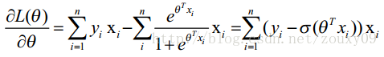

**Linear Classification:**

$$Loss= \frac{\sum_{i=1}^{N}{{\left[max\left(0, 1-y_{i}w^{T}x_{i}\right)\right]}^{2}}}{N}+γ{\left\|w\right\|}_{2}^{2}$$

$$\frac{∂Loss}{∂w}=-\frac{2\sum_{i=1}^{N}{max\left(0, 1-y_{i}w^{T}x_{i}\right)y_{i}w^{T}x_{i}}}{N}+ 2γw$$

**11. Experimental results and curve:**

## Hyper-parameter selection (η, epoch, etc.):

Linear regression:

* Gamma = 0
* sgd_para_list = {'learning_rate': 0.01}  
  nag_para_list = {'miu': 0.9, 'learning_rate': 0.01}  
  rmsprop_para_list = {'delta': 10e-7, 'rho': 0.95, 'learning_rate': 0.1}  
  adam_para_list = {'delta': 10e-8, 'rho1': 0.9, 'rho2': 0.999, 'learning_rate': 0.1}  
  adadelta_para_list = {'delta': 10e-7, 'miu': 0.9, 'learning_rate': 10}

Linear classification:

* Gamma = 0.1
* sgd_para_list = {'learning_rate': 0.01}  
  nag_para_list = {'miu': 0.9, 'learning_rate': 0.01}  
  rmsprop_para_list = {'delta': 10e-7, 'rho': 0.95, 'learning_rate': 0.1}  
  adam_para_list = {'delta': 10e-8, 'rho1': 0.9, 'rho2': 0.999, 'learning_rate': 0.1}  
  adadelta_para_list = {'delta': 10e-7, 'miu': 0.9, 'learning_rate': 10}

## Assessment Results (based on selected validation):

## Predicted Results (Best Results):

## Loss curve:

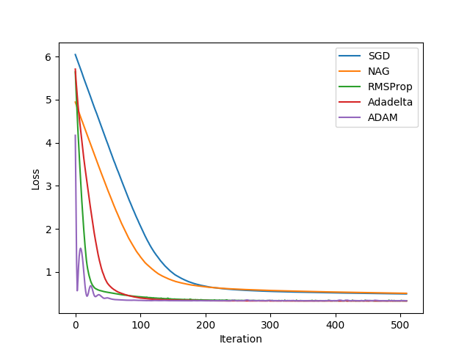

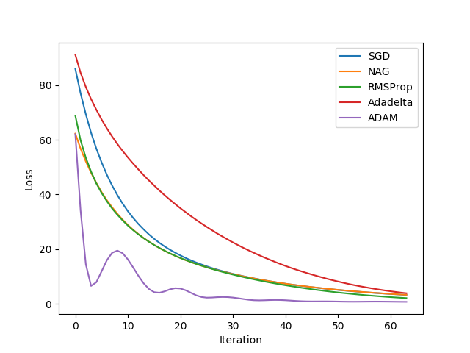

**12. Results analysis:**

**13. Similarities and differences between linear regression and linear classification:**

**14. Summary:**