### Animationinstancing

**Features:**

1. Instancing SkinnedMeshRenderer.
2. Root motion.
3. Lod.
4. Layer,stateMachine.subStateMachine,state.
5. Parameters (int,float,bool).
6. Transition.
7. Attachments.

**How to use：**

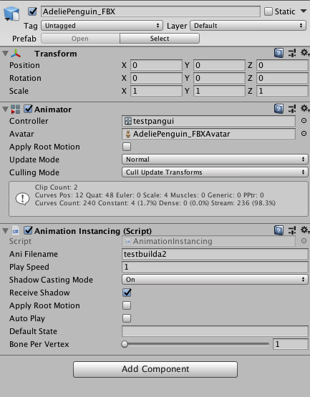

The object must have Animator and AnimationInstancing components.

1.Open the export Window.(AnimatorTool->AnimationInstancingGenerator)

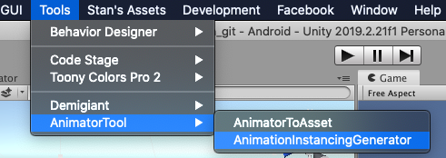

1. Drag the object to the ObjectField box。

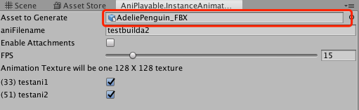

1. Enter file name for animation.its very important.

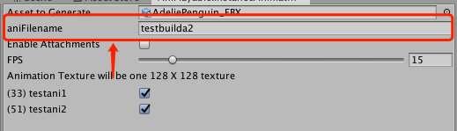

4.export to file.

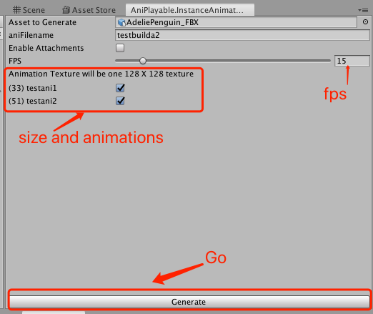

1. Use dedicated shader

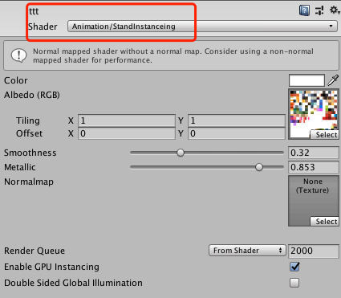

Now,its worked.

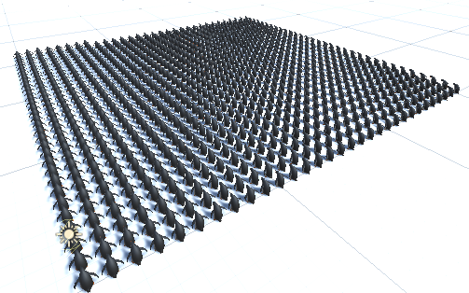



### Behavior Designer

Behavior Designer is a behavior tree implementation designed for everyone – programmers, artists, designers. Behavior Designer offers a powerful API allowing you to easily create new tasks. it offers an intuitive visual editor with extensive third party integration making it possible to create complex AIs without having to write a single line of code.

Documentation:

<https://opsive.com/support/documentation/behavior-designer/overview/>

Video:

<https://opsive.com/support/documentation/behavior-designer/videos/>

**How to use:**

1.Open (Tool->Behavior Designer->Editor)

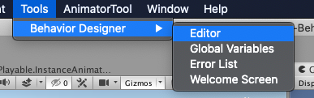

Now,its Empty.

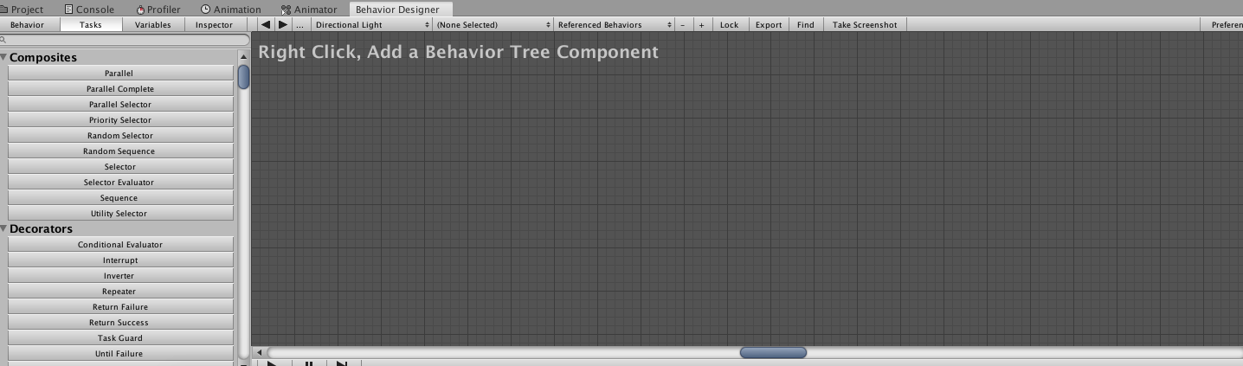

2.Select the object and right click,add a Behavior Tree Component.

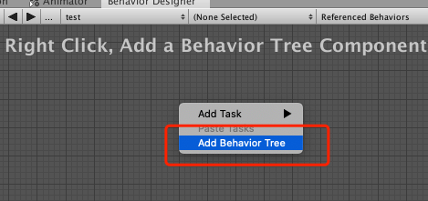

1. Creat the first task.

Right click in window,left click Crossfacd.

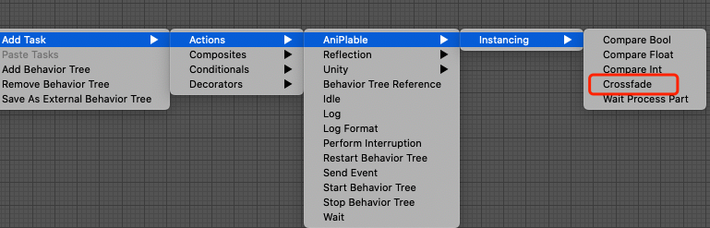

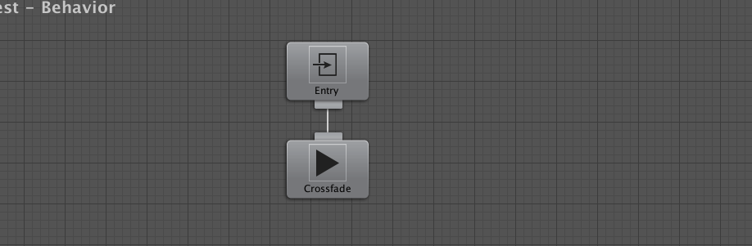

4.Create more tasks。

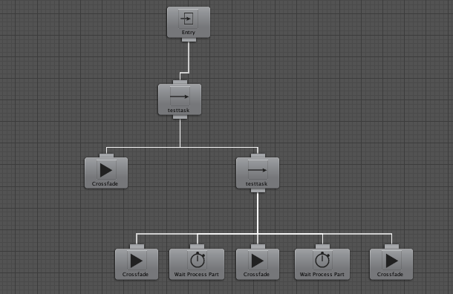

You can customize Task

See Documentation and Video.

### Animationinstancing + Behavior Designer

1. Add Component BehaviorTree to InstancingObject
2. Add task for tree

Add Task->Actions->aniPlable->instancing->Crossfade

1. Edit the properties of this task。

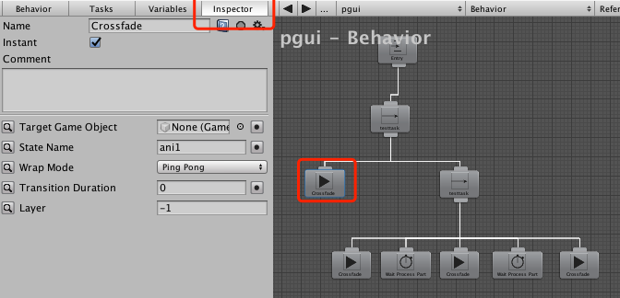

1. now play it.

