**PRJ666 TEAM 8 – UMBRA PHASE**

1. Installation and Startup Instructions
2. Usage Guide
   1. Concepts
   2. Main Menu
   3. Settings Menu
   4. Load Game Menu
   5. Character Creation Menu
   6. Star Map
   7. Wormhole Map
   8. Exploration Map
   9. Battle Map
   10. Character Menu
   11. Trade Menu
   12. Roster Menu
   13. Unit Creation Menu
   14. Reputation Menu
   15. Ship Menu
   16. Ship Upgrade Menu
   17. Outpost Menu
3. Deviations From Proposed PRJ566 Design
4. Known Bugs
5. Notes
6. Installation and Startup Instructions

Open UmbraPhase.exe, type in or select an installation path, then click extract. The installer is a 7-Zip self-extracting archive. There will be no writing to the registry, however do note that the save game files will be stored under “C:\Users\<your username>\AppData\LocalLow\TeamGr8\umbraphase”

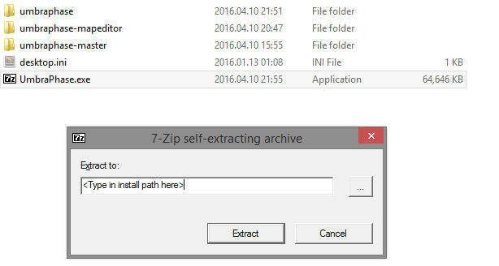

**Virtual Machine Location**

The game installer, as well as an installed instance of the game are located at “C:\UmbraPhase”.

**Virtual Machine Information**

There is only one user, “student”, with the password “8B:w#61M\0"@T(c+"t@N4{c[J3h9?1X~” (no quotation marks).

**Running the Game**

Running the game is done by opening “UmbraPhase.exe”. This will launch the configuration window, where you can set the resolution, whether or not to run in fullscreen mode and which monitor to render the game. All other settings are part of the Unity Engine, but will have no effect on the game.

Click “Play!” to launch the game.

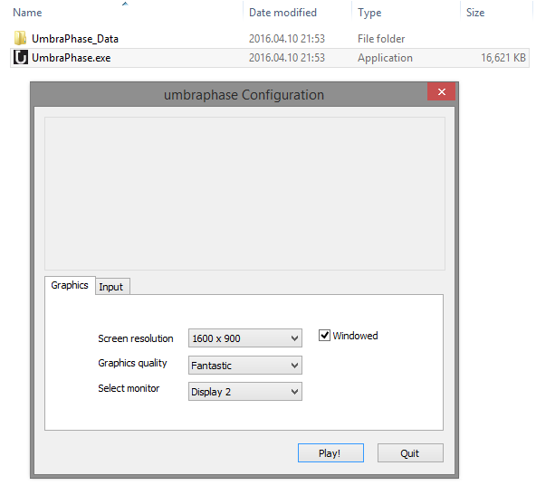

# Usage Guide

## Concepts

### Characters

These are the player character, as well as the companions. Fully controllable by the player in the exploration mode, they can interact with game world objects, and other groups of units. The player can only control friendly characters. Making friends is done by increasing reputations via battles. Some characters may have more than one personal units assigned, allowing the player to make a choice between them.

### Ranks

Each character holds a rank, which changes with character level (ranging from 1 to 5). They exist for cosmetic reasons.

|  |  |  |  |
| --- | --- | --- | --- |
| **Rank** | **Military Title** | **Player Character Level** | **Character**  **Level** |
| 13 | Admiral of the Fleet |  |  |
| 12 | Admiral | 5 |  |
| 11 | Vice Admiral | 4 |  |
| 10 | Rear Admiral | 3 |  |
| 9 | Commodore | 2 |  |
| 8 | Captain | 1 |  |
| 7 | Commander |  | 5 |
| 6 | Lieutenant Commander |  | 4 |
| 5 | Lieutenant |  | 3 |
| 4 | Sub-lieutenant |  | 2 |
| 3 | Ensign |  | 1 |
| 2 | Petty Officer |  |  |
| 1 | Crewman |  |  |

### Perks

Perks offer specific bonuses to each character, such as increased damage, increased defenses or extra resource gains.

|  |  |
| --- | --- |
| **Name** | **Description** |
| Armorer | Increases defense of the group |
| Marksmanship | Increases damage of the group |
| Diplomacy | Affects dialogue and negotiations. Basically increases chances of success. |
| Haggler | Reduces the cost of units and items. |
| First Aid | Increases the effectiveness of helpful abilities |
| Leadership | Boosts morale of the group |
| Pathfinder | Increases distance at which units can travel in battle |
| Scavenger | Increases resource gain when picking up items, or after battles |

### Units

Units are the piece of the battle map, similar to chess pieces on a chess board. These can be controlled either by the player or by the computer, and build by the player in the starbase screen. Units have four to six abilities that can be used against other units in battle maps. See the battle map section for more details.

### Battlegroups

The battlegroup is a group of units and a character, which show up on battle maps. Each battlegroup can hold up to eight regular units, plus the character’s chosen unit. Note however that only the leader character appears on the exploration map.

### Resources

The game features several resources that the player can gain by winning battles or picking up resources caches in the game world. Resources allow the player to construct more units, or upgrade his or her ship. Here is the list of resources:

* + Minerals
  + Gas
  + Fuel
  + Water
  + Food
  + Medical Supplies
  + People
  + Six faction-specific currencies

### Game Flow

The game has several layers, between which the player can freely move:

* Wormhole Map – The topmost layer of the game, which allows the player to move between star systems
* Star Map – Each star map contains a star system and several planets, some of which can be visited and landed upon
* Exploration/Local Map – A world upon which the player landed; here he or she can move characters across the screen or interact with other characters
* Battle Map – Here the player fights against the computer in a chess-like grid, where each participant can do one move per turn

The typical flow is wormhole map -> star map -> exploration map -> battle map -> exploration map.

## Main Menu

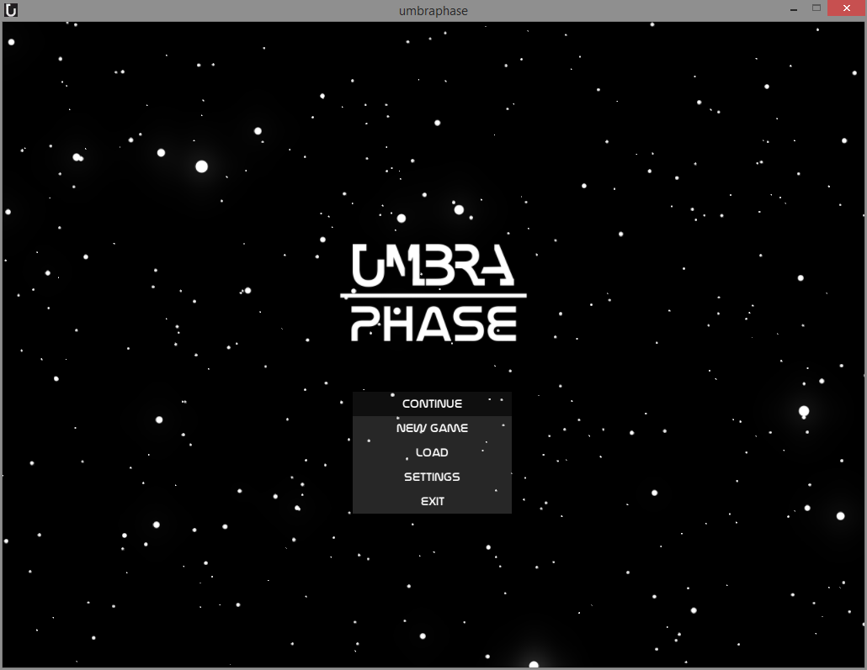

There are five options in the main menu:

* **Continue** – Resumes the most recent save game file. Disabled if there are none.
* **New Game** – Start a new game
* **Load** – Opens the Load Game menu, where the player can choose from a list of save game files
* **Settings** – Opens the ingame settings menu
* **Exit** – Exits the game

## Load Game Menu

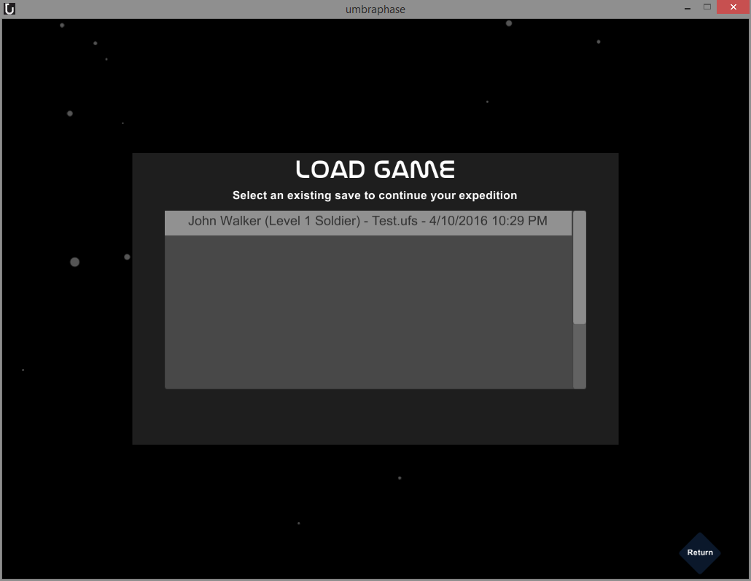

The load game menu will display a list of existing save games. Clicking on one will load the game in the state in which the save game file stored.

## Settings Menu

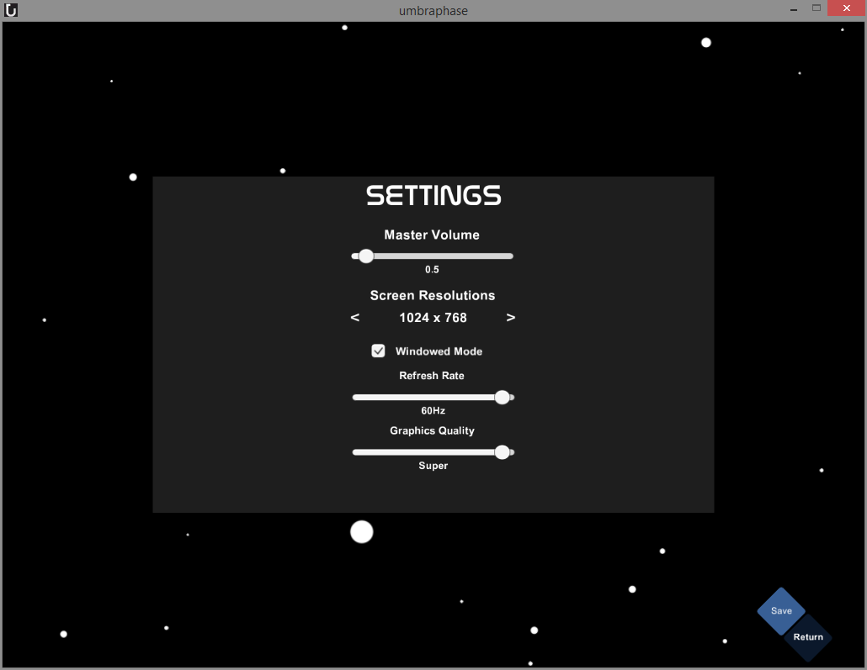

The settings menu allows the player to set the sound volume, screen resolution, toggle between full screen and windowed mode, set the refresh rate and the graphics quality. Upon changing any of those settings, press “Save”, then “Return”.

## Character Creation Menu

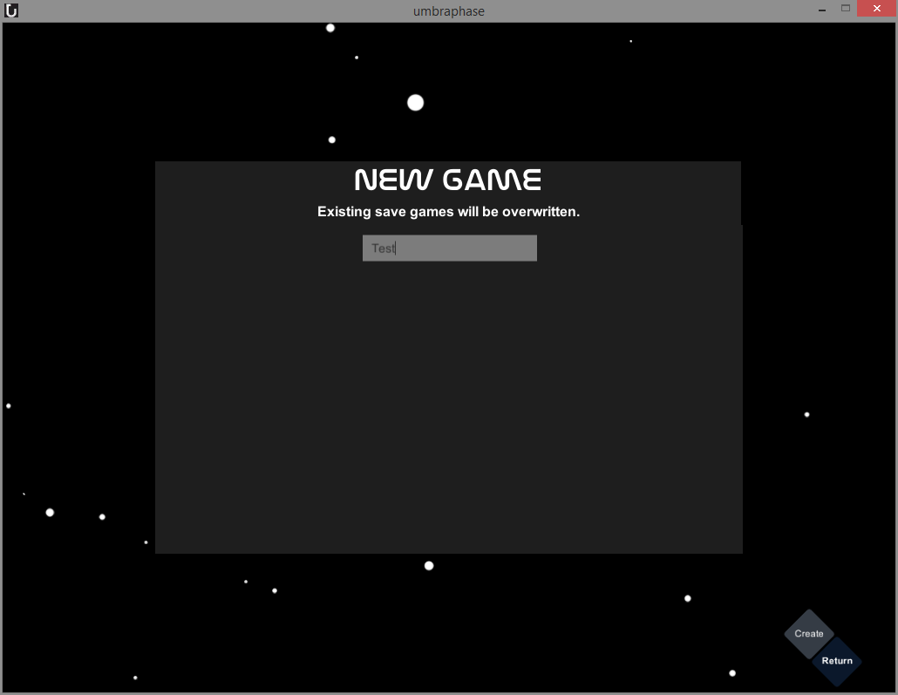

First, you will need to specify a file name for your save game. Note that existing files will be overwritten.

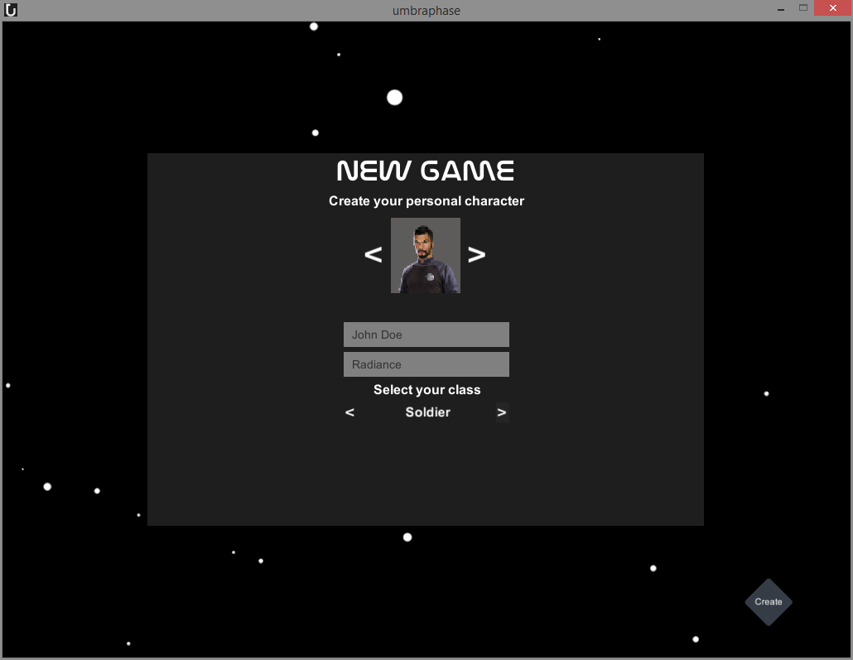

Next step is the character creation menu. Here you can choose an avatar, name and class for your character. You can also give your ship a name.

There are three classes, each with their own specific units:

* **Soldier** – Heavy damage dealer, with a lot of health, armor and shields
* **Saboteur** – Heavy damage dealer, focused on stealth and tactical abilities, at the cost of health, armor and shields
* **Battle Technician** – Support oriented, focused on healing and boosting battlegroups

## Star Map

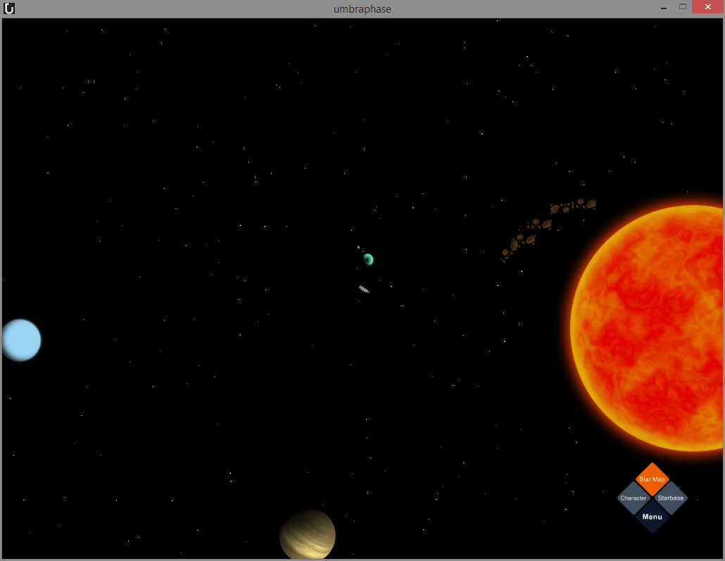

The Starmap is the layer of the game that allows players to land on worlds and travel between systems, as well as access menus. In it, you control your ship and fly around the map.

### Camera Controls

To move around the map, left click and hold, while moving the mouse. You can zoom in and out with the scroll wheel. Double clicking an object causes the camera to center on it.

### Ship Controls

To move the ship to a location or select an object, simply click it.

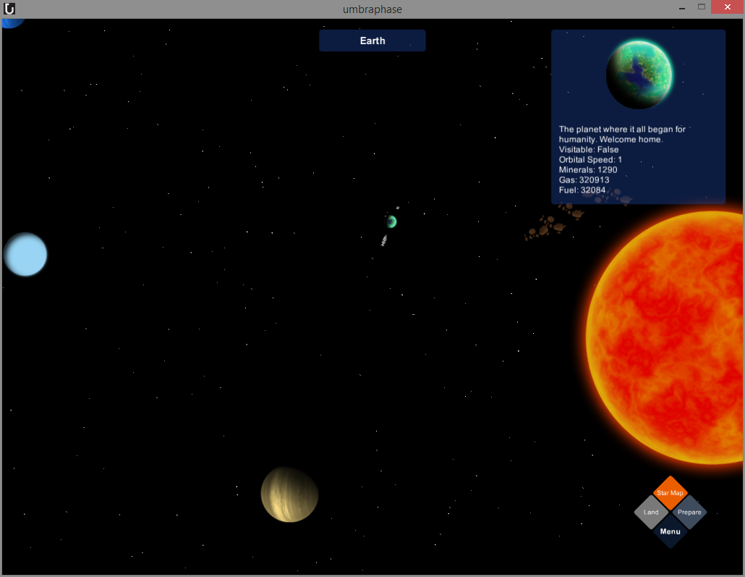

### Menu Buttons

By default, the diamond menu in the bottom right corner has 4 buttons:

**Character:** Opens the character menu

**Starbase:** Opens the starbase menu

**Starmap:** While orange, indicates that you’re on the starmap

**Menu:** Opens the main menu of the game.

When a planet is selected, Character and Starbase are replaced with the following:

**Land:** If the planet can be visited, clicking the button will land on the planet and open the exploration map. Otherwise, the button is grayed out.

**Prepare:** Opens the battlegroup setup screen.

## 

When a wormhole is selected, the menu is replaced with the following button:

**Enter:** Clicking this button opens the wormhole map screen

## Wormhole Map

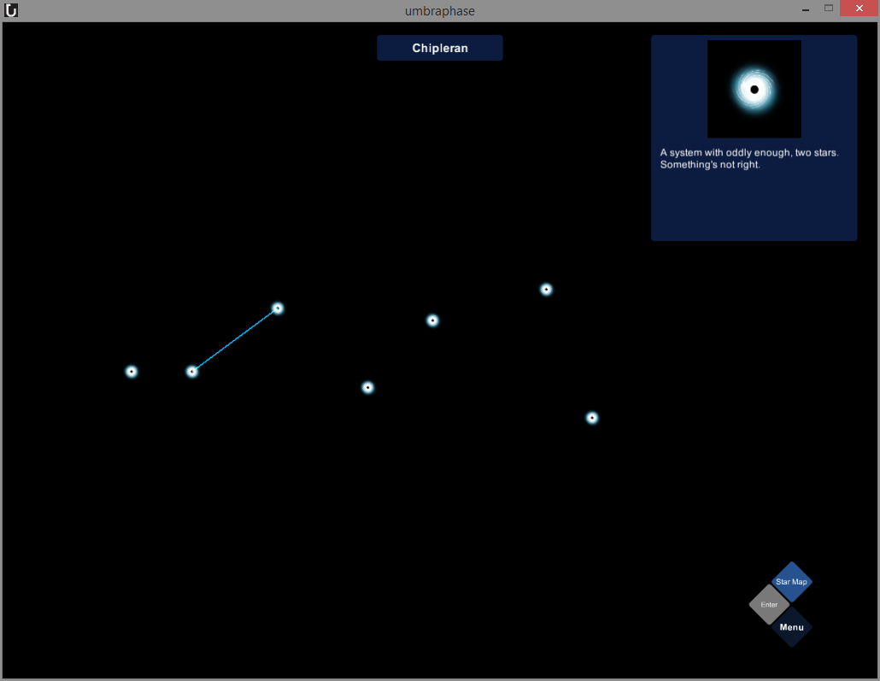

The wormhole map is a subscreen of the starmap that allows travel between star systems. On it, lines will appear between the currently selected wormhole and ones it’s connected to. Clicking a wormhole will select it, allowing you to see which wormholes it’s connect to. If the selected wormhole is connected to your current star map, you can press the enter button on the diamond menu to travel to it. If it is not, the button is deactivated. To return to your current star map, press the star map button.

## Exploration Map

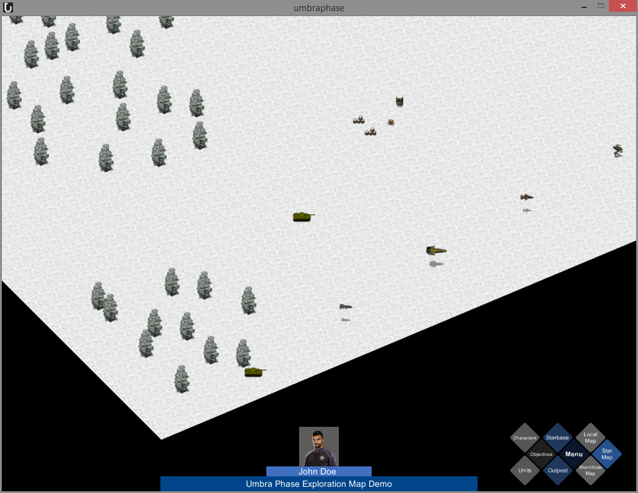

The Exploration Map is the last exploration layer of the game, where the player can control friendly characters. These characters can interact with the world environment moving around it, picking up items or attacking enemy characters. The player can leave the exploration map whenever he or she pleases.

### Camera Controls

To move around the map, left click and hold, while moving the mouse. You can zoom in and out with the scroll wheel.

### Menu Buttons

On the bottom right side of the screen are the menu controls:

**Characters** – Opens the character menu

**Units** – Opens the unit roster

**Objectives** – Opens the objectives panel

**Starbase** – Opens the starbase menu

**Outpost** – If there is no outpost, it will let the player build an outpost, and otherwise it will open the outpost menu

**Menu** – Opens the main menu

**Local Map** – Disabled; highlights the fact that the player is in the exploration map

**Star Map** – Loads the star map

**Wormhole Map** – Loads the wormhole map

### Outpost Creation

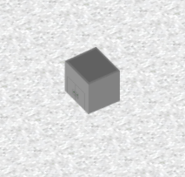

To create an outpost, simply click on a tile that is not occupied by anything else (ie. characters, terrain, trees, objects).

### Character Controls

To control a friendly character, simply click on the tile beneath it. This will display the avatar and name of the selected character. Next step is to click on another tile (that may contain even another character). To clear selection, right click anywhere in the window.

If you click on a character, it will trigger the context menu that gives you the following options:

* **Inspect** – displays Inspection Window
* **Attack** – Starts a battle with an enemy character
* **Talk/Use**

To close the context menu, right click anywhere on the screen.

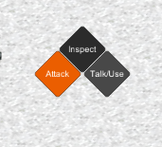

### Inspect Window

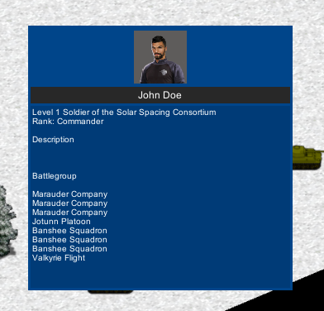

The Inspect Window displays the selected character’s name, avatar, level, class, rank, description and units in its battlegroup. Right click anywhere on the screen to close it.

### Battle Map

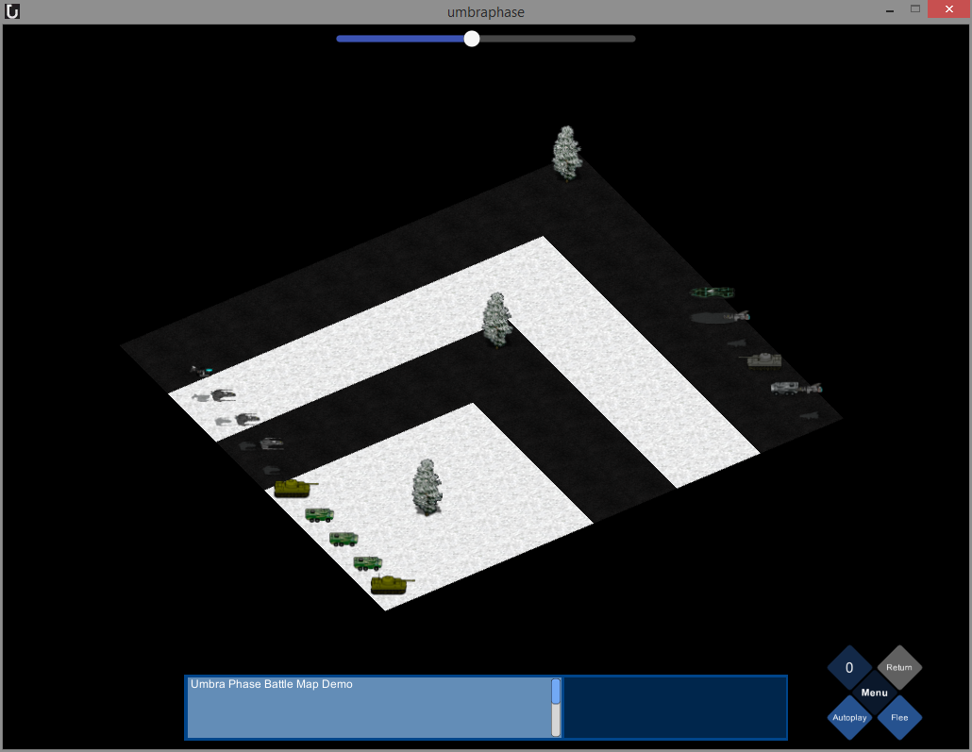

The battle map is where the player fights against the computer, up to nine units on each side of the battlefield.

### Battle Map Flow

The combat flow is heavily inspired by Heroes of Might and Magic III and the Last Remnant. On the left side of the battlefield are the player’s units (also known as the battlegroup), and on the right side are the computer’s units.

Each player (ie. the user and computer) will be allowed to make one move per turn, before the next player’s turn. Turns are “used up” either by moving a unit or casting an ability.

The objective of the player on a battle map is to destroy all enemy units, while losing as few units as possible. Destroyed units will remain in the battlefield, but will not be able to move or cast abilities, or be casted upon by abilities from other units. When a side loses all units, the battle ends. The losing side’s battlegroup leader will disappear from the exploration map, as well as the game. If the battlegroup is controlled by the player character and the player loses the battle, the game ends.

Should the battle go in the computer’s favor, the player can opt to flee the battle, at the cost of resources. If the player wins, he or she gains resources, as well as reputation points with each faction (either negative or positive), and experience points, which will level up the winning character.

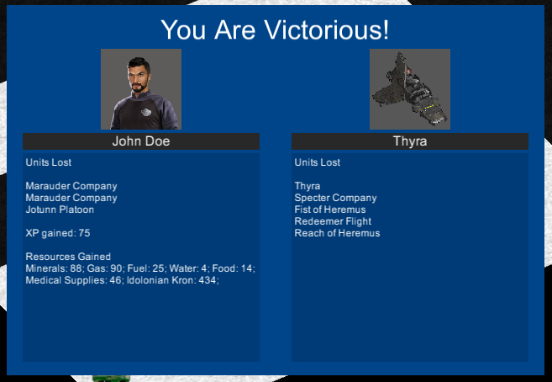

### Camera Controls

To move around the map, left click and hold, while moving the mouse. You can zoom in and out with the scroll wheel.

### Menu Buttons

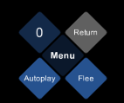

On the bottom right side of the screen are the menu controls:

* **Menu** – Returns to the main menu
* **Return** – Return to the Exploration Maps; is activated upon ending the battle
* **Flee** – Allows the player to flee the battle and avoid further losses of units, at the cost of random amounts of the various resources
* **Autoplay** – Lets the computer take over the player’s units as well
* **Turn Counter** – Displays the number of turns performed by the player and computer since the start of the battle

### Character Controls

To control a friendly character, simply click on the tile beneath it. This will display the avatar, name and primary statistics (health, armor, and shield) in the unit plate within the bottom bar. The bottom bar also gives feedback based on what an ability did on its target.

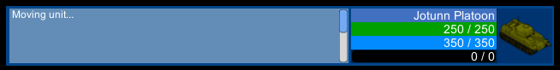

Just like in the exploration map, the next step is to click on another tile (that may contain even another character). To clear selection, right click anywhere in the window.

### Context Menu/Abilities

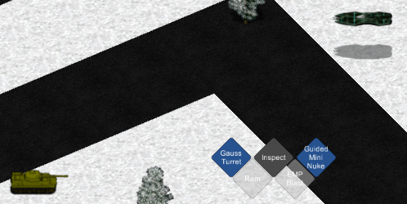

If you click on a character, it will trigger the context menu that gives you the following options:

* **Inspect** – displays Inspection Window
* **Abilities 1 to 6** – Up to six abilities that can be performed by the selected unit
* **Items 1 and 2 –** Characters can hold items, which may have abilities attached to them

The ability buttons will be greyed out under the following conditions:

* **Ability is on cooldown** – The vast majority of abilities have cooldown timers, which decrease with each turn. While an ability is on cooldown, it cannot be cast and the context menu will show the number of turns left until it is available.
* **Target is out of range** – If the target is out of reach, the ability cannot be cast
* **Caster and target are on different layers** – Some abilities function only if both units are on the same layer (ie on the ground, or in the air); these occur usually with vehicles that are in close range to each other
* **Target is friendly and ability is harmful** – The game will disallow the player from harming his/her units
* **Target if an enemy and ability is helpful** – The game will disallow the player from healing or buffing enemy units
* **Target is dead** – The game disallows the player (and AI) from casting abilities on dead units

Note that only the player character can use six abilities and two items. Regular characters have five abilities and can equip one item, while regular units can only use four abilities.

To close the context menu, right click anywhere on the screen.

### Buffs/Debuffs

Some abilities can apply “buffs” to friendly targets, enhancing their damage and defenses, making them invincible or hiding them from the sight of enemy units.

Debuffs can be applied to enemy units via harmful abilities, reducing their damage and defenses, or dealing small amounts of damage over time, once per turn.

Units affected by buffs and debuffs are highlighted, based on the color of the buff or debuff.

### Morale Bar

On top of the screen is the morale bar, which swings from left to right, depending on which side of the battlefield has the higher morale. The side with the most morale gets a damage and defensive bonus (up to 25% for each), and a small chance to gain an extra turn (up to 5% chance).



### Artificial Intelligence (AI)

The artificial intelligence is quite rudimentary, meant only to showcase the platform. It will select a random living unit from its battlegroup and a random living unit from the enemy battlegroup, and then cast the highest priority ability on the target. If the target is too far away, the AI will move in as close as possible to the target.

## Character Menu

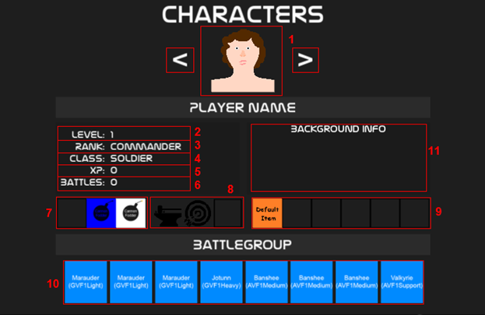

1.  Clicking on either of the arrows alternates between all the characters currently in the player’s control, and displays their corresponding portrait.

2.  Displays the currently displayed character’s level. Levels can be gained in battle and represents your overall progression in Umbra Phase. Use the character in battle to level it up.

3.  Displays your currently displayed character’s rank, rank being representative of the character’s effort in battle.

4.  Displays your currently displayed character’s class. Class is merely a category for a character and can be chosen for the player only at the start. Starting bonuses very on the class.

5.  Displays your currently displayed character’s experience. Experience can be gained by fighting in battles. Gaining enough experience levels you up.

6.  Displays your currently displayed character’s number of battles they have fought.

7.  Displays three kinds of units if owned by the selected character: infantry, ground, and flying. You can select one of these units at any time, depending on the type of map you are currently visiting.

8.  Displays your currently displayed character’s perks. Perks gain you bonuses in battle.

9.  Displays the currently displayed character’s inventory. The inventory contains items, and you may equip a number of them varying on the character. The player may equip a maximum of two items, and a normal character may equip only one. Items provide their own varying bonuses.

10.  Displays the currently displayed character’s battlegroup. A battlegroup is a group of units that you can control and command in battle.

11.  Displays the currently displayed character’s background information.

## Trade Menu

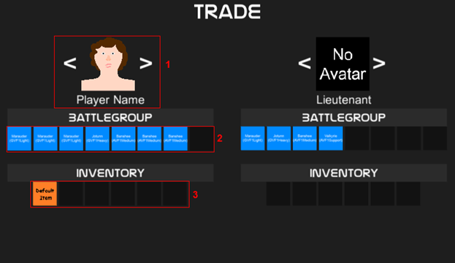

1.  Displays the currently viewed character. Clicking the arrow will alternate between a list of characters owned by the player, or, if in Exploration Map, will be disabled due to a fixed trade between two characters.

2.  Displays the units in a character’s battlegroup. Dragging and dropping them in the slots opposite of the character will transfer and save the units accordingly.

3.  Displays the items in a character’s inventory. Much like #2, you may drag and drop them into the opposite slots to transfer and save them.

## Roster Menu

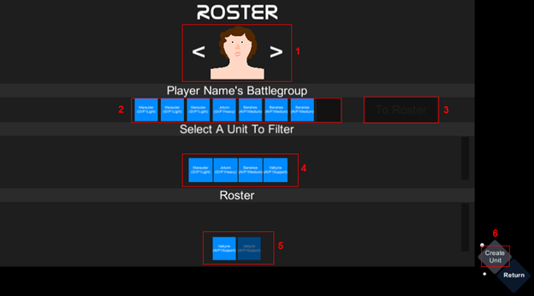

1.  Displays the currently viewed character. Clicking the arrows will alternate between a list of characters currently owned by the player.

2.  Displays all the units currently a part of the character’s battlegroup. To remove a unit from a character’s battlegroup, look at #3.

3.  Dragging a unit from the character’s battlegroup (#2) and dropping it into the ‘To Roster’ box will transfer the unit into the global roster where you may then organize it as you see fit.

4.  Isolates and displays each type of unit contained out of all the battlegroups in your faction. Select a type of unit will filter it out into #5.

5.  Displays a list of units as per the result of #4. You may drag these units into a character’s battlegroup. Grayed out unit icons depict a unit that is already apart of another battlegroup.

6.  If you are short of a unit, you may go to the ‘Create Unit Menu’ to recruit one.

## Unit Creation Menu

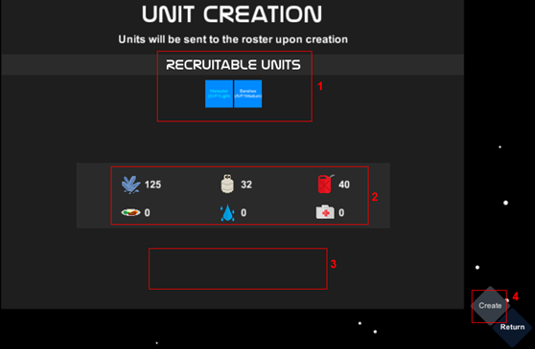

1.  Displays a list of all recruitable units. Select the unit you wish to recruit. The list varies depending on your reputation with other alien factions you have interacted with. Become friendly enough with a faction and you may recruit some of their units who have strengths of their own. On top of that, the player must have upgraded corresponding sections on their ship. For more details, see **2.p**.

2.  Displays the number of resources required to recruit the selected unit. You can hover over any of the icons if you forget what represents what resource.

3.  A successful or unsuccessful message will appear if you have the exact amount of resources necessary to recruit the selected unit.

4.  Will recruit the unit if the required resources for it are met.

## Reputation Menu

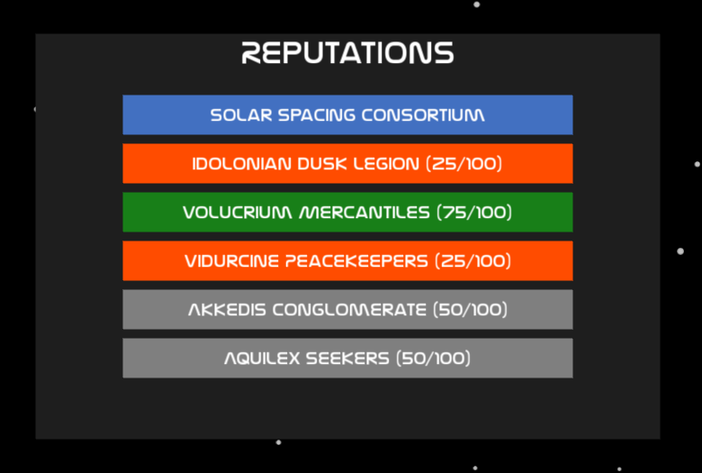

The reputation menu shows the reputation status of the player with each of the other five factions, both as percentage and as a color code.

Hated – Your relationship with the faction means you are on very unfriendly terms; there is no way to gain reputation anymore

Hostile – Your reputation with the faction means you can attack the target, and there is no way to gain anymore reputation

Neutral – Your reputation with the faction is neutral, and you can opt to attack its members, or you can gain further reputation by defeating hostile and hated enemies

Friendly – Being friendly with a faction gives you the option to control its characters and recruit its units; you cannot attack friendly characters

## Ship Menu

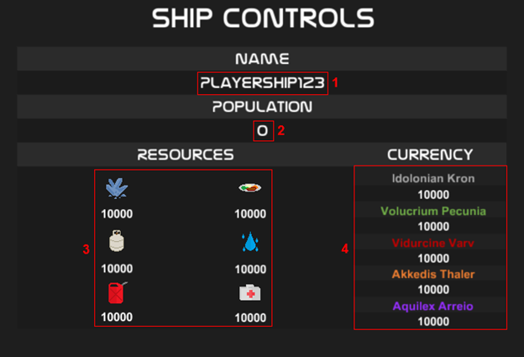

1.  Displays the ship name assigned by the player at the start of the game.

2.  Displays the total number of people aboard the ship.

3.  Displays the total number of resource owned by the player’s faction.

4.  Displays the total number of currency for each of the factions in the universe of Umbra Phase.

## Ship Upgrade Menu

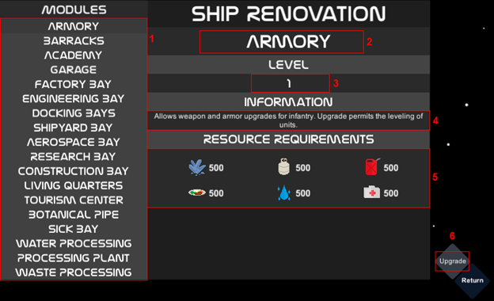

1.  Displays a list of all modules (sub-sections) on the ship. Each module their own advantage/bonus. Selecting one will update the information on the right-hand side of the menu.

2.  Displays the name of the selected module.

3.  Displays the level of the selected module. Modules can only be upgraded to the maximum of level 3. Each upgrade increases the efficiency of the base bonus.

4.  Displays a basic summary of what the selected module does if upgraded.

5.  Displays the resources required to upgrade the selected module.

6.  Upgrades the selected module if the resource requirements have been met.

## Outpost Menu

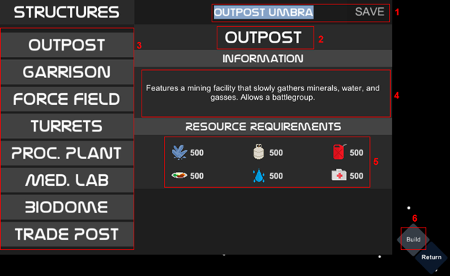

1.  Displays your outpost name. You may right-click the name to change it at any time. By clicking the ‘Save’ button, you are applying and saving changes.

2.  Shows the currently selected outpost sub-section. The default sub-section is the first one which is ‘Outpost’.

3.  A list of buttons that represent each sub-section in an outpost. Selecting one updates all the information on the right-hand side of the menu. Each sub-section provides different bonuses.

4.  Displays a basic summary of what the selected sub-section does.

5.  Displays the resource requirements required to build the selected sub-section.

6.  Builds the selected sub-section if the resource requirements have been met.

# 3. Deviations from Proposed PRJ566 Design

### List of Deviations

For the most part, the project stayed quite close to the original PRJ566 design, however features were removed or disabled out of necessity, especially the content of the game. The platform is mostly complete however.

|  |  |  |
| --- | --- | --- |
| Feature | State | Note |
| Karma system | Removed | Removed due to no dialog system |
| Luck system | Removed | Replaced by morale |
| Character recruitment | Not Added | Not implemented |
| Resource gathering | Incomplete | Can only be done via combat, but cannot be harvested or picked up from game worlds |
| Player character customization | Incomplete | Cannot select perks or abilities anymore, just the class |
| Dialogue system | Removed | Only the basics were implemented, but are not connected to the rest of the game. There are no dialogue scripts to use. |
| Quest system | Removed | Only the basics were implemented, but are not connected to the rest of the game. Each map can hold a list of objectives however, but have no effects on the game. |
| Starbase upgrades | Incomplete | They work, but only unlock more units; they have no effect over unit upgrades |
| Outposts | Incomplete | They can be constructed and upgraded, however they have no effect over local battlegroups and do not allow the recruitment of other characters |
| Subunits | Removed | Units no longer display multiple subunits on the battlemap, however the group names still remain |
| Character leveling | Incomplete | Characters can still level up, however levels have no effect on how many units a character can control, and they do not unlock abilities or perks. Implementation is only at the back end level. |
| Inventory system | Incomplete | The inventory system itself is implemented and working, however there are no items to pick up in the game world |
| Infantry units | Removed | The functionality is in the game, however there are no infantry units added to the game, just vehicles |
| Perks | Incomplete | Only the perks that provide battle map bonuses are implemented (ie Marksmanship, Armorer, First Aid) |
| Characters | Incomplete | Only faction leaders were implemented. There are no generic characters. |
| Minimaps | Removed | There are no minimaps in any of the game’s layers |
| Maps | Incomplete | Not all maps were completed |
| Surrender and Negotiation options | Removed | Removed due to the removal of the dialogue system |
| Sound effects | Incomplete | Only music was added to the game |

# 4. Known Bugs

### List of Known Bugs

|  |  |
| --- | --- |
| Bug | Workaround/Notes |
| Windowed mode resolution resets, attempting to cover the entire screen. | Go to the main menu, under settings and manually set the resolution. |
| Quitting the game during the character creation screen will show a partial save game in the game’s main menu; this will break the game. | Do not quit the game while creating a new character. If the bug happens, start a new game. |
| Moving units sometimes go below tiles | Just a cosmetic issue that has no effect over the game |
| Battle map bottom bar text box keeps scrolling to the bottom | This is an issue with the Unity scroll view element; only workaround is to scroll up |
| Map bounds do not work, so the player can move into the black areas of the map to infinity | Do not move off the map |
| AI moves dead units | This only happened once during testing, however the dead unit caused no damage (ability logic prevents dead units |
| Music manager generates null pointer errors | This has no effect on the game’s stability or functionality, however the music might not always play |
| Objective window shows duplicates | No workaround. This triggers sometimes only. |
| Characters spawning on top of objects in exploration maps, or in inaccessible areas | No workaround. Spawn points were not implemented in the exploration map, so characters are placed on the map via an override function. |