**UPDATING THINGSPEAK CHANNEL USING DHT11 AND RASPBERRY PI**

This manual is about creating and updating ThingSpeak channel using Temperature and Humidity values from DHT11 humidity sensor with Raspberry Pi.

To learn how to connect DHT11 with RaspberryPi download the project form this link:

*https://github.com/ashishk7/raspberrydht11.git*

1. **Components Required**

DHT11 Humidity sensor

10K Resistor

Raspberry Pi

Jumper wires

1. **Connecting DHT11 to Raspberry Pi**

There are two variants of the DHT11 you’re likely to come across.

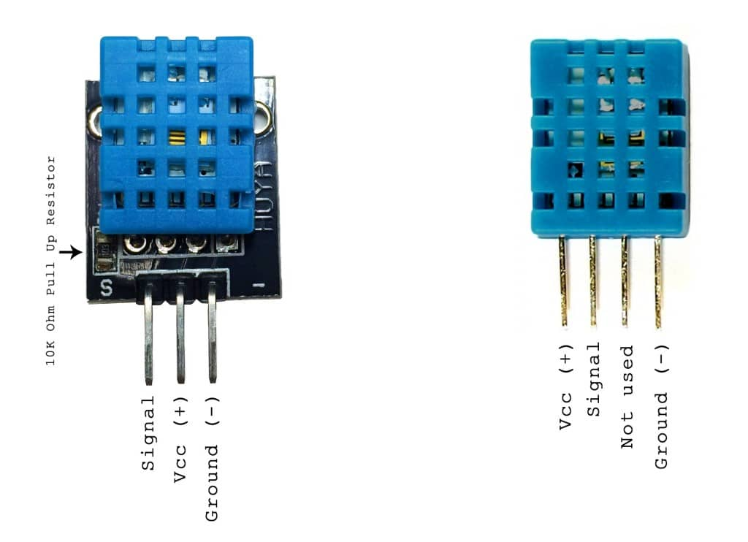

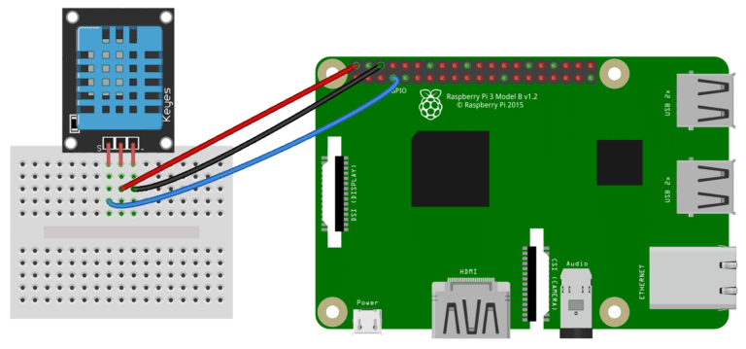**Three pin DHt11 with SSH output:**

**Four pin DHT11 with SSH output:**

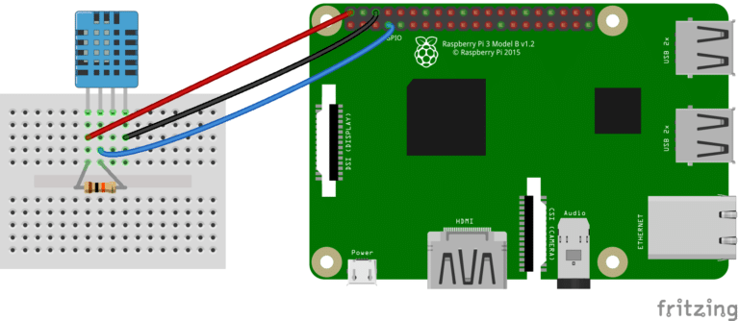

1. **Creating Channel on ThingSpeak Server.**

**Step 1:** SignUp and fill in your details.

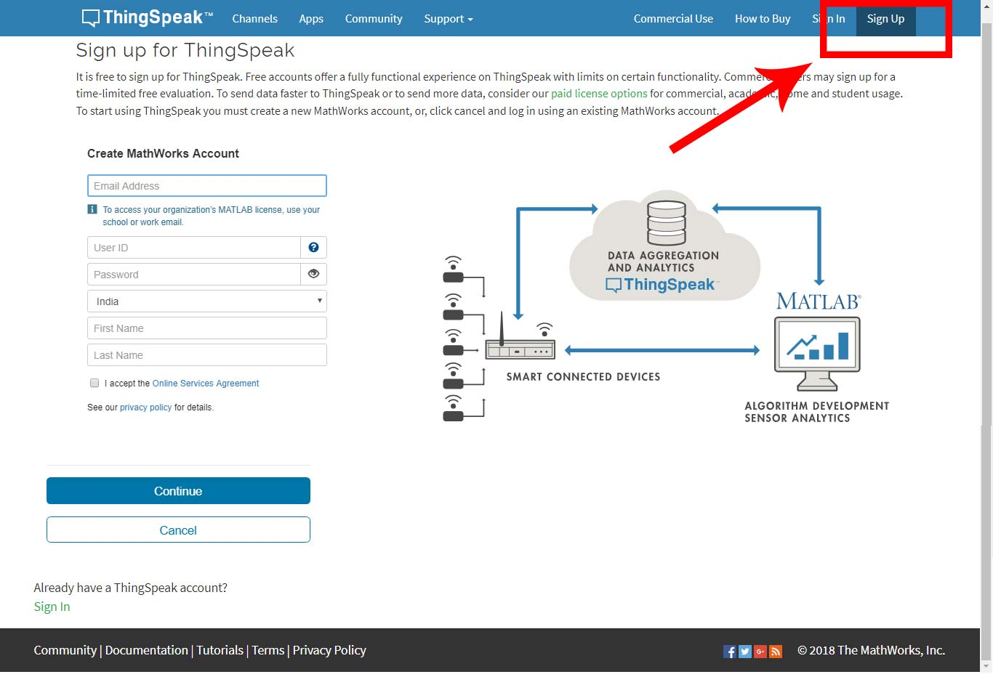

**Step 2:** Sign in and click on Channels



**Step 3:** Now create new Channel

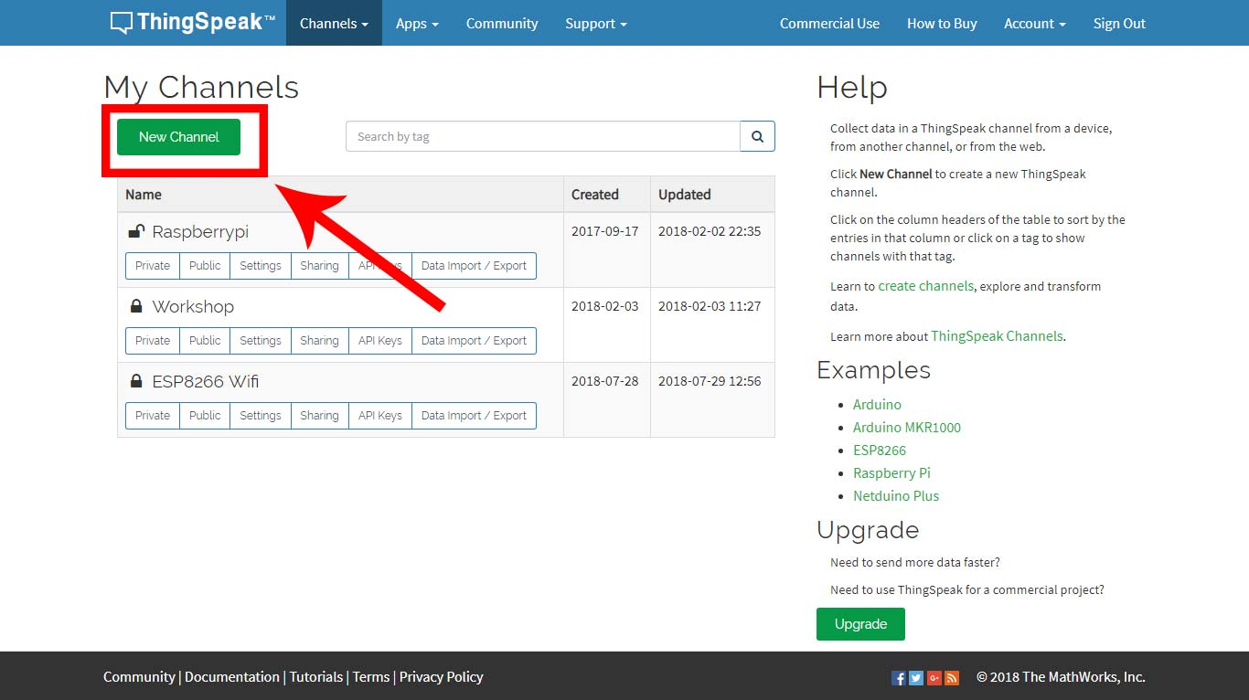

**Step 4:** Fill the following details and click on Save Channel.

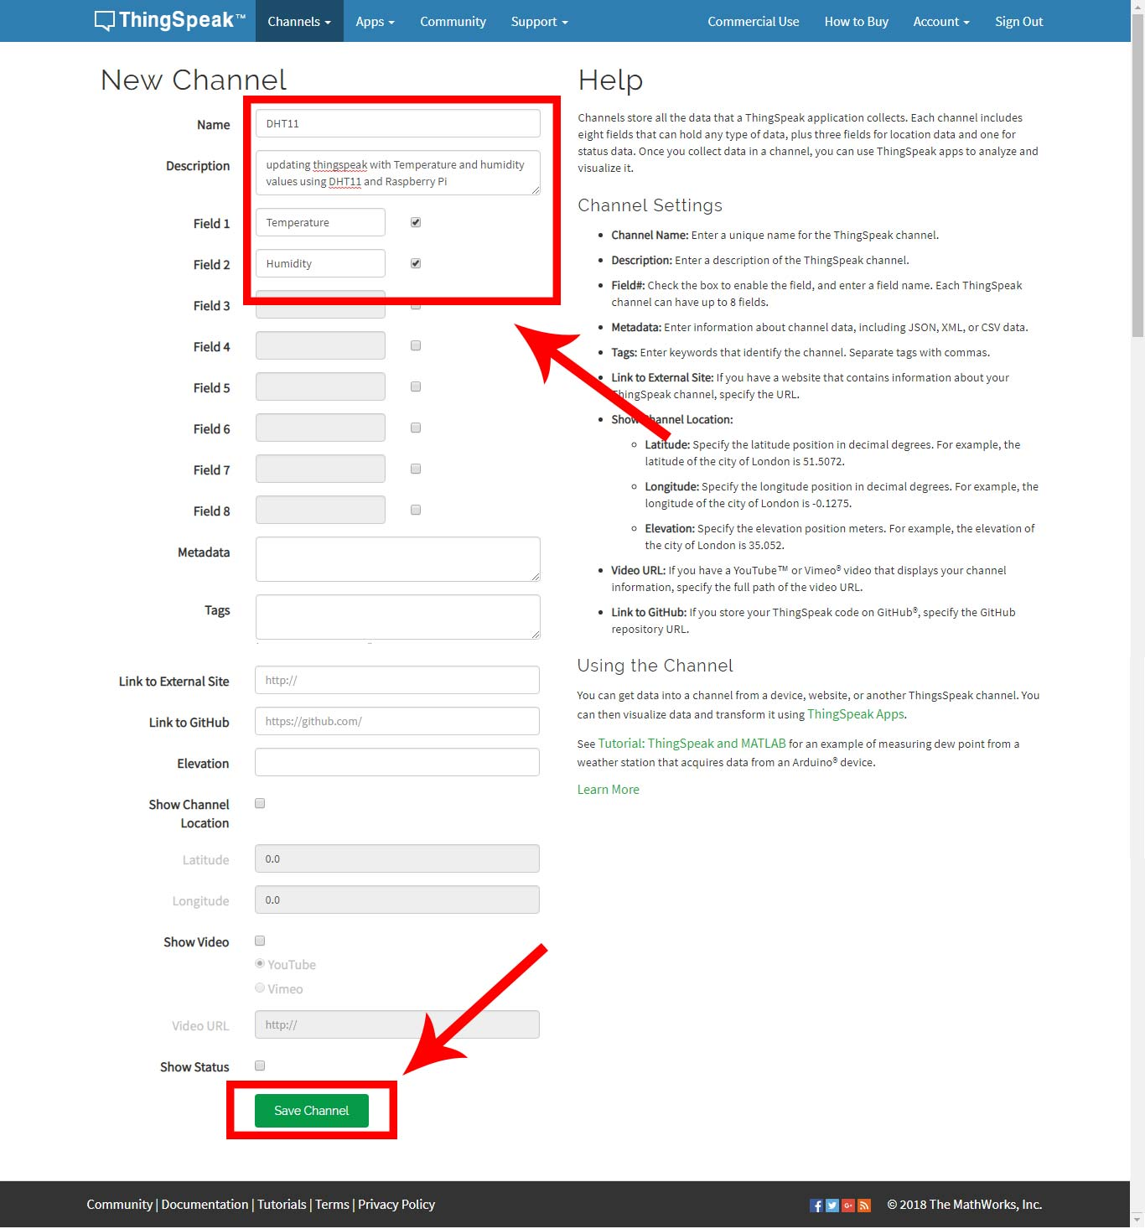

When channel is created, Select **“API keys”** in the tabs above and note the API key of your channel. See the picture on next page.

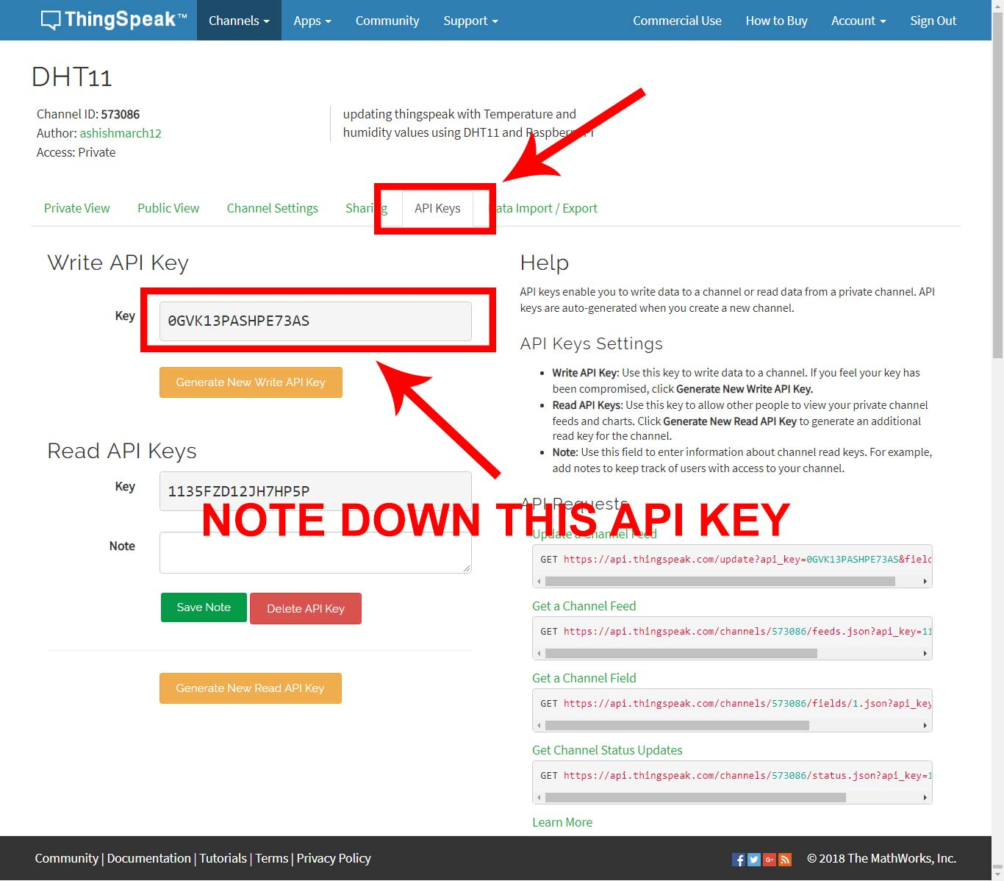

1. **Installing necessary libraries**

We’ll be using the Adafruit DHT11 and psutil Python libraries.

**To install the Adafruit DHT11 library:**

Enter this at the command prompt to download the library:

*git clone https://github.com/adafruit/Adafruit_Python_DHT.git*

Change directories with

*cd Adafruit_Python_DHT*

Now enter this:

*sudo apt-get install build-essential python-dev*

Then install the library with:

*sudo python setup.py install*

**To install psutil library:**

Enter this at the command prompt to download the library:

*https://github.com/giampaolo/psutil*

Change directories with

*cd psutil*

Then install the library with:

*sudo python setup.py install*

**To install Paho client library library:**

Enter this at the command prompt to install the library:

*sudo pip install paho-mqtt*

**To install requests:**

Enter this at the command prompt to install the library:

*sudo pip install requests*

1. **Code :**

import json

import requests

import time

import sys

import Adafruit_DHT

API = "0GVK13PASHPE73AS*" # enter you Thingspeak Write API key here*

while(True):

humidity, temperature = Adafruit_DHT.read_retry(11, 4) *#11=DHT11, 4=GPIO4*

print("Temperature = %s Humidity = %s" % (temperature, humidity))

payload = "https://api.thingspeak.com/update?api_key=" + str(API)+ "&" + "field1=" + str(temperature) + "&field2=" + str(humidity)

data=requests.get(payload)

if data.status_code!=200:

print("error!!! uploading")

else:

print("uploaded to server sucessfully")

written by: Ashish Kumar (ashishmarch12@gmail.com)