**HOME AUTOMATION USING GOOGLE ASSISTANT**

In this project we are going to control our devices with voice commands using Google assistant.

1. **Installing required libraries**

Install these libraries by typing the commands in terminal

*pip install requests*

*sudo apt-get install build-essential python-dev*

1. **Setting up Google Assistant and linking it to ThingSpeak Channel**

**Step 1:** Create account on IFTTT website and click on your ID.

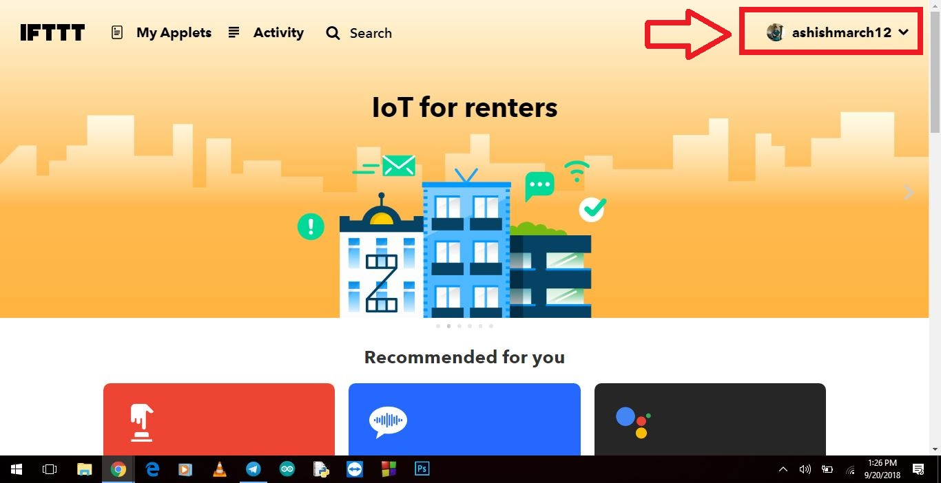

**Step 2:** Now click on “New Applet”

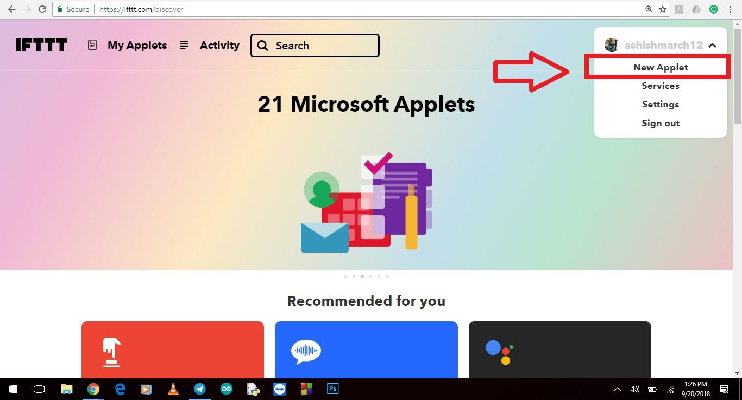

**Step 3:**  Click on “+this”.

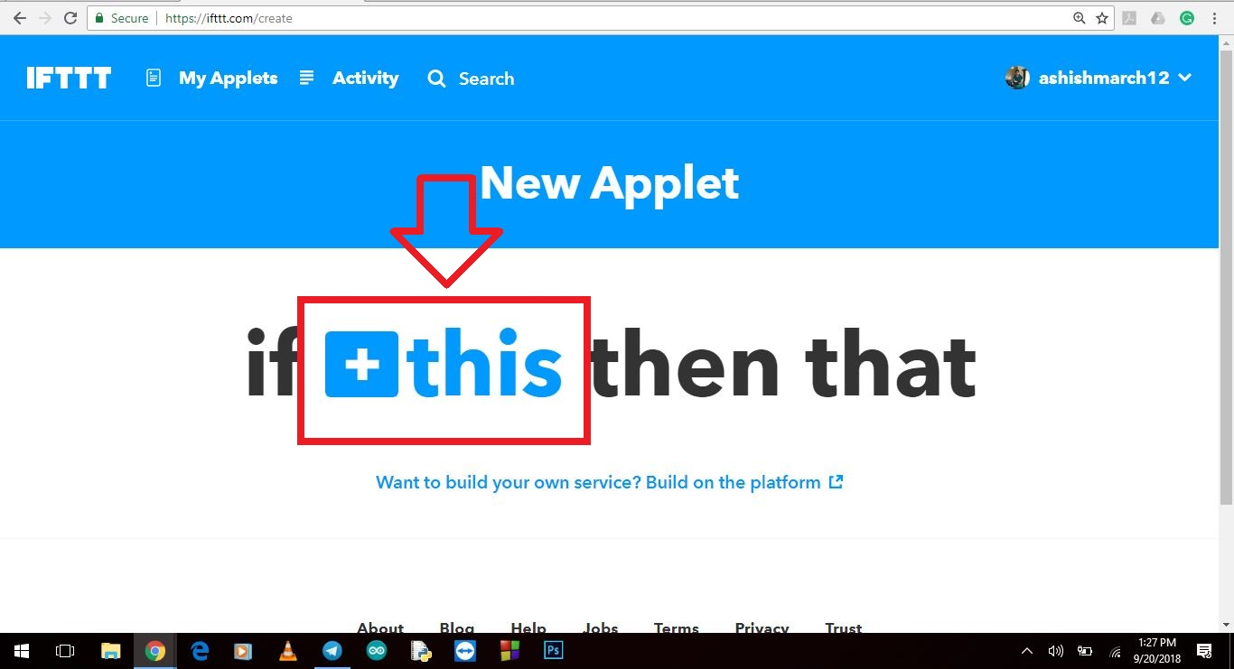

**Step 4:**  Choose Google Assistant from the list.

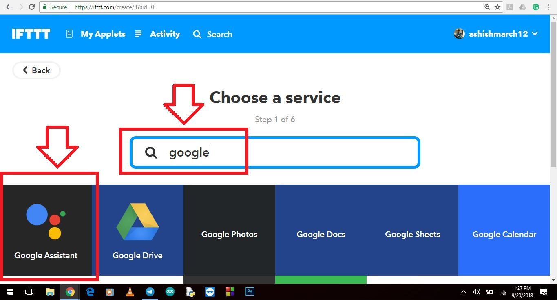

**Step 5:**  Click on “Say a simple phrase” applet.

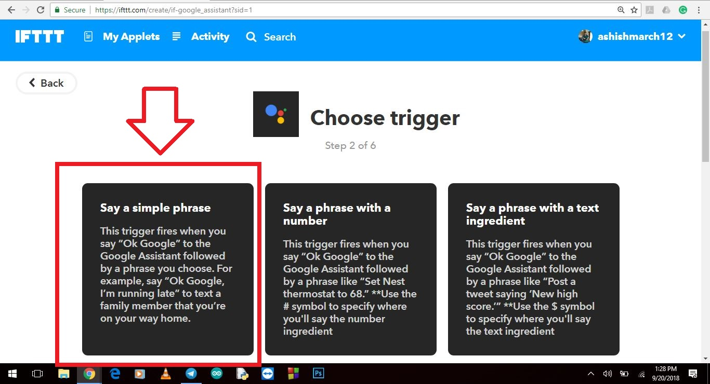

**Step 6:**  Fill the following fields and click “Create trigger”.

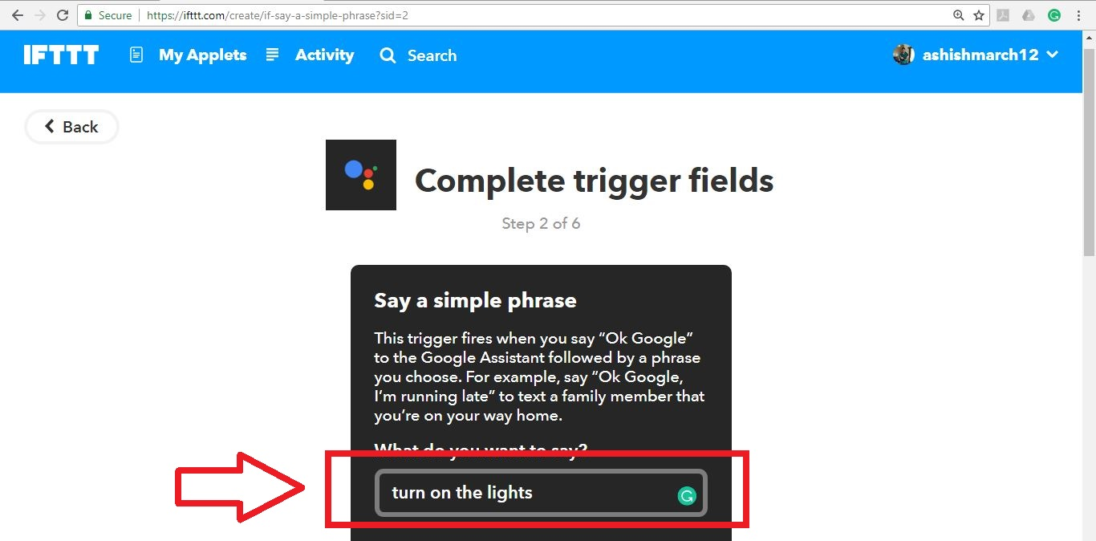

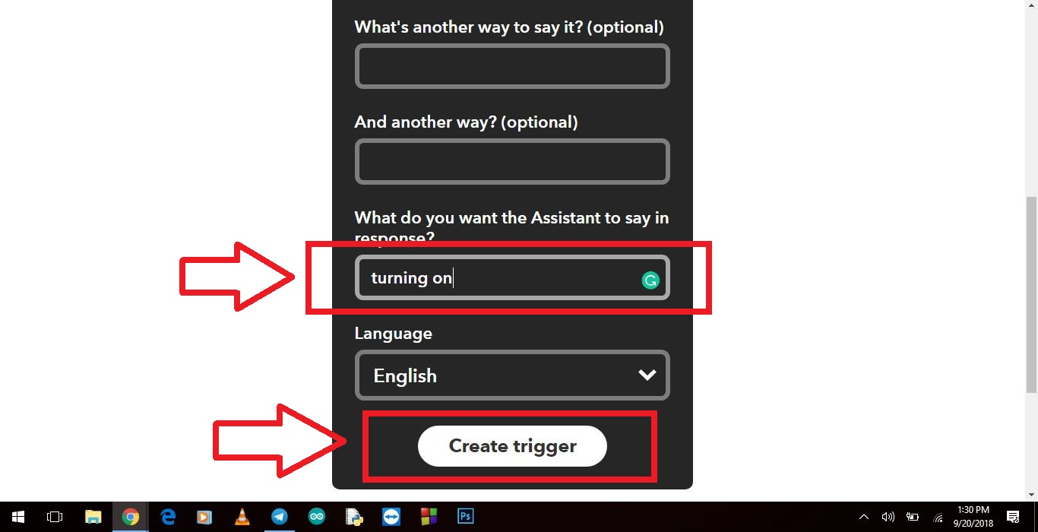

**Step 7:**  Click on “+that”.

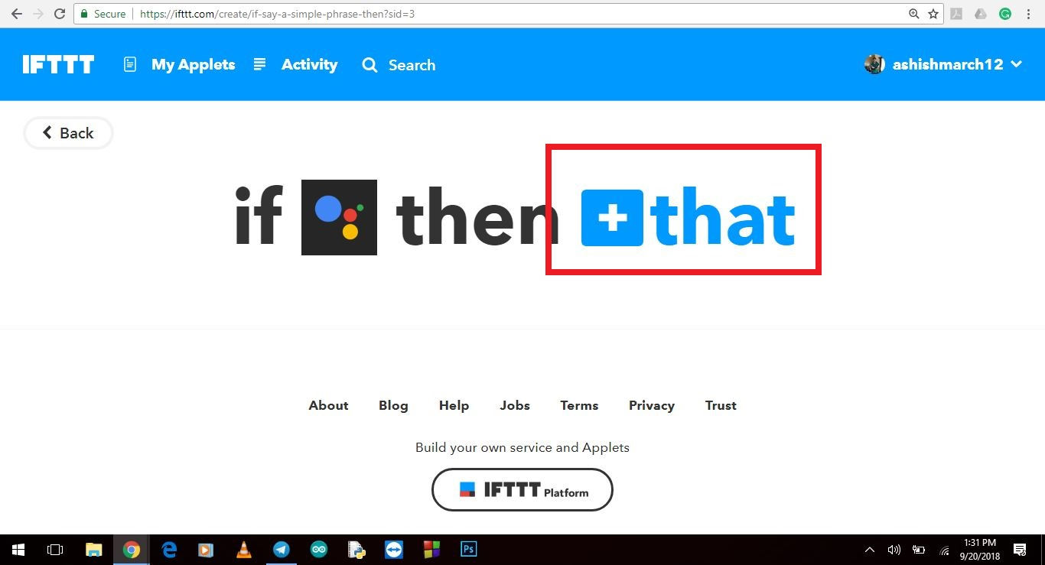

**Step 8:**  Search for webhooks and select it.

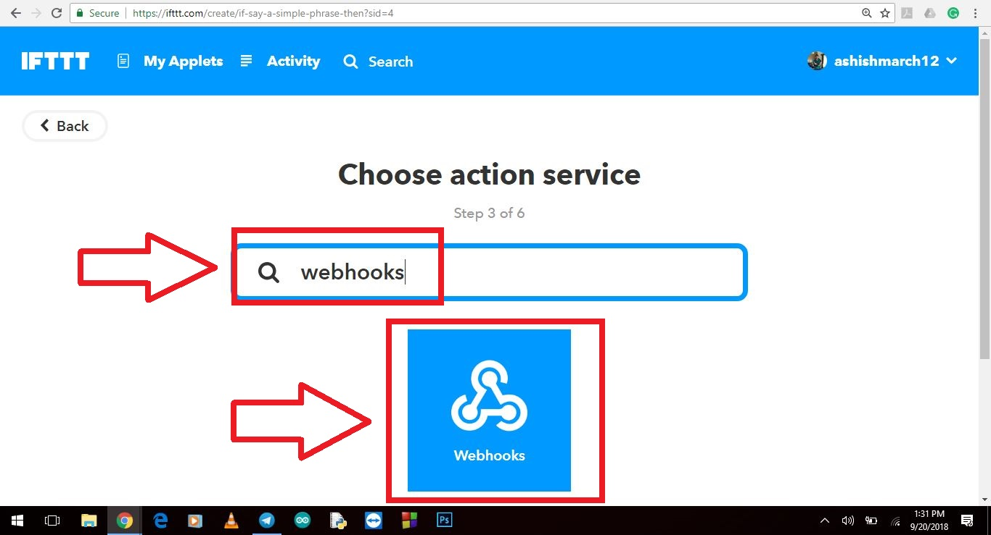

**Step 8:**  Choose action “Make a web request”.

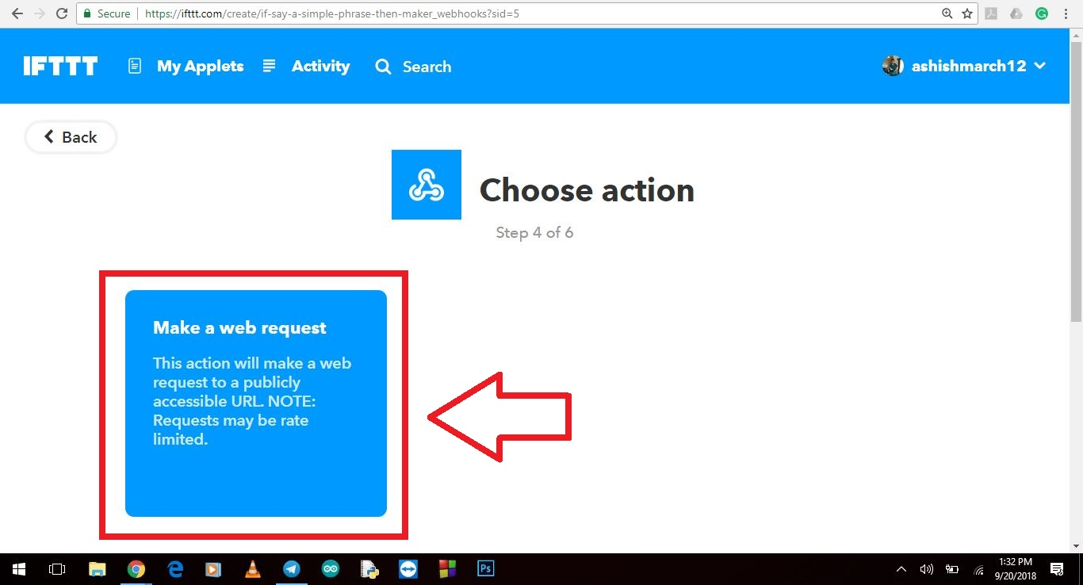

**Step 9:**  Here we have to fill the ThingSpeak Channel.

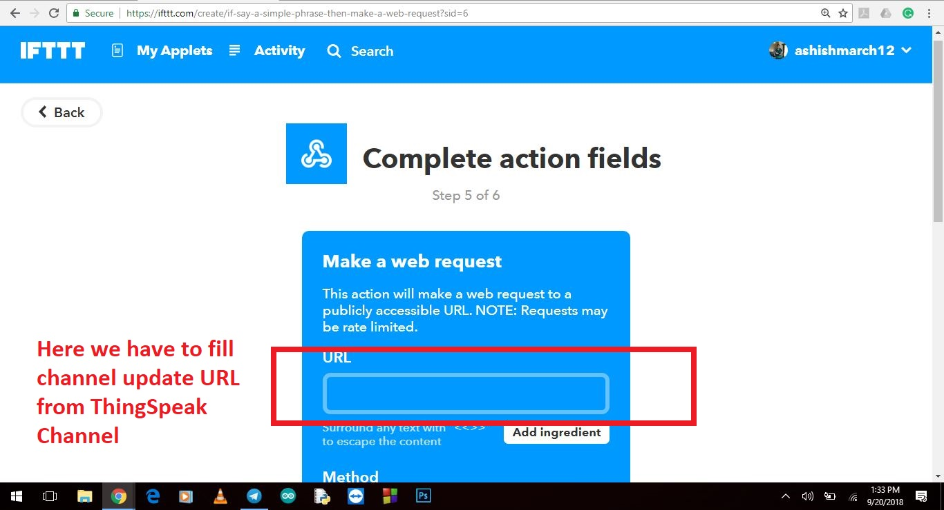

**Step 10:**  Goto Thingspeak.com, sign in to your account and create a new channel.

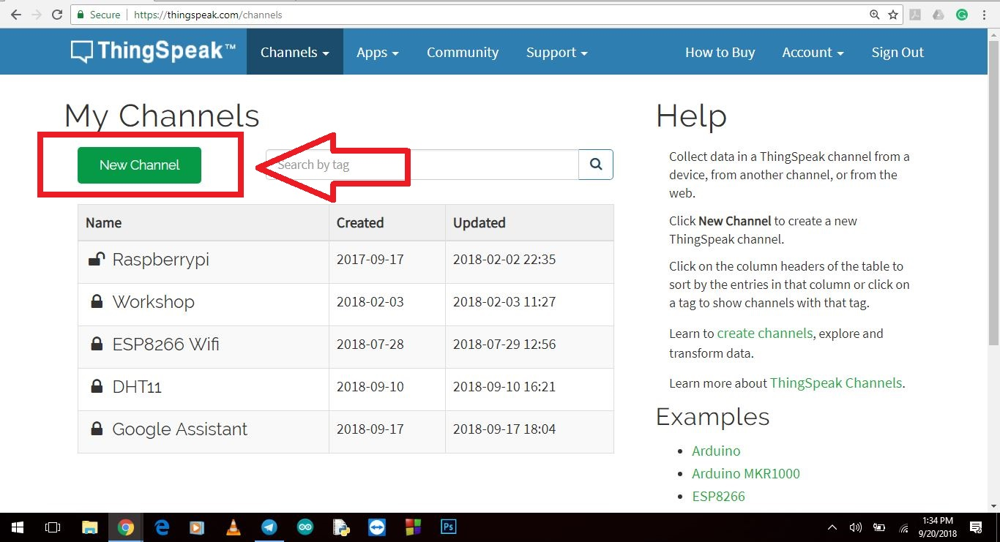

**Step 11:** Give this channel a name.

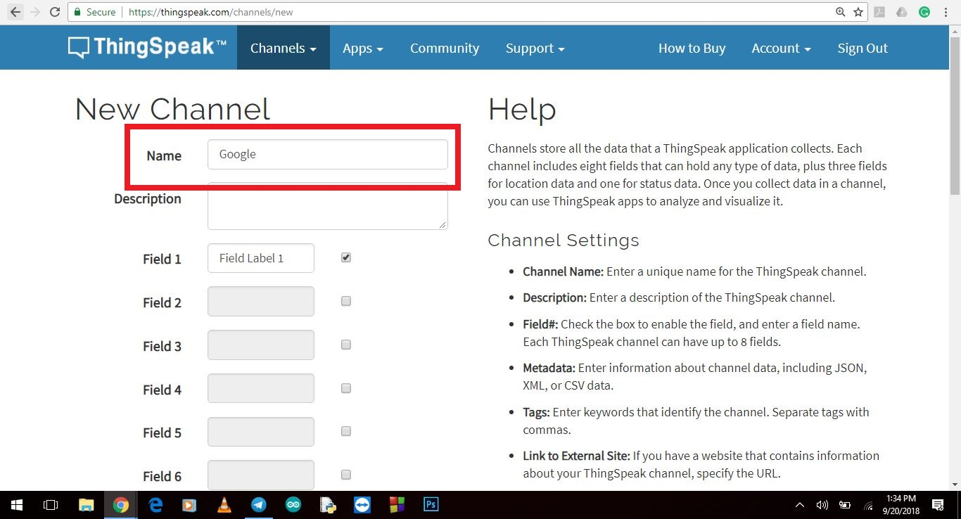

**Step 12:**  Click on “API” keys.

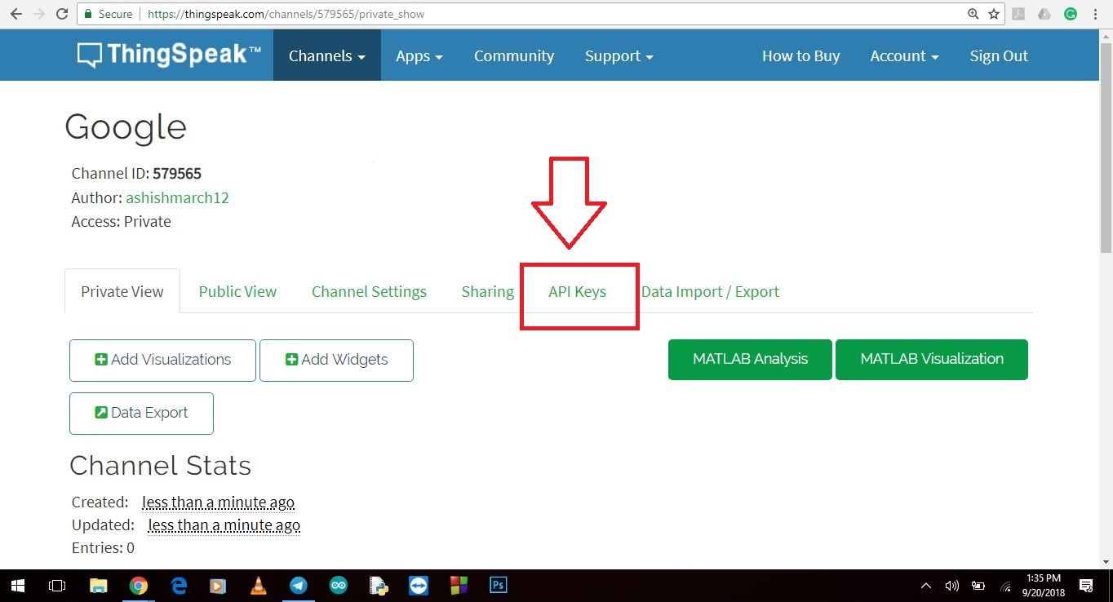

**Step 13:**  Copy the “Update channel feed” link. Make sure you don’t copy “GET” prefix written in front of it.

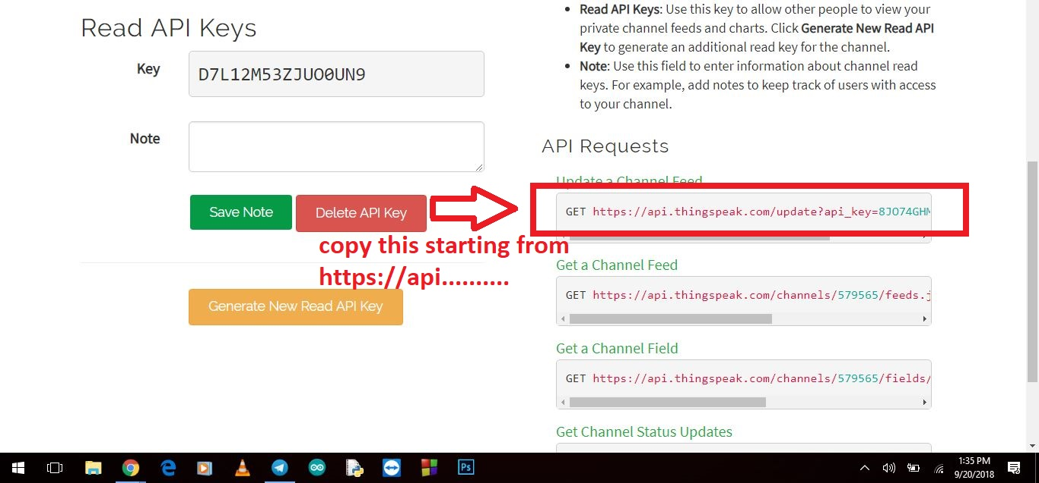

**Step 14:**  Paste the URL here and change the last values according to what data you want to send. The same data will be updated on ThingSpeak channel.

For eg: you can send “1” as a signal to turn on LED/Light.

And you can send “0” to turn it off.

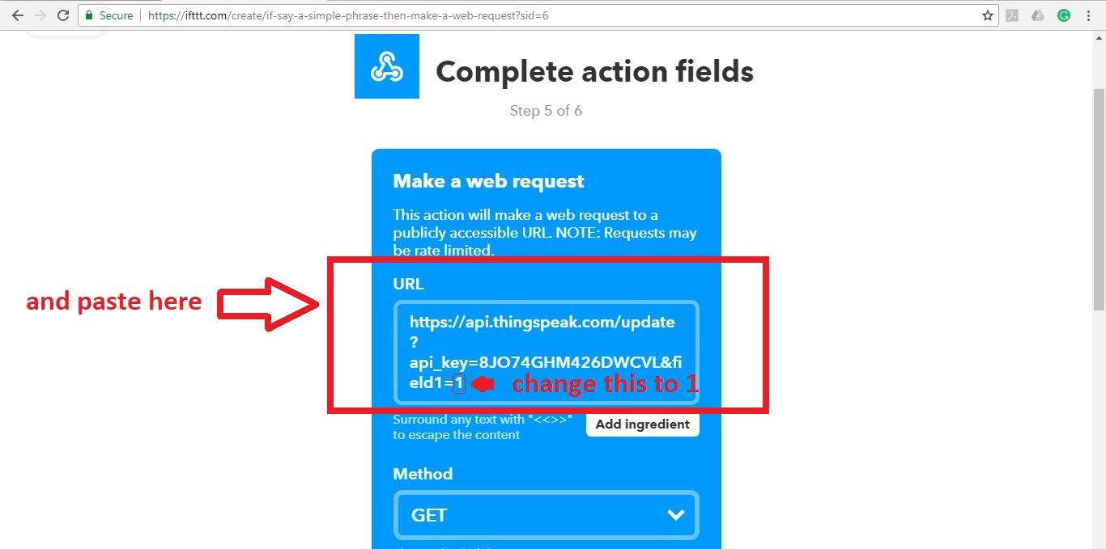

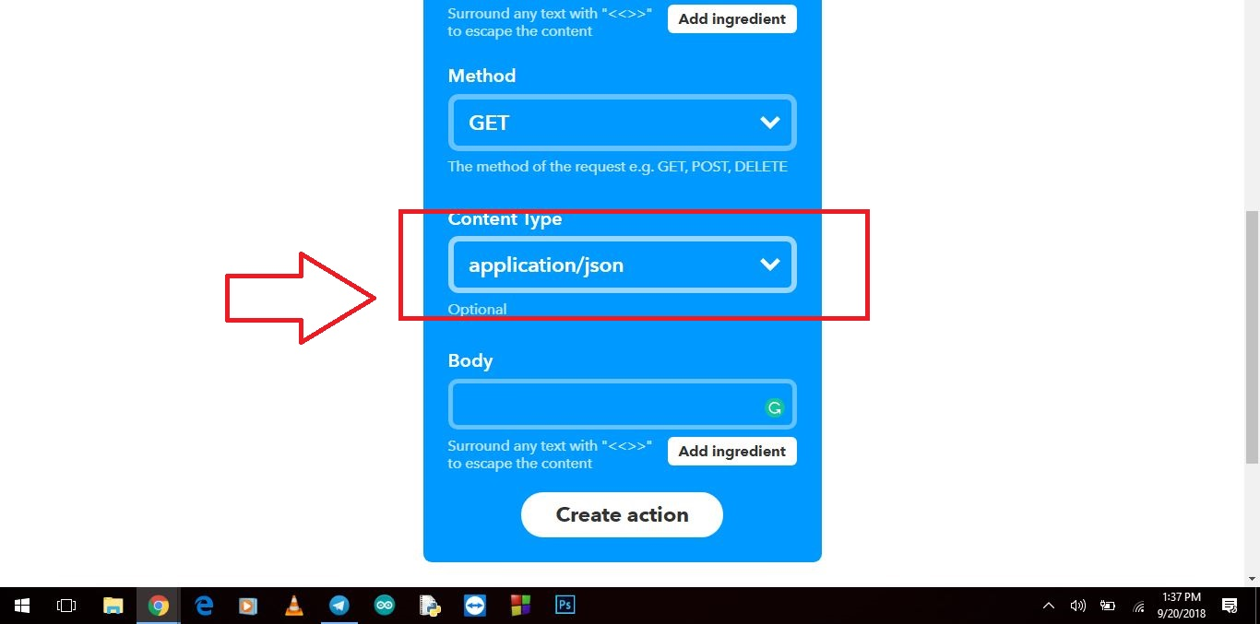

Make sure you select json from the Method drop down menu

Select content type as application/json

Now click on “Create action”.

**Step 15:**  Click on “Finish”.

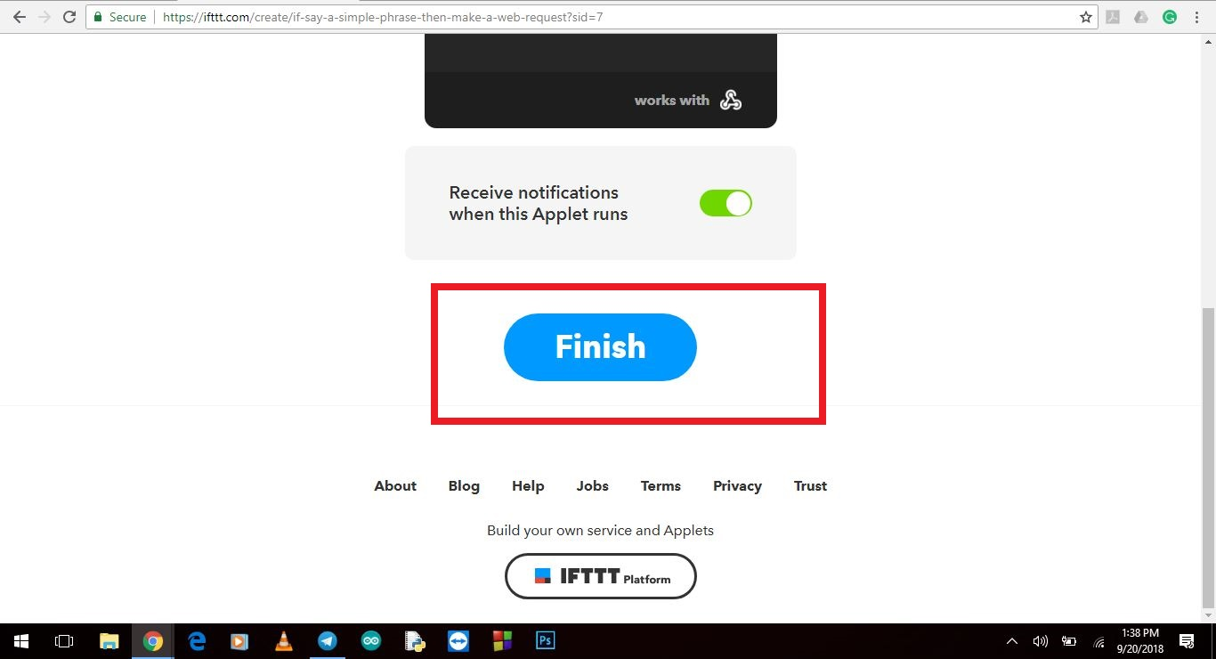

**Step 16:**  Click on “check now”.

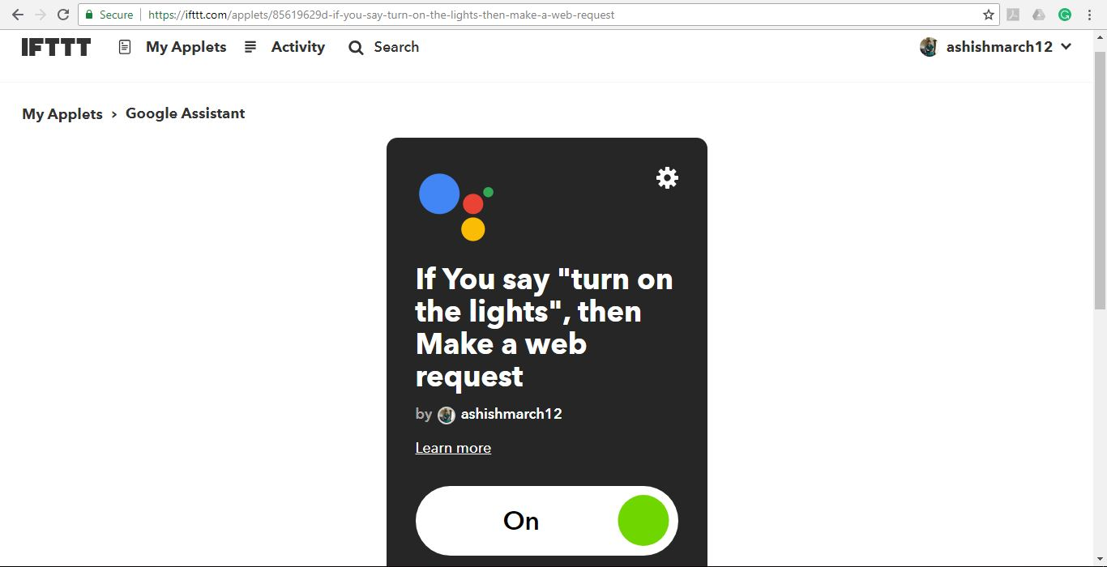

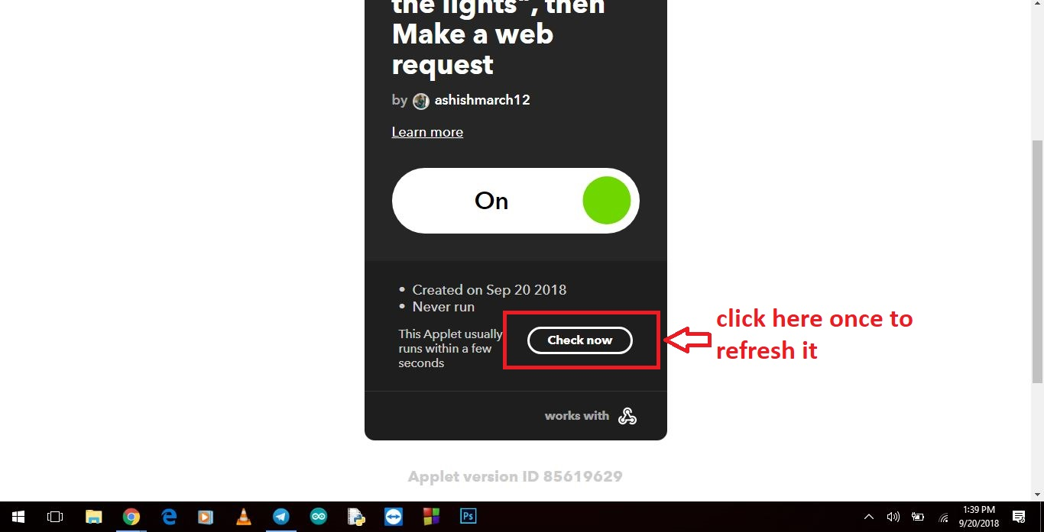

1. **­­­­­­­­­­­­Code to Fetch data from ThingSpeak Channel**

import json

import requests

import time

import RPi.GPIO as GPIO

led = 3

GPIO.setmode(GPIO.BOARD)

GPIO.setup(led,GPIO.OUT)

myserverURL = "https://www...... enter your URL here"

while(True):

data=requests.get(myserverURL)

if data.status_code!=200:

print("error");

try:

data=json.loads(data.text)

except:

data=None;

if data!=None:

value =data["feeds"][0]["field1"]

print("value = %s" % (value))

if value=='1':

GPIO.output(led,True)

if value=='0':

GPIO.output(led,False)

time.sleep(0.01)