Name: Benito Moeckly
Section: 4
University ID:853255423

Lab 2 Report

Summary:
In lab we ran several C programs that showed off different features of the the UNIX architecture of the Linux kernel. One of the commands showed off was fork() which we discussed in lecture. Using fork we can create child processes that are copies of the current processes. These child processes pick up where the parent left off so as to not create an infinite loop of creating child processes (unless that’s what you want, then that’s called a denial of service attack.) This command can lead to some interesting consequences depending on when the fork is. As we saw in some of the exercises, there may be occasions where we want the child process’ parent PID but the parent process might finish fast enough, that is enters a zombie state and leaves the child process orphaned. We also observed how scheduling in the linux kernel might affect the output that we get from two simultaneously running programs.
Lab Questions:

3.1:
6pts In the report, include the relevant lines from “ps -l” for your programs, and point out the following items:
- output
- process name
- process state (decode the letter!)
- process ID (PID)
- parent process ID (PPID)
2pts Repeat this experiment and observe what changes and doesn't change.
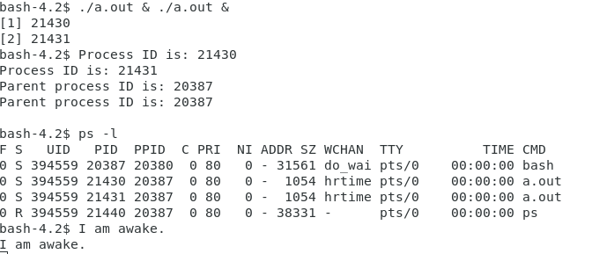

2pts Find out the name of the process that started your programs. What is it, and what does it do?
Process 1:
process name: a.out
process state: S (sleeping)
process ID: 21430
parent process ID: 203387
Process 2:
process name: a.out
process state: S (sleeping
process ID: 21431
parent process ID: 20387

The parent process is the bash because the parent ID of the two processes we started was 20387. When we run the ps -l command we can see that the process with PID 20387 is the bash. The bash is the Linux process that runs receives commands.
3.2:
1pt Include the output from the program
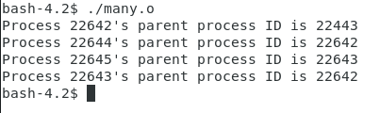

4pts Draw the process tree (label processes with PIDs)

3pts Explain how the tree was built in terms of the program code
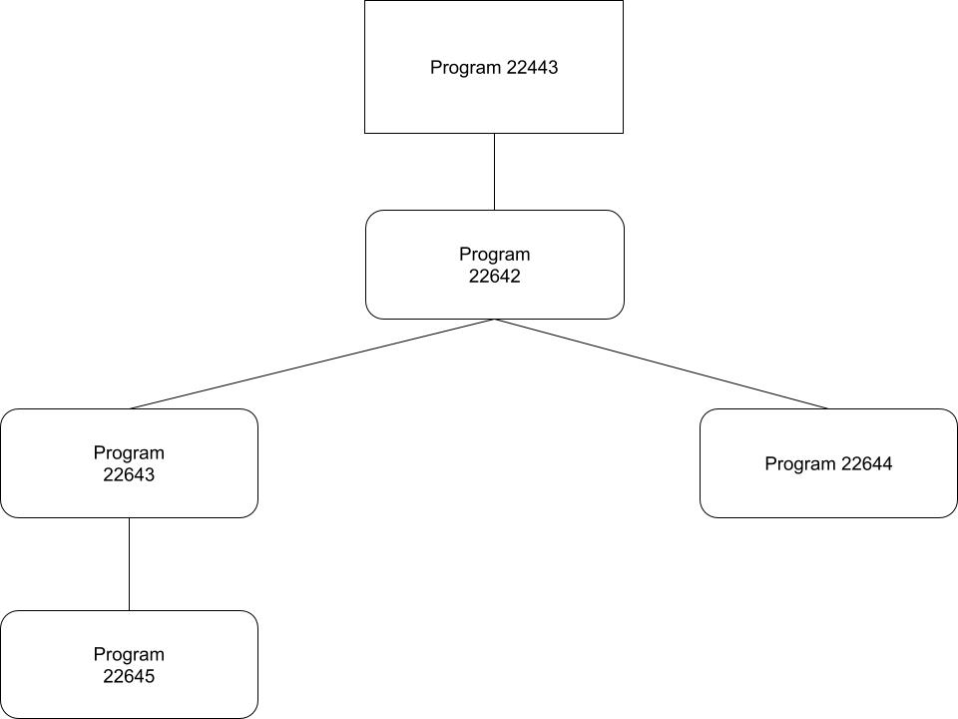
2pts Explain what happens when the sleep statement is removed. You should see processes reporting a parent PID of 1. Redirecting output to a file may interfere with this, and you may need to run the program multiple times to see it happen.
The first program (22443) is whatever executed the C code, probably the bash. Then Program 22642 is the first iteration of the C program. It spawns a child(probably 22643) through fork() then another (22644) and then sleeps for a microsecond, prints the first line in the screenshot. Then it sleeps for 2 seconds. The first fork() child 22643 then picks up where the parent left off and forks once, creating process 22645. Since Process 22644 and process 22645 were created on the second fork, they do pick up on the line after that and do not create a child process.
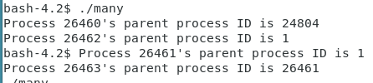

From what I could read on PID 1, it is reserved for the initialization of a program. I think what has happened is that the parent program ended early enough that the child program was orphaned by the time it got to the print statement, therefor it’s only parent was PID 1.

3.3:
2pts Include the (completed) program and its output
4pts Speculate why it might be useful to have fork return different values to the parent and child. What advantage does returning the child's PID have?
#include <stdio.h>

int main() {
int ret;
ret = fork();
if (ret == 0) {
/* this is the child process */
printf("The child process ID is %d\n", getpid());
printf("The child’s parent process ID is %d\n", getppid());
} else {
/* this is the parent process */
printf("The parent process ID is %d\n", getpid());
printf("The parent’s parent process ID is %d\n", getppid());
}
sleep(2);
return 0;
}
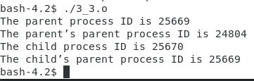

It is important to return a value from fork in order to be able to differentiate the child and the parent processes. An advantage of returning the child’s PID is that the parent can kill the child process if needed.
3.4:
2pts Include small (but relevant) sections of the output
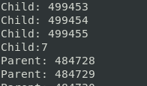

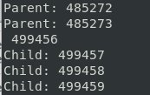

4pts Make some observations about time slicing. Can you find any output that appears to have been cut off? Are there any missing parts? What's going on (mention the kernel scheduler)?
It seems like the kernel scheduler is alternating between the child and parent process’ out statements every few hundred clock cycles or so. As we can see in the screen shots the child’s output is cut off in the middle of iteration #499456 and then picks up again after parent iteration #485273.

3.5:
6pts Explain the major difference between this experiment and experiment 4.
Be sure to look up what wait does (man 2 wait).
Wait() will wait for the process’ child program to terminate before executing the next lines of the program. In the previous experiment, the two were occurring simultaneously.
3.6:
2pts The program appears to have an infinite loop. Why does it stop?
4pts From the definitions of sleep and usleep, what do you expect the child's count
The parent kills the child program after 10 seconds.
to be just before it ends?
2pts Why doesn't the child reach this count before it terminates?
Around 1000; the reason for this is it prints ever 1/100 of a second for 10 seconds, to we can expect 10*100 or 1000 print statements.
I think the child program loses some microseconds initializing. That and the printf() statement doesn’t necessarily happen instantaneously (takes a nonzero amount of time to execute.)

3.7:
8pts Read the man page for execl and relatives (man 3 exec). Under what conditions is the printf statement executed? Why isn't it always executed?
(consider what would happen if you changed the program to execute something other than /bin/ls.)
If you try to run something that is not executable, then the error message “What happened?” will print. Otherwise the program given as an agrument to execl() will be ran. The second print statement will not execute.
3.8:
2pts What is the range of values returned from the child process?
2pts What is the range of values sent by child process and captured by the parent process?
The range of numbers is 0 – RAND_MAX/4
2pts When do you think the return value would be useful?
The range of values seem to be 0-255

Hint: look at the commands true and false.
Knowing the exit status of the process can tell you if it was executed successfully or not. This can tell the parent program how to proceed forward.

