MIDLANDS STATE UNIVERSITY

Qualification Verification System
Technical Report
  - MIM736 Software Engineering
Practical Assignment August 2026
Design and implementation using Git and CI/CD practices
Project team
Charlton
Simba
Mncedisi Artwell Nyathi
Doreen
Cleopatra
Updated 14 September 2026
Main report approximately 3,300 words
References and supporting appendices are additional
Assessed development version 59d32ede40ba

Contents
Executive summary 3
1 Problem analysis 3
2 Requirements 4
3 System architecture 5
4 Design decisions 6
5 DevOps workflow 8
6 Testing strategy 9
7 Verification strategy 10
8 Critical evaluation 11
References 12
Appendix A Revision and execution evidence 13
Appendix B Requirement verification matrix 16
Appendix C Data model and report preparation 18
This update follows the eight technical-report areas in the assignment. The appendices record changes since the first report, current execution evidence, selected requirement checks and implemented data relationships.

Executive summary
Our Midlands State University Qualification Verification System combines a Django web application and REST API for maintaining qualification records, checking certificate status and recording verification activity. This revised group report assesses develop commit 59d32ede40ba9734057e9d3580de21d205b85bfc on 14 September 2026. It supersedes the report based on e12f7d92e280 and incorporates merged PRs 16, 17 and 18.
PR 17 substantially improves the delivery process. The current GitHub Actions run passed 56 tests on PostgreSQL, achieved 83.19% backend statement coverage, passed configured Ruff checks, verified container health and persistence, and published the tested image to GitHub Container Registry. Production Docker settings now require explicit configuration, use Gunicorn and WhiteNoise, and avoid automatic demonstration accounts. Django has moved to the supported 5.2 LTS series.
These results close several earlier DevOps gaps. Functional acceptance remains partial: fresh synthetic-data checks reproduced privileged-role changes, unauthorised document access and inconsistent verification outcomes. The public Vercel deployment also remains separate from the tested Docker delivery. This report records the improvements and outstanding work against the assignment's eight required areas [1].

1 Problem analysis

Operational problem and project scope
Employers and institutions need a dependable way to check presented qualifications without lengthy manual correspondence or unrestricted disclosure of graduate records. Our application centralises students, qualification definitions and issued certificates. Registry staff maintain records, employers verify credentials and inspect their history, graduates access linked dashboards, and administrators oversee users and reports.
Public verification is narrower than internal search. A person presenting a certificate can supply its number or verification code; wider identity searches require registry authority. This boundary reduces disclosure while retaining useful internal retrieval. The four assignment functions are registration, search and retrieval, authenticity verification, and auditable verification history [1].
The implemented decision checks the status of a certificate held in this application's database. Its reliability depends on accurate institutional records, controlled issuance and authorised changes. External university validation, admissions, examinations, payments and full transcript processing are outside the implemented scope. A database match alone cannot establish the legitimacy of the original award.

Method and revision boundary
This update compares the original baseline with the latest integrated develop revision [2]. Inspection covered the source, templates, models, migrations, tests, documentation, Git history, pull requests, review submissions and actual workflow logs. A detached checkout supported fresh checks in an isolated environment with synthetic records. Read-only public checks examined availability and operational URLs.
Evidence is attributed to its environment and commit. The successful integration run is 34888206172, created on 14 September at 19:39:16 UTC [5]. The main branch remains at 72dc30903fda; it does not contain the same integrated history. Repository documentation contains dated assessments, so current conclusions use source and execution evidence instead of carrying historical statements forward.

2 Requirements

Functional requirements
Registration separates three operations: creating a student, defining a qualification and issuing a certificate linking the two. Authorised APIs and Django administration support qualification and certificate maintenance. The student web form does not automatically issue a certificate. Database uniqueness protects identity fields and credential identifiers, although complete transactional issuance and duplicate-input acceptance need further testing.
Public lookup accepts exact certificate numbers or verification codes. Administrators and registrars can additionally search student numbers, National IDs and partial names. List APIs provide pagination with 20 records per page. The verification helper returns the first matching certificate, leaving ambiguous internal name searches without the required result-selection workflow.
The API maps active, revoked and suspended certificates to VERIFIED, REVOKED and PENDING. Malformed input returns HTTP 400; an unmatched, well-formed query returns 404 and INVALID; recognised statuses return 200. Scoped API throttles return 429 when their limits are exceeded. Acceptance must inspect the outcome and disclosed fields, because a 200 response does not necessarily describe a valid credential.
VerificationLog stores the processed query, result, time, associated certificate, authenticated verifier when available, network metadata and heuristic risk score. Employer history and CSV exports are filtered to the current user. Administrative reports aggregate activity. AuditLog separately records selected HTTP write requests and response codes.

Quality requirements and acceptance
Security, reliable decisions, durable records, maintainable modules and usable interfaces support the functional requirements. The brief additionally requires meaningful Git collaboration, CI/CD, automated tests, coverage, static analysis, coding standards and execution evidence. The enforced 80% statement-coverage threshold is a project target; the lecturer does not specify that percentage [1].
The specification's FR and NFR identifiers provide traceability, but a stated requirement is not proof of implementation. For example, FR-REG-06 requires multiple certificates per student, while the current relationship permits one. FR-IAM-04 reserves privileged-role changes for administrators, but the registrar API boundary remains incomplete. Appendix B records selected requirement outcomes.
Assignment area | Current evidence | Remaining acceptance work
Register records | Models, maintenance APIs and student form | Complete issuance, duplicate and lifecycle scenarios
Search and retrieve | Public lookup and tested internal privacy controls | Ambiguous names and combined search parameters
Verify qualifications | Status decisions, QR generation and PDF output | Consistent status display and authorised downloads
Auditable history | Verification logs, request logs and filtered exports | Domain changes, protected history and retention
DevOps and quality | PostgreSQL tests, quality gates, container checks and GHCR | Required reviews and accessible release verification

3 System architecture

Application structure
The system is a modular monolith: Django applications divide responsibilities inside one deployable application and relational database. Server-rendered templates, Bootstrap and JavaScript provide browser interfaces; Django REST Framework provides API endpoints. Both channels reuse models and the certificate lookup helper. There are no separately deployed microservices or message broker.
Authentication extends Django's user model with application roles. Students and qualifications maintain graduate records, award definitions and certificates. Verification performs lookup, status mapping, logging and document generation. Employers supports organisation records and history; reports supplies dashboards and exports; audit records write requests; ai_fraud calculates deterministic risk scores. The api application assembles resource routes [2].
Middleware handles security, sessions, cross-origin requests, CSRF protection, authentication and audit recording. Web sessions and API tokens identify callers. Resource permissions restrict registry APIs, while public verification allows anonymous access. The production profile adds WhiteNoise for collected static assets and health endpoints for operational checks.
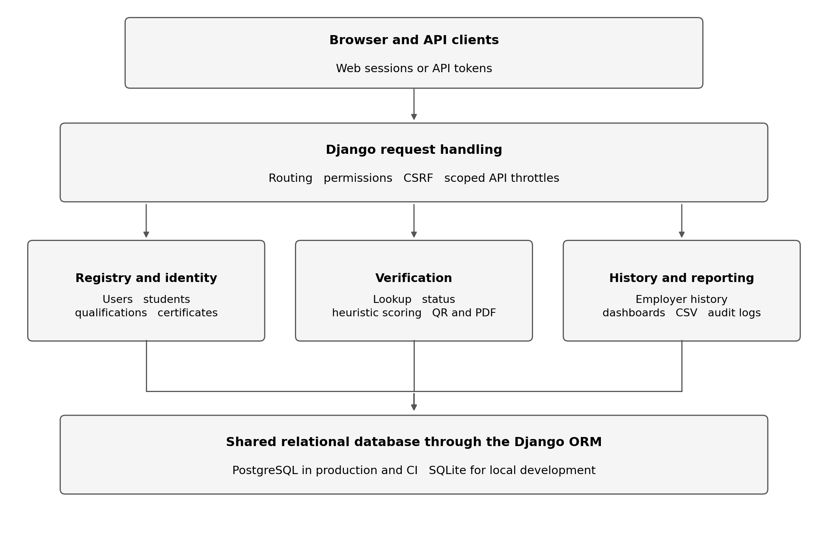
Figure 1 shows the implemented application structure and shared persistence layer. The domain boxes describe code responsibilities within the same application.

Data and deployment architecture
Seven principal entities organise the data. User can have optional Student and Employer profiles. Certificate references one Student through a one-to-one relationship and one Qualification through a foreign key. VerificationLog may reference a Certificate and User; AuditLog may reference a User. Nullable log references preserve rows after referenced records are deleted, while qualification deletion is protected when certificates exist. Appendix C diagrams these relationships.
Unique fields and identifier indexes support retrieval, and select_related fetches associated records with a certificate. These design features require representative query-plan and load measurements before making scalability claims. The one-certificate restriction and record-count numbering constrain future registry use.
SQLite remains the default local database. CI now exercises PostgreSQL 16. The production Compose stack uses separate PostgreSQL and media volumes, a non-root Gunicorn application container and loopback binding for an external HTTPS proxy. Vercel retains its separate entry point and temporary-storage behaviour; successful Docker validation does not establish equivalent Vercel durability.

4 Design decisions

Framework and interface choices
Python, Django and Django REST Framework provide authentication, validation, ORM persistence, migrations, administration and API routing with limited infrastructure overhead. A monolith suits a five-person academic project by simplifying transactions and deployment coordination. Its trade-off is coupled releases, so module boundaries and shared contracts must remain clear.
Server-rendered pages avoid a second frontend application, while the REST API supports integration and automated request tests. ReportLab generates PDFs; qrcode and Pillow generate QR images. Templates and JavaScript still need browser-level verification beyond Python coverage.
The updated dependency files pin Django 5.2.17, REST Framework 3.18.1 and the runtime and testing packages. Django 5.2 is a supported LTS series [6]. Pinning makes installations more repeatable, but updates still require review and testing. Docker base images and workflow actions use tags, so these declarations do not make every external build input immutable.

Security and verification choices
Public registration allows EMPLOYER and PUBLIC_VERIFIER only. Web and API registration apply Django password validation, and login redirects are checked for safe destinations. Application roles remain distinct from Django staff and superuser permissions.
Verification accepts trimmed, non-empty strings of at most 150 characters and rejects malformed payload shapes. Public searches exclude personal identifiers; authorised internal responses and recognised National-ID query logs use masking. PR 17 adds committed privacy regression tests for these earlier controls. API verification is limited to 30 requests per minute and login to five; equivalent web routes remain outside these scopes. No shared throttle cache is configured, and client identification and concurrency remain relevant limitations of the framework throttles [8].
Production settings require a strong secret, explicit hosts and PostgreSQL connection values. They disable debug mode and unrestricted CORS, secure session and CSRF cookies, and enable HTTPS redirection by default. Proxy-header trust requires an explicit setting. The image uses Gunicorn, collects static assets and applies committed migrations without generating migrations or seeding accounts at startup, consistent with Django's production guidance [7]. These safeguards depend on using the production profile.

Integrity and optional features
Certificate numbers combine year, qualification code and record count; verification codes use UUID values. The count-based number can collide under concurrent creation or deletion. The field named digital_signature_hash contains a SHA-256 digest of selected fields, without a signing key or verification-time comparison. It therefore does not establish cryptographic authenticity.
AIFraudDetector uses fixed rules for certificate status, repeated queries, invalid identifiers and selected user agents. Scores are capped at 100 and flagged from 40. This is heuristic scoring without a trained model, autonomous agent or measured detection accuracy. Browser QR decoding, blockchain verification and digitally signed PDFs are not implemented. Generated QR URLs also remain fixed to the Vercel hostname, which needs configuration when promoting Docker to another host.

5 DevOps workflow

Collaboration and integrated changes
The documented workflow uses main for intended releases, develop for integration, and feature, fix or documentation branches for changes. The responsibility allocation is shown below; individual authorship requires substantive diffs, reviews and each member's contribution evidence.
Team member | Documented responsibility
Charlton | Project management, architecture, CI and deployment
Simba | Database and qualification registry
Mncedisi Artwell Nyathi | Search and retrieval
Doreen | Verification and frontend interface
Cleopatra | Audit trail, QA and documentation

Earlier corrections connect issue 3 with PR 4 for CI discovery, issue 5 with PR 6 for authentication, issue 9 with PR 10 for input validation, issue 11 with PR 12 for search privacy, and issue 13 with PR 14 for API throttling. PR 15 added an individual report. On 14 September, PR 16 integrated the original technical report, PR 17 introduced quality gates and tested image delivery, and PR 18 updated Mncedisi Artwell Nyathi's contribution report and supporting screenshots [3].
Independent APPROVED reviews exist for PRs 4 and 6. The current review queries returned no submitted reviews for PRs 16, 17 and 18. Their merge records prove integration, not a submitted peer approval. Both main and develop remain unprotected; their histories contain seven commits unique to main and 31 unique to develop. A release still requires reconciliation and a clearly identified approved revision.
The retained history-generation script can change Git identity and create empty commits. Such entries must not be used as evidence of separate implementation achievements. Meaningful content changes and review records support collaboration claims. A completed genuine merge-conflict resolution was not verified and must not be fabricated for assessment.

Automated quality and container validation
GitHub Actions runs on specified branch pushes and pull requests targeting develop or main. Its first job installs pinned dependencies, checks dependency consistency, enforces Ruff E4/E7/E9/F/I rules, runs Django checks, detects migration drift, applies migrations and runs pytest on PostgreSQL. Coverage below 80% blocks further progress. JUnit, coverage and lint outputs are retained [4].
The dependent container job builds a non-root image with the source revision, checks production configuration, starts a disposable PostgreSQL stack and checks liveness, readiness, homepage, CSS and JavaScript. It writes a synthetic database record and media marker, recreates the containers and checks both survive. It also checks that no accounts were automatically seeded. The stack is removed after validation.
Run 34888206172 passed all three jobs for the assessed commit. Its quality job passed 56 tests in 7.04 seconds with 83.19% coverage. Container checks and persistence checks passed. The production diagnostic output retained warnings W005 and W021 for HSTS subdomain coverage and preload; the command uses an error-level failure policy [5]. This is recorded evidence rather than a warning-free security certification.

Continuous delivery and operation
On successful develop or main push events, the publication job loads the same tested image and pushes commit and branch tags to GHCR. Its release manifest records the image digest and source commit. Only this job receives package-write permission; pull-request jobs retain read-only repository permissions. The observed digest is preserved in Appendix A.
This provides continuous delivery of a tested artifact. Promotion to a persistent public service remains an operator step described in docs/CI_CD_DELIVERY.md. The runbook covers configuration, health checks, media serving, backups and rollback, but their documentation does not prove successful live execution. Read-only Vercel checks returned 200 for the landing page and 404 for the checked CSS, JavaScript and both health endpoints. Its deployed commit could not be established.

6 Testing strategy

Suite and observed results
The suite now collects 56 cases: ten authentication, fourteen verification, one fraud-rule, seventeen delivery/configuration and fourteen quality-workflow cases. Parameterised functions account for several cases. Coverage includes helper behaviour and request-level integration using Django and REST Framework clients. PostgreSQL migration application and the disposable container stack extend verification beyond the Python suite.
New tests cover public identity-search restrictions, internal masking and logging, PDF result content, employer history isolation, dashboard totals, restricted registry/report access, production configuration and health failures. Fixtures isolate generated media and reset throttle state. Removing nomigrations means committed migrations now participate in test setup. Existing authentication, malformed-input and throttle regressions remain in the suite [2].
Environment | Test outcome | Statement coverage
GitHub, Python 3.13.15 and PostgreSQL 16 | 56 passed in 7.04 seconds | 876 of 1053 statements, 83.19%
Fresh local check, Python 3.12.14 and SQLite | 56 passed in 12.28 seconds | 881 of 1053 statements, 83.67%

Both environments used Django 5.2.17, REST Framework 3.18.1, pytest 9.1.1 and coverage 7.16.1. Different configuration paths explain why coverage must be reported per environment. The timings are execution observations, not performance benchmarks. The original 72.35% local measurement used an earlier source tree and coverage scope, so it is not a controlled like-for-like comparison.

Scope and remaining tests
Coverage measures backend Python statements and excludes migrations; migrations are instead executed. It does not measure template behaviour, JavaScript, branch coverage, user experience or load capacity. CI reports 100% statement coverage for production settings and health modules, but only 60.00% for student views and 74.55% for authentication views. Even executed lines can contain incorrect permissions or business rules.
Ruff passed the selected rules in CI and returned zero diagnostics locally. Dependency consistency, Django system checks and migration-drift checks also passed. This establishes the configured checks, not complete PEP 8 compliance, dependency vulnerability scanning or penetration-test acceptance.
Fresh probes on a separate migrated SQLite database reproduced the earlier role-escalation, PDF-access, certificate-page access and lifecycle defects. Suspended certificates still appear as PENDING in the API but INVALID in the web presentation. These observations are separate from the 56 committed cases. Regression assertions for these defects, full issuance, concurrent numbering, browser workflows and backup/restore remain priorities. No load or accessibility test result is claimed.

7 Verification strategy

Requirements and observable outcomes
Our verification approach links a requirement to implementation, a named test or probe, and a recorded result at the same revision. For FR-SRCH-08, public exact-identifier lookup is implemented and the new quality-workflow tests reject identity-based searches without certificate disclosure. For FR-SRCH-11, issue 9, PR 10 and malformed-input regressions connect the defect, correction and continuing execution evidence. Appendix B gives representative mappings.
Acceptance checks returned fields and side effects as well as response codes. A PDF containing correctly masked data can still be disclosed to the wrong requester. A verification log can be created even when the underlying decision is inconsistent. Consequently, PDF-content tests and employer export isolation do not close PDF-download authorisation, and statement coverage does not close lifecycle correctness.
The pipeline now blocks delivery on failed tests, insufficient coverage, lint findings and container-validation failures. Formal peer approval is not enforced by branch protection. Complete release acceptance must also demonstrate correct critical workflows, a deployed revision matching the approved image, stable storage and recovery procedures. These remaining checks should use synthetic records and preserve evidence without private identifiers.

Evidence management
Appendix A records commits, runs, job identifiers, digest, environment details and selected log messages. Quality and deployment artifacts have 14-day retention; the release manifest has 90-day retention. The temporary tested-image transfer artifact lasts one day. Evidence needed for marking should be retained before expiry, with its source revision and outcome.
The older requirements matrix and testing plan carry historical statements and now point to the delivery runbook. Their detailed statuses still need consolidation against the current release. This report's current findings supersede its earlier assessment, while the technical report, individual reports and required 10–15-minute demonstration should all identify the same assessed version [1].

8 Critical evaluation

Achievements and engineering lessons
The application demonstrates the four core workflows through a shared model, web interface and API. September patches improved authentication, validation, public-search privacy and basic API rate control. PR 17 adds repeatable PostgreSQL integration, continuous quality checks, production configuration tests, container persistence checks and delivery of the tested image. Earlier findings that coverage, static analysis, production serving and image publication were absent are therefore superseded for this revision.
The strongest improvement is the connection between source revision, tests, deployed CI container and published digest. This makes a delivery claim independently checkable. Privacy tests also preserve earlier fixes that previously relied mainly on inspection evidence. The remaining defects show why test selection matters as much as test count: a green pipeline can coexist with a missing negative permission case.

Outstanding risks and next priorities
Access control remains the highest priority. A synthetic registrar changed its own role to ADMINISTRATOR. An anonymous client downloaded an employer's verification PDF, and an unrelated public-verifier account opened another student's certificate page. Role changes need administrator-only enforcement; document views need explicit ownership or narrowly scoped sharing rules. Employer approval flags also require consistent enforcement.
Verification needs a shared decision and presentation contract. A revoked student with an active certificate still returned VERIFIED, and suspended certificates were mislabelled on the web page. The verified-result template also labels its risk score Safe without adapting that label to the score. Multiple awards per student, unambiguous name selection and collision-resistant issuance remain necessary registry improvements.
Audit middleware records requests and response codes rather than complete before-and-after domain changes. Logs lack enforced immutability and external archival. Historical PDFs combine a stored result with current certificate details. Retention, protected snapshots and integrity verification therefore need explicit design and tests before stronger audit or signature claims are made.
Operational progress is substantial, but public deployment remains unfinished evidence. The tested Docker stack does not update Vercel, QR links still point there, and production media serving requires the documented proxy arrangement. Live promotion, backup/restore, rollback and browser acceptance have not been demonstrated. The piped production-check command should also explicitly preserve the check's failure status; its final tee command can otherwise obscure an upstream failure under the configured shell.
The next cycle should close the reproduced permission and outcome defects with regression tests, reconcile the release branch, enforce agreed reviews and verify a persistent accessible deployment. Current requirement statuses and team evidence should then be aligned with that release. The prototype now has credible continuous-delivery evidence, while the remaining acceptance work is specific and testable.

References
[1] Midlands State University. 2026. MIM736 Practical Assignment August 2026. Supplied assignment brief, pages 1 to 4.
[2] MSU QVS project team. 2026. Qualification Verification System source and documentation. Develop snapshot 59d32ede40ba9734057e9d3580de21d205b85bfc. Pinned repository snapshot
[3] MSU QVS project team. 2026. Pull requests, issues and review records. PRs 4, 6, 10, 12, 14, 15, 16, 17 and 18; selected links in Appendix A. Closed pull requests
[4] MSU QVS project team. 2026. GitHub Actions workflow and delivery runbook at the assessed commit. Pinned GitHub Actions workflow ; CI and CD delivery runbook
[5] GitHub Actions. 2026. MSU QVS pipeline run 34888206172, 14 September 2026. Quality, container and GHCR publication jobs. GitHub workflow run 34888206172
[6] Django Software Foundation. n.d. Download Django and supported versions. Django supported versions
[7] Django Software Foundation. n.d. Deployment checklist, Django 5.2 documentation. Django deployment checklist
[8] Django REST Framework. n.d. Throttling. Django REST Framework throttling documentation
Current source, workflow and web evidence were inspected on 14 September 2026. Earlier review approvals remain historical records. Local execution observations were produced for this update; they are distinguished from GitHub-hosted results.

Appendix A Revision and execution evidence

Assessment baseline
Repository: Project repository
Current develop commit: 59d32ede40ba9734057e9d3580de21d205b85bfc
Previous report baseline: e12f7d92e280e8a8fc7714a67154d69692d906e3
Observed main commit: 72dc30903fda80e589eb6339c08916e72805af91
Inspection used an unchanged detached checkout. The main...develop comparison returned 7 commits unique to main and 31 unique to develop. Both branches were reported as unprotected. The comparison from the original report baseline spans 74 changed files, including documentation and evidence files; many Python changes are import cleanup rather than new features.
Area | Earlier assessment | Current assessed revision
Framework | Django 5.1.15 | Pinned Django 5.2.17 LTS
Committed test cases | 25 | 56, including 31 added cases
Continuous quality | No enforced coverage or Ruff gate | Ruff and 80% statement gate pass
Database testing | Local SQLite and migration check | PostgreSQL migrations and suite pass in CI
Container operation | Development server and startup seed | Non-root Gunicorn, static assets and no startup seed
Delivery evidence | Docker image build only | Tested stack, persistence and GHCR publication
Functional findings | Permission and lifecycle gaps | Selected earlier gaps reproduced

Current GitHub execution
Evidence | Recorded outcome
Workflow | Run 34888206172, push to develop, attempt 1
Run timing | Created 14 September 2026, 19:39:16 UTC; completed by 19:41:39 UTC
Runtime | Python 3.13.15, Django 5.2.17, DRF 3.18.1
Database | PostgreSQL 16 service; log identifies 16.15
Quality checks | Dependency consistency, Ruff, Django checks and migration checks succeeded
Pytest | 56 collected; 56 passed in 7.04 seconds
Coverage | 1053 statements, 177 missed; 83.19%; gate 80%
Container | Build, production check, health, revision, homepage, CSS and JavaScript passed
Persistence | Database row and media marker survived container recreation; no seeded users
Publication | Tested image delivered with commit and develop tags

Selected log messages from this run:
No broken requirements found.
System check identified no issues (0 silenced).
No changes detected
collected 56 items
TOTAL 1053 177 83.19%
56 passed in 7.04s
Persistence probe check: passed; no seeded users
Quality job 104124003963: GitHub job 104124003963
Container job 104124260410: GitHub job 104124260410
Delivery job 104124666251: GitHub job 104124666251
Registry image: ghcr.io/unclechipaz/qualification_verification_system
Both the full-commit tag and develop tag were pushed with this digest, as recorded in the publication log:
sha256:28ef04c3f75df5e5de24d06cc0579c57c64bdd36479ef27f7c2e7f2982654434
Listed artifacts were quality-evidence (10365358442), deployment-evidence (10365498464), release-manifest (10365169014) and tested-image (10365538415), each suffixed with the commit. Findings use workflow source, job statuses and decoded logs; individual archived files were not independently examined.
Production checks reported two warnings, security.W005 and security.W021, concerning HSTS subdomains and preload, and no errors. The runbook leaves these policies to the domain owner. The tee pipeline needs explicit upstream failure propagation; the successful run does not test that path.

Fresh local execution
The local environment used Python 3.12.14 and the pinned requirements-dev.txt, including Django 5.2.17, DRF 3.18.1, pytest 9.1.1, coverage 7.16.1 and Ruff 0.16.7. Database and media paths were isolated.
Check | Result | Interpretation
Committed suite | 56 passed in 12.28 seconds | Independent execution on SQLite
Statement coverage | 881 of 1053 statements, 83.67% | Local configuration paths differ from CI
Ruff configured rules | Zero diagnostics | Selected static checks passed
Django and dependencies | No system issues, no migration drift, no broken requirements | Configuration and dependency checks passed
Committed migrations | Applied to a fresh synthetic SQLite database | Separate migration execution for probes

Local probes are separate from the 56 committed cases. Docker and PostgreSQL results come from the verified GitHub jobs.
Representative reproduction commands, from the pinned repository root with an isolated environment and database configuration:
python -m pip install -r requirements-dev.txt
python -m pip check
ruff check backend tests scripts index.py
python backend/manage.py check
python backend/manage.py makemigrations --check --dry-run
python backend/manage.py migrate --noinput
python -m pytest --cov=backend --cov-report=term-missing

Integration and review records
PR | Evidence of change | Integration or review
4 | CI discovery and workflow checks | Merged 9 Sept; cleonyabadza approval
6 | Registration, passwords and redirects | Merged 9 Sept; cleonyabadza approval
10 | Input validation for issue 9 | Merged 11 September
12 | Search privacy for issue 11 | Merged 11 September
14 | API throttling for issue 13 | Merged 12 September
15 | Individual contribution report | Merged 13 September
16 | Original group technical report | Merged 14 Sept, 07:24:36 UTC; no submitted review returned
17 | Quality gates and tested image delivery | Merged 14 Sept, 07:37:47 UTC; no submitted review returned
18 | Updated individual report and screenshots | Merged 14 Sept, 19:39:13 UTC; no submitted review returned

Current revision PRs: PR 16 ; PR 17 ; PR 18
Earlier remediation: PR 4 ; PR 6 ; PR 10 ; PR 12 ; PR 14 ; PR 15
Independent approvals: PR 4 approval ; PR 6 approval

Public deployment observation
Read-only checks completed on 14 September 2026 at 20:04 UTC: Hosted Vercel application
The deployed commit and hosted writes, durability and recovery remain unverified. The successful Docker checks concern the separate disposable CI stack.
Path | HTTP result | Meaning of observation
/ | 200, HTML | Landing page reachable
/static/css/style.css | 404 | Checked local stylesheet unavailable
/static/js/main.js | 404 | Checked local script unavailable
/health/live/ | 404 | Assessed operational response unavailable
/health/ready/ | 404 | Assessed readiness response unavailable

Appendix B Requirement verification matrix
The identifiers originate in REQUIREMENTS.md. A supported selected scenario is not acceptance of every clause in a requirement. Committed tests, fresh local probes and source-only observations are distinguished below.
Requirement | Implementation or execution evidence | Current conclusion
FR-IAM-03 and FR-IAM-10 | Authentication regressions retained and passing | Public-role and safe-redirect controls tested
FR-IAM-04 | Fresh registrar PATCH probe against UserViewSet | Gap: own role changed to ADMINISTRATOR
FR-REG-01 and FR-REG-04 | Qualification and Certificate models and protected APIs | Implemented paths; complete issuance acceptance pending
FR-REG-05 and FR-REG-06 | Count-based numbering and one-to-one Student relationship | Collision and multiple-award requirements remain open
FR-SRCH-07 and FR-SRCH-08 | New public/internal privacy tests and fresh probes | Selected identity restrictions and masking pass
FR-SRCH-02 and FR-SRCH-05 | Helper accepts one query and selects first match | Combined-filter and ambiguity handling remain open
FR-SRCH-11 | Committed malformed-input regressions | Selected validation cases pass
FR-SRCH-12 | Scoped API throttles and existing regressions | API limits pass; equivalent web coverage incomplete
FR-SRCH-14 | Internal ID-log masking tests and fresh probes | Recognised synthetic ID masked; broader retention acceptance pending
FR-VER-03 to FR-VER-06 | Fresh active, revoked, suspended and linked-student probes | API mapping observed; lifecycle and web-display gaps remain
FR-VER-02 | Scanner template and JavaScript inspection | Camera preview exists; decoding remains absent
FR-VER-09 and FR-VER-10 | PDF-content tests pass; anonymous-download probe returns PDF | Content checks pass; download authorisation gap remains
FR-AUD series | Logs, employer isolation tests and middleware inspection | Basic history supported; protected domain audit incomplete
NFR-TEST and NFR-DEV series | Current tests, coverage, Ruff, PostgreSQL, Docker and GHCR jobs | Configured gates and delivery pass; final acceptance remains partial

Named regression evidence
tests/test_quality_workflows.py includes test_public_identity_search_does_not_disclose_certificate, test_registrar_identity_search_masks_id_and_log, test_public_certificate_verification_omits_national_id and test_employer_export_and_portal_isolate_history. It also checks PDF text, restricted administrative access, student-search masking and report totals.
tests/test_delivery.py covers missing production configuration, weak secrets, unrestricted hosts, production defaults, explicit proxy trust, liveness without a database, readiness failures and rejection of writes to health endpoints. Its 17 collected cases include parameterised inputs.
Pinned test source: Committed quality workflow tests ; Committed delivery tests

Additional behavioural observations
These probes were rerun against the assessed commit using a separate synthetic SQLite database after applying migrations. They are inspection observations, not additional committed tests or a completed user-acceptance exercise.
Scenario | Observed behaviour | Assessment
Anonymous exact certificate number or verification code | HTTP 200, VERIFIED; no full National ID | Expected tested boundary observed
Anonymous student number, National ID or name | HTTP 404, INVALID; no certificate details | Expected tested boundary observed
Registrar student number, National ID or name | HTTP 200, VERIFIED; masked National ID | Internal retrieval retained
Recognised National ID query logging | Raw synthetic ID absent from query field | Masking observed for tested format
Active and revoked certificates | VERIFIED and REVOKED respectively | Expected API mapping observed
Suspended certificate | API PENDING; web displays INVALID / NOT FOUND | Presentation defect reproduced
Revoked student with active certificate | VERIFIED | Lifecycle inconsistency reproduced
Anonymous employer-report download | HTTP 200 and PDF bytes | Download authorisation gap reproduced
Unrelated public verifier opens certificate page | HTTP 200 and student name visible | Object-access gap reproduced
Registrar changes own privileged role | HTTP 200; role becomes ADMINISTRATOR | Privileged-role boundary absent
Verification and write activity | VerificationLog and AuditLog records created | Basic recording observed

Relevant source includes backend/authentication/views.py and serializers.py; backend/qualifications/models.py and views.py; backend/verification/views.py and utils.py; backend/audit/middleware.py; and the verification and scanner templates. The findings describe the inspected development version and should not be used to infer unknown hosted behaviour.

Appendix C Data model and report preparation
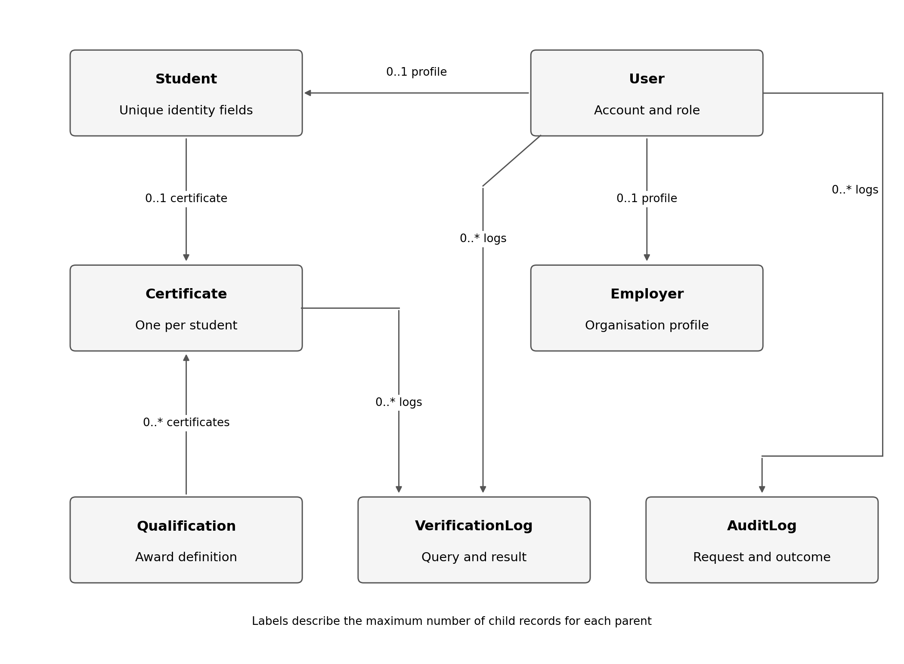
Figure 2 shows the principal implemented relationships. A parent may have no related records; each existing certificate requires one student and one qualification. User references in both log models are nullable. Student deletion cascades to its certificate; certificate deletion leaves verification logs with a null certificate reference. Qualification deletion is protected while referenced.
This updated report was prepared with AI assistance for repository inspection, execution analysis, diagrams and drafting. Observed implementation and evidence are distinguished from proposed work. No repository commits, pull-request submissions, merges or live deployment changes were made while preparing this update. The document records the existing repository state; submitting the revised report to the repository is a separate publication step.
Team responsibilities follow CONTRIBUTING.md. Individual contribution reports provide each member's evidence of actual work, lessons and challenges.

