

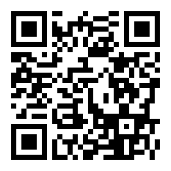

**Work, Health & Safety**

Daily Acknowledgement and Register

No: 7779

**PLEASE SCAN**