 |  | CIRI |  |  |  | CIRI
 | CIRI | 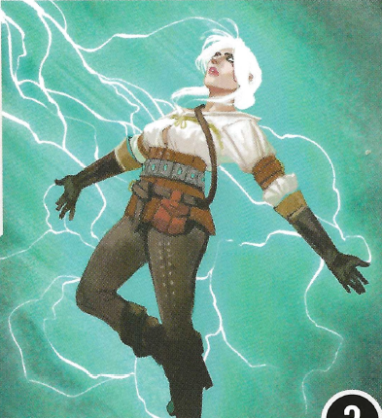 |  |  | CIRI |   CIRI  & Ihuarraquax | CIRI
 |  | CIRI |  |  |  | CIRI

 |  | GERALT  OF RIVIA |  |  |  | GERALT  OF RIVIA
 | GERALT  OF RIVIA | 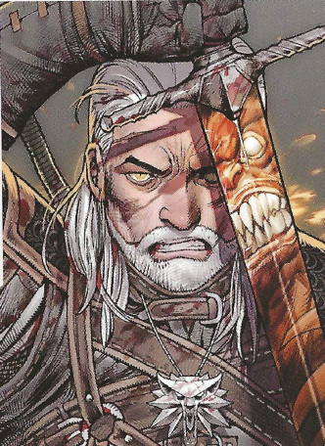 |  |  | GERALT  OF RIVIA |   GERALT OF RIVIA  & Dandelion | GERALT  OF RIVIA
 |  | GERALT  OF RIVIA |  |  |  | GERALT OF RIVIA

 |  | ANCIENT LESHEN |  | ANCIENT  LESHEN
 | ANCIENT LESHEN | 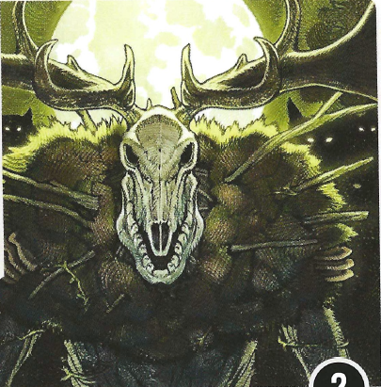 | ANCIENT LESHEN |   ANCIENT LESHEN | ANCIENT LESHEN
 |  | ANCIENT  LESHEN |  | ANCIENT LESHEN

*** To fit the extra-large mini for Ancient Leshen, and fit that template on a single page (for easier DIY) you’ll notice a slightly different design here. Rather than the spine of the box going up, then down, then up again (with the tabs within those folds… you’ll know what I mean when you make the other boxes) this box will simply have two small tabs that need to be taped inside of the spine.

It’s not ideal….. but it’s the best solution I have to fit the minis in a way that matches the other boxes. This box is twice the size of the other boxes, so it should fit with those nicely….

