 | X |  |  | x |  |  | X
 |  |  | PANDORA |  | PANDORA
Discard Pile |  | PANDORA | 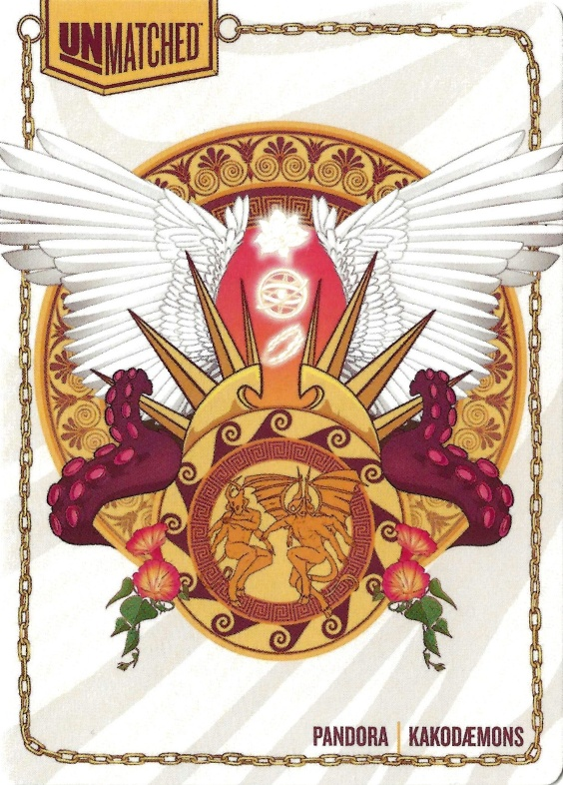 | PANDORA | 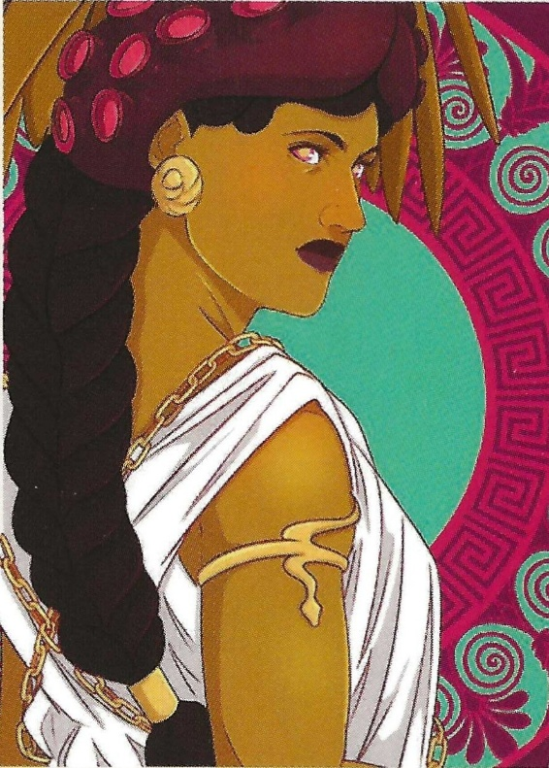  PANDORA  & Kakodæmons | PANDORA |  | Draw Pile
 |  |  | PANDORA |  | PANDORA
 | X |  |  |  |  |  | X
 |  |  |  | X

 | X |  |  | x |  |  | X
 |  |  | BLACKBEARD |  | BLACKBEARD
Discard Pile |  | BLACKBEARD | 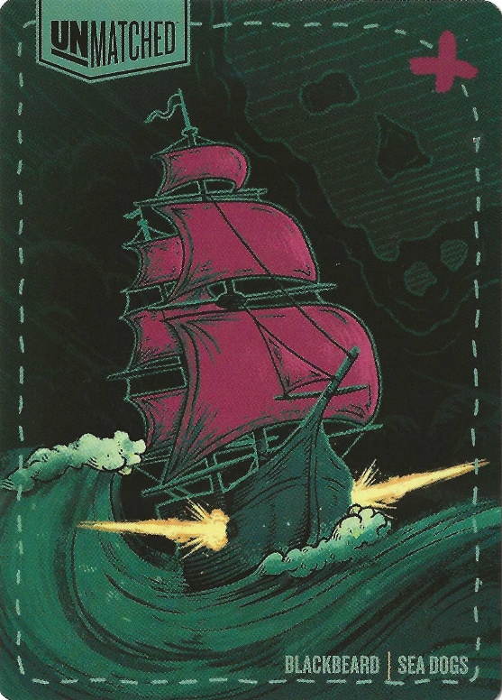 | BLACKBEARD | 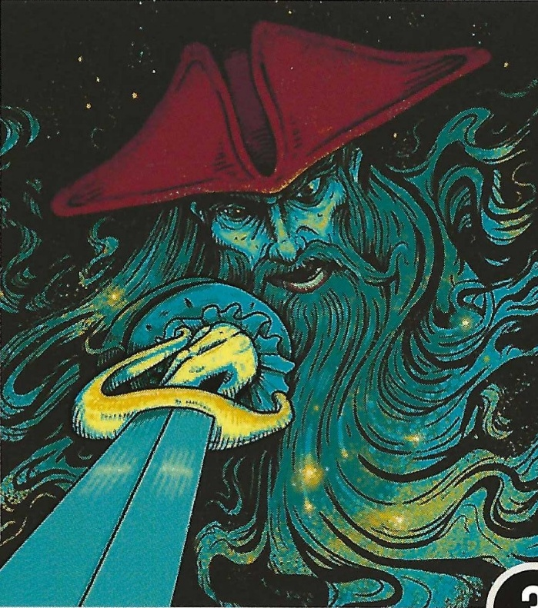  BLACKBEARD  & Sea Dogs | BLACKBEARD |  | Draw Pile
 |  |  | BLACKBEARD |  | BLACKBEARD
 | X |  |  |  |  |  | X
 |  |  |  | X

 | X |  |  | x |  |  | X
 |  |  | CHUPACABRA |  | CHUPACABRA
Discard Pile |  | CHUPACABRA | 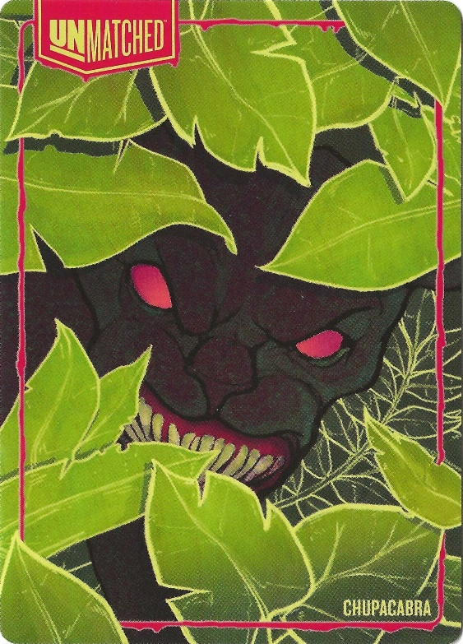 | CHUPACABRA | 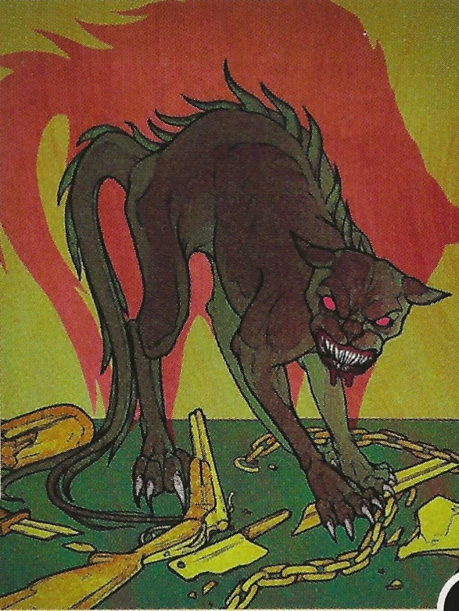  CHUPACABRA | CHUPACABRA |  | Draw Pile
 |  |  | CHUPACABRA |  | CHUPACABRA
 | X |  |  |  |  |  | X
 |  |  |  | X

 | X |  |  | x |  |  | X
 |  |  | LOKI |  | LOKI
Discard Pile |  | LOKI | 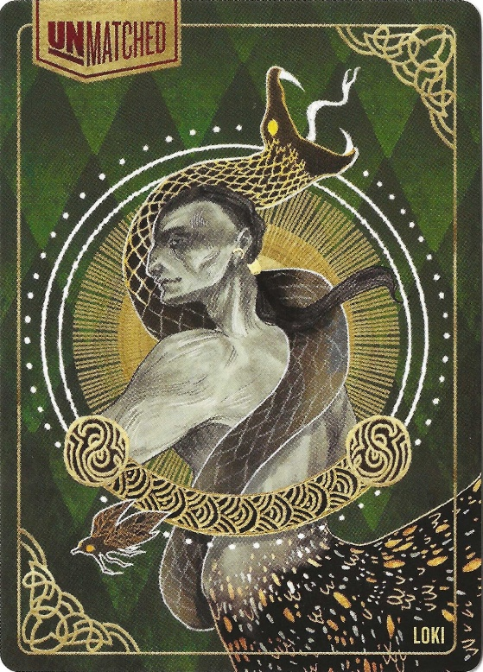 | LOKI | 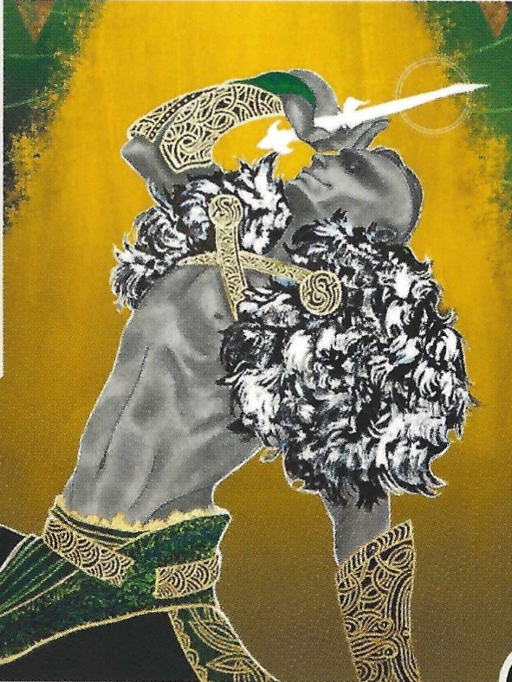  LOKI | LOKI |  | Draw Pile
 |  |  | LOKI |  | LOKI
 | X |  |  |  |  |  | X
 |  |  |  | X

