 |  | PANDORA |  |  |  | PANDORA
 | PANDORA | 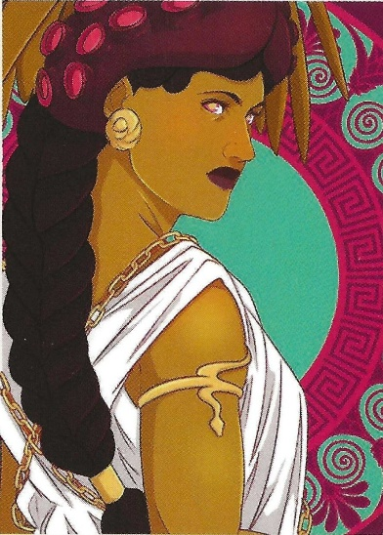 |  |  | PANDORA |   PANDORA | PANDORA
 |  | PANDORA |  |  |  | PANDORA

 |  | BLACKBEARD |  |  |  | BLACKBEARD
 | BLACKBEARD | 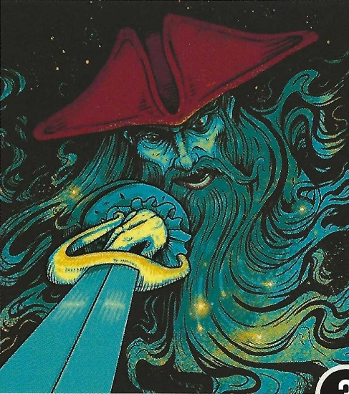 |  |  | BLACKBEARD |   BLACKBEARD | BLACKBEARD
 |  | BLACKBEARD |  |  |  | BLACKBEARD

CHUPACABRA
 |  | CHUPACABRA
 | CHUPACABRA | 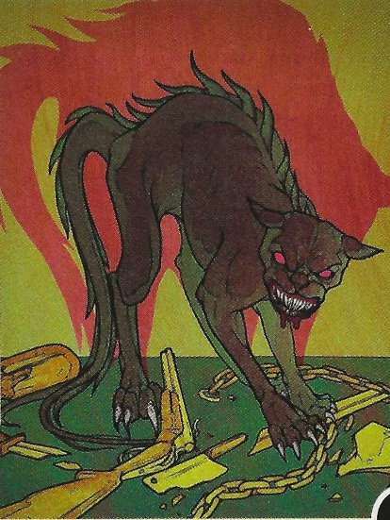 |  |  | CHUPACABRA |   CHUPACABRA | CHUPACABRA
 |  | CHUPACABRA |  |  |  | CHUPACABRA

 |  | LOKI |  |  |  | LOKI
 | LOKI | 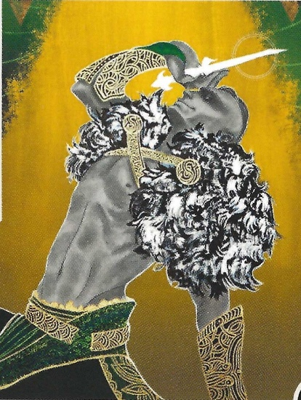 |  |  | LOKI |   LOKI | LOKI
 |  | LOKI |  |  |  | LOKI

