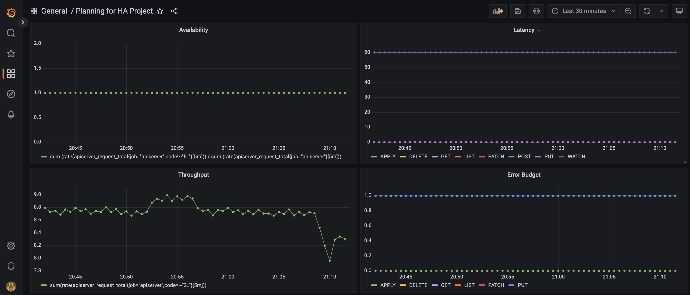

Successful Deploy to Zone 1 After Making HA

Screen Shot of ALB After Deployment

