CROSS-INSTITUTIONAL ACADEMIC COLLABORATION, AND REAL-TIME EVENT NOTIFICATION SYSTEM
CASE STUDY: UoK and UR

Divine IRADUKUNDA
2309000063

The research finalized and submitted in partial fulfillment of the requirement for the award of a Bachelor Degree with honours in Business and Information Technology (BBIT) to the School of Computing and Information Technology of the University of Kigali.
August 2026
DECLARATION
I, Divine IRADUKUNDA the student of University of Kigali does declare that truly, to the best of our knowledge, this Research is my own work and contribution to the fulfillment of the requirements for the award of Bachelor of Science with honours in Business and Information Technology. It has never been presented or submitted anywhere in Rwanda or elsewhere before, for a similar award at any university or institute of higher learning as a whole or in part and also declares that the information contained in this work has been obtained from sources believed to be reliable.
Date: …. /….../2026 Signature: ………………………

APPROVAL
This research proposal, titled “Cross-Institutional Academic Collaboration, and Real-Time Event Notification System,” has been reviewed and approved as meeting the academic requirements for conducting the study. The proposal was evaluated for its relevance, clarity of objectives, research methodology, and its potential contribution to improving web accessibility and fostering inclusive digital interactions. Therefore, the study is recommended for further research and implementation under the guidance and supervision of the assigned academic supervisor.
Mr. James KARAMUZI
Date: …... /…….../2026 Signature: ……………………

ACKNOWLEDGEMENT
First and foremost, I give all glory, honour, and thanks to Almighty God for His endless grace, strength, wisdom, protection, and guidance through this research journey. Without His blessings and favour, the successful completion if this study would not have been possible.
I would like to express my sincere gratitude to my supervisor for valuable guidance, encouragement, constructive suggestions, and continuous support provided throughout this research. I am also thankful to all lectures and academic staff for their knowledge, assistance, and inspiration during my studies.
My special appreciation goes to my family and friends for their prayers, patience, motivations, and unwavering support throughout the completion of this research project. There encouragement gave me strength and confidence during difficult moments.
Finally, I extend my appreciation to everyone who contributed directly or indirectly to the success of this study. My Almighty God Bless you all abundantly.

TABLE OF CONTENTS
APPROVAL iii
ACKNOWLEDGEMENT iv
TABLE OF CONTENTS v
TABLE OF FIIGURES viii
LIST OF SYMBOLS AND ABBREVIATIONS ix
ABSTRACT x
CHAPTER 1: GENERAL INTRODUCTION AND BACKGROUND STUDY 1
1.0 Introduction 1
1.1 Background to the Study 1
1.2 Statement of the Problem 3
1.3 Objectives of the Study 4
1.3.1 General Objective 4
1.3.2 Specific Objectives 4
1.4 Research Questions 5
1.5 Significance of the Study 5
1.5.1 Significance for Public 5
1.5.2 Significance for Researchers 6
1.5.4 Significance for Institutions 6
1.6 Scope of the Study 6
1.6.1 Geographic Scope 6
1.6.2 Content Scope 7
1.6.3 Time Scope 7
1.7 Limitations 7
CHAPTER 2: LITERATURE REVIEW 8
2.0 Introduction 8
2.1 Definitional of Key Concepts 8
2.2 Review of Related Literature 9
2.2.1 Empirical Review 9
2.2.2 Theoretical Review 9
2.2.3 Summary of the Gap 12
2.2.4 Conceptual Framework 13
CHAPTER 3: RESEARCH METHODOLOGY 15
3.0 Introduction 15
3.1 Research Design 15
3.2 Population Study and Sampling 16
3.2.1 Target Population 16
3.2.2 Sample Size 17
3.2.3 Technique Sampling: 18
3.3 Data Collection Methods 19
3.3.1 Interview 19
3.3.2 Observation 19
3.3.3 Secondary Data Collection 19
3.4 Data Collection Instruments 20
3.5 System Development 20
3.6 Proposed System Architecture 21
3.7 Data Analysis and Presentation Methods 23
3.7.1 Qualitative Data Presentation and Analysis 23
3.7.2 Quantitative Data Presentation and Analysis 23
3.6 Validity and Reliability Assessments 23
3.6.1 Validity 23
3.6.2 Reliability 24
3.8 Ethical and Legal Considerations 25
REFERENCES 26

TABLE OF FIIGURES
Figure 1: Conceptual Framework 22
Figure 2: System Development 30
Figure 3: System architecture 31

LIST OF SYMBOLS AND ABBREVIATIONS
ABBREVIATION | FULL TERM
AAU | Association of African Universities
API | Application Programming Interface
ARUA | African Research Universities Alliance
COAR | Confederation of Open Access Repositories
CRDT | Conflict-free Replicated Data Type
HEC | Higher Education Council of Rwanda
HEI | Higher Education Institution
LDN | Linked Data Notifications
MINEDUC | Ministry of Education of the Republic of Rwanda
MQTT | Message Queuing Telemetry Transport
NCST | National Council for Science and Technology
NREN | National Research and Education Network
OAI-PMH | Open Archives Initiative Protocol for Metadata Harvesting
OT | Operational Transformation
OTP | One-Time Password
PHEI | Private Higher Education Institution
RREN | Regional Research and Education Network
RwEdNet | Rwanda Education and Research Network
TEL | Technology-Enabled Learning
UoK | University of Kigali
UR | University of Rwanda
WSS | WebSocket Secure

ABSTRACT
The rapid growth of digital technologies has created unprecedented opportunities for collaboration and information sharing within educational institutions. However, many academic institutions, particularly in developing higher education sectors, continue to operate as independent of knowledge production, relying on localized libraries, physical classrooms, and fragmented manual communication channels. This structural isolation restricts active knowledge sharing, limits the reach of academic research, and prevents students from participating in cross-institutional academic communities. This study proposes a Cross-SInstitutional Academic Collaboration, and Real-Time Event Notification system, a web-based platform designed to connect students, lecturers, researchers, and institutions through a unified digital environment. The system facilitates academic collaboration, knowledge exchange, networking, and community engagement while providing users with access to shared resources and collaborative opportunities. The system aims to enhance communication, strengthen institutional partnerships, promote collaborative learning, and support community development. Ultimately, the platform contributes to creating a more connected, efficient, and responsive academic system that benefits both educational institutions and the communities they serve. How the System Works: A Use-Case Scenario. Consider a computer science student at the University of Kigali (UoK) who registers on the platform and joins the "Artificial Intelligence Research Community" a cross-institutional group including peers from the University of Rwanda (UR), Mount Kenya University Rwanda, and other accredited institutions. Upon joining, the student's profile is federated through the platform's identity management system, which respects institutional boundaries while enabling unified access. When a lecturer at UR publishes a new dataset on machine learning for agriculture and tags it with relevant metadata, the repository integration middleware detects the update within milliseconds. The MQTT broker immediately categorizes this event into the "AI Research" topic channel, and the WebSocket manager pushes a real-time notification to all subscribed members, including the UoK student, who receives an instant alert on their mobile device or desktop interface: "New dataset published: 'Crop Disease Detection Model UR Computer Science Dept. Click to collaborate." Simultaneously, when UR announces an inter-university hackathon focused on climate-tech solutions, the event is not buried on a static webpage. Instead, it is broadcast through the real-time event distribution engine, which uses publish-subscribe architecture to stream notifications to relevant user segments based on their academic interests, institutional affiliations, and geographic proximity. The UoK student receives the hackathon alert, registers through the platform's unified interface, and is automatically added to a temporary collaborative workspace where participants from multiple institutions can co-edit project proposals in real-time, share code repositories, and communicate through integrated messaging channels, all synchronized via WebSocket Secure (WSS) connections with sub-second latency. Ultimately, this study contributes both theoretical advancement in digital academic collaboration architectures and practical implementation of an integrated, real-time system tailored to Rwanda's higher education context. By transforming passive digital archives into active, notification-driven collaborative environments, the proposed system creates a more connected, efficient, and responsive academic landscape, one where knowledge flows freely across institutional boundaries, students engage dynamically with nationwide academic communities, and research innovation reaches its full collective potential.

CHAPTER 1: GENERAL INTRODUCTION AND BACKGROUND STUDY

1.0 Introduction
In the contemporary higher education paradigm, scientific inquiry and technological creation demand highly integrated, cross-institutional collaborations that transcend geographical boundaries and individual institutional limits. Historically, academic institutions operated as independent silos of knowledge production, relying on localized libraries, physical classrooms, and manual communication channels. This structure restricted active knowledge sharing, limited the reach of academic research, and isolated student communities.
With the rapid expansion of high-speed digital networks, distributed computing, and open-access protocols, modern higher education requires advanced application-layer platforms that support real-time inter-university communication, cooperative learning, and instantaneous notifications.
However, a persistent challenge remains in many developing higher education sectors: while the underlying network infrastructure has improved, the software layers needed to facilitate real-time collaboration and cross-institutional awareness among students are often missing.
This research focuses on addressing this structural gap by designing a Cross-Institutional Academic Collaboration, and Real-Time Event Notification system, utilizing the Rwanda Research & Innovation Repository as a primary case study.

1.1 Background to the Study
Globally, academic collaboration has shifted from a model of delayed, periodic publication and isolated physical laboratories toward a paradigm of open science, real-time data sharing, and continuous digital connection (EduTech Global, 2026). Prominent global initiatives have established that the value of scholarly outputs increases exponentially when they are widely accessible and integrated into active notification networks (Software Heritage, 2026; COAR Notify Network, 2026).
Architecturally, this transition has been driven by the evolution of institutional repositories. Traditional frameworks, which relied on passive metadata harvesting, are increasingly giving way to decentralized, web-native, push-based communication. This shift is exemplified by the Confederation of Open Access Repositories (COAR) through its COAR Notify protocol, which leverages the World Wide Web Consortium's (W3C) Linked Data Notifications (LDN) to create dynamic links between institutional resource repositories and external collaborative, peer-review, and learning management systems (COAR Notify, 2026). These advanced global systems minimize notification latency and eliminate manual informational checks, allowing researchers, students, and collaborative tools to communicate automatically and dynamically (COAR Notify Network, 2026; Code4Lib, 2026).
Across the African continent, higher education is undergoing a rapid digital expansion, guided by the Association of African Universities (AAU) and localized National Research and Education Networks (NRENs) (Association of African Universities, 2026). Organizations such as the UbuntuNet Alliance for Eastern and Southern Africa play a critical role in mitigating historical digital divides. Historically, African universities were severely constrained by the high cost of regional and global satellite bandwidth, which could exceed twenty-five thousand Euros per megabit per month (KCL, 2023).
Over the past decade, however, the collaborative procurement of fiber-optic connectivity through regional educational networks has dramatically reduced connectivity costs to less than twenty Dollars per megabit per month for major consumer universities (KCL, 2023; AfricaConnect3, 2026). Consequently, research networks have evolved to support advanced identity federation (such as eduroam and eduGAIN), shared cloud storage, security incident response teams, and multi-university e-learning environments (Association of African Universities, 2026; AfricaConnect3, 2026). However, while regional physical backbones are expanding, the development of localized application software that leverages this infrastructure to drive student-centered collaboration and immediate inter-university activity awareness remains highly restricted (KCL, 2023; Sikubwabo, 2026).
In Rwanda, the higher education landscape has undergone exceptional structural changes since the mid-1990s (HEC, 2026). The sector has transitioned from a highly restricted, post-conflict system graduating fewer than two thousand students over three decades to a robust, diversified network of approximately thirty-five to forty accredited higher learning institutions as of 2024, collectively educating over eighty-six thousand tertiary students (Grokipedia, 2026; HEC, 2026). This landscape consists of a consolidated public sector, led by the multi-campus University of Rwanda (UR) and Rwanda Polytechnic, alongside a dominant private sector that accounts for approximately fifty-nine percent of total student enrolment (ResearchGate, 2020; HEC, 2026).
To support this expanding educational base, the Government of Rwanda has implemented several policy initiatives, including the ICT in Education Policy and national socio-economic frameworks (such as Vision 2020 and Vision 2050), which aim to transform Rwanda into an innovation-driven, technology-led knowledge hub (Opening Up Education in Rwanda, 2024; ITU, 2015).
Crucially, on July 1, 2024, the Rwanda Education Network (RwEdNet) was successfully re-established as the official National Research and Education Network of Rwanda under the direct supervision of the Ministry of Education (AfricaConnect3, 2026). Following a period of rebuilding, RwEdNet connected over one thousand institutional sites, establishing a high-speed ten gigabit-per-second link to the regional UbuntuNet Network (AfricaConnect3, 2026; AJIC, 2026).
Concurrently, the National Council for Science and Technology (NCST) launched the Rwanda Research & Innovation Repository (National Council for Science and Technology, 2026). This national platform is designed to collect, preserve, and disseminate the country's scientific outputs, policy briefs, doctoral theses, and registered innovations (National Council for Science and Technology, 2026). Despite these advancements in core transport network infrastructure and centralized repository databases, an operational gap remains: there is no cohesive application-layer environment that translates this high-speed connectivity into a live, interactive workspace for student innovation, inter-university hackathons, and real-time project collaboration (Sikubwabo, 2026).

1.2 Statement of the Problem
Despite substantial national investments in the high-speed fiber-optic backbones of the Rwanda Education Network (RwEdNet) and the creation of the Rwanda Research & Innovation Repository under the National Council for Science and Technology (NCST), Rwandan higher education institutions continue to operate alone. Currently, there is no online platform or system that connects these diverse university communities in real time (AfricaConnect3, 2026).

While institutions like the University of Kigali (UoK) and the University of Rwanda (UR) occasionally interact through specialized, externally funded frameworks, such as international student mobility programs, a massive informational divide persists for the standard academic demographic. For example, a student enrolled in a computer science program at a private institution like UoK faces severe informational isolation. There is no structural mechanism to seamlessly learn about academic events, open hackathons, software tools, or collaborative research initiatives occurring within the UR ecosystem or other nearby campuses (ResearchGate, 2020; EduTech Global, 2026).
The existing information dissemination model in Rwandan higher learning is heavily fragmented, relying on manual website updates, social media posts, or periodic physical notifications. This unstructured approach causes high latency and structural information loss. Furthermore, the NCST national repository functions primarily as a static, pull-based digital archive. While it allows researchers and students to manually upload or search for peer-reviewed articles, datasets, and intellectual property, it lacks proactive, push-based communication mechanisms. Users across UoK, UR, and other institutions are forced to log in and search the archive manually, preventing immediate awareness of new cross-institutional innovations, data publications, or shared research tools. (National Council for Science and Technology, 2026).

1.3 Objectives of the Study

1.3.1 General Objective
The general objective of this study was to design, implement, and evaluate a Cross-Institutional Academic Collaboration, and Real-Time Event Notification system establishing a unified, web-based environment to connect higher education stakeholders across Rwanda.

1.3.2 Specific Objectives
- To identify key challenges affecting cross-institutional collaboration, research visibility, and real-time academic event communication.
- To design and implement a real-time event distribution and push notification engine using WebSocket and Message Queuing Telemetry Transport protocols to broadcast academic events, hackathons, and research updates instantly across universities.
- To develop a system architecture that enables real-time collaboration, notifications, and co-editing among students, lecturers, researchers, and administrators.

1.4 Research Questions
To guide this study, the following research questions were addressed:
- What are the key technical, institutional, and cultural communication barriers that prevent collaborative academic projects, and shared real-time information’s?
- How does the implementation of a cross-institutional collaboration platform impact communication and knowledge share among students, lecturers, and researchers across different academic institutions?
- What impact does cross-institutions collaboration, and real-time event notification have on participation in academic and community events?

1.5 Significance of the Study
This investigation provides significant value to several key stakeholders within the Rwandan higher education and technological innovation:

1.5.1 Significance for Public
This investigation provides a structural pathway to resolve informational isolation, particularly for students at private institutions such as the University of Kigali. By offering a single, unified channel for real-time notifications, the platform allows students to access cross-institutional hackathons, joint software projects, and peer-to-peer mentoring opportunities. This access bridges the resource gap between public and private universities, helping students apply practical programming, artificial intelligence, and database concepts in active, real-world projects (uniRank, 2026).

1.5.2 Significance for Researchers
The proposed platform streamlines collaborative research workflows, enabling investigators from different institutions to co-author papers, share datasets, and co-supervise postgraduate dissertations. By automating notifications through the repository, researchers receive immediate alerts when complementary papers, innovations, or grant opportunities are published.

1.5.4 Significance for Institutions
This research supports national strategic goals by turning static repository records into active drivers of innovation (Opening Up Education in Rwanda, 2024; National Council for Science and Technology, 2026). It provides a blueprint for integrating National Research and Education Network (NREN) bandwidth with collaborative software systems, maximizing the public return on infrastructure investments.

1.6 Scope of the Study

1.6.1 Geographic Scope
This research is defined by a precise operational boundary that ensures the feasibility and validity of its empirical analysis. The study addresses the critical structural gap in Rwanda’s higher education sector by designing and evaluating a Cross-Institutional Academic Collaboration, and Real-Time Event Notification system. To maintain focus and scientific rigor, the research is delimited across geographic, temporal, and content-related.
The geographic boundaries of this research are concentrated in Kigali, Rwanda, which serves as the hub for the country’s primary academic and technological infrastructure (HEC, 2026; ResearchGate, 2017). The study focuses specifically on accredited public and private higher learning institutions operating within this region. To ensure a balanced representation of the Rwandan academic landscape, the empirical validation and system testing were conducted primarily at two institutions: The University of Kigali (UoK), representing the private higher learning sector, and the University of Rwanda (UR), representing the public sector. This dual-institution focus allows the study to account for the distinct operational characteristics, funding models, and connectivity environments of both sectors, ensuring the proposed ecosystem is scalable and applicable across the broader Rwandan higher education framework (ResearchGate, 2020).

1.6.2 Content Scope
The content scope is strictly restricted to the design, construction, and latency verification of the application-layer collaborative platform and its associated real-time notification engine. Functionally, the study focuses on the implementation of user identity federation, performance benchmarking of message brokers, the integration of real-time synchronization algorithms (such as CRDT and Operational Transformation), and the development of Notify integration middleware.

1.6.3 Time Scope
The study was conducted over a three- to four-month period across four distinct phases: a one-month foundational research phase, a one-month architectural design phase, a two-month development period for the prototype, and a final phase focused on usability testing and performance validation.

1.7 Limitations
During the formulation of this study, several technical and technical-institutional limitations were identified:
A primary technical challenge is the varying level of information technology infrastructure and internet quality available to students at different campuses. Bandwidth limitations can disrupt persistent TCP connections, which are essential for WebSocket communication, potentially causing notification delays.
Another major limitation lies in governance and coordination. Without clearly defined policies, shared standards, and decision-making structures, disagreements may arise over data ownership, platform control, and institutional responsibilities, weakening long-term collaboration.
Organizational and cultural differences among institutions also constrain effective collaboration. Variations in academic priorities, resource availability, and institutional norms can reduce trust and willingness to actively participate in shared digital environments.
Finally, sustainability remains a concern for such ecosystems. Limited funding, dependence on external support, and insufficient technical capacity can hinder continuous system maintenance, scalability, and long-term impact.

CHAPTER 2: LITERATURE REVIEW

2.0 Introduction
This chapter examines the theoretical and empirical literature surrounding cross-institutional academic networks and real-time notification architectures. Building a highly responsive, collaborative environment in higher education requires connecting sociological theories of collaboration with advanced software design patterns.
By analysing international, regional, and national studies, this review highlights the technical limitations of traditional, database-driven repositories and examines how event-driven models can bridge communication gaps in developing academic landscapes.

2.1 Definitional of Key Concepts
Academic Collaboration Community: A web-based system that connects students, researchers, and lecturers from separate institutions to facilitate joint project development, scientific mentorship, and academic exchange (EduTech Global, 2026).
Real-Time Event Notification system: An asynchronous, push-based software environment that processes system events and streams updates to subscribed clients within sub-second latencies (WJARR, 2025; Medium, 2026).
Publish-Subscribe Architecture: A messaging pattern where the senders of messages (publishers) do not program the messages to be sent directly to specific receivers (subscribers) Instead, published messages are categorized into named channels or topics. Subscribers express interest in specific topics and receive relevant messages dynamically (WJARR, 2025). This pattern allows for highly scalable, decoupled communications across different institutional systems (HiveMQ, 2026).
Linked Data Notifications (LDN): A W3C protocol standard that defines how web applications can send and receive notifications using resource URIs, forming the foundation of decentralized repository communication (Software Heritage, 2026).
Metadata Harvesting: The automated retrieval of structured XML schemas from remote repository servers by central aggregation search tools, traditionally run via the OAI-PMH framework (CASRAI, 2026).

2.2 Review of Related Literature

2.2.1 Empirical Review
The digital transformation of Rwanda's higher education sector has progressed through a series of key infrastructure upgrades, starting with initial internet deployments by early service providers and developing into the modern, fiber-optic backbone of the Rwanda Education Network (RwEdNet) (AfricaConnect3, 2026; ResearchGate, 2017). Under the ICT in Education Master Plan, RwEdNet has successfully connected over one thousand sites, including schools, universities, and student labs, establishing a high-speed link to the UbuntuNet regional network (AfricaConnect3, 2026; Opening Up Education in Rwanda, 2024).
Concurrently, the National Council for Science and Technology (NCST) launched the Rwanda Research & Innovation Repository (National Council for Science and Technology, 2026). This platform functions as Rwanda's official digital hub, designed to collect, preserve, and provide open access to scientific articles, datasets, doctoral theses, and patent filings (National Council for Science and Technology, 2026).
Thematic coding, statistical modelling, and data synthesis from participants across Kigali show that private institutions like the University of Kigali (UoK) frequently host academic conferences, alongside international research partnerships like the KA171 Erasmus+ Mobility Project (University of Kigali, 2026).
Yet, because there is no application-layer platform linking these institutions, these events and research updates are confined to individual campus networks. This structure prevents real-time student participation across universities and limits the wider impact of these academic milestones (ResearchGate, 2020).

2.2.2 Theoretical Review
Theoretical frameworks are important for informing research because they provide a basis for understanding the principles behind the design of the system, how users interact with it, and how knowledge is shared within it. Theories underpinning academic collaboration systems and digital research repositories research include those in the field of information systems, knowledge management, collaboration and technology adoption. Theories relating to the interaction between people and institutions and technology for the generation, sharing and use of knowledge in a digital environment are used to anchor this study (Nonaka & Takeuchi, 1995).

The Knowledge Management Theory is one of the most applicable theories that support the research. To know what Knowledge Management Theory is, we should focus on the systematic process of Knowledge creation, Knowledge storage, Knowledge sharing, and Knowledge application within organizations. There are four types of knowledge in academic and research institutions: research output, publications, data sets, and academic events. Lack of integration can create knowledge silos with valuable research that remains accessible only within individual institutions. By efficiently capturing, structuring and disseminating knowledge, a centralized research and innovation repository reflects the basic principles of Knowledge Management Theory. With shared repositories and collaboration features, institutions can turn personal knowledge into collective academic intelligence, improving research productivity and innovation (Vygotsky, 1978).

Another theory that is closely related with knowledge management is Collaborative Learning Theory, where emphasis is placed on the role of social interaction and joint activities in building knowledge. This theory suggests that learning and innovation is more effective when individuals work collaboratively, instead of alone. For Higher Education and Research, shared research, mentoring and skills development are achieved through collaboration between students, lecturers and researchers, leading to interdisciplinary research. A cross-institutional collaboration system realises CLT with digital spaces for co-editing research documents, exchange of ideas and real-time academic discussions. These systems can transcend the limits of geography and facilitate the sharing of expertise and viewpoints among institutions (Trist & Bamforth, 1951).

Another theoretical underpinning is Socio-Technical Systems Theory that considers an organization as a blend of social (people, culture, processes) and technical (hardware, software, networks). This theory suggests that the effectiveness of an information system is contingent upon the congruence among the social and technical aspects. However, the establishment of a digital repository and a real-time notification system in academic settings demands comprehensive technical support, acceptance from users, institutional policies, and a conducive academic environment. This study recognizes that technology may not be the answer to collaboration without considering user needs, workflows and institutional practices. Hence it is important that this is done by making this system usable, engaging stakeholders and providing administrative support (Davis, 1989).

This study is also grounded in the Critical Theoretical framework of the Technology Acceptance Model (TAM). TAM is a model that postulates that users adopt and adopt the use of new technologies when they believe that they will be useful and easy to use. Even when it's working, resistance to this new system may make it difficult to adopt in academic settings. The proposed system is designed to be user-friendly and intuitive, using clear workflows and relevant features that are consistent with TAM principles, including real-time notifications and collaborative tools. Knowing the user perception helps understanding the differences in the usage of the system between students, lecturers, researchers and administrators, and directs the strategies for adoption and continued use. (Davis, 1989).

Furthermore, the Diffusion of Innovation Theory provides knowledge on the spread of new technologies inside and between institutions. This theory proposes that the process of innovation adoption is a gradual one and is driven by some factors like the relative advantage, compatibility, complexity, trialability and observability. A national or cross institutional research repository is a great innovation in the academic world. It will be successful if it can prove to be more beneficial than the current, piecemeal approach, adaptable to institutional research processes, and measurable and tangible such as greater research visibility and collaboration. Active research and institutions focusing on innovation can drive wider adoption within the academic community (Rogers, 2003).

In addition, Information Systems Success Theory helps to understand the relationship between user satisfaction and the overall impact of the system, between information quality and user satisfaction, and between system quality and user satisfaction. System reliability, timeliness of data synchronization, accuracy of research metadata, and responsiveness of notifications are important metrics for success in this study. The value of high-quality information systems is significant when it comes to facilitating users' trust and fostering ongoing interactions and participation, particularly for collaborative academic platforms (DeLone & McLean, 2003).

To summarize, the theoretical basis used in this study was a combination of knowledge management, collaboration, socio-technical alignment, technology acceptance, innovation diffusion, and information systems success perspectives. When combined, these theories offer a holistic view on the potential of a cross-institutional academic collaboration and a real-time event notification system to improve research visibility, facilitate knowledge exchange and foster collaboration between academic institutions in Rwanda. The theories underpinning the system design and evaluation provide a scientific basis for the study and ensure its theoretical soundness and practical relevance in solving the issues of the higher education and research system.

2.2.3 Summary of the Gap
The existing literature shows that the research areas of knowledge management, collaborative learning, technology acceptance and information systems success have received significant attention in academic settings. These studies offer useful insights into the role that digital platforms play in learning and research, but have tended to concentrate on systems used in one institution or individual collaboration tools. This has led to a lack of focus on ‘cross-institutional academic systems', as defined by collaboration, research repositories and real-time communication all in one place.

In addition, most of the current academic systems focus on static knowledge repositories for the storage of research results without providing support for real-time communication, co-editing, or timely dissemination of academic event. This results in a disconnect between knowledge captured and knowledge in use, especially when researchers, students and lecturers require up to date knowledge and constant interaction. The absence of real-time notification systems decreases participation in academic events and lessen the potential for institutional networking.

However, in the Rwandan higher education and research environment, there is a lack of documented evidence of integrated national-level digital platforms that connect higher education institutions, research institutions and academic communities. Current solutions are fragmented, causing duplication of research effort, lack of awareness of local research products and poor collaboration between institutions.

Thus, the identified gap is filled by proposing and testing an academic collaboration and real-time event notification system for cross-institutional academic collaboration, which integrates knowledge management, collaborative learning, and real time-communication into a single platform. The study not only helps advance the theory of digital academic collaboration and research visibility, but also provides a practical application to the theories in a real institutional context.

2.2.4 Conceptual Framework
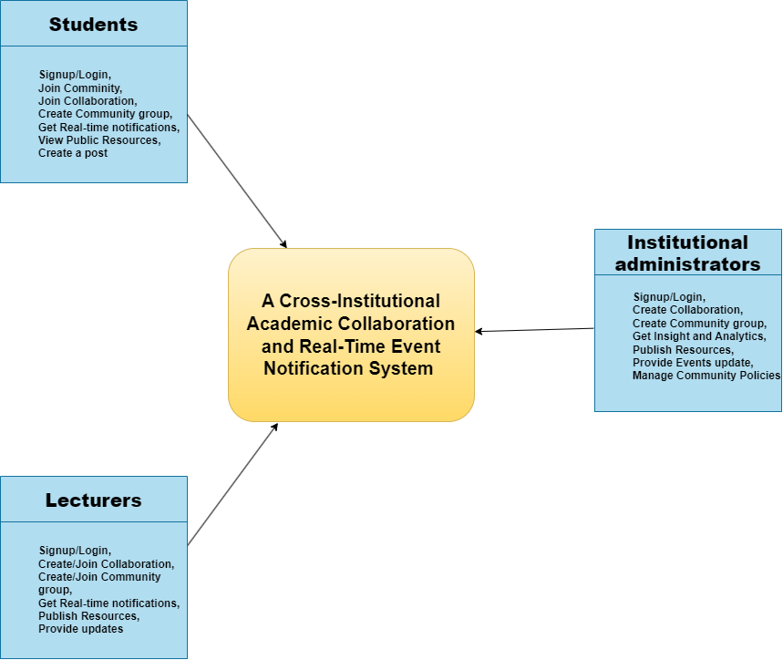
Figure 1: Conceptual Framework
The conceptual framework illustrates a Cross-Institutional Academic Collaboration, and Real-Time Event Notification System as a central digital platform that connects four key stakeholder groups: students, lecturers, researchers, and institutions.
Students interact with the system by registering and logging in to join academic communities and collaborative groups. Through the platform, they can participate in discussions, create posts, access public resources, and receive real-time notifications about academic and community events. This role highlights the system’s contribution to collaborative learning, engagement, and timely access to academic opportunities.
Lecturers and researchers play a dual role as both knowledge consumers and producers within the ecosystem. They can create or join collaborations and communities, publish academic resources, provide updates, and receive real-time notifications. Their interaction with the system supports knowledge exchange, research networking, and interdisciplinary collaboration across institutional boundaries.
Institutions represent the governance and coordination layer of the framework. They use the platform to create collaborations and community groups, publish resources, provide event updates, manage community policies, and access insights and analytics. This role ensures institutional oversight, sustainability, and alignment of collaborative activities with academic and community development goals.
Overall, the framework demonstrates how a centralized digital ecosystem enables continuous interaction among academic stakeholders, strengthens institutional partnerships, enhances communication, and promotes a responsive and connected academic community supported by real-time information flow.

CHAPTER 3: RESEARCH METHODOLOGY

3.0 Introduction
This chapter explains the comprehensive research methodology that was employed in investigating the proposed Cross-Institutional Academic Collaboration, and Real-Time Event Notification system. Evaluating a modern, distributed technological intervention of this scale requires a transparent, rigorous, and highly systematic approach. Consequently, this chapter outlines the research design, specify the target population, and justify the sampling techniques, sample size calculations, data collection instruments, and concrete procedural steps.
Furthermore, the chapter delineates the statistical methods for data analysis, concrete strategies for ensuring validity and reliability, and the foundational ethical protocols that guided the interaction with human subjects. The primary goal of this methodological framework is to establish a clear roadmap that directly aligns with the study’s core objectives. By executing this methodology, the study generated empirically sound, replicable, and highly generalizable findings capable of informing institutional policy and software design within higher learning networks (Creswell, 2014).

3.1 Research Design
To systematically explore and define the user requirements, structural challenges, and the potential utility of the proposed academic collaboration system, this study adopted a qualitative research design. Given the exploratory nature of developing a new technological intervention, a qualitative approach was essential for gaining a deep, nuanced understanding of the social, institutional, and technical barriers that currently restrict inter-university communication and digital interaction.
Grounded in an interpretivist paradigm, this methodology focused on capturing the subjective experiences and diverse perspectives of key stakeholders, students, lecturers, and institution administrators within the Rwandan higher education landscape, specifically at the University of Kigali (UoK) and the University of Rwanda (UR). Rather than seeking broad statistical generalizations, this design prioritized the detailed "why" and "how" behind institutional silos, providing the necessary depth to inform the system's architecture and design requirements. By utilizing qualitative methods such as semi-structured interviews, direct usability observations, and qualitative document analysis, including a thorough review of the institutional contexts and academic frameworks outlined. This study generated the rich, context-specific insights required to create a functional, user-cantered prototype that effectively bridged the gap in the current academic information ecosystem.

3.2 Population Study and Sampling

3.2.1 Target Population
The target population for this research comprised primary stakeholders across selected higher learning institutions who served as the immediate users and decision-makers within the collaborative system. To ensure a multi-dimensional perspective, the total population (N = 10,025) was partitioned into three distinct strata:
Students: This group represents the largest users which are 10,000. They engaged with the collaboration platform for peer-to-peer learning, multi-institutional study groups, cross-campus event navigation, and social community building. They presenting 99.6% of the population
Lecturers: These academic staff members used the system to distribute academic materials, publish research-driven educational announcements, coordinate joint lectures across campuses, and evaluate student engagements. 20 Lectures, representing0.3% of the population:
Institutional Administrators: This administrative tier includes IT coordinators, deans, and registrar representatives who guided institutional compliance, manage platform permissions, monitor user metrics, and align system outputs with national education policy goals (Dawson, 2010).5 Admin, representing 0.1% of the population

The student population was obtained from the Office of the Academic Registrar, University of Kigali, which is responsible for maintaining official student admission, registration, and enrolment records. The lecturer and administrator populations were obtained from the respective academic and administrative departments of the University. According to the institutional records collected for this study, the target population consists of 10,000 students, 20 lecturers, and 5 institutional administrators, giving a total population of 10,025 respondents. The Academic Registrar's Office was used as the official source because it maintains accurate and up-to-date records of enrolled students, making it the most reliable source for determining the study population.

3.2.2 Sample Size
To capture a representative sample that balances widespread demographic representation with specialized domain knowledge, a multi-stage stratified sampling approach was executed in the quantitative phase, followed by purposive selection in the qualitative phase.
Table 1: Table Population
Stakeholder Group | Population Number | Sampling Method
Students | 10,000 | Random
Lecturers | 20 | Purposive
Administrators | 5 | Purposive
Total | 10,025 | Mixed sampling approach

Where:
n = required sample size
N = total population size
e = margin of error (0.05)
Given that the total population (N) is 10,025 and the margin of error (e) is 0.05, the calculation is as follows:
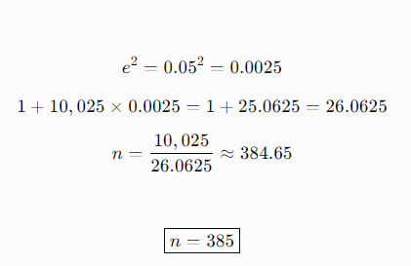
Since a sample size must be a whole number, the value was rounded down to 385 respondents.

3.2.3 Technique Sampling:
Simple Random Sampling (Students): Because the student population across the selected universities is vast and highly diverse, simple random sampling was applied. This ensures that every eligible student has an equal, non-zero probability of being selected, which reduces selection bias and maximizes the external validity of the survey findings.
Purposive Sampling (Lecturers, and Administrators): In contrast, non-probability purposive sampling was deployed for key professionals (Etikan, 2016). Institutional administrators, principal investigators, and educational technology lecturers possess deep, specialized knowledge regarding software procurement, pedagogical standards, and cross-institutional barriers. Selecting them purposively ensures that the study captures expert insight that random selection might miss due to smaller sub-population sizes.
Purposive Subset Selection: For the subsequent qualitative phase, the study purposively selected key informants who participated in the quantitative phase. This subset represented individuals who express diverse viewpoints in their survey feedback (such as early adopters, sceptical administrators, or highly collaborative researchers), ensuring that the interview phase targets individuals with rich, illustrative feedback to share (Creswell & Creswell, 2018).

3.3 Data Collection Methods
The researcher used the following research methods: interviews, questionnaires, observation, and secondary data collection.

3.3.1 Interview
An interview guide, questionnaire, observation checklist, usability testing task sheet, and prototype evaluation form were utilized in the study.
A series of interviews were conducted to get detailed, specific feedback from students, lecturers, and researchers regarding the problems they encounter while trying to use the Rwanda Research & Innovation Repository and collaborate across different institutions. These interviews enabled the researcher to better grasp problems with discovering resource materials, finding collaboration links, navigating cross-institutional interfaces, co-editing files, understanding metadata guidelines, and tracking live event updates.

3.3.2 Observation
The observation checklist aided in documenting what the user is doing during the usability test.
Participants were observed, and usability testing was conducted on the Rwanda Research & Innovation Repository platform. The participants were given a set of tasks to execute, including looking up a research dataset, reading through specific repository metadata details, navigating to a shared project registration page, co-editing a research section in real-time, and filtering upcoming academic hackathons. Usability testing is appropriate since it examines users as they attempt to accomplish tasks to test design decisions and performance. It is particularly significant to test with researchers and students as it uncovers inter-university sharing and coordination issues which cannot be identified by automated network tests or isolated developer testing.

3.3.3 Secondary Data Collection
The information in this study was collected from existing sources such as National Council for Science and Technology publications, Rwanda Education Network reports, the file named Academic Collaboration Research.docx, academic papers, books, research papers, interoperability guidelines, W3C web specifications, and open-access metadata protocols. For this study, secondary data collection is important as it provides relevant background information without a large amount of time and money spent on conducting large-scale field data collection. It enabled the researcher to gain insight into the current challenges faced by academic institutions in digital sharing, as well as to identify gaps in the current collaboration frameworks, to analyse previously conducted studies, and to provide a solid theoretical and conceptual basis for developing the proposed cross-institutional system. Additionally, secondary data helped to assess the existing repository infrastructures and inform the creation of a more integrated and accessible system for student, lecturer, and researcher cohorts when using Web-based collaboration networks.

3.4 Data Collection Instruments
The study utilized two primary data collection instruments: an interview guide and an observation checklist.
The interview guide consisted of open-ended, semi-structured questions designed to explore participants' experiences, challenges, and perceptions regarding cross-institutional academic collaboration and the use of collaborative digital platforms. The questions were presented in clear and simple language to encourage detailed responses and to provide insights into the usability, effectiveness, and potential value of the proposed system.
The observation checklist was used during usability testing to systematically record participants' interactions with the prototype while performing assigned tasks. It captured whether participants successfully completed each task, requested technical assistance, encountered navigation difficulties, made operational errors, misunderstood system features, or were unable to complete the task. The usability task sheet outlined the specific activities participants are required to perform during testing. Following task completion, participants provided verbal feedback on their experience, including the clarity of system navigation, ease of collaboration, perceived usefulness, reliability of real-time notifications, privacy concerns, and overall satisfaction with the proposed system.
3.4.1 Data Collection Tools
To standardise and validate data collection during the qualitative phases, the researcher deployed five specialized instruments:
Interview Guide: Consisting of open-ended, semi-structured questions designed to explore participants' experiences, challenges, and perceptions regarding institutional silos and academic collaboration.
Questionnaire: A structured, Likert-scale questionnaire distributed to the broader sample to measure user expectations, technology readiness, and perceived system utility.
Observation Checklist: A physical or digital recording sheet used during usability testing to systematically note task completion rates, errors, help requests, and navigation choices.
Usability Testing Task Sheet: A clear step-by-step instruction sheet directing participants through critical platform actions, such as editing a shared canvas or checking dynamic alerts.
Prototype Evaluation Form: A feedback instrument completed by participants post-test to gather subjective evaluations of system responsiveness, layout clarity, and notification accuracy.

3.5 System Development
The collaborative platform and notification engine were built in a user-cantered prototyping process with the help of AI. The user-cantered design approach is suitable since the ecosystem is designed for users who have special collaborative and real-time interaction requirements. The researcher first sought to understand user needs by interviewing and observing them. Then, the researcher created the database schemas, real-time message streams, project interface designs, and push-notification flows for the platform. The prototype was then developed and tested with users. The prototype was iteratively improved based on feedback from testing.
The process of development was an iterative process consisting of several phases:
Requirement Analysis: The researcher carried out a requirement analysis, determining what users expect from the ecosystem.
Architecture and Interaction Design: The researcher designed the prototype architecture and cross-university interaction flow.
Core Development: The researcher implemented all the principal characteristics, such as WebSocket connections, MQTT messaging, real-time co-editing synchronizations, repository API integrations, and event feeds.
User Testing and Refinement: The researcher ran the prototype with students and lecturers, gathering evaluations and making the necessary structural adjustments. This is consistent with academic engineering guidance which suggests integrating end-users during discovery, prototyping, testing, piloting, and validation.
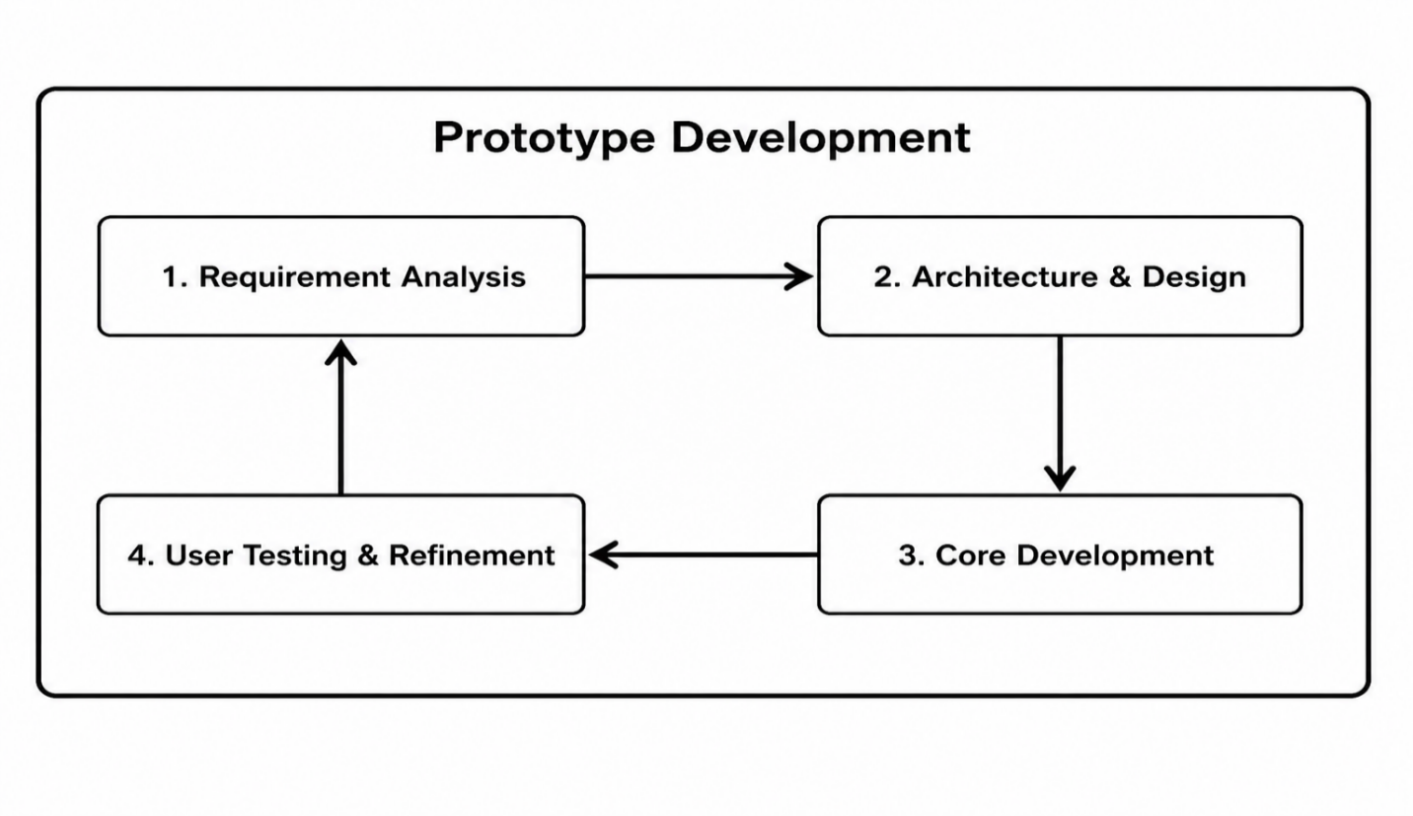
Figure 2: System Development

3.6 Proposed System Architecture
An AI-powered middleware and real-time notification engine was used as an interaction and collaboration support layer on top of the Rwanda Research & Innovation Repository database framework. Communication occurred primarily through real-time WebSocket’s and MQTT push notifications with web interfaces. The system executed synchronization commands, interpreted resource updates, parsed data streams from the current repository page, selected the appropriate broadcast action, and delivered instant notifications to the user.
There were multiple components in the system architecture:
User Layer: Includes students, lecturers, and researchers across the participating public and private universities.
Input Layer: Handles collaborative query commands, metadata registrations, project uploads, and real-time co-editing text streams.
Middleware Processing Layer: Contains speech/text parsers, WebSocket session managers, MQTT notification brokers, metadata indexing engines, and collaborative document conflict-resolution logic.
Interaction Layer: Renders the collaborative canvas, document text boxes, real-time message alerts, and unified campus event feeds.
Repository and Database Layer: Encompasses the underlying Rwanda Research & Innovation Repository endpoints, NCST repository databases, and institutional directory servers.
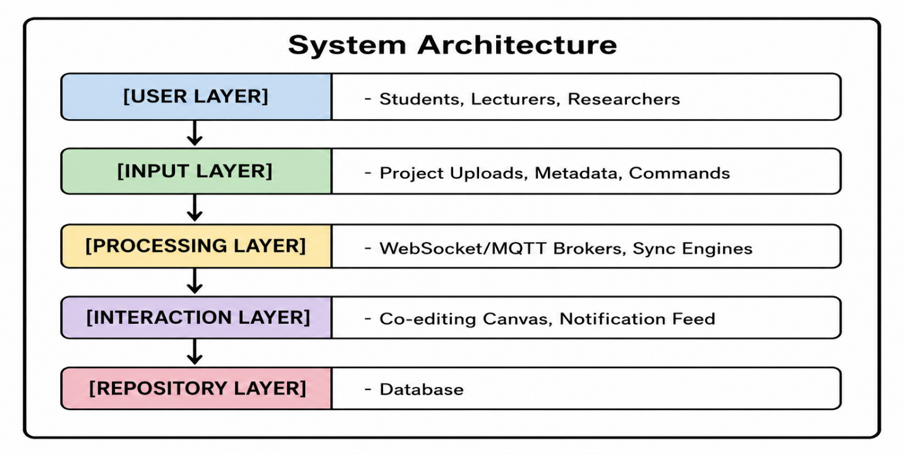
Figure 3: System architecture

3.7 Data Analysis and Presentation Methods
This section covers how the data were processed and analysed so that the design, development, and evaluation of the cross-institutional collaboration platform are delivered clearly, accurately, and comprehensively in the research outcomes.

3.7.1 Qualitative Data Presentation and Analysis
Thematic analysis was used for the qualitative analysis of the interview data and the observations data. The researcher highlighted common patterns of challenges, including problems accessing remote repository pages, reliance on fragmented social media announcements, institutional coordination barriers, fear of intellectual property exposure, data security issues, and real-time notification expectations. These themes were used to map user experience requirements and to inform the development of the prototype.

3.7.2 Quantitative Data Presentation and Analysis
The quantitative data obtained from the questionnaires and usability tests were analysed descriptively. The researcher determined task completion rates, the average time to complete the collaborative tasks, sync conflicts encountered, requests for technical assistance, and system usability ratings. The researcher compared the results of academic projects completed with the collaborative notification system with those conducted without it, to see if the platform enables greater academic accessibility, resource sharing, and communication efficiency. The analysis was conducted to see if the platform co

3.6 Validity and Reliability Assessments

3.6.1 Validity
Content and Face Validity: The survey items were reviewed by academic supervisors and IT specialists to ensure they are clear, readable, and accurately measure the intended research constructs.
Construct Validity: Exploratory Factor Analysis (EFA) was used to check that questionnaire items align correctly with their target variables (usability, communication, and collaboration).
Internal Consistency Reliability: The primary metric for verifying internal reliability was Cronbach's Alpha coefficient, computed for each Likert-scale dimension. In accordance with psychometric standards, any construct sub-scale registering a coefficient of 0.70 or higher were deemed highly reliable for the final academic research. Sub-scales scoring below this threshold were systematically modified or rebuilt.
Credibility: Achieved through data triangulation (comparing interview responses with survey statistics and system logs) and member-checking (sharing interview transcripts with participants to verify their statements).
Transferability: Provided by documenting rich, detailed accounts of the institutional contexts, network limitations, and participant demographics of the participating universities.
Dependability: Maintained through a detailed audit trail of all research decisions, coding paths, and research logs.
Confirmability: Supported by keeping a reflexivity journal to identify and minimize personal assumptions and biases during data analysis.

3.6.2 Reliability
Reliability measures confirm the internal consistency and stability of the research instruments. For the quantitative portions of the questionnaire, internal reliability was evaluated by calculating the standard Cronbach’s alpha coefficient based on the pilot study data. This analysis assessed how closely related the set of Likert-scale items are as a group. In line with established academic research standards, a coefficient value of zero point seven zero or higher was used as the minimum threshold for acceptable reliability. Any questionnaire sub-scales or items registering values below this score were systematically restructured, re-worded, or removed to maintain high measurement consistency.
To ensure qualitative reliability (trustworthiness) during the semi-structured interviews and observations, the researcher maintained a clear audit trail. This trail documented every interpretive decision made during transcription, coding, and thematic clustering. Additionally, source triangulation was achieved by cross-checking qualitative interview insights against physical observation logs and descriptive survey data, ensuring a balanced, multi-dimensional representation of stakeholder experiences.

3.8 Ethical and Legal Considerations
To ensure ethical compliance and protect human subjects, the study implemented the following protocols:
Institutional Clearance: Formal research clearance was obtained from the University of Kigali's institutional review board, as well as administrative approvals from participating institutions (such as the University of Rwanda).
Informed Consent: All participants received and signed an informed consent form prior to completing surveys or participating in interviews. The form outlined the research objectives, verify that participation is voluntary, and clarify that participants can withdraw at any time.
Anonymity and Confidentiality: Personal identifiers were not collected on surveys. Interviews were de-identified and assigned pseudonyms (e.g., Respondent Student A, Administrator B).
Data Security and Protection: All research data were stored on password-protected cloud storage systems. Hard copies of documents were kept in secure, locked filing cabinets. Data will be retained for a maximum of five years following the completion of the study, after which all digital and physical records will be permanently deleted.

CHAPTER 4: SYSTEM ANALYSIS, DESIGN, IMPLEMENTATION AND EVALUATION

4.0 Introduction
This chapter presents the analysis, design, implementation and evaluation of the Cross-Institutional Academic Collaboration and Real-Time Event Notification System. It connects the study problem and objectives to the system that was implemented. The chapter explains the available research evidence, the existing information-sharing situation, the functions of the developed platform, its database and process design, the technologies used, the visible interfaces and the tests performed.
The chapter uses two evidence sources. First, it uses the barriers and user expectations already recorded in Chapter 3. Second, it uses direct inspection of the supplied source code, database schema, running application and build output. No questionnaire dataset, completed interview transcripts or signed user acceptance forms were supplied with the manuscript. Therefore, no response rate, percentage, mean, Cronbach's alpha value or participant success rate is invented in this chapter. Places that require verified field statistics are clearly identified for completion after the original records are available.

4.1 Data Analysis and Presentation
The study planned to collect information through interviews, questionnaires, observation and prototype testing. The available manuscript identifies repeated qualitative themes, while the implementation provides objective evidence about the functions that were built. Table 2 separates verified evidence from information that is still required for a final empirical report.
Table 2: Evidence Available for Chapter 4 Analysis
Evidence item | Available evidence | Status and use in this chapter
Qualitative themes | Chapter 3 records fragmented announcements, difficult repository discovery, institutional barriers, security concerns and demand for immediate notifications. | Available; used for thematic analysis and requirements.
Population and planned sample | Target population of 10,025 and planned sample of 385 respondents. | Available as a research plan; not treated as completed responses.
Questionnaire results | Raw responses, completed response count and coded Likert-scale data were not supplied. | Pending; percentages, means and reliability statistics must be inserted from the verified dataset.
Interview and observation records | Themes are summarized in Chapter 3, but transcripts and observation sheets were not supplied. | Themes reported without fabricated quotations or participant counts.
Prototype evidence | Source code, PostgreSQL schema, running interface, API health response and production build output. | Available; used for system description and technical evaluation.
User acceptance evidence | No signed UAT form or participant-level result sheet was supplied. | Acceptance criteria are provided; outcome remains pending verification.

The qualitative information was organized into themes. Each theme was then translated into a design response so that the analysis directly informed the system rather than remaining separate from the implementation.
Table 3: Thematic Analysis and Design Response
Theme | Meaning of the finding | System response
Fragmented communication | Academic notices are spread across websites, social media, email and physical channels. | One portal combines news, events, communities, projects and notifications.
Pull-based discovery | Users must repeatedly visit institutional pages or repositories to find new information. | Event feeds, global search and stored notifications make information easier to discover.
Institutional isolation | Students and staff have limited visibility of people and work outside their institution. | Institution-linked profiles, cross-institution communities and eligible project discovery support connection.
Coordination difficulty | Project membership, shared files, roles and discussions are managed through separate tools. | Private project workspaces provide roles, join requests, members and supportive documents.
Need for immediate feedback | Delayed messages and event notices reduce timely participation. | Socket.IO rooms deliver live chat messages and user-specific notifications.
Trust, privacy and security | Users and institutions are concerned about access, ownership and misuse of academic content. | JWT authentication, active-account checks, role controls, private projects and controlled file routes protect access.

The quantitative analysis planned in Chapter 3 cannot be completed responsibly without the original response file. When it becomes available, the final version should report the completed sample, response rate, participant characteristics, item frequencies, means, standard deviations, reliability results and pre-test/post-test or task-completion comparisons. These values should be calculated from the raw data and should not be estimated from the planned sample.
Table 4: Field Statistics to Complete from the Verified Dataset
Required statistic | Value to enter | Source required
Completed questionnaires | [Insert verified number] | Final response dataset
Response rate | [Insert verified percentage] | Completed responses divided by 385
Interview participants | [Insert verified number by role] | Interview register and consent records
Usability participants | [Insert verified number by role] | Prototype test attendance sheet
Task completion and time | [Insert verified values] | Observation and usability task sheets
System usability / satisfaction | [Insert verified mean or percentage] | Prototype evaluation forms
Cronbach's alpha | [Insert calculated coefficient] | Final Likert-scale item dataset

4.2 Interpretation and Discussion of Findings
The findings show that the main problem is not only lack of internet access. It is also the absence of one application layer that connects people, projects, events and communication across institutions. Better network infrastructure cannot by itself make a student aware of a workshop, help a lecturer find a partner or give a project team a shared private workspace. The developed system responds by bringing these actions into one authenticated portal.
The theme of fragmented communication supports the need for a unified feed and global search. In the developed platform, users can search across people, communities, projects, events and news. This reduces the need to check many separate channels. The events module also supports publication, filtering, capacity management and registration, which creates a direct path from discovery to participation.
The theme of institutional isolation is addressed through profiles linked to institutions and departments, cross-institutional communities and collaboration projects. Communities provide posts, comments, likes, invitations and membership rules. Projects add requirements, access scope, join requests, team roles and supportive files. These functions change collaboration from an informal announcement into a managed academic workflow.
The need for immediate communication is addressed with Socket.IO. Messages are saved in PostgreSQL and broadcast to chat rooms, while notifications are stored and emitted to a room belonging to the intended user. This gives both a permanent history and immediate delivery. The implemented prototype does not contain an MQTT broker. MQTT was proposed in the earlier design, but the current code uses Socket.IO over web-compatible real-time transport. This difference should be treated as an implementation decision and a future extension, not as a completed MQTT feature.
Security findings are reflected in authentication and authorization controls. Passwords are hashed, sessions use signed JWT tokens, protected routes check both the token and the current account status, and administrator functions are restricted by role. Projects remain private, with controlled eligibility and owner approval. These controls answer important trust concerns, although production deployment still requires stronger secret management, secure cookies or protected token storage, file scanning, HTTPS, auditing and regular security testing.
The running system demonstrates technical feasibility, but it does not prove the size of the platform's effect on communication or event participation. Such impact requires verified field data and comparison over time. The correct interpretation is therefore that the system provides the mechanisms needed to improve collaboration and awareness; the degree of improvement must be established through the planned multi-user evaluation.

4.3 Summary of Findings and System Requirements
The analysis produced a clear set of system requirements. The most important requirement was to combine identity, discovery, collaboration, events and real-time communication in one controlled environment.
Table 5: Summary of Functional System Requirements
ID | Requirement | Priority | Implemented evidence
FR-01 | Register, sign in and maintain an institution-linked profile. | High | Authentication and profile routes and pages
FR-02 | Create, discover, join and manage academic communities. | High | Community membership, invitations and privacy rules
FR-03 | Publish posts and support comments and likes inside communities. | Medium | Post, comment and like controllers
FR-04 | Create private collaboration projects with requirements and access scope. | High | Projects and project join-request workflow
FR-05 | Manage project members, roles and supportive documents. | High | Membership and protected file functions
FR-06 | Publish, update, discover and register for academic events. | High | Event routes and event workspace
FR-07 | Send direct and group messages in real time. | High | Chat rooms, stored messages and Socket.IO broadcast
FR-08 | Create, store, deliver and mark notifications as read. | High | Notification service, table and user rooms
FR-09 | Search across the main academic content types. | Medium | Global search endpoint and search interface
FR-10 | Administer users, roles, communities, events and summary statistics. | High | Role-protected administration functions

4.4 Description of the Existing Academic Collaboration System
Before the proposed platform, academic collaboration and event communication were handled through a collection of separate methods. Institutional websites published selected notices, repositories stored research outputs, social media carried informal announcements, email reached limited mailing lists and physical notice boards served people already on campus. These methods were useful individually, but they did not form one connected workflow.
The existing approach was mainly pull-based. A user had to know which website, page or social account to visit. Information could be duplicated, delayed or missed. There was no shared identity layer for academic users from different institutions, no consistent project membership process, no protected common file space and no single event-registration path. Conversations often moved to unrelated messaging tools where academic context, institutional roles and project history were difficult to preserve.
Administration was also fragmented. Institutions could publish information on their own channels, but they had limited visibility of how users interacted across communities, projects and events. This made it hard to manage participation, apply common rules or maintain one reliable record of activity. These limitations formed the basis for the developed system.

4.5 Description of the Developed System
The developed solution is a web-based academic collaboration portal. It provides one interface for students, lecturers, researchers and administrators. The frontend is a React single-page application. The backend is an Express API connected to PostgreSQL. Socket.IO provides live chat and notification delivery. The system uses institution and department records to give academic context to users and to enforce selected access rules.
A user signs in and enters a personalized portal. From the portal, the user can discover communities, review private collaboration projects, check events, read news, search for academic content, communicate with other users and receive alerts. Project and community owners manage membership. Administrators can monitor summary information, manage account status and roles, and remove selected content when necessary.

4.5.1 Functional Module Descriptions
Authentication and profile module: registers users, validates credentials, hashes passwords, issues JWT tokens, maintains profile details and links users to institutions and departments.
Institution metadata module: provides institution and department lists used during registration, profile management and access decisions.
Academic community module: supports public, private and institution-restricted communities, invitations, membership, posts, comments and likes.
Collaboration project module: creates private projects, defines requirements, controls who may request access, supports owner approval, assigns roles and manages shared documents.
Event module: allows authorized users to create and update events, add physical or online meeting information, manage capacity and let users register or withdraw.
News module: publishes academic news with a feature image, optional external link and protected supporting documents. Content changes are restricted to administrators.
Chat module: supports direct and group rooms, stores message history and broadcasts new messages to active room members.
Notification module: stores user-specific alerts, emits them in real time and lets users mark one or all notifications as read.
Search module: returns matching users, communities, eligible projects, events and news from one query.
Administration module: shows system summary statistics and supports account suspension, role changes and selected content moderation.

4.5.2 System Configuration
Table 6: System Configuration
Layer | Implemented configuration | Minimum deployment requirement
Client | React 18, Vite, Axios/fetch, Tailwind CSS, Lucide icons and Socket.IO client | Modern Chrome, Edge, Firefox or mobile browser
Application server | Node.js with Express, CORS, JSON/form parsing, Multer and Socket.IO | Node.js 18 or later; controlled process service
Database | PostgreSQL relational database | PostgreSQL 14 or later; dedicated database and backup account
Authentication | bcrypt password hashing and JSON Web Tokens | Strong JWT secret, short expiry policy and HTTPS
File storage | Server upload folders plus database metadata | Protected directory, file limits, malware scanning and backup
Network | HTTP API and Socket.IO real-time connection | HTTPS/WSS reverse proxy, stable internet and firewall rules
Development | npm scripts, Vite production build and modular controllers | Version control, environment-specific configuration and CI

For local development, the frontend is served separately from the API. In production, a reverse proxy should serve the compiled frontend and forward API and Socket.IO traffic to the Node.js service. Database passwords, JWT secrets and allowed origins must be supplied through protected environment variables rather than source code defaults.

4.5.3 Non-Functional Requirements
Table 7: Non-Functional Requirements
Category | Requirement
Security | Authenticate protected requests, enforce current account status and roles, hash passwords, validate uploads and use HTTPS/WSS in production.
Performance | Load normal pages and search results without unnecessary delay; deliver live messages promptly under expected institutional traffic.
Availability | Recover the API and database after service interruption and maintain tested backups.
Usability | Use clear labels, predictable navigation, readable text, helpful validation and responsive layouts.
Accessibility | Support keyboard use, semantic headings, visible focus, useful alternative text and suitable colour contrast.
Scalability | Allow more institutions, users, communities, projects and concurrent sockets without redesigning the basic data model.
Maintainability | Keep route, controller, service, configuration and interface concerns modular and documented.
Data integrity | Use primary keys, foreign keys, checks, uniqueness rules and transactions for related updates.
Compatibility | Operate on common desktop and mobile browsers and standard institutional networks.
Auditability | Record security-sensitive administrative and content actions in a future audit log.

4.6 Illustration of the System Design
The diagrams in this section use a white background and simple labels so that the system boundary, data movement and relationships remain clear when printed in black and white.

4.6.1 Data Flow Diagrams
The Level 0 diagram treats the whole platform as one process. Academic users send account, collaboration, project, event and message data to the system and receive feeds, results and notifications. Administrators supply management decisions and receive operational information.
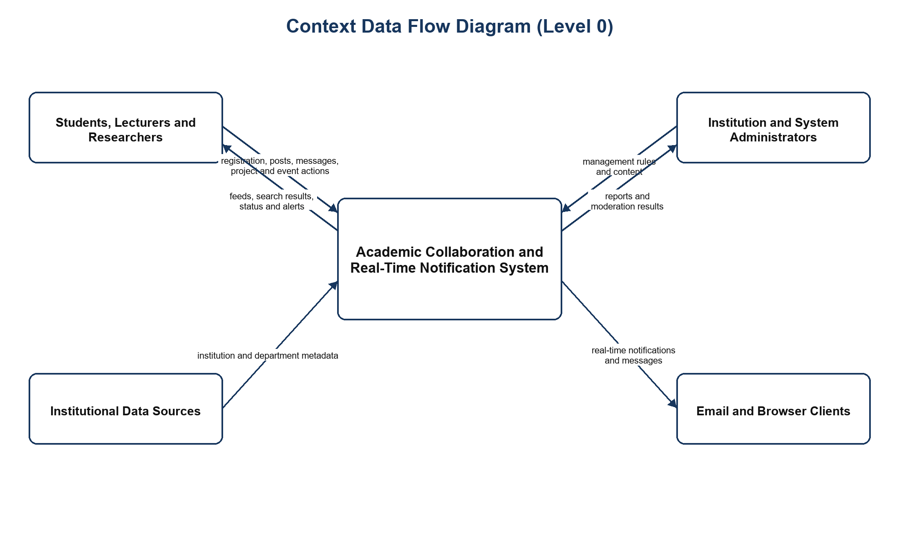
Figure 4: Data Flow Diagram Level 0 (Context Diagram)
The Level 1 diagram divides the system into six main processes and four logical data stores. Protected operations pass through authentication and current-account checking before a controller reads or changes data. The communication process adds real-time delivery to the stored records.
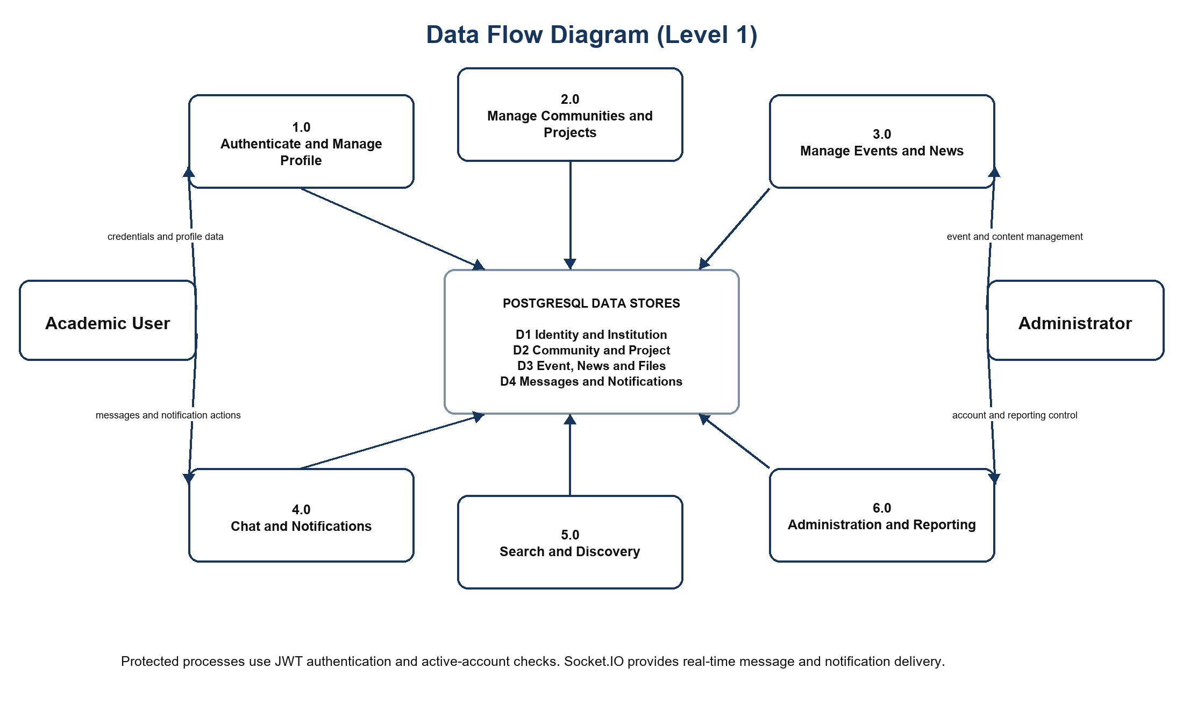
Figure 5: Data Flow Diagram Level 1

4.6.2 Use-Case or System Sequence Diagram
The sequence diagram illustrates a common event-notification use case. An administrator publishes an event through the React interface. The API authenticates and validates the request, writes the event to PostgreSQL and creates relevant notification records. Socket.IO then sends an immediate alert to the intended user rooms. The receiving client displays the alert and can refresh the event feed.
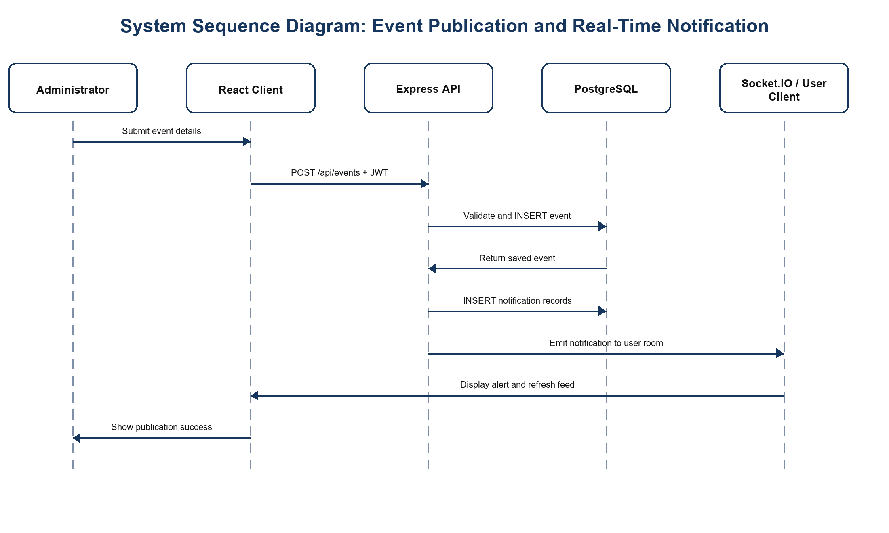
Figure 6: System Sequence Diagram for Event Publication and Notification

4.6.3 Database Normalization
The PostgreSQL database is organized to reduce duplication and protect data integrity. In First Normal Form (1NF), each table has identifiable rows and fields contain one logical value. Repeating relationships are placed in separate tables. For example, community members are stored in community_members rather than in a comma-separated field inside academic_communities.
In Second Normal Form (2NF), non-key values depend on the full key. Intersection tables such as community_members, project_members, event_registrations and chat_members use both foreign keys as their primary key. Attributes such as joined_at or role describe the complete membership relationship rather than only one side of it.
In Third Normal Form (3NF), descriptive information is separated so that non-key fields do not depend on other non-key fields. Institution names and locations are kept in institutions, department names are kept in departments, and users store only the related identifiers. Similarly, chat room details, messages and membership are separated. This prevents update, insertion and deletion anomalies.
The projects.requirements field is stored as a JSONB array because it is a bounded document-like property of one project rather than a relationship reused across the system. If requirements later need independent owners, scoring or reuse, they should be moved into a project_requirements table.

4.6.4 Data Dictionary
Table 8 summarizes the implemented relations. PK means primary key and FK means foreign key. The complete column definitions and constraints are maintained in the supplied schema.sql file.
Table 8: Data Dictionary
Relation | Key fields | Important attributes and purpose
institutions | PK id | name, type, location; stores participating institutions
departments | PK id; FK institution_id | name; stores departments within an institution
users | PK id; FK institution_id, department_id | email, password_hash, full_name, role, bio, avatar_url, status
academic_communities | PK id; FK created_by, institution_id | name, description, category, privacy_type
community_members | PK/FK community_id + user_id | joined_at; resolves community membership
community_invitations | PK id; FK community_id, user_id | status, created_at; controls invitations
posts | PK id; FK user_id, community_id | title, content, created_at
comments | PK id; FK post_id, user_id | content, created_at
likes | PK/FK post_id + user_id | created_at; prevents duplicate likes
projects | PK id; FK created_by, institution_id | title, description, requirements, status, access_scope
project_members | PK/FK project_id + user_id | role, joined_at
project_join_requests | PK id; FK project_id, user_id | status, requested_at, responded_at, responded_by
project_files | PK id; FK project_id, uploaded_by | filename, filepath, mime_type, file_size, uploaded_at
events | PK id; FK organizer_id, institution_id | title, description, event_date, location, meeting_link, capacity
event_registrations | PK/FK event_id + user_id | registered_at
news | PK id; FK created_by | title, description, category, feature_image, external_link
news_documents | PK id; FK news_id | filename, filepath, mime_type, file_size
chat_rooms | PK id | name, is_group, created_at
chat_members | PK/FK room_id + user_id | joined_at
chat_messages | PK id; FK room_id, sender_id | message, created_at
notifications | PK id; FK user_id | title, content, type, is_read, link, created_at

4.6.5 Physical Data Model
The physical model is implemented in PostgreSQL with SERIAL integer keys, VARCHAR and TEXT fields, TIMESTAMP WITH TIME ZONE values, BOOLEAN flags and one JSONB array. Foreign keys use controlled delete actions such as CASCADE or SET NULL. Uploaded files are stored on the server, while their names, paths, types and sizes are recorded in PostgreSQL.
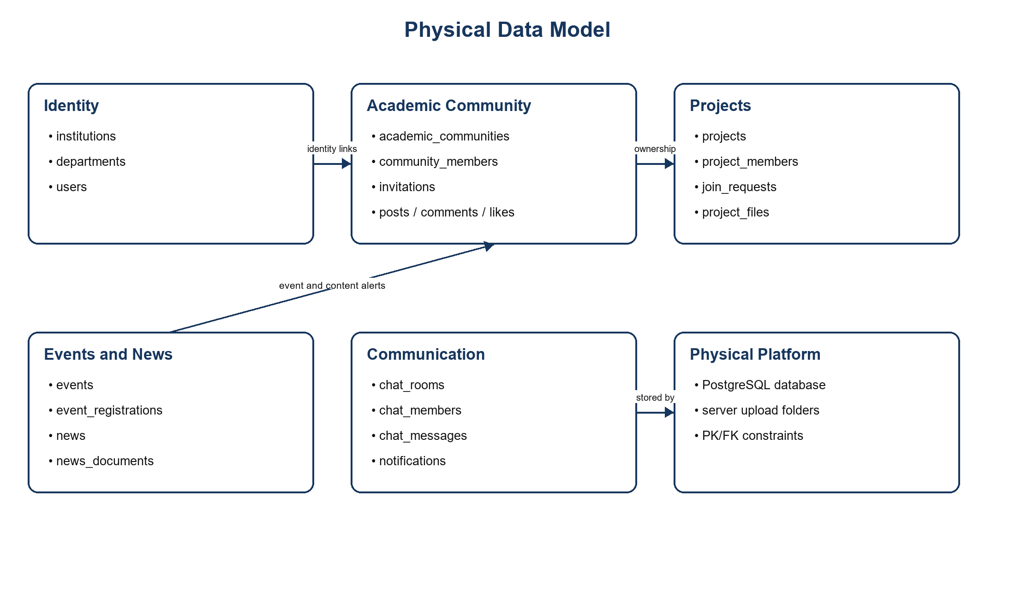
Figure 7: Physical Data Model

4.6.6 Entity Relationship Diagram
The core entity relationship diagram shows how users connect to academic structures and platform activity. One institution has many departments and users. A user may create or join many communities and projects, organize or register for events, join chat rooms and receive many notifications. Intersection relations resolve many-to-many relationships and dependent tables store posts, files, registrations and messages.
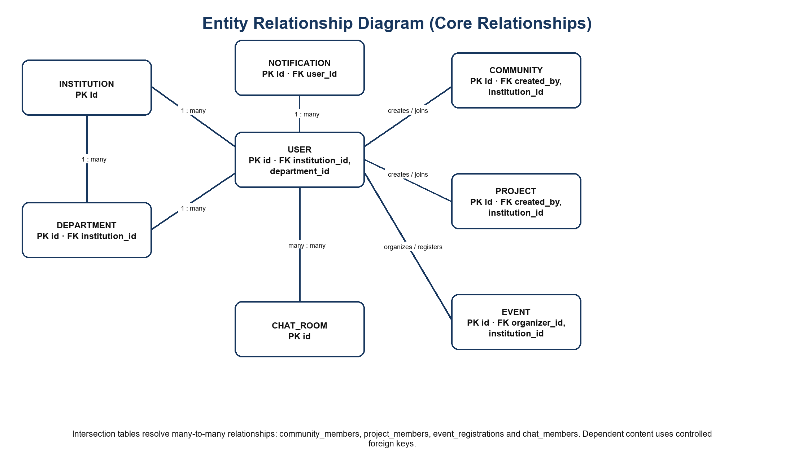
Figure 8: Entity Relationship Diagram

4.7 System Implementation and Coding

4.7.1 Introduction
Implementation converted the requirements into a modular web application. The frontend presents a responsive interface and calls the API. The backend validates requests, applies authorization rules, queries PostgreSQL and emits real-time events. The code is divided into configuration, middleware, routes, controllers and services so that each part has a clear responsibility.

4.7.2 Implementation Tools and Technologies
Table 9: Implementation Tools and Technologies
Tool or technology | Use in the developed system
React 18 | Builds reusable user-interface pages and manages client state.
Vite 5 | Runs the development server and produces the optimized frontend build.
Tailwind CSS and CSS | Provide responsive layout, typography, spacing and component styling.
Lucide React | Provides consistent interface icons.
Node.js and Express | Run the API, middleware, routing and business logic.
PostgreSQL and pg | Store structured application records and enforce relationships.
Socket.IO | Delivers live chat messages and user-specific notifications.
bcryptjs | Hashes and compares account passwords.
jsonwebtoken | Creates and verifies JWT authentication tokens.
Multer | Validates and stores uploaded avatars, news documents and project files.
Git-compatible source structure | Supports controlled development and future continuous integration.

4.7.3 System Screenshots and Selected Source Code
Figure 9 shows the authenticated home page. It gives the user one starting point for communities, projects, events and news. The page also summarizes the academic network and highlights upcoming activity.
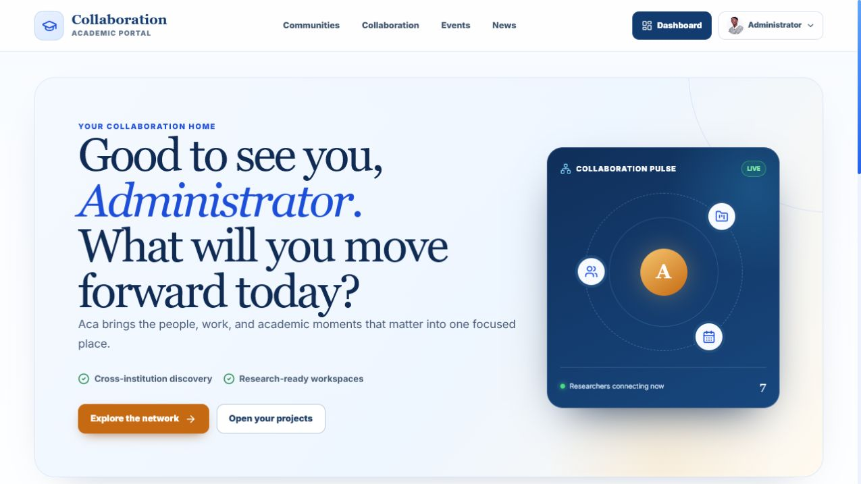
Figure 9: Authenticated Collaboration Home Page
Figure 10 shows the private project directory. It displays eligible projects, membership status, access scope and project counts. A project owner can create a workspace, define requirements, review join requests and share documents with accepted members.
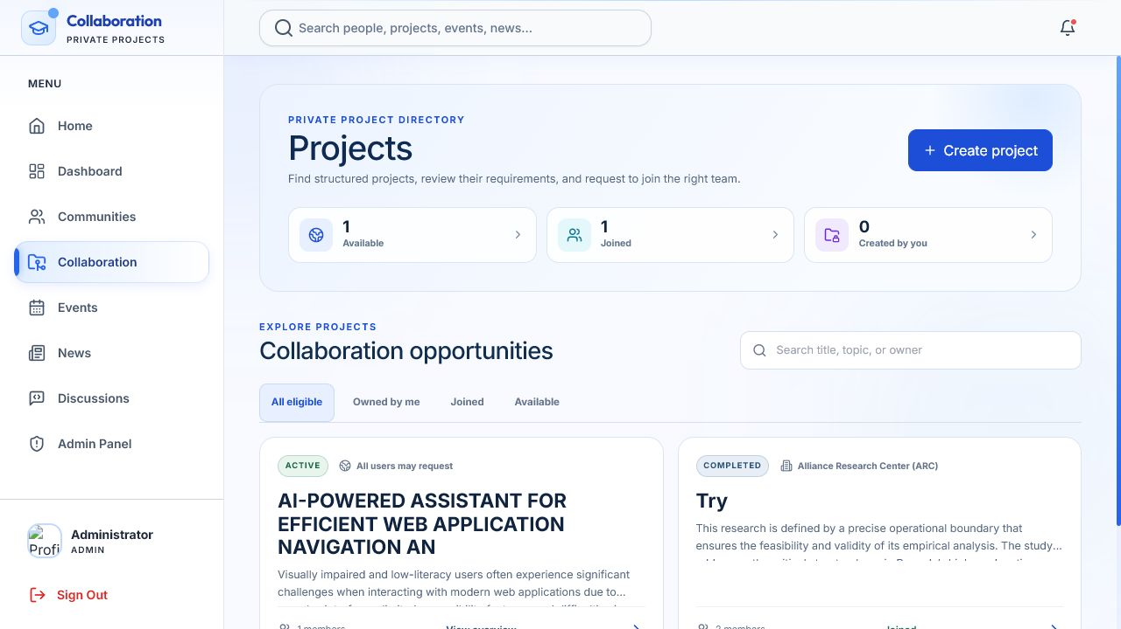
Figure 10: Collaboration Project Workspace
Figure 11 shows the event workspace. Users can filter upcoming, registered, created and past events. Authorized creators can publish an event and provide location, capacity and an online meeting link.
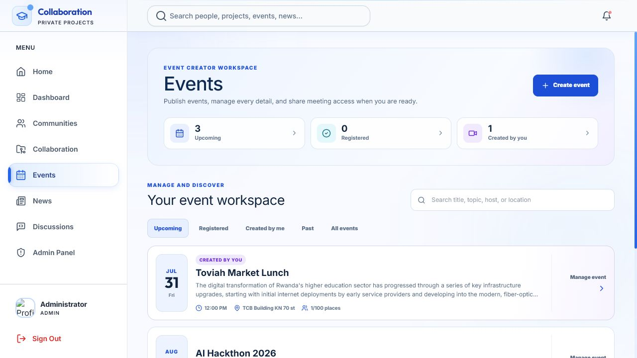
Figure 11: Academic Event Workspace
The following selected code shows how a notification is stored and then delivered to the intended user's Socket.IO room. Storing the record first ensures that the user can still view the notification later.
const result = await query(
`INSERT INTO notifications (user_id, title, content, type, link)
VALUES ($1, $2, $3, $4, $5) RETURNING *`,
[userId, title, content, type, link || null]
);
sendNotification(userId, result.rows[0]);
The Socket.IO helper targets a user-specific room. This prevents a normal notification from being broadcast to every connected client.
function sendNotification(userId, notification) {
if (!io) return;
const room = `user_${String(userId)}`;
io.to(room).emit('notification', notification);
}
Protected API routes pass through token authentication and a live account-status check. Administrative routes add a role restriction, as shown below.
router.use(authenticateToken);
router.use(checkUserActive);
router.get('/admin/stats',
authorizeRoles('admin'),
adminCtrl.getAdminStats
);

4.8 System Testing

4.8.1 Introduction
Testing examined whether the supplied application could be built, whether the backend files were valid, whether the service responded and whether protected content rejected an unauthenticated request. The running authenticated interface was also inspected on the home, project and event pages. A dedicated automated unit-test suite was not included in the supplied project, so this chapter distinguishes verified technical checks from tests that should be added before production deployment.

4.8.2 Testing Objectives
- Confirm that the frontend compiles into a production build.
- Confirm that backend JavaScript files contain no syntax errors.
- Confirm that the application server responds through its health endpoint.
- Confirm that protected API routes reject requests without a token.
- Confirm that authenticated pages can load data from the API and present the main modules.
- Define validation, integration, functional, system and user-acceptance checks for the final release.
Table 10: Verified Technical Test Results
Test ID | Check performed | Expected result | Observed result | Status
VT-01 | Vite production build | Frontend compiles successfully | 1,555 modules transformed; build completed | PASS
VT-02 | Backend JavaScript syntax | All source files parse | 18 files checked; 0 failures | PASS
VT-03 | GET /health | HTTP 200 and UP status | Server returned UP | PASS
VT-04 | GET /api/projects without JWT | Request rejected | HTTP 401 returned | PASS
VT-05 | Authenticated interface inspection | Home, projects and events render | All three pages rendered with live records | PASS

4.8.3 Unit Testing
Unit testing should isolate small functions and controller decisions. The source contains clear units for project ID parsing, requirement cleaning, JWT verification, role checking, file filtering and notification delivery. Syntax validation passed, but a repeatable automated unit-test framework was not supplied. The following cases should be implemented with mocked database and Socket.IO dependencies.
Table 11: Unit Test Case Matrix
Case | Input or condition | Expected behavior | Current evidence
UT-01 | Missing email, password, name or role at registration | Return HTTP 400 | Controller rule present
UT-02 | Invalid or expired JWT | Return HTTP 403 | Middleware rule present
UT-03 | Project without title, description or requirement | Reject creation | Controller rule present
UT-04 | Invalid join-request action | Accept only accept or reject | Controller rule present
UT-05 | Executable upload type | Reject unsafe upload | Multer filter present
UT-06 | Notification for one user | Emit only to user_<id> room | Socket helper present

4.8.4 Validation Testing
Validation testing checks that incorrect or incomplete information is stopped before it damages stored data. The application validates required account fields, unique email addresses, allowed roles, project requirements, access scope, event values and upload limits. PostgreSQL adds check, unique and foreign-key constraints. Final validation testing should also cover invalid dates, negative capacities, empty messages, oversized files, unsupported image types and client-side/server-side error consistency.

4.8.5 Integration Testing
Integration testing checks the connections between the React client, Express API, PostgreSQL database, file storage and Socket.IO. The authenticated pages loaded records from the live API, showing that the main client-API-database path was working during inspection. The project build and backend health checks also passed. A full repeatable integration suite should create temporary test data, verify database changes, observe socket delivery and remove the temporary records inside isolated test transactions.
Table 12: Integration Test Scenarios
Scenario | Integrated components | Expected result
User signs in | React, API, bcrypt, JWT, PostgreSQL | Valid user receives a token and profile; invalid credentials are rejected.
Project join request | Project page, API, database, notification service, Socket.IO | Owner receives a stored and live alert; approved user becomes a member.
Event registration | Event page, API and registration table | Registration is added once and capacity information updates.
Chat message | Chat page, API, message table and Socket.IO room | Message is stored and appears for other room members.
Protected file access | Project/news page, API authorization, file metadata and storage | Only eligible authenticated users receive the file.

4.8.6 Functional and System Testing
Functional testing should follow complete user journeys: registration, profile completion, community participation, project creation and approval, document sharing, event publication and registration, messaging, notifications, search and administration. System testing should repeat these journeys under different roles, browsers, screen sizes and network conditions. It should also measure response time, concurrent socket behavior, recovery after database interruption, backup restoration and permission boundaries.
The supplied system passed the verified build, syntax, service and authentication-boundary checks shown in Table 10. No evidence was supplied for high-load, recovery, cross-browser or long-duration testing. These items should be completed before institutional deployment.

4.8.7 User Acceptance Testing
User Acceptance Testing (UAT) determines whether intended users consider the system useful and ready for their academic work. The final UAT should include students, lecturers, researchers and administrators from more than one institution. Participants should complete the same tasks with clear success criteria and recorded assistance, time, errors and satisfaction.
Table 13: User Acceptance Test Criteria
Acceptance task | Success criterion | Verified result
Create or update a profile | User completes the task without researcher intervention | [Insert from signed UAT record]
Find and join an eligible community | Correct privacy rule is applied and membership is visible | [Insert from signed UAT record]
Request access to a project | Owner receives the request and can accept or reject it | [Insert from signed UAT record]
Publish or register for an event | Event is stored and registration status changes correctly | [Insert from signed UAT record]
Send and receive a message | Other room member receives the stored message in real time | [Insert from signed UAT record]
Find content using global search | User locates the intended person or academic item | [Insert from signed UAT record]
Overall acceptance | Agreed threshold is met for usefulness, ease of use and intention to adopt | [Insert calculated UAT outcome]

Because no completed UAT forms or participant-level result sheet were provided, the system cannot be academically described as user-accepted at this stage. The interface and core technical flow are ready for a controlled pilot, after which the verified results should replace the placeholders in Table 13.

4.9 Chapter Summary
This chapter translated the documented collaboration problems into functional and non-functional requirements and described the implemented solution. The system combines user identity, academic communities, private projects, files, events, news, search, chat, notifications and administration in one React, Express, PostgreSQL and Socket.IO platform. The database was organized using normalized relations and controlled foreign keys. Diagrams, screenshots and selected code demonstrated the design and implementation.
Technical verification confirmed that the frontend production build completed, all 18 backend JavaScript files passed syntax checking, the service health endpoint returned UP, and an unauthenticated protected request was rejected with HTTP 401. The chapter also identified the remaining evidence gap: verified survey statistics and completed UAT records are still needed before claims about measured user impact can be made. MQTT and live document co-editing remain proposed extensions rather than implemented functions.

CHAPTER 5: CONCLUSIONS AND RECOMMENDATIONS

5.0 Introduction
This chapter concludes the study by responding directly to the three research objectives and questions. It also presents recommendations for improving the technology, strengthening institutional ownership, supporting user adoption, protecting information and deploying the system responsibly. The conclusions are limited to the evidence available in the manuscript, source code, running prototype and technical checks.

5.1 Conclusion
The general objective was to design, implement and evaluate a unified web-based environment for academic collaboration and real-time event notification. This objective was substantially achieved at prototype level. A working portal was developed with institution-linked accounts, communities, private projects, events, news, search, chat, notifications and administration. The prototype passed the recorded build, syntax, health and authentication-boundary checks. Full empirical evaluation remains incomplete until the planned survey and UAT records are supplied and analysed.
Specific Objective 1 and Research Question 1: The study sought to identify the barriers affecting cross-institutional collaboration, research visibility and immediate academic communication. The documented findings identify fragmented communication channels, pull-based discovery, institutional isolation, weak coordination of joint work, delayed awareness and concerns about privacy and intellectual property. Therefore, the answer to the first research question is that the problem combines technical fragmentation, institutional access boundaries and human trust or adoption concerns. It cannot be solved by network connectivity alone.
Specific Objective 2 and Research Question 2: The study sought to implement real-time event distribution and examine how a cross-institutional platform affects communication and knowledge sharing. The prototype implements stored notifications and Socket.IO-based push delivery, supported by events, communities, projects, files and chat. These functions create a practical improvement over separate static channels because discovery, communication and action occur in one environment. However, the implemented system does not use MQTT, and the size of the effect on users cannot yet be quantified without the missing field dataset. The conclusion is therefore one of demonstrated technical capability, not a statistically proven impact.
Specific Objective 3 and Research Question 3: The study sought to develop an architecture for real-time collaboration, notifications and co-editing, and to determine the effect on event participation. The implemented architecture supports live messaging and notifications, structured communities, private project workspaces, file sharing, event discovery and registration. These features provide a direct mechanism through which awareness and participation may improve. Real-time document co-editing is not present in the supplied code, and no verified before-and-after participation data were supplied. The prototype should therefore be described as ready for a controlled institutional pilot, not as proof of a measured participation increase.
Overall, the project demonstrates that a unified, role-aware and real-time academic portal is technically feasible in the study context. Its main contribution is an integrated foundation that turns separate announcements and informal conversations into searchable, managed and persistent academic activity. The next stage is to strengthen security and operations, complete the missing real-time extensions and conduct a documented multi-institution evaluation.

5.2 Recommendations

5.2.1 Technical Recommendations
- Add an automated test suite for controller units, API integration, database transactions, Socket.IO delivery and end-to-end user journeys.
- Implement MQTT only where broker-based topic distribution provides a clear advantage, and document how it works with the existing Socket.IO layer.
- Add real-time document co-editing through a proven Operational Transformation or Conflict-free Replicated Data Type service instead of describing file sharing as co-editing.
- Add pagination, database indexes, background jobs and a shared Socket.IO adapter before supporting a large number of institutions and concurrent users.
- Provide a progressive web application or mobile client with low-bandwidth behavior, cached reading and graceful reconnection.
- Improve accessibility through a formal WCAG review, keyboard testing, screen-reader testing and accessible error messages.

5.2.2 Institutional Recommendations
- Create a governance committee with representatives from participating institutions, students, lecturers, researchers, IT teams and data-protection staff.
- Agree on institution onboarding, verified identity, content ownership, moderation, intellectual-property and dispute-resolution policies.
- Assign local platform coordinators who approve official accounts, support event publishers and maintain institution and department records.
- Begin with a small pilot between the University of Kigali and one partner institution, then expand using lessons from the pilot.
- Define measurable institutional indicators such as active collaborations, cross-institution event registrations, completed joint projects and response time to invitations.

5.2.3 User-Adoption Recommendations
- Provide short role-based training for students, lecturers, researchers, event organizers and administrators.
- Use academic champions in each institution to demonstrate valuable communities, projects and events during the pilot.
- Offer a simple onboarding checklist that helps users complete a profile, join a community, find a project and register for an event.
- Provide in-platform help, clear empty states and a support channel for users who experience access or notification problems.
- Collect structured feedback at regular intervals and publish visible improvements so that users see that their concerns influence development.

5.2.4 Security Recommendations
- Remove all default production credentials and fallback secrets; use a secret manager and rotate secrets regularly.
- Serve the platform only through HTTPS and WSS, restrict CORS to approved origins and place the service behind a hardened reverse proxy.
- Use secure session storage or carefully protected tokens, short token lifetimes, refresh-token rotation and multi-factor authentication for administrators.
- Scan uploads for malware, verify file content as well as extensions, randomize stored filenames and keep protected documents outside public static folders.
- Add rate limiting, login protection, security headers, detailed audit logs and alerts for sensitive administrative actions.
- Carry out vulnerability scanning, dependency review, penetration testing, backup restoration tests and incident-response exercises before launch.
- Adopt clear retention, consent, privacy, breach-response and account-deletion procedures aligned with applicable Rwandan data-protection requirements.

5.2.5 Deployment Recommendations
- Use separate development, testing and production environments with environment-specific configuration.
- Deploy the frontend, API, database and file storage as monitored services with daily automated backups and tested restoration.
- Use a continuous-integration pipeline that runs syntax checks, tests, dependency audits and the frontend production build before release.
- Add health monitoring, centralized logs, uptime alerts, database performance monitoring and Socket.IO connection metrics.
- Plan capacity for users, uploads and concurrent connections; use object storage and a shared real-time adapter when the platform is scaled horizontally.
- Release in phases: internal technical trial, limited institutional pilot, corrected release and then controlled multi-institution expansion.

5.3 Areas for Further Research
- A longitudinal multi-institution study comparing communication speed, collaboration activity and event participation before and after adoption.
- The performance and adoption of MQTT, COAR Notify or other event protocols alongside Socket.IO in Rwanda's higher-education environment.
- Real-time academic co-authoring using Operational Transformation or Conflict-free Replicated Data Types, including conflict, ownership and version-history management.
- The effect of low-bandwidth, offline-first and mobile designs on participation outside well-connected campuses.
- Trust, intellectual-property protection and willingness to share research across public and private institutions.
- Accessible multilingual interaction in English, Kinyarwanda and French for academic discovery and notifications.
- Privacy-preserving recommendation methods for matching users to projects, experts, communities and events.
- Governance and sustainability models for operating a national academic collaboration platform through institutional partnerships.

REFERENCES
- Breaking the Final Connectivity Barriers for Higher Education, accessed June 23, 2026, https://kcl.co.ug/wp-content/uploads/2023/01/Circulation-Version-Breaking-the-Final-Connectivity-Barriers-for-Higher-Education-Institutions-in-Africa.pdf
- COAR Notify: COAR Notify, accessed June 23, 2026, https://coar-notify.net/
- A Deep Dive into WebRTC, WebSockets, and Conflict Resolution, accessed June 23, 2026, https://medium.com/@himansusaha/building-real-time-collaborative-applications-a-deep-dive-into-webrtc-websockets-and-conflict-9eb75800e221
- National Center for Sustainable Transportation Center Data, accessed June 23, 2026, https://rosap.ntl.bts.gov/view/dot/72261/dot_72261_DS1.pdf
- Event-Driven Architecture: 99% of Your System Requests Are, accessed June 23, 2026, https://flowfuse.com/blog/2026/02/what-is-event-driven-architecture-in-manufacturing/
- Event-driven architecture in cloud computing: Principles, patterns, accessed June 23, 2026, https://wjarr.com/sites/default/files/fulltext_pdf/WJARR-2025-1080.pdf
- List of universities in Rwanda - Grokipedia, accessed June 23, 2026, https://grokipedia.com/page/List_of_universities_in_Rwanda
- Information and Communication Technology in Higher Education, accessed June 23, 2026, https://brill.com/display/book/9789004731271/BP000019.pdf
- Events - University of Kigali, accessed June 23, 2026, https://uok.ac.rw/events/
- University of Kigali Hosts International AI-in-Education Conference, accessed June 23, 2026, https://uok.ac.rw/news/university-of-kigali-hosts-international-ai-in-education-conference-in-kigali/
- Research and Innovation Archives - University of Kigali, accessed June 23, 2026, https://uok.ac.rw/news-categories/research-and-innovation/
- RwedNet Roars Back to Life - AfricaConnect3, accessed June 23, 2026, https://africaconnect3.net/rwednet-roars-back-to-life/
- About NCST - Rwanda Research and Innovation Repository, accessed June 23, 2026, https://research-innovationhub.gov.rw/content/About-NCST-11
- Using Event Notifications, Solid and Orchestration for Decentralizing, accessed June 23, 2026, https://journal.code4lib.org/articles/17823

