MULTI-CHANNEL AI AGENT
PHASE 10 - COMPLETE DETAILED NOTES
Testing, Optimization, Documentation & Final Demonstration

Project | Multi-channel AI Agent
Fictional Business | NexaTech Solutions
Automation Platform | n8n + Docker + Google Sheets + AI / APIs
Channels | Website Chat, Email, WhatsApp
Prepared by | Muhammad Junaid Hassan
Internship | AI Automation - Using n8n | Big Brains

Document Purpose
This document explains Phase 10 in full detail: what was tested, which major features are working, how the final architecture behaves, the 30-case QA matrix, screenshots of successful flows, and the important errors/fixes discovered during optimization.

Accuracy Note
Important evidence note: the archived master document shows the 30-scenario matrix as prepared and says the Actual Result / PASS-FAIL fields should be filled from real n8n executions before treating the QA matrix as fully complete. The screenshots in this PDF prove several key working flows, but this report does not invent PASS results that are not present in the archive.

Contents
- Phase 10 objective and success criteria
- Working feature summary
- Final integrated architecture
- Phase 10 validation plan and 30 test scenarios
- Website Chat testing notes
- Email testing notes
- WhatsApp testing notes
- CRM, identity matching and duplicate prevention
- Cross-channel history and context
- Central AI Brain and knowledge-grounded replies
- Channel routing and human escalation
- Optimization: errors, causes and fixes
- Final demonstration procedure
- Final submission checklist and evidence

1. Phase 10 Objective and Success Criteria
Phase 10 is the final quality-assurance and portfolio phase. The goal is not to rebuild the system; the goal is to prove that the complete multi-channel architecture is stable, understandable, testable, and ready to demonstrate.
- Run structured fictional tests across Website Chat, Email and WhatsApp.
- Verify new customers, returning customers, duplicate identities and incomplete customer data.
- Verify cross-channel continuity so the same customer can continue a conversation on a different channel.
- Verify major intents: product inquiry, pricing, technical support, complaint, general question and human assistance.
- Verify unknown-knowledge cases use a safe fallback instead of inventing information.
- Verify human escalation, support email notification and CRM status updates.
- Review workflow errors, remove duplicate response paths, fix type/mapping errors and document the solutions.
- Prepare a final demonstration showing one centralized customer profile and context across all channels.
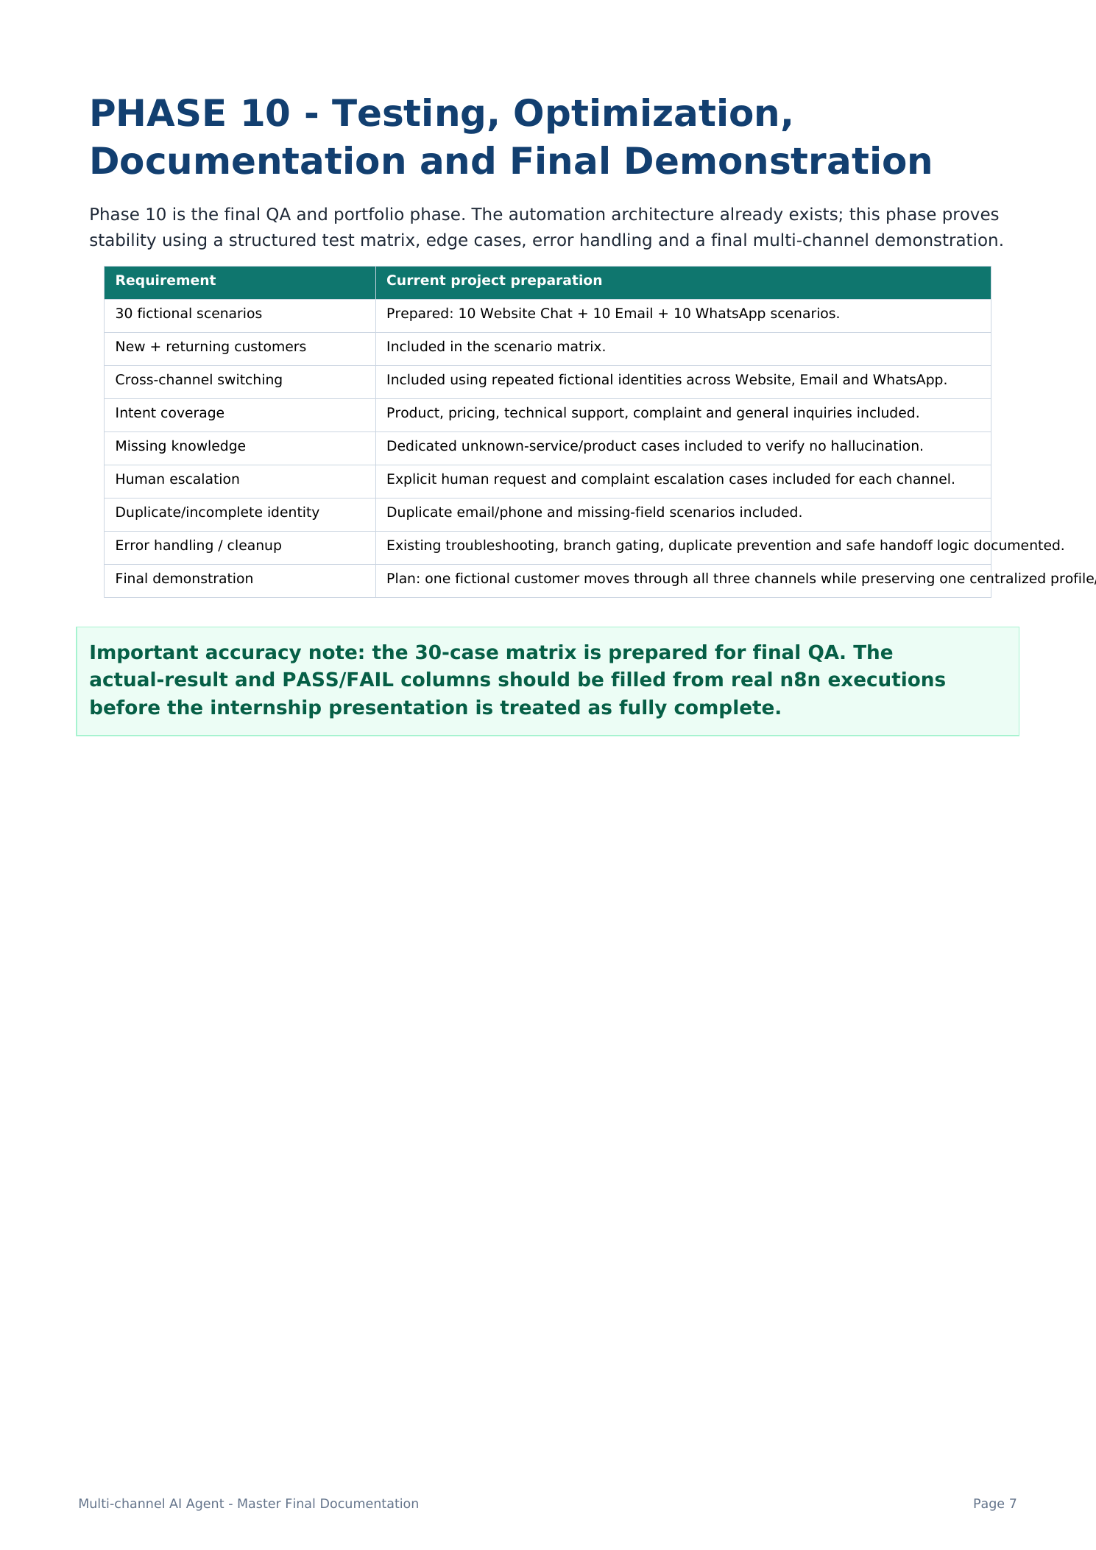
Screenshot 1 - Official Phase 10 Scope and QA Requirements
Description: The master project page defines Phase 10 as Testing, Optimization, Documentation and Final Demonstration. It lists the 30-scenario plan, cross-channel switching, intent coverage, missing knowledge, escalation, duplicate/incomplete identity and final demonstration requirements.

2. Working Feature Summary
Feature | How it works | Evidence / Status
Website Chat input | Receives website customer messages through webhook/chat flow. | Implemented; used in QA matrix and architecture.
Email input | Receives email and routes it into the same central logic. | Implemented in integrated architecture.
WhatsApp input | Meta WhatsApp webhook receives and sends live messages. | Working flow captured in screenshots.
Message standardization | Converts channel-specific fields into one common schema. | Foundation for all later phases.
Customer CRM | Finds existing customer or creates a new profile in Google Sheets. | Working create/update flow captured.
Duplicate prevention | Reuses customer profile when email/phone already exists. | Built into lookup + IF branching.
Conversation storage | Stores message and conversation records with customer ID. | Visible in final workflow.
Previous conversation context | Retrieves prior messages and builds previous_context. | Integrated before Central AI Brain.
Central AI Brain | One shared AI workflow processes all channels. | Integrated; screenshots show parent/subworkflow behavior.
Knowledge grounding | Answers known services/pricing and uses safe fallback for unknown items. | Included in Phase 10 scenarios.
Intent + decision output | Produces structured fields such as intent, priority and escalation decision. | Captured in Channel Response Switch screenshot.
Channel response switch | Routes response to website_chat, email or whatsapp. | Working channel output captured.
Human escalation | Generates escalation summary, emails support, updates CRM and sends handoff reply. | Integrated and demonstrated in workflow screenshots.
Error handling | Debugs no-output, boolean-type, mapping and provider errors. | Documented in optimization section.

3. Final Integrated Architecture
The final design connects three customer channels to one shared CRM, one conversation history, one Central AI Brain, one routing layer and one human-escalation system. This avoids building three separate AI agents and keeps customer context centralized.
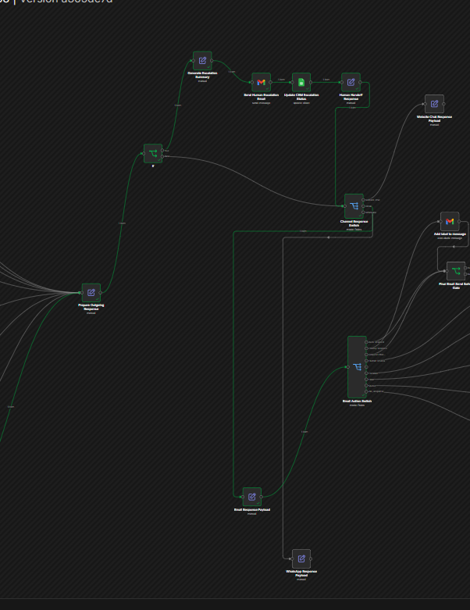
Screenshot 2 - Central AI Brain / Final Routing Architecture
Description: A wide view of the integrated Central AI workflow showing outgoing response preparation, channel routing, email actions and escalation-related branches. This is the decision and response side of the final system.
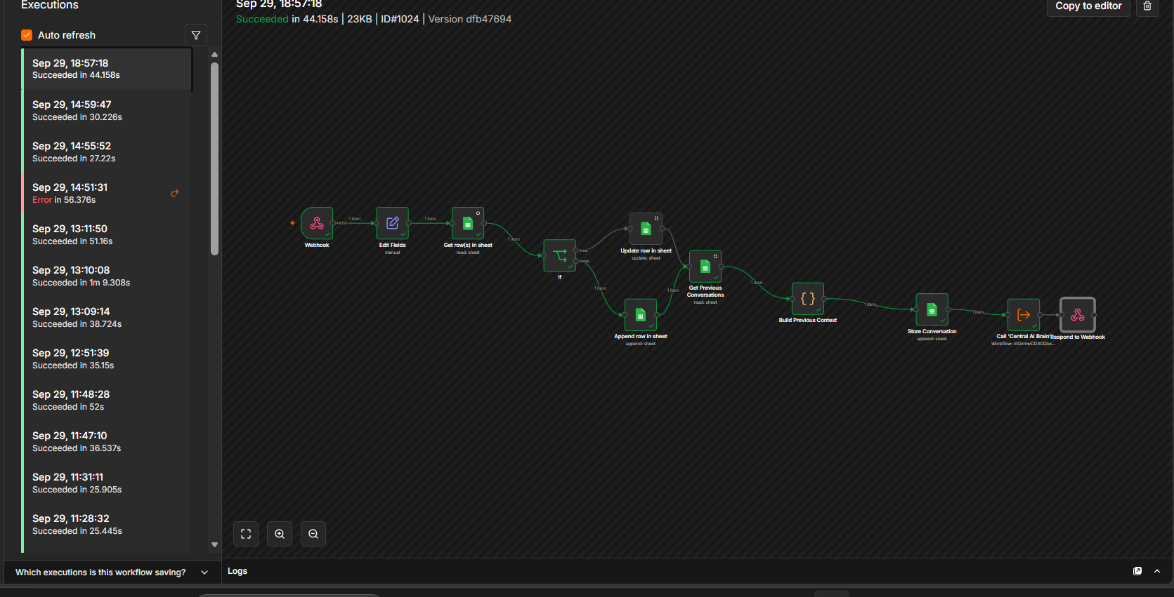
Screenshot 3 - Successful Integrated Execution
Description: n8n Executions view showing multiple succeeded runs and the complete chain from webhook to Edit Fields, CRM lookup, IF branching, previous conversation retrieval, context building, conversation storage, Central AI Brain and response.
Working Evidence
Key proof: the execution history contains multiple successful runs. The flow is not just a diagram; the n8n execution screen shows data moving through the integrated pipeline.

4. Phase 10 Validation Plan - 30 Fictional Scenarios
The Phase 10 matrix contains 30 realistic test cases: 10 Website Chat, 10 Email and 10 WhatsApp. Together they cover new customers, returning customers, cross-channel continuation, pricing, technical support, complaints, missing knowledge, human requests, duplicate identities and incomplete data.
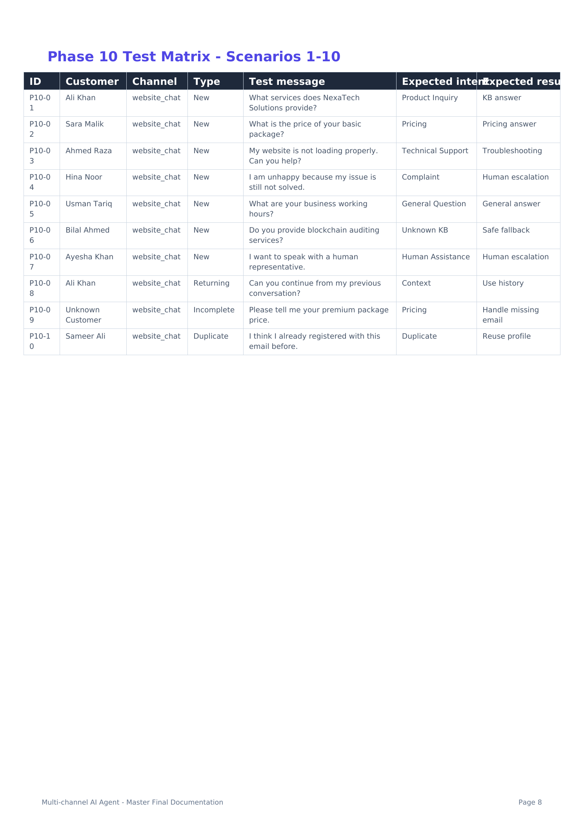
Screenshot 4 - Test Matrix Scenarios 1-10 (Website Chat)
Description: The first ten cases test Website Chat with product inquiry, pricing, technical support, complaint escalation, general questions, unknown knowledge, direct human request, returning-customer context, incomplete identity and duplicate identity.
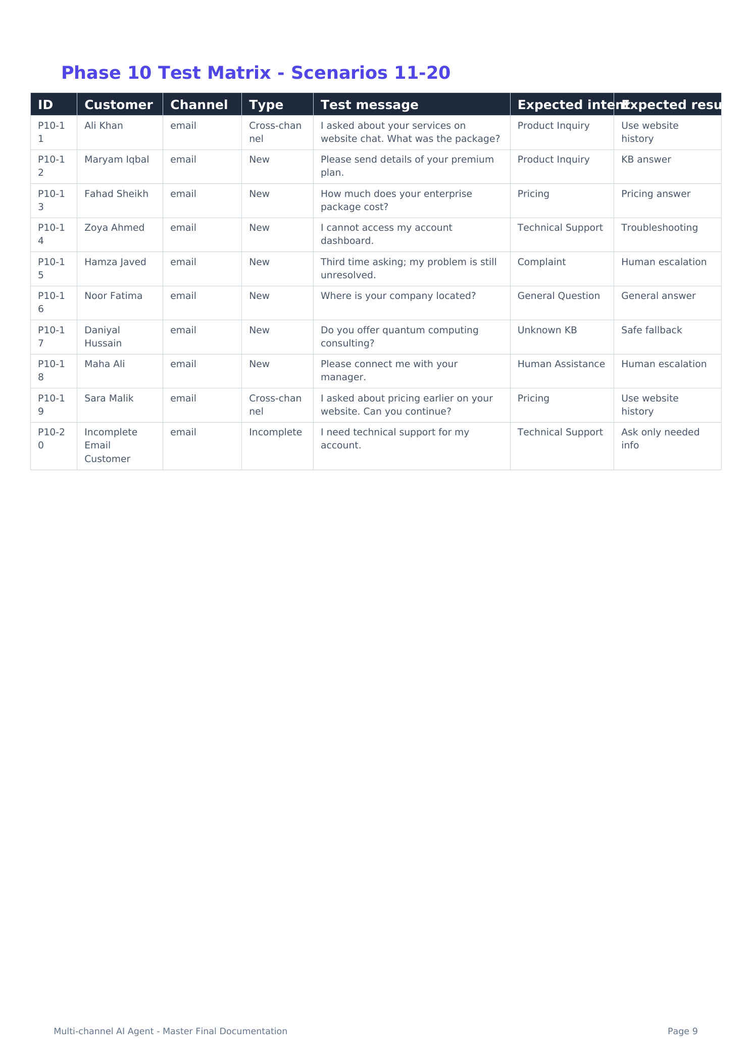
Screenshot 5 - Test Matrix Scenarios 11-20 (Email)
Description: The second ten cases test Email, including cross-channel history from Website Chat, new product/pricing/technical requests, complaint escalation, general questions, safe fallback, human assistance and incomplete customer data.
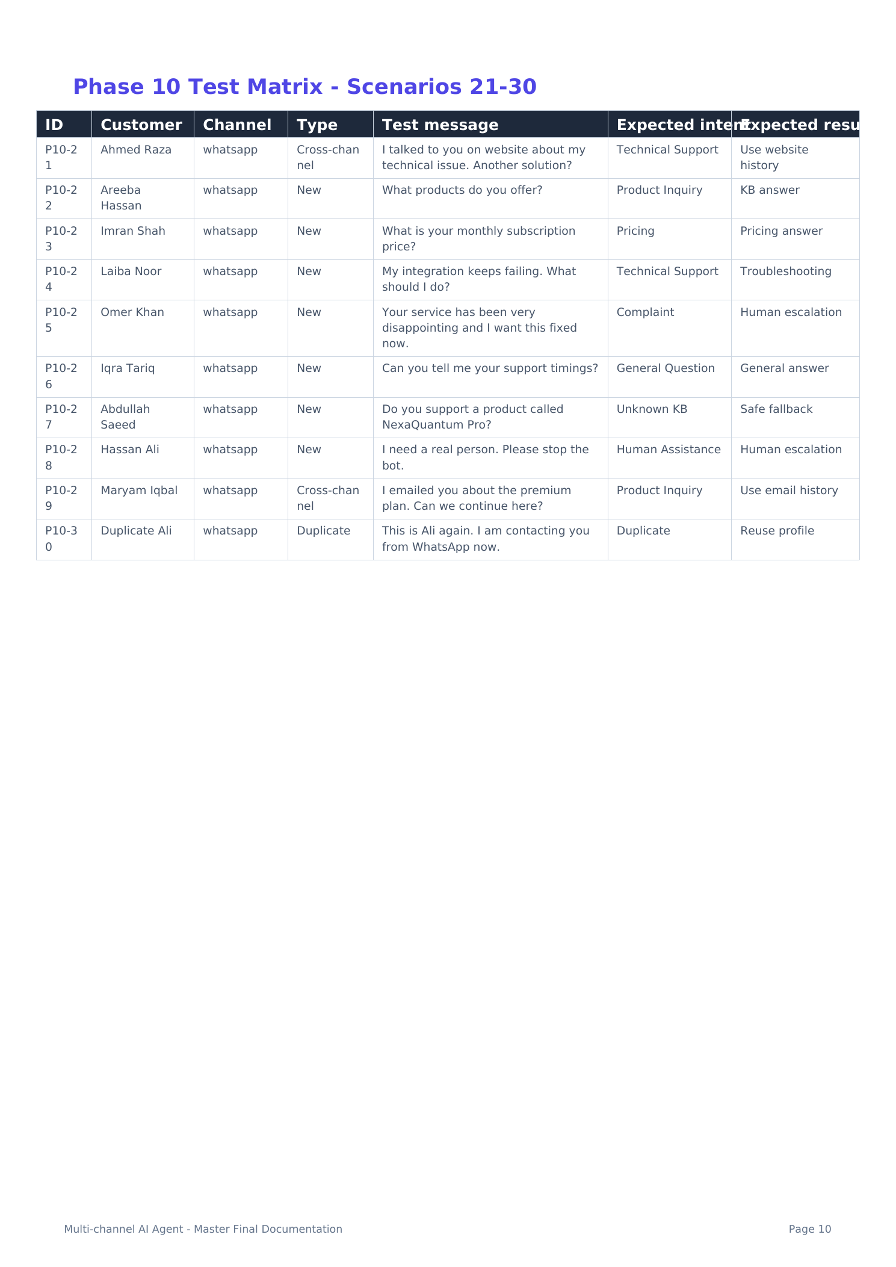
Screenshot 6 - Test Matrix Scenarios 21-30 (WhatsApp)
Description: The final ten cases test WhatsApp, including cross-channel continuation from Website/Email, product/pricing/support, complaints, unknown products, direct human assistance and duplicate identity reuse.

5. Website Chat Testing Notes - Scenarios 1-10
- P10-01 - Ali Khan (New): asks what services NexaTech Solutions provides. Expected: Product Inquiry -> knowledge-base answer.
- P10-02 - Sara Malik (New): asks price of basic package. Expected: Pricing -> pricing answer.
- P10-03 - Ahmed Raza (New): website not loading. Expected: Technical Support -> troubleshooting.
- P10-04 - Hina Noor (New): issue still unresolved and unhappy. Expected: Complaint -> human escalation.
- P10-05 - Usman Tariq (New): asks business working hours. Expected: General Question -> general answer.
- P10-06 - Bilal Ahmed (New): asks about blockchain auditing, not in KB. Expected: Unknown KB -> safe fallback.
- P10-07 - Ayesha Khan (New): asks to speak with a human. Expected: Human Assistance -> human escalation.
- P10-08 - Ali Khan (Returning): asks to continue previous conversation. Expected: Context -> use history.
- P10-09 - Unknown Customer (Incomplete): asks premium price without email. Expected: Pricing -> handle missing email.
- P10-10 - Sameer Ali (Duplicate): says already registered with same email. Expected: Duplicate -> reuse profile.
Expected Flow
Website Chat should return a direct chat response while still creating/updating the CRM, storing the conversation and using the same Central AI Brain as Email and WhatsApp.

6. Email Testing Notes - Scenarios 11-20
- P10-11 - Ali Khan (Cross-channel): refers to service question asked on website chat. Expected: Product Inquiry -> use website history.
- P10-12 - Maryam Iqbal (New): asks for premium-plan details. Expected: Product Inquiry -> KB answer.
- P10-13 - Fahad Sheikh (New): asks enterprise package cost. Expected: Pricing -> pricing answer.
- P10-14 - Zoya Ahmed (New): cannot access account dashboard. Expected: Technical Support -> troubleshooting.
- P10-15 - Hamza Javed (New): third unresolved request. Expected: Complaint -> human escalation.
- P10-16 - Noor Fatima (New): asks company location. Expected: General Question -> general answer.
- P10-17 - Daniyal Hussain (New): asks about quantum computing consulting. Expected: Unknown KB -> safe fallback.
- P10-18 - Maha Ali (New): asks to connect with manager. Expected: Human Assistance -> human escalation.
- P10-19 - Sara Malik (Cross-channel): refers to pricing asked on website. Expected: Pricing -> use website history.
- P10-20 - Incomplete Email Customer: requests technical support with incomplete identity. Expected: ask only needed information.
Expected Flow
For Email, the AI decision can route to auto-response, escalation email/draft, human review, queue or no-response logic depending on the structured decision.

7. WhatsApp Testing Notes - Scenarios 21-30
- P10-21 - Ahmed Raza (Cross-channel): refers to website technical issue. Expected: Technical Support -> use website history.
- P10-22 - Areeba Hassan (New): asks what products are offered. Expected: Product Inquiry -> KB answer.
- P10-23 - Imran Shah (New): asks monthly subscription price. Expected: Pricing -> pricing answer.
- P10-24 - Laiba Noor (New): integration keeps failing. Expected: Technical Support -> troubleshooting.
- P10-25 - Omer Khan (New): strong complaint. Expected: Complaint -> human escalation.
- P10-26 - Iqra Tariq (New): asks support timings. Expected: General Question -> general answer.
- P10-27 - Abdullah Saeed (New): asks for unknown product NexaQuantum Pro. Expected: Unknown KB -> safe fallback.
- P10-28 - Hassan Ali (New): asks for a real person and to stop the bot. Expected: Human Assistance -> human escalation.
- P10-29 - Maryam Iqbal (Cross-channel): wants to continue premium-plan discussion from email. Expected: Product Inquiry -> use email history.
- P10-30 - Duplicate Ali (Duplicate): same customer contacts via WhatsApp. Expected: Duplicate -> reuse profile.
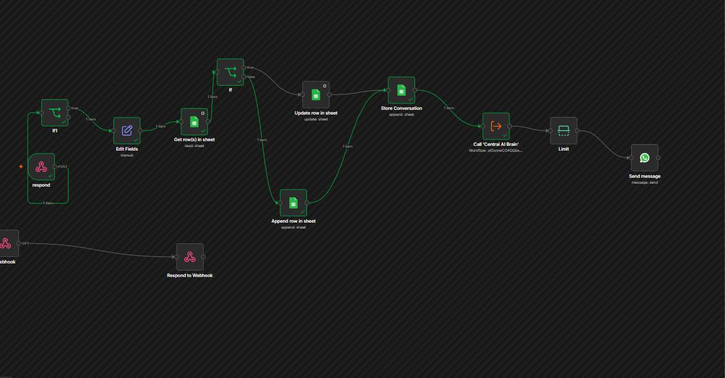
Screenshot 7 - WhatsApp End-to-End Workflow
Description: The WhatsApp workflow shows webhook receipt, field editing, customer lookup, IF branching, CRM update/append, conversation storage, call to Central AI Brain, limiting/control and final Send Message node.

8. CRM, Identity Matching and Duplicate Prevention
The CRM is implemented in Google Sheets. Every incoming message is normalized first, then the workflow checks whether a customer already exists. Existing customers are updated; new customers are appended. This prevents a new CRM row from being created for every message.
- Lookup uses stable identity fields such as email and/or phone depending on channel availability.
- Existing customer -> update row and refresh Last Interaction while preserving the existing Customer ID.
- New customer -> append row and create a new Customer ID.
- Conversation data is stored separately so CRM profile data and message history remain organized.
- During escalation, only required CRM fields should be updated; mapping blank fields can accidentally overwrite good data.
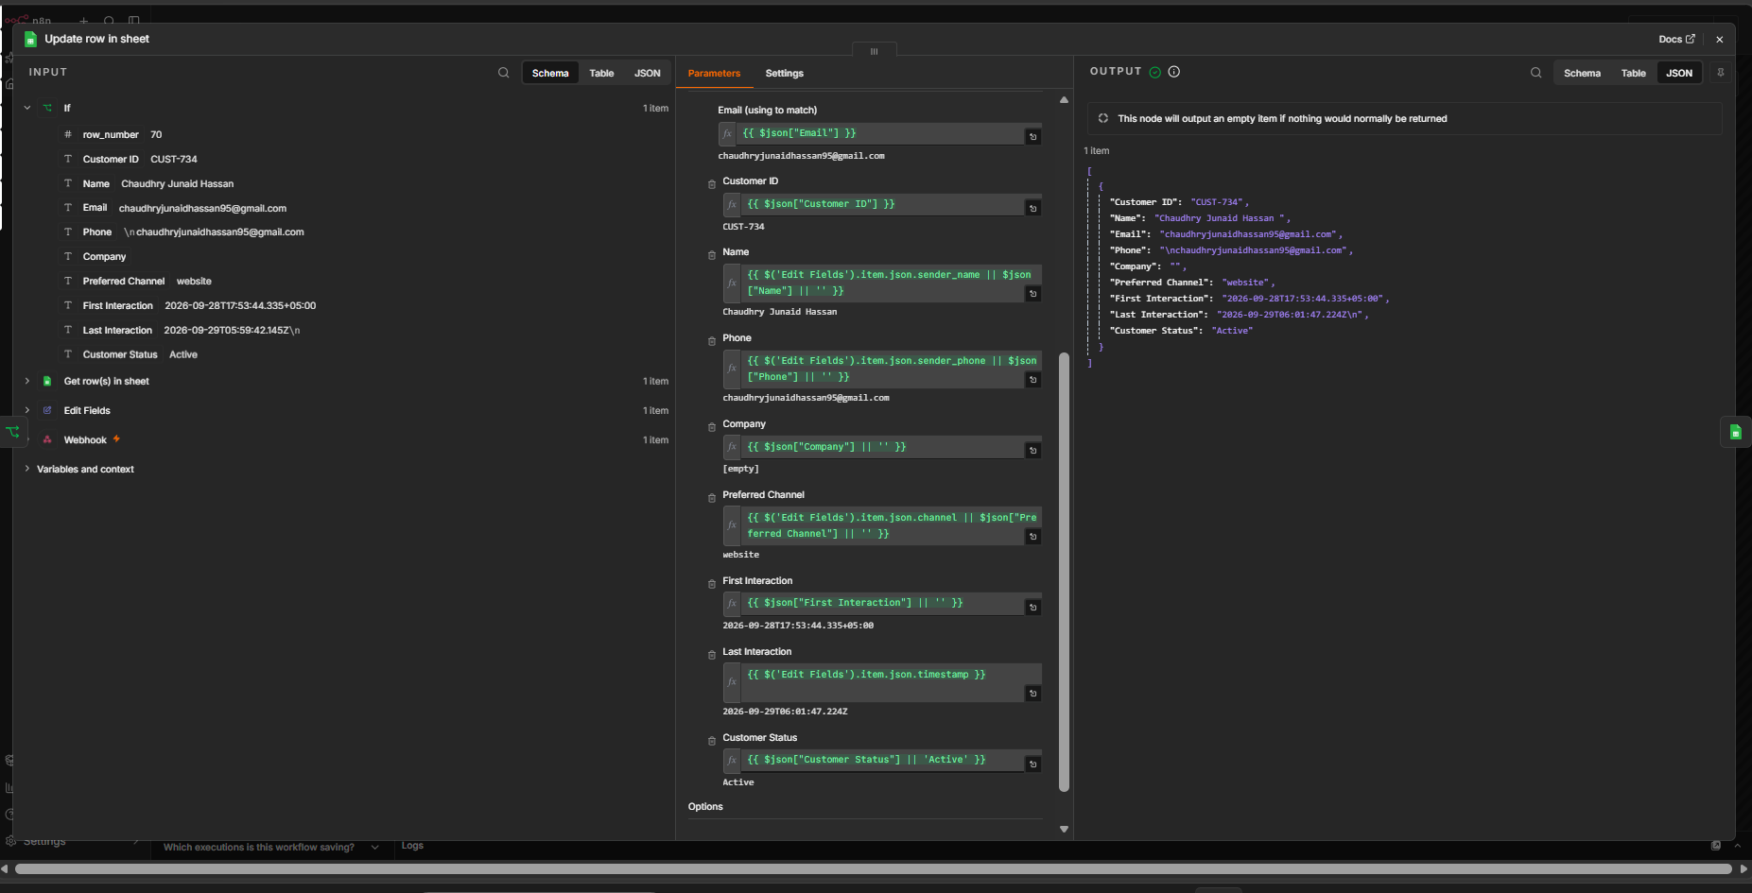
Screenshot 8 - Working CRM Update Row
Description: The Google Sheets Update Row node returns a customer object successfully. The screenshot shows Customer ID, Name, Email, Phone, Preferred Channel, First Interaction, Last Interaction and Customer Status after the update.
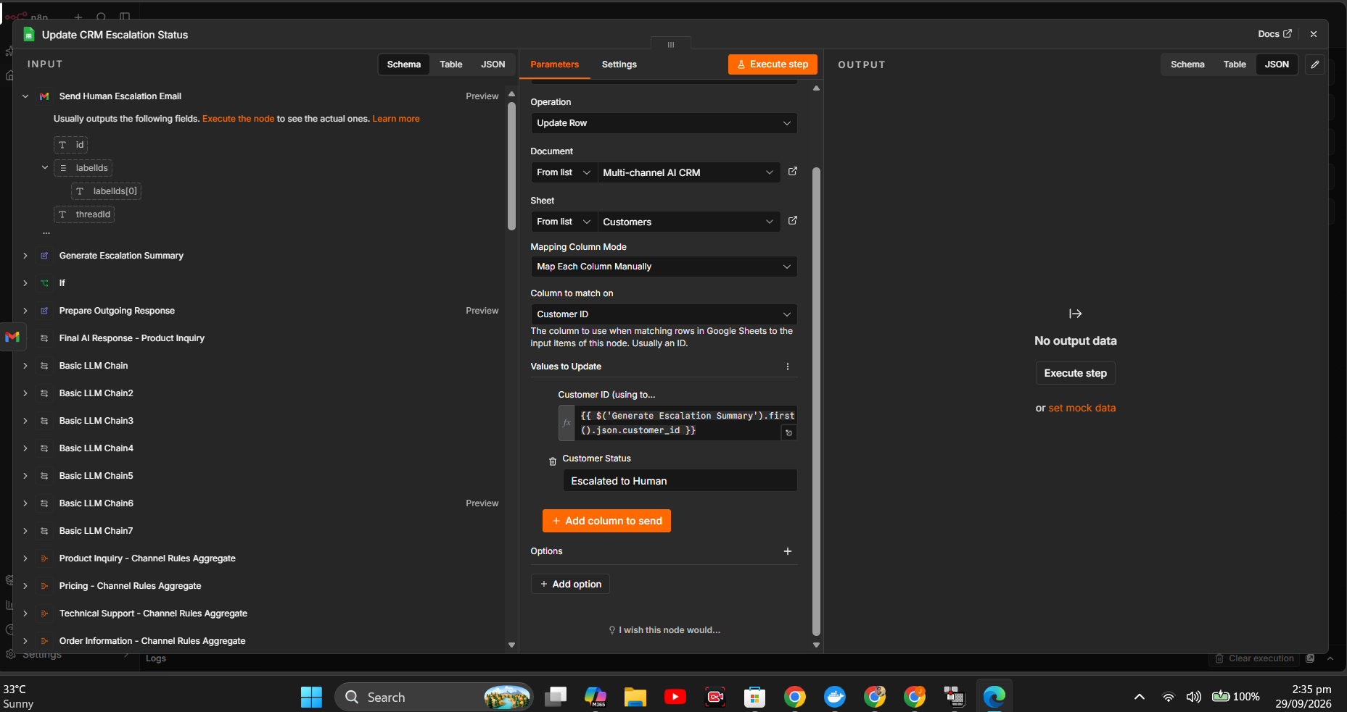
Screenshot 9 - CRM Escalation Status Configuration
Description: The escalation update is intentionally limited to the matching Customer ID and Customer Status = Escalated to Human. This avoids overwriting unrelated profile fields with blank values.

9. Cross-Channel History and Context
A major feature of the final agent is cross-channel continuity. Before calling the Central AI Brain, the workflow retrieves previous conversations for the Customer ID and builds a compact previous_context. That context is sent with the current message.
- Customer ID is the link between Website Chat, Email and WhatsApp.
- Get Previous Conversations filters stored conversation rows for the same customer.
- Build Previous Context formats recent messages into a compact history string.
- The Central AI Brain receives current message + identity + previous_context.
- Cross-channel test cases reuse the same fictional identity to verify continuity.
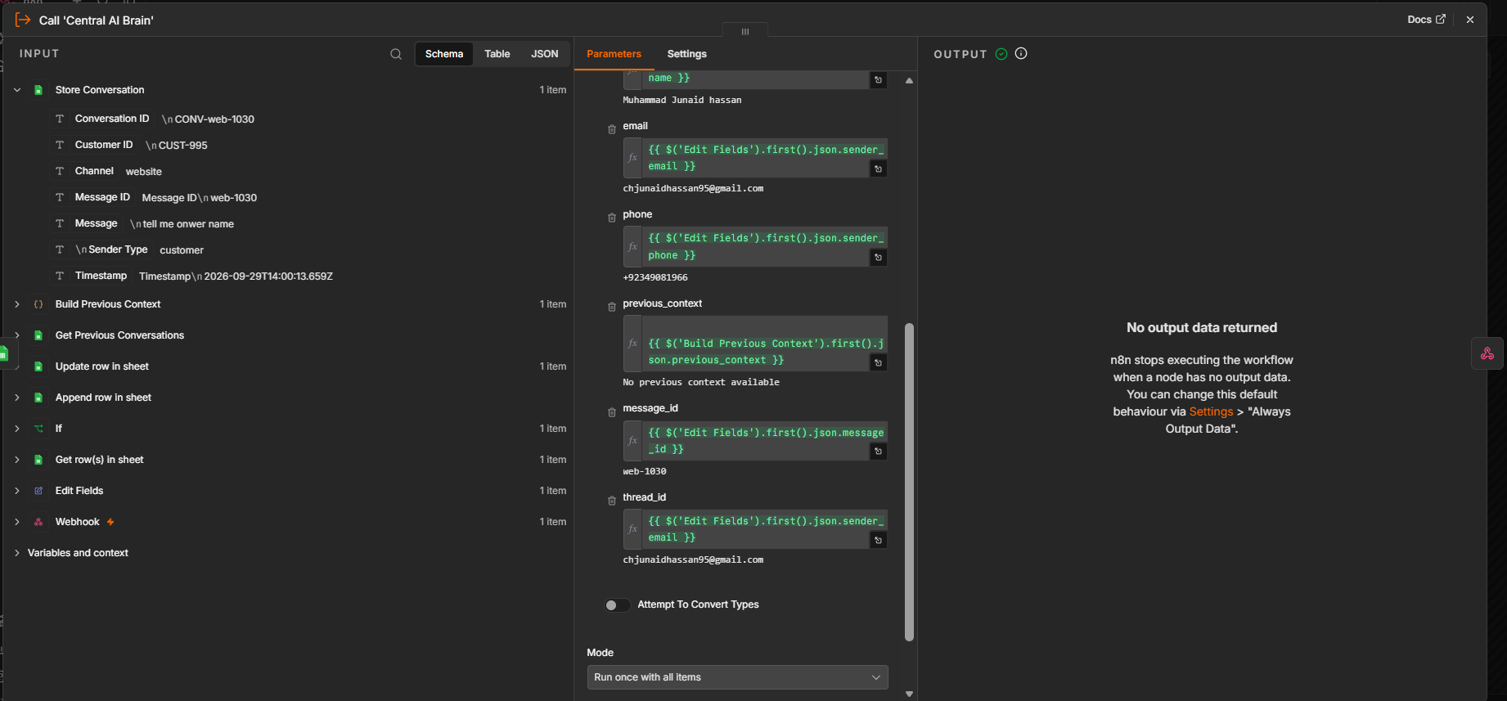
Screenshot 10 - Central AI Brain Input with Previous Context
Description: The screenshot shows customer_name, email, phone, previous_context, message_id and thread_id being mapped into the Central AI Brain. It also captures a no-output condition that was investigated during optimization.

10. Central AI Brain and Knowledge-Grounded Replies
All three channels share the same Central AI Brain. The AI layer identifies intent, decides whether human escalation is needed, uses knowledge-base information when available, prepares a channel-neutral response and returns structured fields to the parent workflow.
- Intent examples: Product Inquiry, Pricing, Technical Support, Complaint, General Question and Human Assistance.
- Decision data includes fields such as urgency, priority, risk level, confidence, response_type, human_escalation_required and conversation_state.
- Known information should come from the knowledge base; unknown services/products should produce a safe fallback instead of hallucinated facts.
- The same AI output is passed to the Channel Response Switch so the response can be delivered through the correct channel.
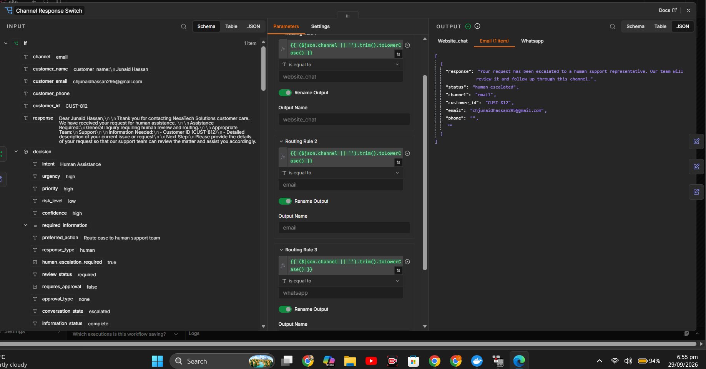
Screenshot 11 - Structured AI Decision + Channel Response Switch
Description: The left side shows structured AI decision data, including Human Assistance and human_escalation_required = true. The middle shows routing rules for website_chat, email and whatsapp. The right side shows the email branch returning a human-escalated response object.

11. Human Escalation and Safe Handoff
When the AI decision says human_escalation_required = true, the normal automated path changes into a controlled human-handoff path. The system prepares a summary, sends an internal escalation email, updates the CRM status and sends a safe customer-facing handoff message.
- Central AI Brain returns human_escalation_required = true.
- IF node sends the item to the escalation branch.
- Generate Escalation Summary prepares customer ID, name, channel, message and reason.
- Send Human Escalation Email notifies the support team.
- Update CRM Escalation Status changes the customer status to Escalated to Human.
- Human Handoff Response prepares the message the customer should receive.
- Channel Response Switch sends that handoff reply to Website, Email or WhatsApp.
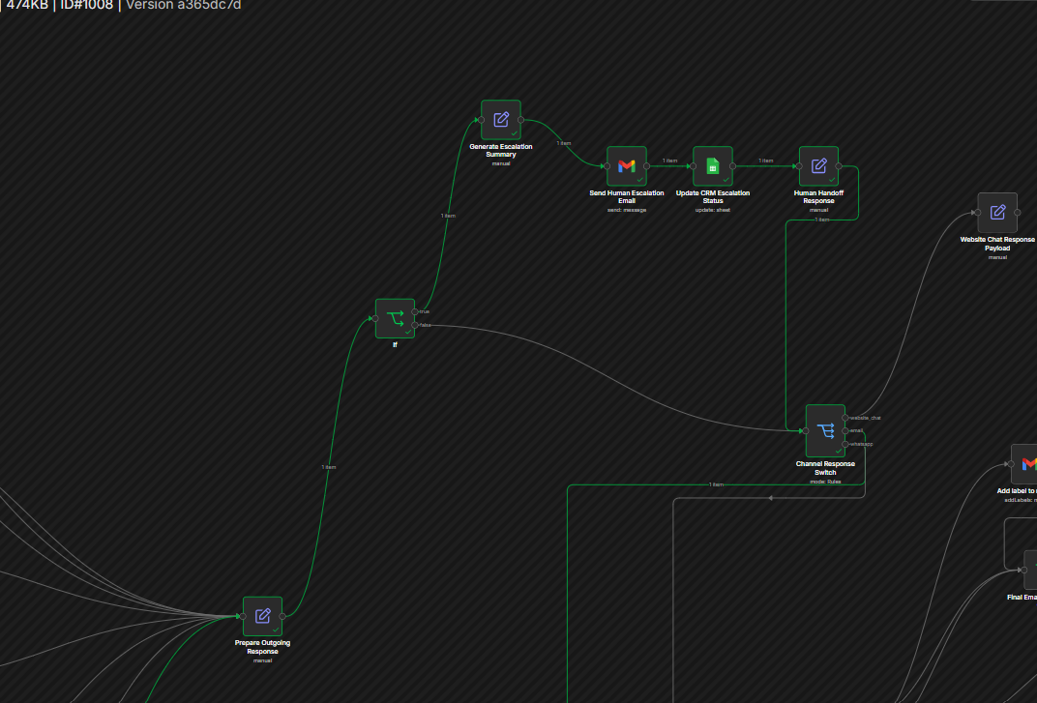
Screenshot 12 - Human Escalation Branch in the Final Workflow
Description: The branch shows IF -> Generate Escalation Summary -> Send Human Escalation Email -> Update CRM Escalation Status -> Human Handoff Response -> Channel Response Switch. This is the core safe-handoff design.

12. Optimization - Errors, Causes and Fixes
Phase 10 is also about stability. The project archive contains several important debugging cases. These errors are useful because they show what can break in a real automation and how the workflow was hardened.

12.1 No Output Data Returned from Sub-workflow
Symptom: the parent workflow reaches Call Central AI Brain, but the node returns no parent item. n8n can stop downstream execution when a node produces no output.
- Cause seen during debugging: one or more expected input fields or channel values were missing/undefined, or a sub-workflow branch did not return an item.
- Fix: correct parent input mappings (especially channel, message and customer_name), ensure a matching branch returns data, and use Always Output Data only where appropriate.
- Lesson: a sub-workflow can succeed internally but still break the parent flow if it returns nothing.
Screenshot 13 - No Output Data Returned
Description: This debugging screenshot shows the Central AI Brain call with mapped fields and n8n reporting No output data returned. It was used to identify missing/incorrect mapping and branch-return issues.

12.2 Boolean Type Error in Human-Escalation IF Node
Symptom: the IF node reports that true is a boolean but the condition expected a string. This happens when a boolean AI decision is compared using a text condition.
- Incorrect setup: treat human_escalation_required as text/string.
- Correct setup: use a Boolean condition such as is true.
- Lesson: structured AI output types must match the n8n condition type exactly.
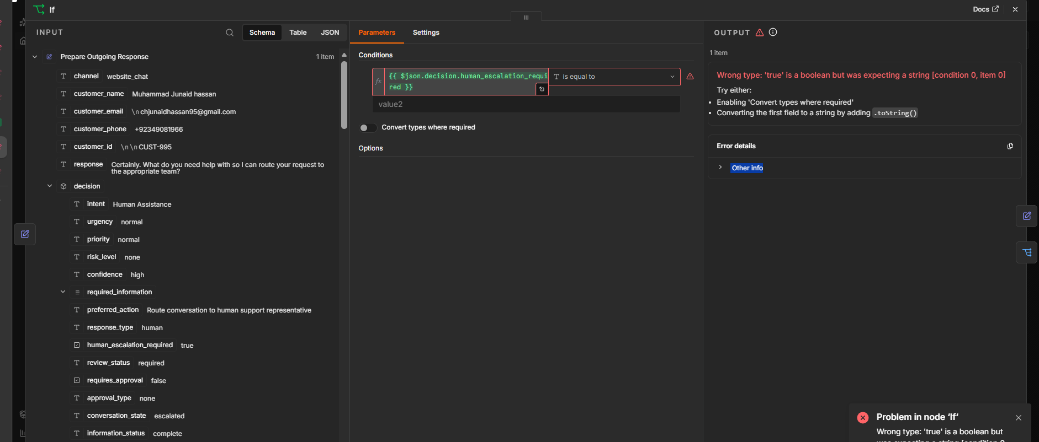
Screenshot 14 - Boolean Type Error During Escalation Testing
Description: The screenshot captures the IF-node type error for human_escalation_required. It clearly shows that the value is boolean true while the node was expecting a string.

12.3 External AI Provider / Service Unavailable
Symptom: Call Central AI Brain reports Service unavailable. This is not always a logic error in the workflow; external AI providers can temporarily fail, throttle requests, or reject a model.
- Retry after a short delay when the provider is temporarily unavailable.
- Keep workflow logic separated from provider availability so the failure can be diagnosed independently.
- Use controlled error handling or retry settings for production-style resilience.
- Never expose credentials or access tokens in final documentation.
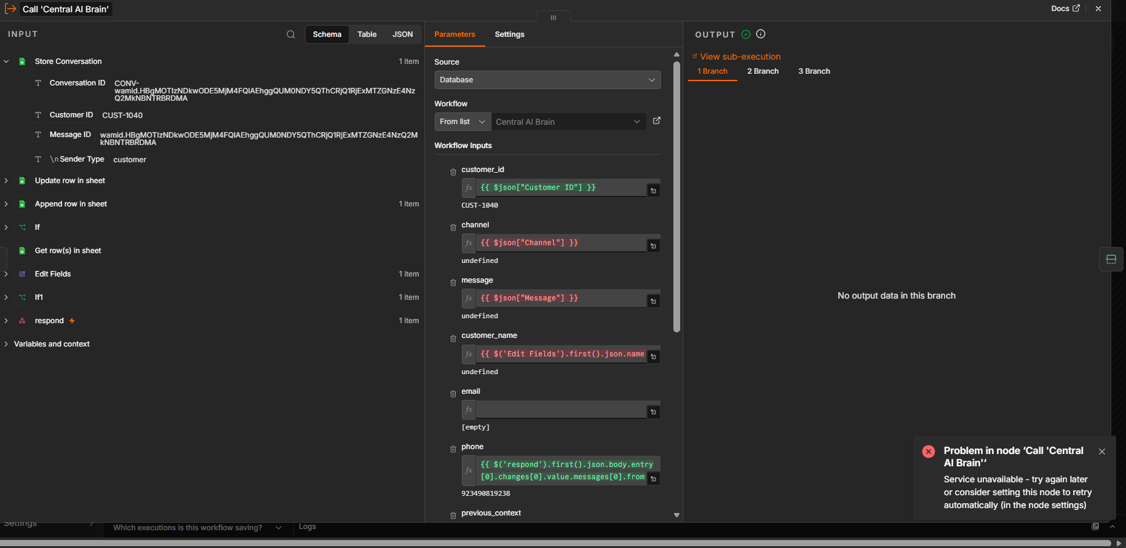
Screenshot 15 - Central AI Brain Service-Unavailable Error
Description: The node shows a provider/service-unavailable error while also exposing several undefined input mappings. This screenshot represents two checks: provider health and mapping correctness.

12.4 Google Sheets Update Mapping / Column-to-Match Error
Symptom: Google Sheets Update Row reports that Column to Match On is required. An update operation cannot identify which row to modify unless a stable matching field is configured.
- Select a stable match field such as Email or Customer ID.
- Map the matching value from the current item.
- Do not map blank values over existing customer data.
- After fixing the match field, the working screenshot shows the correct customer row returned with updated Last Interaction.
Screenshot 16 - Corrected CRM Update Producing Output
Description: After the Google Sheets mapping is corrected, the node returns the customer record. This demonstrates a successful update path with preserved profile values and refreshed interaction information.

12.5 Duplicate Response Paths
Another optimization lesson was avoiding duplicate customer replies. Parallel or duplicate response connections can make the same message send more than once.
- Keep one normal automated-response path.
- Keep one controlled human-escalation path.
- Route both through a single channel-response decision before sending.
- Check the final graph for accidental parallel connections to the same Send Message node.

13. Final Demonstration Procedure
A clean final demonstration should use one fictional customer across all three channels so the audience can see that the system is truly centralized.
- Start with Website Chat using a fictional customer such as Ali Khan. Ask a product/service question.
- Show that the message enters n8n, the customer profile is created or found, the conversation is stored and the Central AI Brain returns a grounded answer.
- Switch the same customer to Email and refer to the previous website conversation. Show that previous history is retrieved and used.
- Switch the same customer to WhatsApp and ask a follow-up question. Show the same Customer ID / profile context being reused.
- Send a direct human-support request. Show human_escalation_required = true, escalation summary generation, internal support email, CRM status update and customer handoff response.
- Open the n8n execution history and show a successful end-to-end run.
- Open Google Sheets to show the single centralized customer profile and the stored conversation history.
- Explain one or two Phase 10 debugging fixes to demonstrate reliability engineering, not only happy-path automation.
Security Rule
For presentation, never expose real API tokens, credentials, personal customer data or production secrets. Use fictional data and redacted credentials only.

14. Final Submission Checklist and Evidence
Checklist Item | Status / Note
Phase 10 requirements documented | Yes
30 fictional scenarios prepared | Yes - 10 Website + 10 Email + 10 WhatsApp
New + returning customer cases | Included
Cross-channel cases | Included
Unknown-knowledge safe fallback cases | Included
Human escalation cases | Included
Duplicate / incomplete identity cases | Included
Successful integrated execution screenshot | Included
CRM create/update proof | Included
Human escalation workflow proof | Included
Error / optimization proof | Included
Actual Result / PASS-FAIL for all 30 cases | Not shown as completed in archived master document
Final three-channel demo recording | Should be recorded for presentation/portfolio if required

Appendix A - Internship Completion Evidence
These final documents are included as internship completion evidence and are separate from the technical Phase 10 screenshots.
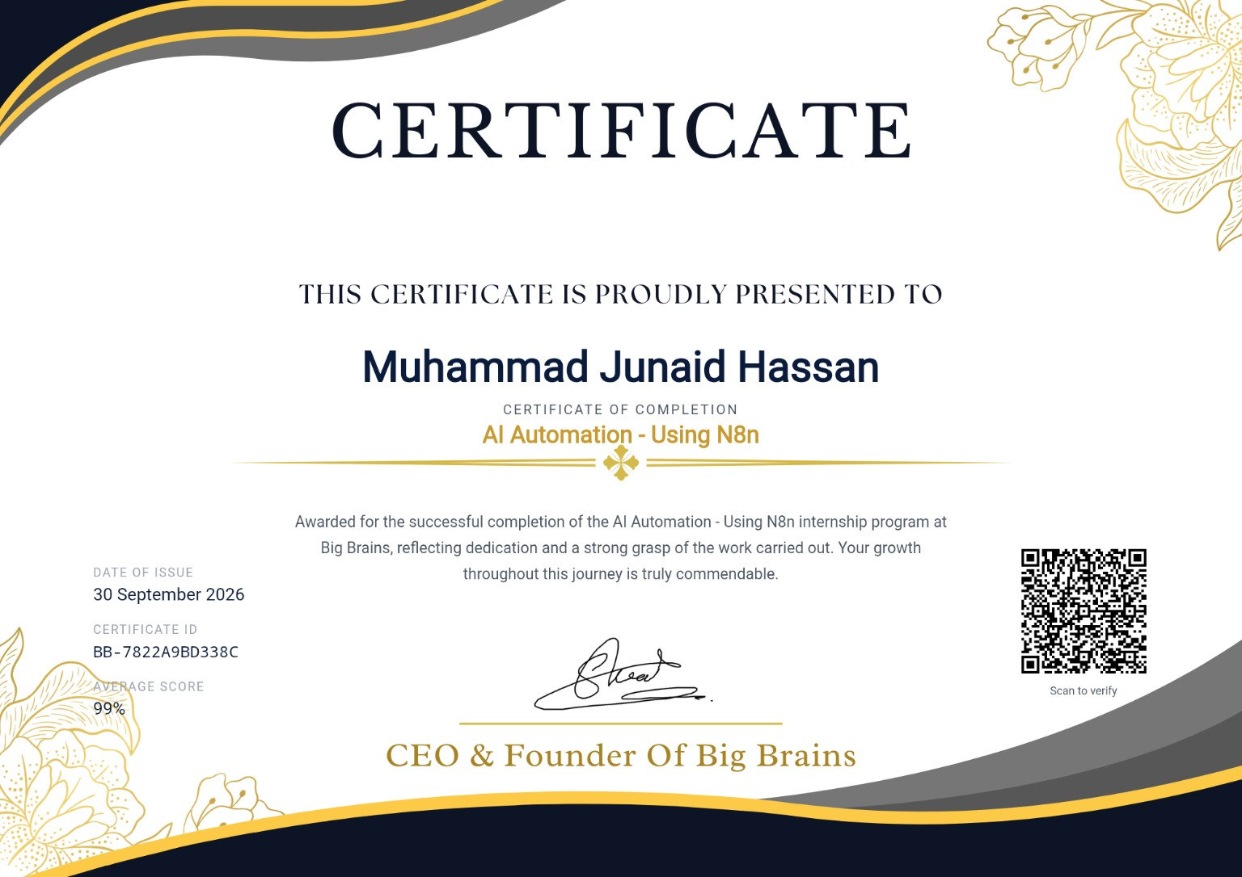
Appendix Screenshot A1 - Big Brains AI Automation Internship Certificate
Description: Certificate of completion for AI Automation - Using n8n, issued on 30 September 2026.
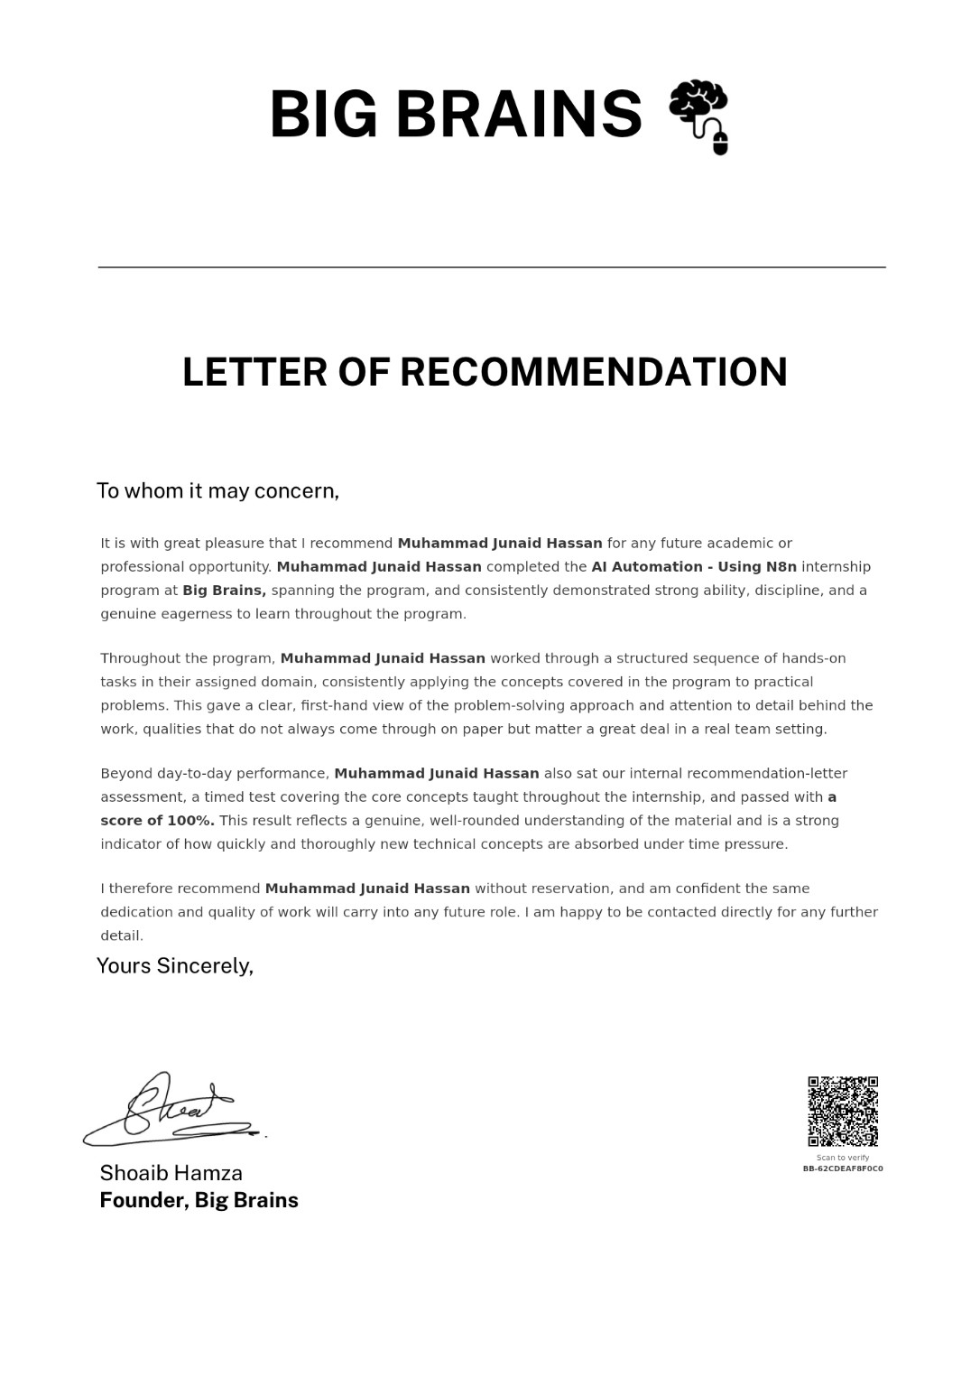
Appendix Screenshot A2 - Big Brains Letter of Recommendation
Description: Recommendation letter describing completion of the AI Automation - Using n8n internship and the learner’s hands-on task performance.

Final Phase 10 Summary
Phase 10 turns the project from a set of workflows into a documented, testable automation system. The key value of the final project is the centralized design: Website Chat, Email and WhatsApp all share one customer profile, one conversation history, one AI decision layer and one escalation system.
- The architecture is integrated across all three channels.
- CRM identity matching and update logic are working in captured executions.
- Cross-channel context is built before the Central AI Brain.
- Structured AI decisions control routing and human escalation.
- Human escalation includes support notification, CRM status update and customer handoff.
- Phase 10 records important engineering fixes for no-output, type, mapping, duplicate-response and provider errors.
- The 30-case QA matrix gives a complete validation plan; archived evidence should be updated with actual result and PASS/FAIL values after each real run if a fully executed matrix is required.
Portfolio Summary
Final project statement: A centralized multi-channel AI Agent built in n8n for Website Chat, Email and WhatsApp, with Google Sheets CRM, cross-channel context, Central AI Brain, knowledge-grounded responses, channel routing and safe human handoff.

