This is a chirograph by UNCOPIED with 5 parts (CENTER,TOP,BOTTOc,LEFT,RIGHT):

-1 Print it on quality 100+ gram paper (ex. C by Clairfontaine recommended https://uncopied.art/blog/papers or other ISO-9706).

-2 Cut it using scissors into 5 parts along the blue lines (slight imperfections are OK, make it unique and tamper-proof).

-3 Optionally, add your own identical physical mark or signature to each of the 5 parts (without corrupting the QR Codes).

-4 Glue its CENTER part to the back of your painting or limited edition print (ex. 3c recommended https://uncopied.art/blog/glues).

**PrimaryLinkURL**

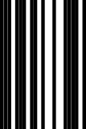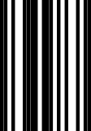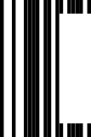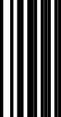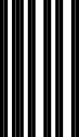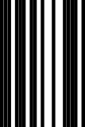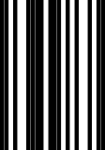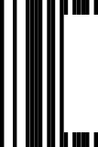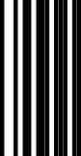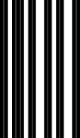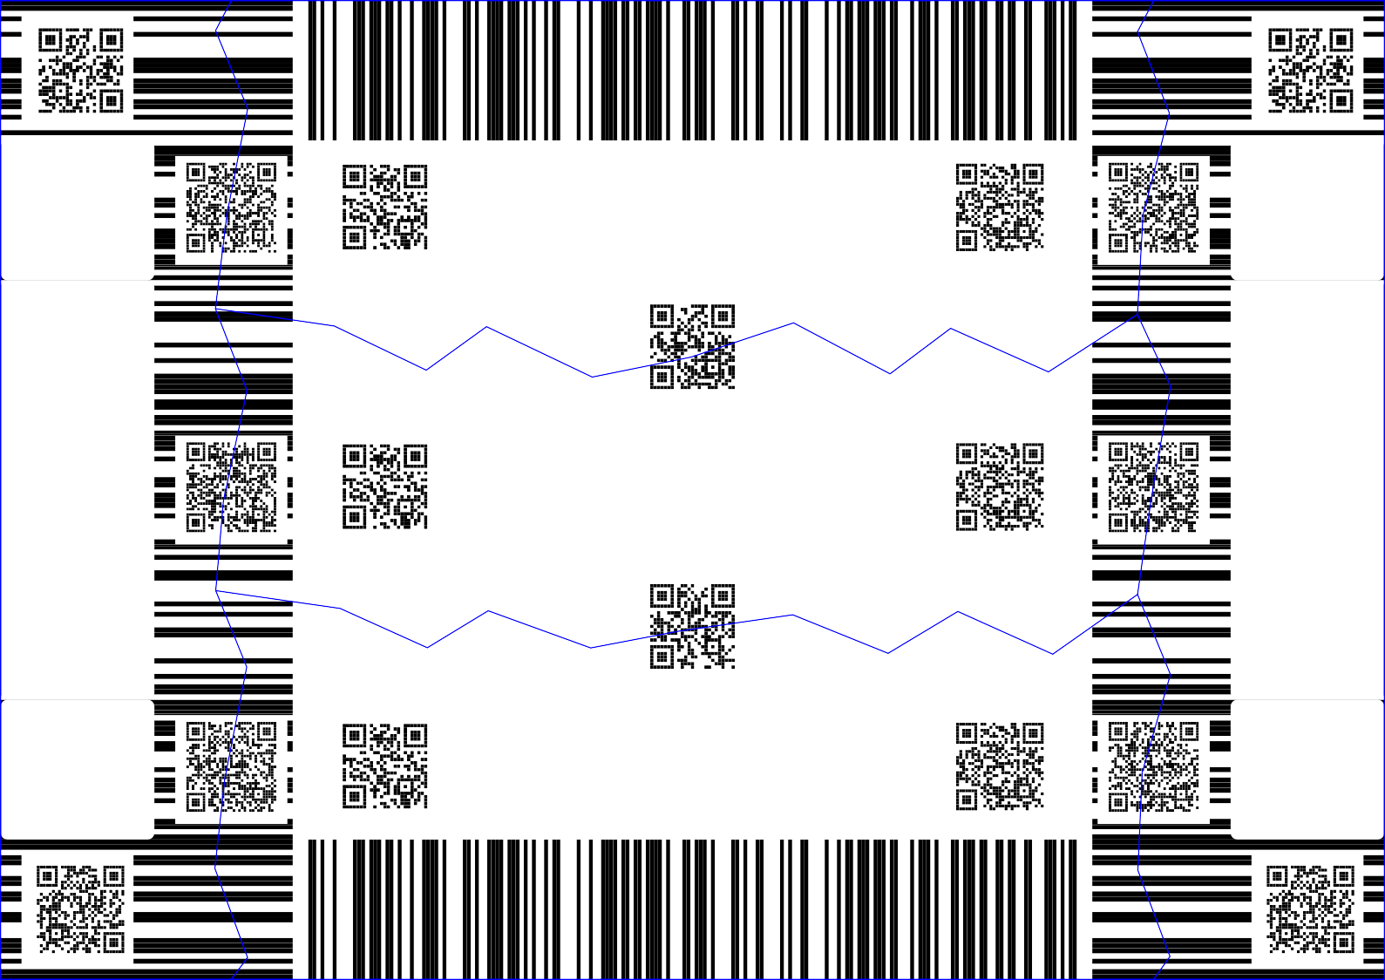

**cailToContentRight**

**cailToContentLeft**

Bonjour la France!

**SecondaryLinkURL**

**PrimaryLinkURL**

Bonjour la France!

Bonjour la France!

Bonjour la France!

**SecondaryLinkURL**

**PrimaryLinkURL**

**cailToContentLeft**

Bonjour la France!

**cailToContentRight**

Please, do not forget to send this RIGHT part by post. We will activate the digital certificate within 3 days of receiving the physical copy in our PO Box. The RIGHT part will be archived by a third party.

Please, do not forget to send this LEFT part by post. We will activate the digital certificate within 3 days of receiving the physical copy in our PO Box. The LEFT part will be archived by UNCOPIED internally.

**SecondaryLinkURL**

-5 Glue the other 4 parts to each 4 copies of the legal documentation (make sure labels correspond).

-6 Retain one copy of the legal document (the one with the TOP chirograph part).

-7 Send one copy of the legal document to the other contracting party (the one with the BOTTOc chirograph part).

-8 Send the other two copies of the legal documents to UNCOPIED PO Box by post (the ones with LEFT and RIGHT chirograph parts).