# Technical note on critical minerals

# Supply chains, trade flows and value addition

# Introduction

The move towards a low-carbon future is well underway and has brought to the fore the importance of several minerals judged critical to this process. These minerals include lithium, cobalt, graphite, manganese, and others essential to producing clean energy technologies, including solar panels, wind turbines, rechargeable batteries for electric vehicles (EVs), and grid battery storage. Developing countries hold large reserves of these minerals. African countries, for example, have about 25 per cent of global reserves, including 19 per cent of those needed for EVs.[1]

Many developing countries are already playing a vital role in supplying world markets, such as the Democratic Republic of the Congo, from where 68 per cent of cobalt imports originate, Chile, a significant lithium exporter, and Indonesia, which accounts for 48 per cent of nickel exports.[2] Since 2010, the typical quantity of minerals required for each new unit of power generation has risen by 50 per cent due to the growing proportion of renewables in total energy production.[3] Demand for some critical minerals is expected to increase rapidly in a Net Zero Emissions scenario: by 115 per cent for cobalt and 454 per cent for lithium in the period from 2022 to 2030.[4] With increased demand, the number of new critical minerals projects announced across 2021 and 2022 was more than twice the level of the previous decade.[5]

The type and volume of critical minerals needed for the energy transition vary with specific applications and industries. For example, lithium, cobalt, and graphite are commonly used in lithium-ion batteries that are considered most suitable for EVs.[6] Raw critical minerals are processed and refined to increase purity, enhance their performance characteristics, and increase suitability for specific applications. The processed and refined critical materials enjoy significantly higher values than those in their raw form and can stimulate the development of related downstream industries in the mineral-producing developing countries.

This technical note presents a snapshot of the trade dynamics of the critical minerals and critical-mineral-based products in different processing stages of rechargeable lithium-ion batteries for EVs. The note highlights specific characteristics of critical mineral markets, which indicate the areas for more in-depth analysis to support mineral-producing developing countries in increasing domestic value addition in rechargeable battery value chains.

# Data and methodology

The assessment in this technical note uses bilateral trade data from UN Comtrade using the Harmonized System (HS) product classification at the 6-digit level. It uses Sankey flow diagrams to visualize the bilateral (i.e., country-to-country) trade flows of the selected critical minerals and minerals-based products at different processing stages.

The processing stages in this analysis are defined as follows: (i) the **extraction** stage where minerals underwent only initial beneficiation; (ii) the **processing** or refining stage where minerals underwent a chemical or metallurgical process to become refined minerals; (iii) the **manufacturing** stage where the refined minerals are processed to form battery materials based on those minerals (e.g., cathodes, anodes) and incorporated to produce battery cells and battery packs, many of which are for electric vehicles.

The diagrams presented in this note have the following characteristics:

1. Each line connects the exporting country on the left and the importing country on the right of the product concerned at each processing stage;
2. In the diagrams focusing on the amount traded, the width of the lines is proportional to the value of each bilateral flow in United States dollars. On the other diagrams highlighting concentration of exports, the width of the lines is proportional of the share of the bilateral trade in total exports;
3. The top three exporting countries and the top three destinations of their exports are presented in the diagrams; and
4. Using countries as “nodes”, a Sankey diagram at one processing stage (e.g., the extraction stage) is connected to the trade flows at the next processing stage (e.g., the processing stage).

Based on a literature review, the analysis identifies the HS codes for the products associated with each processing stage of the selected critical minerals (Table 1). Using the HS Codes, the analysis provides the world trade values of products at each processing stage and the unit value estimated from the reported trade value and quantity.[7]

**Table 1. The product classification of selected critical mineral products at different processing stages**

|  |  |  |  |
| --- | --- | --- | --- |
|  | **Lithium** | **Cobalt** | **Graphite** |
| **Raw minerals or minerals that underwent only initial beneficiation** | Lithium ores and concentrates, and lithium carbonate  HS Codes:  253090 - Arsenic sulfides, alunite, pozzuolana, earth colours and other mineral substances, n.e.s.  283691 - Lithium carbonates | Cobalt ores and concentrates  HS Codes:  260500 - Cobalt ores and concentrates | Graphite flakes and raw material for manufacturing artificial graphite  HS Codes:  250410 - Natural graphite in powder or in flakes 271312 - Petroleum coke, calcined 270810 - Pitch obtained from coal tar or from other mineral tars |
| **Processed minerals** | Lithium processed and/or refined raw materials  HS Codes:  282520 - Lithium oxide and hydroxide  282739 - Chlorides (excl. ammonium, calcium, magnesium, aluminium, nickel, and mercury chloride)  282690 - Fluorosilicates, fluoroaluminates and other complex fluorine salts (excl. sodium hexafluoroaluminate "synthetic cryolite" and inorganic or organic compounds of mercury)  282619 - Fluorides (excl. of aluminium and mercury) | Cobalt processed and/or refined raw materials  HS codes:  282200 - Cobalt oxides and hydroxides; commercial cobalt oxides  810520 - Cobalt mattes and other intermediate products of cobalt metallurgy; unwrought cobalt; cobalt powders | Artificial graphite  HS code:  380110 - Artificial graphite (excl. retort graphite, retort carbon and goods of artificial graphite, incl. refractory materials based on artificial graphite) |
| **Battery materials** | Lithium cathode materials  HS codes:  284290 - Salts of inorganic acids or peroxoacids, incl. aluminosilicates whether chemically defined (excl. of oxometallic or peroxometallic acids and azides, and inorganic or organic compounds of mercury)  284169 - Manganites, manganates, and permanganates (excl. potassium permanganate)  382499 - Chemical products and preparations of the chemical or allied industries, incl. those consisting of mixtures of natural products, n.e.s. | Cobalt cathode materials  HS codes:  284190 - Salts of oxometallic or peroxometallic acids (excl. chromates, dichromates, peroxochromates, manganites, manganates, permanganates, molybdates and tungstates "wolframamtes")  285390 - Phosphides, whether chemically defined (excl. ferrophosphorus); inorganic compounds, incl. distilled or conductivity water and water of similar purity, n.e.s.; liquid air, whether rare gases have been removed; compressed air; amalgams (excl. amalgams of precious metals) | Graphite cathode materials  HS codes:  854519 - Electrodes of graphite or other carbon, for electrical purposes (excl. those used for furnaces) |
| **Battery packs** | Cell components of batteries and battery packs  HS Codes:  850790 - Plates, separators, and other parts of electric accumulators, n.e.s.  850760 - Lithium-ion accumulators (excl. spent) | | |
| **Electric vehicles** | Electric and plug-in hybrid vehicles  HS Codes:  870240 - Motor vehicles for the transport of >= 10 persons, incl. driver, with only electric motor for propulsion  870360 - Motor cars and other motor vehicles principally designed for the transport of <10 persons, incl. station wagons and racing cars, with both spark-ignition internal combustion reciprocating piston engine and electric motor as motors for propulsion, capable of being charged by plugging to external source of electric power (excl. vehicles for travelling on snow and other specially designed vehicles of subheading 870310)  870370 - Motor cars and other motor vehicles principally designed for the transport of <10 persons, incl. station wagons and racing cars, with both diesel engine and electric motor as motors for propulsion, capable of being charged by plugging to external source of electric power (excl. vehicles for travelling on snow and other specially designed vehicles of subheading 870310)  870380 - Motor cars and other motor vehicles principally designed for the transport of <10 persons, incl. station wagons and racing cars, with only electric motor for propulsion (excl. vehicles for travelling on snow and other specially designed vehicles of subheading 870310) | | |

*Source*: UNCTAD based on data from UN Comtrade.

The analysis comes with a certain caveat. First, the diagrams in the note do not represent the actual supply chains of renewable batteries. Some countries may be significant producers of a certain critical mineral but may not export them to the world, or some countries may have a domestic supply chain through which everything is produced or processed. Such information on local production is not included in the analysis. Second, lithium, cobalt and graphite have various applications apart from their use in batteries. For example, lithium can be used in glass and ceramic manufacturing, lubricating greases, and pharmaceutical production and medical devices. Lithium-ion batteries themselves are used in numerous electronic devices apart from EVs. The battery materials and battery packs in the diagrams thus include those that are used in appliances other than electric and plug-in hybrid vehicles.

# Trade flows of critical minerals

## Lithium

Lithium is a soft silvery metal with the lowest density of all metals. It does not occur as a metal in nature but is found in hard rock forms, or in brine deposits as lithium chloride salts. Although found in many rocks and several natural brines, commercial exploitation of lithium is only possible in a few deposits with high concentrations that make exploitation economically feasible.[8] Lithium ore or brine are used to manufacture lithium hydroxide and lithium carbonate, which are essential in producing battery cathodes.

Figure 1 illustrates bilateral trade flows of lithium and lithium-based products of the year 2022, highlighting the major bilateral trade flows in United States dollars in each processing stage. The graph illustrates the high values of trade of the raw mineral and also of the cell components and battery packs. Figure 2 shows the same trade flows but the widths of these flows represent the share of the bilateral trade in total exports in each processing stage. The graph highlights the concentration of trade in the upstream part of the value chain.

**Figure 1. Lithium trade flows along the EV value chain, 2022 (United States dollars)**

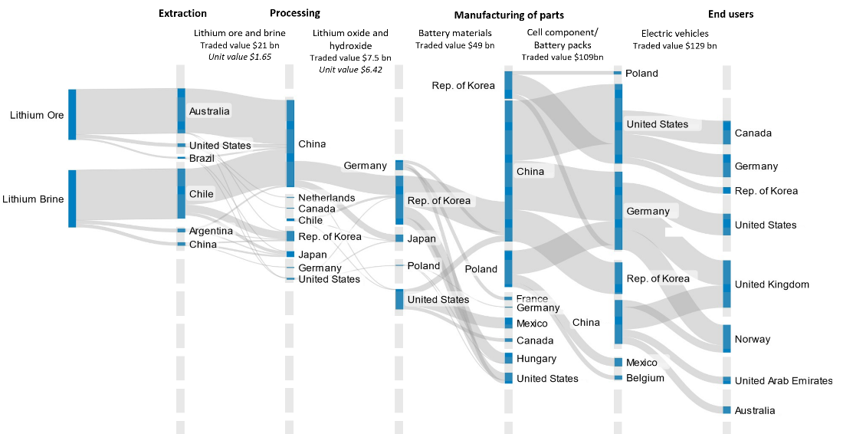

Source: UNCTAD secretariat calculations based on data from UN Comtrade.

Note: The figure shows trade between countries in terms of exports and imports, but it does not provide information on local production within individual countries. The trade data are as reported in the following 6-digit level HS Codes : 253090, 283691 (Lithium ores and concentrates, and lithium carbonate); 282520, 282739; 282690; 282619 (processed and/or refined raw materials); 284290, 284169, 382499 (lithium cathode materials); 850790, 850760 (Cell components of batteries and battery packs; and 870240, 870360, 870370, 870380 (Electric and plug-in hybrid vehicles). Unit value is calculated from the reported trade value and quantity.

**Figure 2. Share of lithium trade flow to total export value along the EV value chain, 2022 (percentage of total exports)**

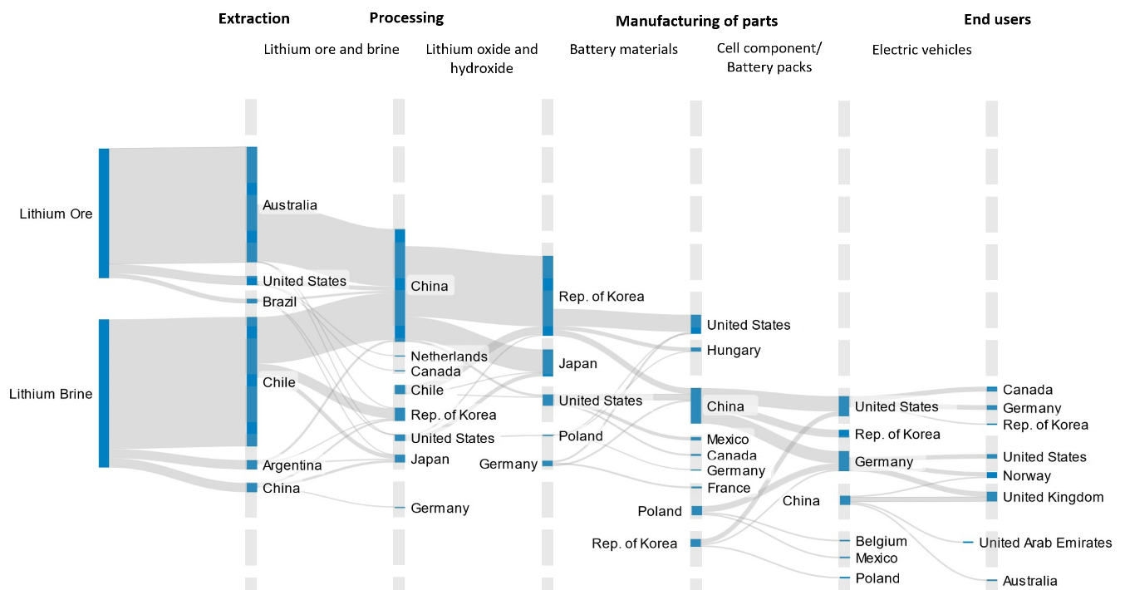

Source: UNCTAD secretariat calculations based on data from UN Comtrade.

Note: The figure shows the share of trade to total export value at each stage of the value chain. This is based on trade data as reported in the following 6-digit level HS Codes: 253090, 283691 (Lithium ores and concentrates, and lithium carbonate); 282520, 282739; 282690; 282619 (processed and/or refined raw materials); 284290, 284169, 382499 (lithium cathode materials); 850790, 850760 (Cell components of batteries and battery packs; and 870240, 870360, 870370, 870380 (Electric and plug-in hybrid vehicles). The first node represents the share of exports of the main exporting countries of raw material.

At the extraction stage, Australia and Chile account for more than 79 per cent of lithium ore and brine exports, and China imports over 73 per cent of lithium traded in the world. Australia, the world's largest exporter of spodumene (lithium ore), had relatively little lithium hydroxide refining capacity in 2022. The country is planning to reach about 10 per cent of global lithium refining capacity by 2024.[9] Chile, the largest exporter of lithium brine, has a refining capacity and is a major exporter of lithium hydroxide. Lithium mining is dominated by Chilean, Chinese, United States and Australian firms, which control a combined 53 per cent of global lithium production.[10]

The diagrams show that China, Republic of Korea, Japan, and other developed countries enjoy the majority of lithium refining capacity. However, Argentina, which accounts for 10 per cent of lithium processing in the world,[11] is not included in the diagram because it exports only a negligible amount of refined lithium.

The diagrams also highlights that China, which accounts for 67 per cent of global exports of lithium oxide and hydroxide at the processing stage, seems to keep lithium-based battery materials for the domestic manufacturing of battery packs. While China’s export of battery materials to the world is small, it imports these products from the Republic of Korea and the United States. China then exports battery packs to countries that are major exporters of EVs, including the United States and Germany. China accounted for46 per cent of the global exports of battery packs in 2022. China’s domestic value addition in the battery value chain is significant: the estimated unit value increases from $6.4 per kilogram for lithium hydroxide to $150 for a battery pack.[12]

Poland was the second largest exporter of battery packs in 2022 but does not have significant mining capacity for lithium-ion battery materials, instead obtaining these materials through trade.[13] Poland imports lithium oxide and hydroxide mainly from the United States (68 per cent) and China (18 per cent), and Lithium cathode materials mostly from China (55 per cent) and Germany (17 per cent).

## Cobalt

Cobalt a critical component in the production of rechargeable battery electrodes as it helps maintain thermal stability - a significant safety issue. It also enables batteries to store and transfer more energy. Cobalt is mainly mined as a byproduct of nickel and copper from both underground and surface mining. The ore is refined using both pyrometallurgical and hydro-metallurgical techniques to obtain intermediate products such as cobalt hydroxide, cobalt metals, and other chemicals. This is further refined to cobalt sulphate, which is used in manufacturing cathodes for batteries, super alloys, and magnets.

Figure 3 illustrates cobalt trade dynamics in the lithium-ion battery value chain focusing on the value traded by the top exporters in each processing stage. Figure 4 shows the same trade flows but represents the shares traded. As in the case of lithium trade flows, the diagrams illustrate the high values traded in the downstream segments of the value chain (Figure 3) and the high concentration of trade in the upstream stages (Figure 4).

**Figure 3. Cobalt trade flows along the electric vehicle value chain, 2022 (United States dollars)**

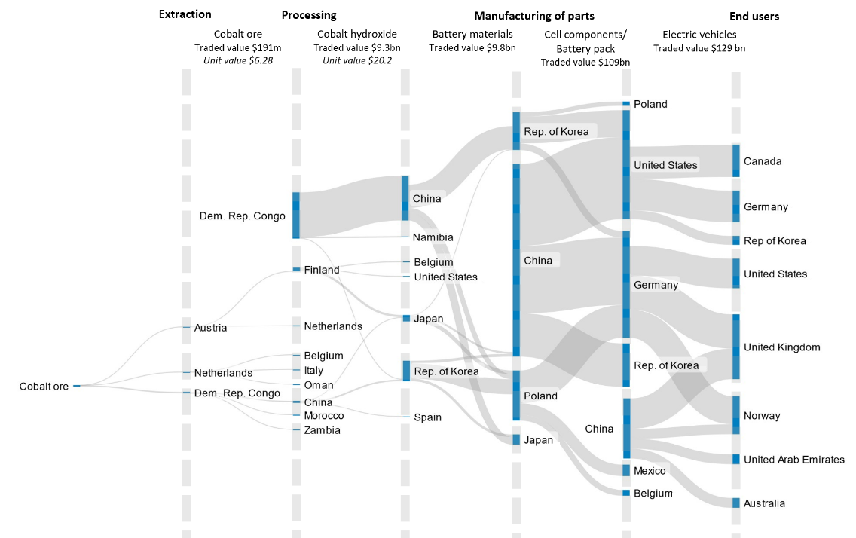

Source: UNCTAD calculations based on data from UN Comtrade.

Note: The figure shows trade between countries in terms of exports and imports, but it does not provide information about local production within individual countries. The trade data are as reported in the following 6-digit level HS Codes: 260500 (cobalt ores and concentrates); 282200, 810520 (processed and/or refined raw materials); 284190, 285390 (cobalt cathode materials); and 850790, 850760 (cell components of batteries and battery packs); and 870240, 870360, 870370, 870380 (Electric and plug-in hybrid vehicles). Unit value is calculated from the reported trade value and quantity. The focus of this note is the trade flows of select critical minerals along the electric vehicle value chain, thus the last two stages in the figure (corresponding to cell components and EVs) are the same as in Figure 1.

**Figure 4. Share of cobalt trade flow to total export value along the EV value chain, 2022 (percentage of total exports)**

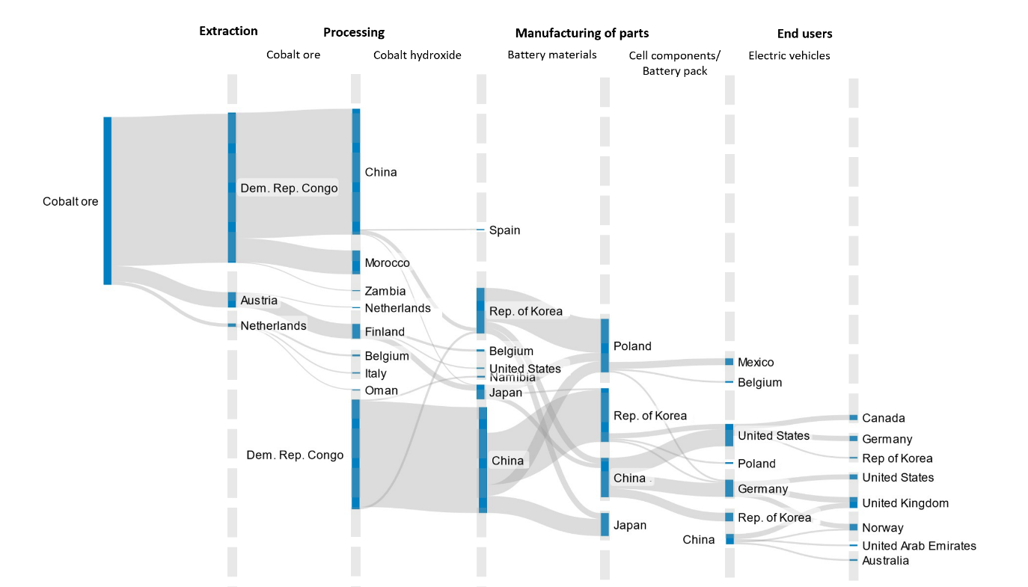

Source: UNCTAD secretariat calculations based on data from UN Comtrade.

Note: The figure shows the share of trade to total export value at each stage of the value chain. This is based on trade data as reported in the following 6-digit level HS Codes: 260500 (cobalt ores and concentrates); 282200, 810520 (processed and/or refined raw materials); 284190, 285390 (cobalt cathode materials); and 850790, 850760 (cell components of batteries and battery packs); and 870240, 870360, 870370, 870380 (Electric and plug-in hybrid vehicles). The first node represents the share of exports going to the main exporting countries of raw material.

In 2022, the cobalt ore market was valued at US$ 191 million, while cobalt hydroxide reached US$ 9.3 billion. The high price of cobalt compared to the other critical minerals is largely attributed to the geographical concentration of its supply. Cobalt mining is dominated by a few major companies, with the top five alone accounting for 48 per cent of global cobalt production.[14]

One bilateral trade relation dominates the refining stage: the Democratic Republic of the Congo, which produces about 70 per cent of cobalt ore worldwide, accounted for 64 per cent of the global cobalt hydroxide exports in 2022, of which 96 per cent was directed to China. This suggests significant value addition taking place within the Democratic Republic of the Congo. The country's processing and refining activities significantly increased the unit price of cobalt from US$ 5.8 per kilogram at the extraction stage to US$ 16.2 per kilogram at the processing/refining stage.[15]

The trade in the manufacturing stage is dominated by countries that are members of the Organization of Economic Cooperation and Development (OECD). No country from Africa or Latin America is a major participant in trade of manufacturing cathodes[16] or battery materials.

At the manufacturing stage, China accounts for about 49 per cent of the exports of cobalt-based battery material (cobalt cathode), in stark contrast to lithium-based battery material which China exported negligibly. The Republic of Korea is the second largest exporter of cobalt-based battery materials, with 31 per cent of global exports, followed by Japan with 9 per cent. Poland is the main importer of cathode materials from the Republic of Korea and Japan, and the third largest importer from China.

## Graphite

Graphite is the most used anode material in lithium-ion battery manufacturing because it provides stability, electrical conductivity, and lightweight properties, all of which enhance the battery’s overall performance and energy storage capacity. Graphite is mined from ores, but different from other minerals critical for the energy transition, graphite can also be manufactured from intensive heat treatment of petroleum coke, coal-tar pitch, or oil, which makes production more carbon intensive.[17] Both types of graphite are used in manufacturing anodes in battery devices. However, natural graphite has an advantage over synthetic graphite because purified natural flake graphite exhibits a much higher crystalline structure and is, therefore, more electrically and thermally conductive.[18] In addition, natural graphite is more cost-effective and has a lower carbon footprint. However, synthetic anodes perform better in electrolyte compatibility, fast charge turn around and battery longevity.[19]

Figure 5 represents trade patterns of graphite along the electric vehicle value chain highlighting the value in each bilateral trade flow. Figure 6 shows the same trade flows but the widths of these flows represent the share of trade in total exports in each processing stage.

**Figure 5. Graphite trade flows along the electric vehicle value chain, 2022 (United States dollars)**

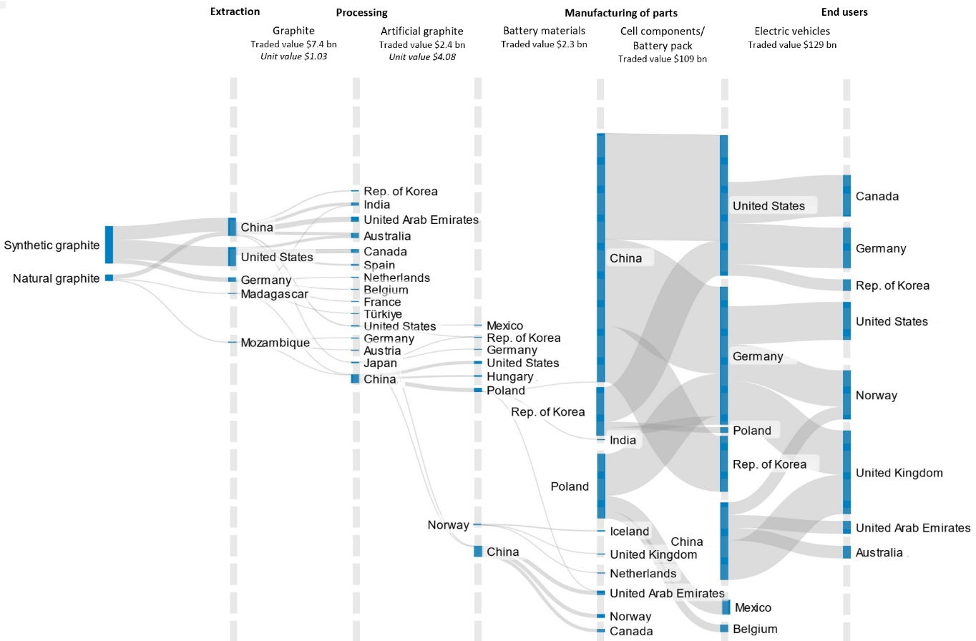

Source: UNCTAD calculations based on data from UN Comtrade.

Note: The figure shows trade between countries in terms of exports and imports, but it does not provide information about local production within individual countries. The trade data are as reported in the following 6-digit level HS Codes: 250410 (graphite flakes) 271312, 270810, (raw material for manufacturing artificial graphite); HS 380110 (artificial graphite), HS 854519 (graphite cathode materials); HS 850790, HS 850760 (cell components of batteries and battery packs); and 870240, 870360, 870370, 870380 (Electric and plug-in hybrid vehicles). Unit value is calculated from the reported trade value and quantity. The focus of this note is the trade flows of select critical minerals along the electric vehicle value chain, thus the last two stages in the figure (corresponding to cell components and EVs) are the same as in Figures 1 and 2.

**Figure 6. Share of graphite trade flow to total export value along the EV value chain, 2022 (percentage of total exports)**

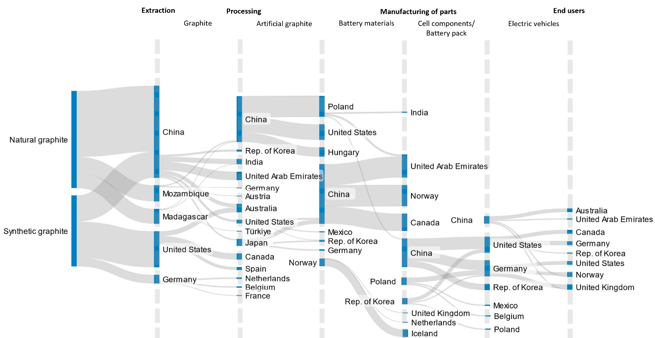Source: UNCTAD secretariat calculations based on data from UN Comtrade.

Note: The figure shows the share of trade to total export value at each stage of the value chain. This is based on trade data as reported in the following 6-digit level HS Codes: 250410 (graphite flakes) 271312, 270810, (raw material for manufacturing artificial graphite); HS 380110 (artificial graphite), HS 854519 (graphite cathode materials); HS 850790, HS 850760 (cell components of batteries and battery packs); and 870240, 870360, 870370, 870380 (Electric and plug-in hybrid vehicles). The first node represents the share of exports going to the main exporting countries of raw material.

Brazil, China, and Türkiye account for 65 per cent of world reserves of graphite. China is the leading graphite producer, contributing 65 per cent of global production.[20] Regarding exports, China is the leader with 53 per cent of natural graphite exports, followed by Mozambique (13 per cent) and Madagascar (12 per cent). In contrast, the United States (29 per cent), China (21 per cent), and Germany (7 per cent) are the main exporters of synthetic graphite.

Figure 6 highlights that concentration of trade in the upstream stages of the value chain exists even when there is a manufacturing process that produces a substitute (synthetic graphite) of the raw mineral (natural graphite).

The diagrams also show concentration in the processing and manufacturing stages with China leading the exports of artificial graphite and graphite battery materials. Thus, exports of refined graphite (i.e., at the processing stage) are not more diversified than that of lithium and cobalt.

# Summary

Two primary observations emerge from the Sankey diagram analysis of bilateral trade flows of lithium, cobalt, and graphite: market concentration and increasing value downstream.

Market concentration is evident, particularly at the stage of trade of raw minerals and of manufactured battery materials and packs. Such concentrations in the supply chain represent potential vulnerabilities, as they can lead to supply disruptions, price volatility, and geopolitical risks. Countries that dominate these stages wield considerable influence over the entire EV market.

The trade flow analysis also underscores an increasing trend in trade value as it moves downstream in the production process. This rise is coupled with a corresponding increase in the value-added of the products. From raw mineral extraction to manufacturing battery packs and EVs, each step adds more value, underscoring the economic significance of each stage in the supply chain. This phenomenon indicates the potential for high returns at various stages and highlights the importance of technological advancement and expertise in processing and manufacturing.

While the Sankey diagrams provide a valuable visualization of trade flows, they are illustrative and cannot capture the full complexity of the actual supply chains of electric vehicles. It is crucial to note that EV production involves multiple minerals, each with its distinct supply chain. Therefore, the representation of the actual supply chain of EVs is inherently more complex than what is depicted in these diagrams. This complexity necessitates a broader understanding of the market dynamics and underscores the importance of diversifying supply sources and developing robust processing capabilities in commodity-dependent developing countries to mitigate risks and ensure a stable supply of these critical minerals. The strategic significance of these minerals in the transition to a low-carbon future makes understanding these supply chains vital for stakeholders across the industry.

1. UNCTAD (2023). Economic Development in Africa Report 2023: The Potential of Africa to capture technology-intensive global supply chains.
2. United States Geological Survey (2023). Mineral commodity summaries 2023.
3. International Energy Association (2022). World Energy Outlook Special Report: The role of critical minerals in clean energy transition.
4. UNCTAD based on data from International Energy Association Critical Minerals Demand Dataset.
5. UNCTAD (2023). World Investment Report 2023: Investing in Sustainable energy for all.
6. UNCTAD (2019). Commodities at a glance No.13: Special issue om strategic battery raw materials.
7. Note that the unit value is provided up to the processing stage. This is due to the aggregated nature of the HS 6-digit level code data for battery materials, cell components and electric vehicles.
8. UNCTAD (2019). Commodities at a glance No.13: Special issue om strategic battery raw materials.
9. https://www.industry.gov.au/sites/default/files/minisite/static/ba3c15bd-3747-4346-a328-6b5a43672abf/resources-and-energy-quarterly-september-2022/documents/Resources-and-Energy-Quarterly-September-2022.pdf
10. https://www.statista.com/statistics/606799/distribution-of-world-lithiuim-mineral-production-by-producer/
11. The share of Argentina in lithium processing is sourced from the estimates in IRENA (2023) “[Geopolitics of energy transition: Critical minerals](https://www.irena.org/Publications/2023/Jul/Geopolitics-of-the-Energy-Transition-Critical-Materials)”.
12. The unit price for a battery pack is based on the estimated price in United States dollar per kilowatt hour, by Statista “[Lithium-ion battery price worldwide from 2013 to 2022](https://www.statista.com/statistics/883118/global-lithium-ion-battery-pack-costs/#:~:text=Lithium%2Dion%20battery%20pack%20price,efficient%20energy%20storage%20devices%20worldwide.)”.
13. Although it is not among the top three destinations of the top exporters in the world of lithium-ion battery materials, thus, these trade flows are not shown in Figure 1.
14. UNCTAD calculations based on data from S&P Global Market Intelligence.
15. UNCTAD calculations based on Comtrade 2022 data.
16. Lithium-ion batteries use various types of cathodes, with the most predominant being the nickel-manganese-cobalt (NMC) cathode. To produce the cathode, the selected precursor materials (in this case nickel, manganese and cobalt) are mixed together and combined with lithium. This is heated and further treated to produce the cathode.
17. https://source.benchmarkminerals.com/article/esg-of-graphite-how-do-synthetic-graphite-and-natural-graphite-compare
18. https://www.canadacarbon.com/synthetic-vs-natural-graphite#
19. https://www.fastmarkets.com/insights/synthetic-versus-natural-graphite-debate/
20. https://pubs.usgs.gov/periodicals/mcs2023/mcs2023.pdf