**NAME:**

**Please email the completed worksheet to Peter Fritzler (**[**fritzlerp@uncw.edu**](mailto:fritzlerp@uncw.edu)**). The worksheet will be graded and returned to you via email.**

**PART I.** The citations below were taken directly from the References section of publications that cited them. You will use these citations to answer questions 1-11.

ASHTON, P. S. 1969. Speciation among tropical forest trees: Some deductions in the light of recent evidence. Biol. J. Linn. Soc 1: 155–196.

GENTRY, A. H. 1995. Diversity and floristic composition of neotropical dry forests. *In* S. H. Bullock, H. A. Mooney, and E. Medina (Eds.). Seasonally dry tropical forests, pp. 243–276. Cambridge University Press, Cambridge, U.K.

Green, J. (1994). The temperate-tropical gradient of planktonic protozoa and rotifera. *Hydrobiologia*, *272*(1-3), 13-26.

1. Ashton (1969) is a citation for a:
2. Book C. Government Document
3. Journal Article D. Book Chapter
4. Gentry (1995) is a citation for a:
5. Book C. Government Document
6. Journal Article D. Book Chapter
7. Green (1994) is a citation for a:
8. Book C. Government Document
9. Journal Article D. Book Chapter
10. What does **Biol. J. Linn. Soc** mean in the Ashton (1969) citation?
11. Try to find the Ashton (1969) publication using the library’s website? How do you search for it?
12. Is the Ashton (1969) publication available at Randall Library? If so, is it online or in print? Or perhaps both?
13. Does the library have the publication represented by the Gentry (1995) citation?
14. If not, can you obtain it? If so, how?
15. Try a Google search for the Green (1994) publication. Can you access it for free?
16. Try to find the Green (1994) publication using the library’s website? How do you search for it?
17. Is the Green (1994) publication available at Randall Library? If so, is it online or in print? Or perhaps both?

**Part II.** Questions 12–15 test what you learned about research databases in today’s library workshop. Please write complete sentences to answer each question.

1. Please describe a few advantages of using a research database instead of Google to find peer-reviewed information.
2. What database(s) would you use to find peer-reviewed information investigating the maintenance of tree species diversity in tropical rain forests?
3. Please describe a few advantages of using Web of Science. What is one of its weaknesses?
4. Please explain why the following searches yielded different results.

**Search 1** retrieved 233,767 publications  
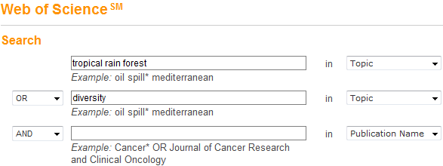

**Search 2** retrieved 2,591 publications

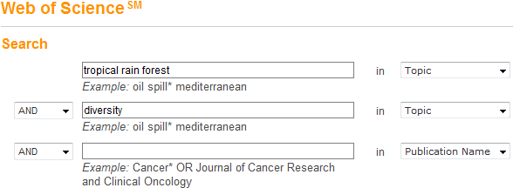

**Search 3** retrieved 48 publications

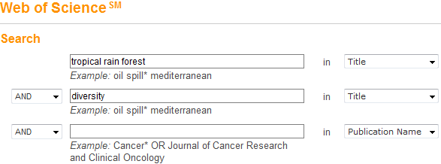

**Part III.** Questions 15-20 deal with the following question: *How is the diversity of tree species in tropical rain forests maintained?*

1. Please identify the main keywords in this research question.
2. Please identify a few synonyms and alternative terms/phrases suitable for finding information on this topic.
3. Why is it important to develop search queries using different terms/phrases?
4. How many results do you get when you run this search query?

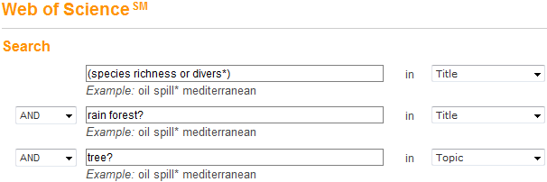

1. Sort the list of results you retrieved in Question 19 by **Times Cited – Highest to Lowest**. How many times has the first article been cited?