**Professor’s Point**  
Welcome to Professor’s Point, a new series by *Local-Sessions* that will feature profiles on local educators that surf in the Cape Fear Region of North Carolina. We begin this series with a profile on Dr. John Bennett, a professor in the Department of Health and Applied Human Sciences at the University of North Carolina Wilmington. Known as “Dr. Stoke,” Bennett can be found sliding the waves at Shell Island or Carolina Beach when he’s not teaching, dancing, fishing, or spending time with his family. So when you’re in the lineup with Dr. Stoke be prepared for a rascal of a good time.

Interview date: May 21, 2008  
Interviewee: Dr. John Bennett  
Interviewer: Peter Fritzler  
Location: John Bennett’s office, Hanover Hall, UNCW  
Transcription completed: May 23, 2008  
Published in *Local-Sessions*, June/July 2008  
Posted online: <http://library.uncw.edu/surf/point/bennettj.pdf>, June 16, 2008.

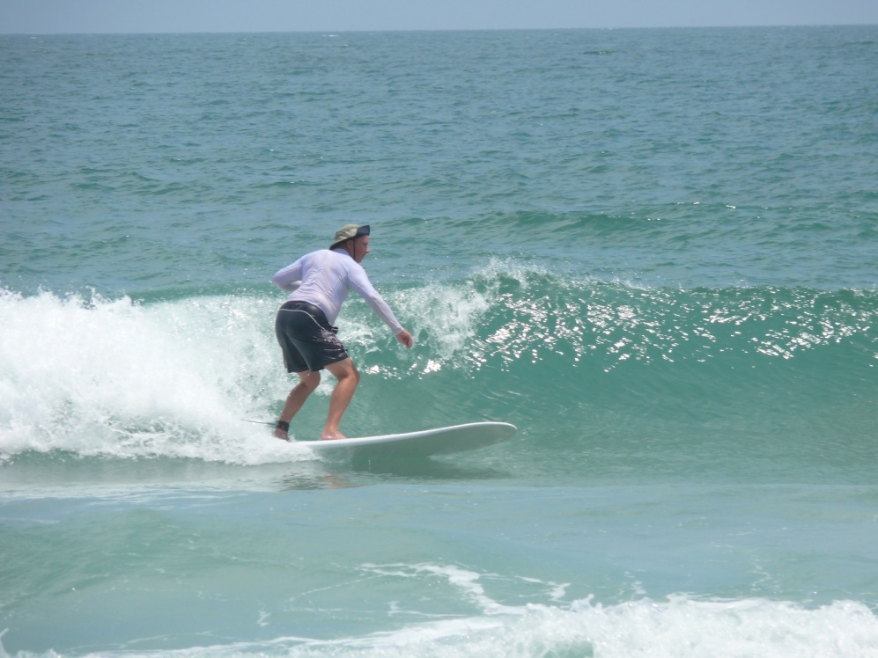  
John Bennett, Wrightsville Beach. Summer 2007  
Courtesy: John Bennett

**What do you do?**  
In a nutshell, I’m a professional educator, I’ll start my 40th year next year, it’ll be my fifth decade. It’s hard for me to imagine that, but I’ve taught kindergarten through the 12th grade – 6 elementary schools, 3 middles, and 1 high school. I’ve been a central office administrator; I’ve been a state level director and a university level program director. But I always I come back to teaching for some reason. I just think it’s been my calling for my whole life. I don’t know how much longer I’m going to do it but it’s been good. It’s allowed me to focus on the things I like which one of those in my own personal research is cultures and dance of the world. It has allowed me to travel literally all over the world in my consultations related to my work. Countries like China, Japan, Philippines, Caribbean, all over the U.S., Canada. Over 500 presentations in my whole career which are pretty significant numbers – it’s hard for me even to imagine that after all these years. It’s been great and I’ve enjoyed it. Now, I teach primarily in teacher preparation for effective teaching with kids, and health and physical education. The area that I like the most is my dance class. I could be happy teaching dance all of the time. I’ve taught in four departments – I don’t know that anybody here at the University has ever done that. It’s kind of unique. I’ve developed several classes that have been cross-disciplinary. I’m really into cross-disciplinary things that cross over other disciplinary lines and other department lines because I really don’t believe that you teach things – you teach people about things. That’s kind of been one of my philosophical things in my life. It’s been a great life and a great career.  
  
**How did you start surfing?**  
When I was 49, I was at church with my family. Everywhere we’ve lived church has been our local community. My daughter, Rebecca, was about 14, and other young lady there wanted surf – they thought that would be really cool. So, the other dad and I said, “If they’re going to do it we can do it too!” Well, it took with me but the other dad quit, and what I’ve learned is that’s very difficult for people to jump into surfing later in life. So I’m up to about 12 years of surfing now which for someone my age is not a whole lot but 12 years is significant. I’m very happy that I found the activity even though I found it later in life than most people do. I grew up as a water rat which I think is critical for a love of surfing. I love to fish, clam and oyster, and walk the beach. All of that is tied into surfing. When you go surfing you walk the beach and look for special things, the animals, birds, and people. So I stuck with it and it’s been one of the greatest activities I’ve ever gotten in to.  
  
**What kind of memories has surfing given you?**  
I think probably in my short 61 years of life it’s given me the most vivid and some of the most rewarding memories that I can even imagine. For instance, helping others to surf who have never surfed, particularly because I work with all kinds of kids. Some who are overweight who decided they wanted to surf and came out with me at daybreak at a time they may have never considered getting up. All of a sudden, they see this sunrise, the slick ocean, and maybe they some porpoises – we see all kinds of things. Those are very vivid in mind. Surfing with my daughter on a moonlight night watching the sun go down and the silver moon come up. And surfing in Mexico with daughter on a surf trip on 10-14 foot waves that terrified me but yet I was out there. And she’d tell me, “Daddy, come over here because the waves are safer or better over here and you’ll survive” – she didn’t want me to get hammered every time I took a wave. I think things like the talk in the parking lot, you can hear the buzz and see the cars come in, the walks down the beach before the sun comes up in the twilight or in the evening when you get out of the water late. Seeing the sun through the waves in the early morning and catching those first waves as the sun comes up. The list could go on forever.  
  
**It sounds like you’ve forged many good relationships through surfing. Would you say that surfing has done a lot for you or that you’ve met a lot of good people that you might not otherwise have met?**  
I don’t think there’s any doubt about it. The surfing group is one of the things that I like so much. It’s a very diverse group and that’s putting it mildly. You’re talking about carpenters, retirees, laborers, physicians, PhDs, librarians – it’s unbelievable. There are a lot of people that I’d never would have met – there’s no doubt about it. There are a lot who have come close personal friends. There were 20 of us that went to Mexico this March none of whom will be the same again. It was 20 people on a journey, never a cross word for 8 days. It was absolutely amazing that people could get along so well in an area that we didn’t have hot water, gourmet dining room, or a Myrtle Beach-type atmosphere. We were at the end of the dirt road and nobody spoke English except us. Those people are friends of mine and will be I’m sure forever. That’s one of the things that I like about the surfing scene or whatever you want to call it is are the wonderful giving people.  
  
**Where do you like to surf?**  
I surf mostly at the north end of Shell Island. It’s a habit thing because it’s the same group I surfed with and started with, and I’ve surfed with a lot of those guys over ten years. I do like to surf at Carolina Beach too but I don’t go there as often. I don’t know why. I go down and surf with daughter there some. I should go more – I live closer to there. I do like Wrightsville because I can go to the north end, shower, and go to work in the mornings. It’s part of the lifestyle for me if nothing else.  
  
**You can keep your board in the car?**  
My board’s in the car right now as we speak. I can keep it in the car. You understand.  
  
**What kind of boards do you ride?**  
Well, the last couple of years I’ve been riding Waldens from Ventura, California and that’s because of a surf trip to California. I had a buddy who was older than me, he was already into his sixties and we were out at a health and physical education conference. And we had one surfing vendor out of a thousand vendors or something. I went to him and said, “I want to surf. I brought my wetsuit but I want a good board.” He said, “I’ll take care of you.” He had two Waldens and we went and got them. They were wonderful boards and we surfed, and I said, “Man, I like those but you can’t get those back on the East Coast.” I found one in Melbourne Beach, Florida and I bought one there. And they moved up the East Coast, and I bought one at Sweetwater in Wrightsville Beach. They’re epoxy and I’d always surfed resin boards. I’ve gotten so I like them. They don’t get beat up as easy as resin, but they don’t ride like a resin board. You can’t compare them, but they have good floatation for my old fat body.  
  
**Do you have any favorite surf films?**  
Oh yeah, *Any Given Morning* [laughs]. And there’s one on the west coast of the old guys surfing but I can’t remember the name of it. You might know the name of it. I can’t think of the name of it – Rebecca gave it to me a couple years ago at Christmas. I think it’s *Surfing for Life*. I remember the old guy going out to surf and he had his baggies down below his knees and a guy says, “What are you doing?” And he says, “Well, I’m going surfing.” And the other guy says, “What are you doing that for?” And his response is the best answer in my profession for anything we do which is, “Because I can!” I thought that’s it – that’ why we do it – cause we can! [laughs]

**Do you have any favorite surf magazines?**  
Uh, I don’t like to read the national ones too much. I’ll look at them if one is sitting around. I have started looking at Local-Sessions. Other than that I don’t know too many of them. I used to look at the longboard magazines but I got out of that too. It’s just another thing to subscribe to or buy and I have enough trouble keeping up with my professional stuff.  
  
**Do you have any favorite website?**  
I go to WBlivesurf.com all the time. I go to Surfchex.com all the time and SNCsurf.com all the time. Magic Seaweed is good for information. That’s enough to go to in one day. I check them everyday first thing in the morning. Now, I’ll get up in the morning and I’ll turn on the national weather because it’ll give you the wind speed direction for Carolina Beach in the subscript. I don’t look at the websites as much at home as I do at work. It’s a great relief from work [laughs].   
  
**What’s your stance?**  
I’m a goofy. That’s why I like Mexico so much with that 2-3 minute “Mexican Malibu.” It was a left.  
  
**What’s your baggie size?**  
Shoot, I’m a plus size. We’ll just call it that? [laughs]

**Favorite wax?**  
Yeah, I like that ‘Bumps’ or whatever it is. ‘Sticky Bumps’ that’s it.

**Who is your favorite local surfer?**  
Wow, that’s hard. I really like Mike Whitmore. I really respect and admire Mike’s surfing style because we’re about the same age, he was never a super hot shot but he’s in the Eastern Surfing Association and does very well. I like him because he’s very relaxed and laid back. He never makes a big deal about how well he rode a wave and he’s always complimentary of me and others who are not at the same level that he’s at. I really like that. And he’ll always yield on a wave anytime because he’s a much better surfer. And I’ve never heard a cross word from him when I’m out surfing. I like that – it makes you feel good.  
  
**What’s most important to you as a surfer?**  
That I keep on doing it. That I can. [laughs] That is what’s most important to me. Now when I surfed Saturday in the contest I was the oldest and I didn’t do well, but I did it. Somebody in the 55 and Older group said, “John, there’s not many people that can do this and the fact that we still can do it is pretty significant.” And I said, “I feel the same way!” I would love to be able to do more of the world breaks before I get so I can’t do them, and I still think I can do some of those things. It gives you a lot of hope because when you go out and ride waves you go, “Man, I can still that. It only takes a couple of decent rides a day.” Billy Curry said to me in Mexico cause I was struggling out there. He said, “I only try to catch six good waves a session.” I thought, “Six waves? That’s nothing!” But what that did was make me quit focusing on trying to catch every wave. It made me focus more on the waves I was on and have a good ride. Okay, that one and I’d come back, and that’s two, and that’s three.  
  
**How does surfing affect you in other parts of your life?**  
Well for me, and I’m probably similar to a lot of folks, it can become addictive almost in terms of your behavior. If you asked my wife she might say I’m addicted to surfing. It has affected me significantly to the point that if I’m going to go on a vacation I think about if there is surf place to go when I go. So, that’s pretty heavy I guess. It also impacts me so much that I’m on the phone every day about surfing with a couple of my buddies. I’ve been on the phone already today. So that’s significant and that’s where my wife would say, “oh my gosh, you’re really wrapped up in this.” It has affected my life very positively with my daughter because she likes to surf as much as I do, and as a result, that’s a great common bond that we have. It’s so strong that our son, Zach, at 28 wants to get better at surfing. He’s not a good surfer and has not really gotten over the hump. As a result, it’s frustrated him some because of his friends here locally. It’s very difficult for me as a father to get him over the hump. I would like to. I would like to more than anything. I’d like for him to have a lot more success than I have but have enough success to love the activity – to develop a passion for it. It affects my life so much that there’s not a class that goes by that I teach that I don’t talk about surfing. And the way I use it as a professional and health promotion is, “find something you have a passion for that has a positive spin on it for your personal health and well-being.” Have balance in your life. I’m not overly balanced on the physical dimension although that’s huge; the social dimension is huge; the mental dimension is huge; the emotional dimension is huge; and the spiritual dimension is huge. In healthful living we have a model called the ‘Pentagon of Health’ – physical, mental, social, emotional, and spiritual. I try to tell my students to find activities that are balanced for them in life. For instance, if all you do is weight lift and you get no ‘social’ out of your weightlifting maybe you need to relook at how you do it. If you’re plugged in with your ears and say, “I need that to do my lifting,” then maybe you missed out on all the social activities that could or should take place. We’re into building communication skills, and now I’m going back to my university professor’s role, but that’s one of the outcomes we want in education. Well that doesn’t promote it. So I work very diligently to try to balance my life in with surfing and keep it in perspective. I’d try to surf everyday if I could, but I don’t. I’d like to surf 5-6 days a week if I can but we don’t have waves all the time here on the East Coast. So, that limits it too. And if you miss some of the days that we have good waves then you limit yourself in the amount of surfing that you get in. And the impact is reduced. That’s why I have other things that I do and I think everybody should have other things that they do. One of the interesting things about some of our buddies like Mike and Joe is that they’ve started making boards and they’re really excited about going over to Mike’s house, hanging out, and making boards. They’re not experts but they’re having fun. I just think that’s cool. So it’s impacted me significantly. I love it. I just love it. I don’t even know how to explain it. It’s one of those things in life that’s very hard to explain to people that don’t surf. When I say that to people that are non-surfers they think I’m being standoffish or something. I say, “What do you like to do? Well, I like to read books. Well I don’t understand that because I don’t like to read books. I like to play tiddlywinks. Well, I don’t like to play tiddlywinks. I don’t think I’d like doing that. I personally like to play bridge. And younger kids of your generation probably go, “Bridge? Good god!” Well, I’ve played bridge with a couple for about 35 years, can you believe that! We just have fun. It’s a social. It’s always the guys against the gals. Two guys against our wives and we know how everybody bids and how everybody plays but because of the nature of the game, and that’s what I like about surfing because of the changing nature of the game – surfing – it’s always a challenge. You know that. You understand that. It’s always a challenge and when you master that challenge just like in any other game you go, “Oh, ah ha! That’s pretty cool! I wonder if I can do that again.” You may never ride another one like that. So, it’s really impacted me huge. I love it. I’d take more trips if I could. That’s really fun. Don’t do too much of it [laughs] it really gets into your psyche.

**Recent reports in the media and science have emphasized the degradation of the environment both locally and internationally. How does surfing fit into this discussion?**  
There are many surfers who are very concerned, maybe even involved actively, fighting for the environment. I don’t know too many of the people that I surf with who I would consider lobbyists with their representatives to have better control on runoff, better control on fertilization, better control on sewage, or better control on beach usage. I don’t think many of the surfers get actively involved. I do feel the surfing group has a very high level concern for it, such as, when we go out there are some guys I surf with that would never leave a spot of any piece of trash on the beach that they’re going to pick it up no matter what. I pick up trash too. I know for instance, times when we’ve had sewage spills here locally that we’ve been very concerned about the quality of the water because we really value the pristine quality of the water, particularly the north end of Wrightsville which has been very good. Some days it’s just like the Caribbean out there – it’s so pretty. It’s absolutely gorgeous. There have been some days when we’ve had massive menhaden kills and we all were very concerned about that; not only the fact that it stunk to high heaven but the fact that a lot of animals that lost their lives. Why is that? What happened? We don’t know the answers and we probably, as surfers, would never research it to that level. Now personally, I’m very concerned about the environment. I haven’t lobbied myself, maybe I should. Maybe as a person who gets out into the environment as much as I do I should be more vocal. Like right now, they’ve got some big things going on with fishing regulations. I’m getting emails and probably I should go to the hearings and speak my piece on them. But I don’t look at myself as a high end user of the environment for fishing like some other people – maybe that’s even more reason to go. So surfing, I don’t get involved in the politics of it – I maybe should. I am a believer in speaking up for what you feel is right and as a person who uses the environment probably surfers should say more because I think we really have a high regard for our environment. That’s just my take.  
  
**What do you like most about surfing?**  
The feel of riding down the wave, the expectation and with the actual riding the wave to what we would as surfers consider a higher level than maybe we’ve ever done before with the hope that the next one will be maybe the wave of our lifetime. You know [pauses] and waiting, the expectation of waiting for that nice set wave, or that monster wave, or the wave of the day and catching it and riding it to perfection. And shootin’ the sections, and making ‘em and riding out on that shoulder and goin’, “Man, that’s really cool. I did that.” I’m totally free. To me it must be like being in space. I feel like if I was out in space I would be weightless. I kind of feel like that when I’m surfing on the wave. As you work on a wave and you feel it I wonder if that wouldn’t be like no gravity or whatever. Because sometimes when you’re up you could be in the air, well, I don’t get airborne because I don’t do airs on my board. But you know, the level of gravity that’s working is very low – there is low intensity of gravity because you go up the wave and then you drop down so there is a time in surfing that you’re pretty much suspended with no gravity impact as you ride the wave. It’s unbelievable feeling to me. I just love it. Every wave that I can get that I get that feeling, I get it on every wave just about. But man, when you get those nice bigger waves with the nice shoulders on them, and you just go on and on. It’s pretty exhilarating.

PF: I can see that you’re visualizing it.   
  
JB: Oh yeah. I can see the waves!

PF: I can see it in your eyes. I’m thinking, “He’s not here right now.”

JB: No, I’m actually out there on a wave. You know, some people might say, “Oh man, I just want this huge barrel. That would be the ultimate for me.” I’d rather be out in front of the barrel so I know the wave’s not so steep and I’m not going to get hammered! I love, like all the rest of those guys around here, I love hurricane swells. Man, just waiting for those northeasters and waiting for that wind to go offshore and get that nice slick wave. I love the sound of a board on a calm day when you can hear it move through the water and see a little rooster tail right behind you. You go, “Oh man, now I’m livin’ – this is really livin’.” Or if it’s a big wave, which I’m not as good on because I’ve only been doing this about a dozen years, when you make that drop on a big wave and make it and you make it good. And it sets up that section and you shoot through that section before it closes out on you, and you’re out there on that shoulder again. Oh boy, that’s livin’. I guess the thing about it that’s so neat is you can do it over and over and over as long as you got the energy. You can keep on riding.

PF: At relatively no cost.

JB: Yeah, at no cost – at virtually no cost. And the spinoff from the fitness that comes from it. Like the guy said the other day at the competition, “John, there ain’t many guys in our age group that are still doing this.” There’s a reason - they just physiologically can’t do it. I highly value that.

Is there anything you don’t like about surfing?  
I think the general thing would be the agro-surfers that I’m seeing coming in. I’m not going to generalize the younger because I see it with older people too. There is, on some of the places I’ve surf, more tension than I’ve ever seen in the past dozen years related to riding and sharing the waves. That’s undoubtedly why I like surfing some of the places I surf where I know the majority of the people particularly at times I know everybody. People can’t imagine that , but there are some places I can go and you know everybody that’s there. I like that. It’s very comforting. I know the young kids will watch out for me and all of us old kids will have fun and watch out for the young kids. That’s the way it works – there’s no age on the waves. I like that too. It’s not like, “Oh, it’s Peter Fritzler, the youngster from the library. It’ just Peter and we’re out there surfing together.” I love that.

PF: It’s a great equalizer.

JB: Equalizer is the word. It definitely is a great equalizer. It’s treating people with respect. Billy Curry [pauses] I love what he said in the film *Any Given Morning* that it’s something that carries out through your life on and off the water. You really should treat people on the water respectfully as we should treat people off the water respectfully. If you really live that life persona that’s exactly what you do.

PF: Regardless of the medium.

JB: Yeah, exactly. I could be over in the library working on a project with you but I should treat you respectfully and work with you cooperatively just as you should on the water. I love that. I think that’s the way it should be.

PF: Well, I thank you for your time. Anything else you want to share with the readership?

JB: The readership. [laughs] Only don’t knock it ‘til you give it a try and stay with a long time if you’re a newbie because the learning curve is very slow. Now, this is a professional and physical development. There’s a slow learning curve as you get older and for younger kids, for many younger kids the learning curve is not nearly as slow. But if you stick with it you’ll reap the benefits.

**Do you have any nicknames?**  
Well, ol’ Tony Puente used to call me “Dr. Stoke” and I kind of let it go because it sounded kind of funny. That was one. “Pops” is another because I was surfing with Mike Abernathy one day – he’s crazy – and I had disappeared and the kids said to him, “Hey where’d your dad go?” [laughs] I said, “That really hurts if they think I’m your dad!” But actually, his dad is only two years older than me and I’m closer to Mike than I am to his dad. I know his dad so “Pops” is one. Patrick Smith used to call me “Dr. J” and you know you get some nicknames [pauses] I’m trying to think if there were any others that have come along. Always the best one is from my daughter and that’s “Dad,” and that’s not a nickname. That’s just a different name on the water. So those are pretty much the ones I’ve had.

PF: Dr. Stoke.

JB: Ain’t that funny! From the psychologist!

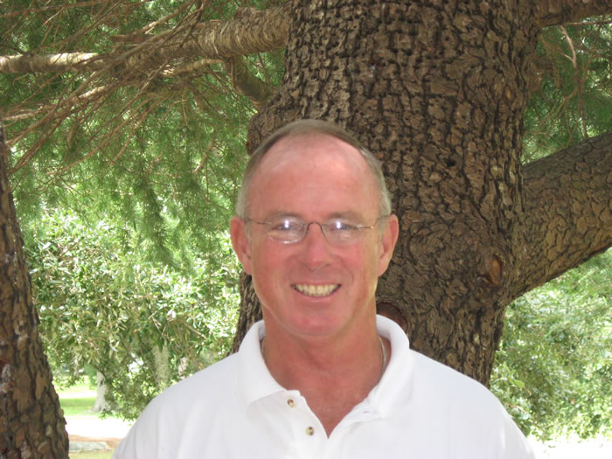  
John Bennett. Courtesy: John Bennett