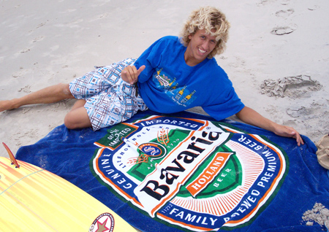
Tony Silvagni. 1st Annual Bavaria Holland Beer Pro/Am Silvagni Benefit Surf
Contest. Fort Fisher, NC. July 22-23, 2006.

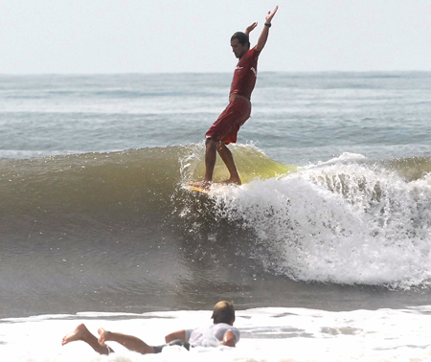

Unidentified. 1st Annual Bavaria Holland Beer Pro/Am Silvagni Benefit Surf
Contest. Fort Fisher, NC. July 22-23, 2006
Surf Contest at Fort Fisher Drew Record Numbers

2nd Annual Bavaria Holland Beer Pro/Am Silvagni Benefit Surf Contest Drew Record Numbers

Thursday, 26 July 2007
By: Rachel N. Johnson
Features Editor

The 2nd Annual Bavaria Holland Beer Pro/Am Silvagni Benefit Surf Contest drew record numbers of surfers and spectators to Fort Fisher on Saturday and Sunday, July 21st and 22nd. This two day surf event saw over a thousand people on the beach on Saturday afternoon, with large crowds attending the benefit party on Saturday evening and returning to the beach again on Sunday afternoon for the finals.
According to Tony Silvagni, coordinator of the event, “the contest was at maximum capacity with 250 surfers. We were blessed with good waves for the contest. On Saturday the waves were chest high and the surf was choppy. On Sunday the waves were waist to stomach high with occasional chest high waves with semi choppy conditions.” He went on to explain his overwhelming happiness with the event, “this was by far the biggest event ever held in this area. The entire contest was great.”
The prizes for this year’s top surfers were a part of the draw that brought record numbers out. First, Second, and Third place in the Amateur Longboard and Shortboard Divisions received a trophy and a variety of lucrative prizes. Fourth through Sixth places also received trophies. The First Place winner in the Pro Shortboard Division received $700 and 1 roundtrip ticket to Panama. 2nd place won $600, 3rd Place took home $400, and 4th Place claimed $300. The first place winner in the Pro Longboard Division won a 10 night/10 day stay in a 4 bedroom house in Panama and 1 round-trip airline ticket to Panama. 2nd Place took home a 9 foot 2 inch Coffin Board Bag from FCS, and 3rd & 4th places each received awesome prize packages. There were also giveaways all day long on the beach. Pick up a copy of next week’s Island Gazette for a full listing of the results from the tournament.
The final heat of the Pro Longboard competition was abruptly interrupted on Sunday afternoon when an approximately 12 to 14 foot shark was spotted in the water. Everyone was called out of the water including surfers and swimmers nearby not participating in the contest. This was quite an unexpected visitor at the event. On Saturday evening, there was a benefit party held at the High Tide Lounge with record breaking crowds in attendance. The event was catered by K38. “I want to extend my thanks to K38 for going way out of their way to accommodate everyone in attendance with awesome food,” commented Tony Silvagni. “I am really thankful to them and all of the sponsors. Bavaria was a huge help, donating $2000. Cement Rocket donated the airline tickets and Lawrence Shotwell donated the trips to Panama. Our sponsors really hooked up the prizes. Thank you.”
During the Benefit Party Surf 98.3 was on hand to give out great gifts and help entertain the crowds. There were 3 live bands, awesome food, a silent auction, and a raffle. All of the proceeds raised from these events are to benefit Andrew Silvagni in his fight with Lyme’s Disease. The annual tournament set up a foundation to help Andrew. The Silvagni family also wants to raise awareness about the disease and how easily it can happen to anyone. During the event there was educational information available.
For more information on the tournament or to keep up with Tony Silvagni’s Professional Surfing Career visit www.bavariaholland beer.us

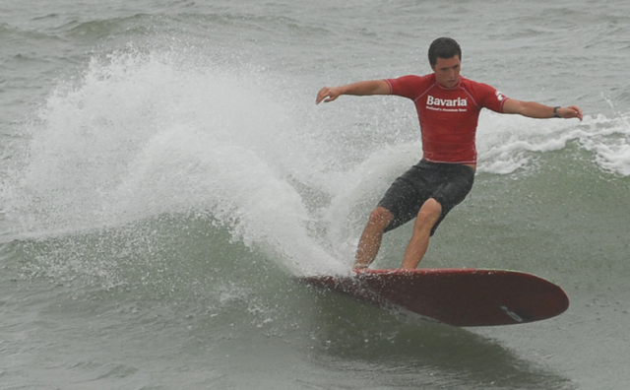
Drake Courie (Kure Beach, NC) cuts back on a wave at the 2nd Annual Bavaria Holland Beer Pro/Am Silvagni Benefit Surf Contest.

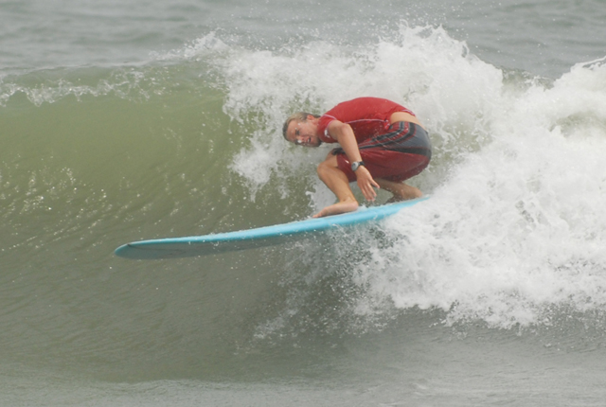

Thomas Cannon (Kure Beach, NC) attempts a head dip during the 2nd Annual Bavaria Holland Beer Pro/Am Silvagni Benefit Surf Contest.
2nd Annual Bavaria Holland Beer Pro/Am Silvagni Benefit Surf Contest
July 21-22, 2007 Fort Fisher, NC (Results)

Pro Longboard
- Dylan Andrews – Jacksonville, FL (win gives him a 10 nights/10 day stay in Casa de Estrelle in Panama and 1 round trip ticket to Panama)
- Drake Courie – Kure Beach, NC
- Ty Roach – Atlantic Beach, NC
- Mike Melichorre – Virginia Beach, VA

Pro Shortboard
- Shane Upchurch – Long Beach, NC ($700 and round trip ticket to Panama)
- Michael Powell – Ocean Isle, NC ($600)
- Wilfredo Deliz – Jobos Beach, Puerto Rico ($400)
- Anthony Osment – Folly Beach, SC ($300)

Menhune Shortboard  - Weston Williams  - Conner Lester  - Stevie Pittman  - David Brigham  - Sam Hart  - Maximillian Beauchene  Junior Men Shortboard  - Erik Kirby  - Owen Moffett  - Evan Barton  - Chase Evans  - Tanner Kehl  - Bradley Rose  Junior Women Shortboard  - Chandler Von Cannon  - Darsha Pigford  - Brie Sciales  - Allison Parks  - Alyssa Horner  Men Shortboard  - Justin Fulford  - Cameron Pappas  - Ben Powell  - Dylan Morris  - Hunter Sapp  - Kyle Kane  Women Shortboard Final  - Eileen O'Conner  - Rebecca Bennett  - Amanda Klutz  - Kristen Kornegay | Master Shortboard  - Jason Andre  - Daniel Cerquerina  - Nick Carty  - Jason Lambeth  - Chad Brown  - John Taylor  Senior Men Shortboard  - Lawrence Shotwell  - Daniel Sacchi  - Peyton Chitty  - John Casselli  - Chester Pittman  - Deane Pye  Grandmasters Shortboard  - Bruce Willis  - Ray Harris, Jr.  - Ed Pickett  - Glenn Sanderson  - Chip Youngblade  Menehune Longboard  - Weston Williams  - Cam Fullmer  - Bradley Rose  - Morgan Taylor Leavel  - Eddie LiBassi  - Doug Pickett  Men Longboard  - Ty Roach  - Mike Melichiorre  - Sean Knight  - Joey Elliott  - Alex Metz  - Scott Strickland | Girls Longboard  - Allison Parks  - Chandler Von Cannon  - Christie Walker  - Alyssa Horner  - Darsha Pigford  - Alyssa Bennett  Women Longboard  - Rebecca Bennett  - Darsh Pigford  - Kristen Kornegay  - Morgan Knight  - Eileen O'Conner  Master Longboard  - Daniel Sacchi  - Chester Pittman  - Lawrence Shotwell  - Andrew Tolhurst  - Randy Sellers  - Jason Andre  Grandmasters Longboard  - Bruce Willis  - John Casselli  - Chip Youngblade  - Ricky Judalena  - John Lagone  - Andy Herzog

Courtesy: Island Gazette Online. < http://www.islandgazette.net/photo2/showimg.php?file=/August-2-2006/Page-6B-Tony-Silvani.jpg> Last accessed August 1, 2007.
Courtesy: Island Gazette Online. < http://www.islandgazette.net/photo2/showimg.php?file=/August-2-2006/Page-4B-Surf-Tournament-2.jpg> Last accessed August 1, 2007.
Johnson, Rachel N. “Surf Contest at Fort Fisher Drew Record Numbers; 2nd Annual Bavaria Holland Beer Pro/Am Silvagni Benefit Surf Contest Drew Record Numbers.” Island Gazette Online. July 26, 2007 <http://www.islandgazette.net/content/> Last accessed July 31, 2007.
Courtesy: Island Gazette Online. <http://www.islandgazette.net/photo2/showimg.php?file=/July-25-2007/Page-10C-Surf-Contest-18.jpg> Last accessed July 31, 2007.
Courtesy: Island Gazette Online. <http://www.islandgazette.net/photo2/showimg.php?file=/July-25-2007/Page-10C-Surf-Contest-19.jpg> Last accessed July 31, 2007.

