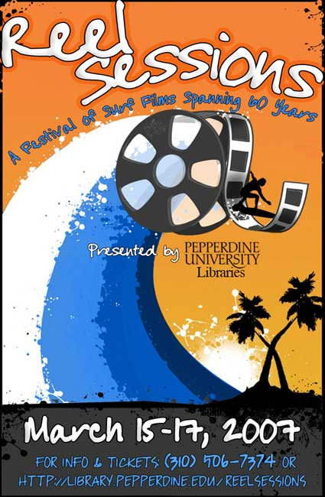
Film News – Ben Marcus
< http://www.globalsurfnews.com/news.asp?Id_news=26746> Last accessed January 16, 2008
Pepperdine Hosts Reel Sessions Surf Culture Festival
Surfersvillage Global Surf News, 15 March, 2007 : - - The surf is going to be way up from March 15 – 17 as Pepperdine University Libraries host Reel Sessions, a three-day exhibit of surfboards, woodies, surf bands and surf icons arranged around a schedule of 12 surf movies that will be a “Celebration of Surf Cinema Spanning 60 Years.”
Each of the 12 movies will be hosted by an important surf culture figure, and there will be a raffle to raise money and interest for the Pepperdine University Libraries Malibu Collection, which will detail Malibu history by land and sea and become a multifaceted research resource for students, faculty and the general public.
Pepperdine enjoys a million dollar view into the surf line at Surfrider Beach and while it is not what you’d call a party school, it is still fitting and proper that such a distinguished institution would dedicate its facilities to a weekend of surf culture:
“Here we are, perched on a bluff overlooking one of the world's great point breaks, a legendary place, and having a surf film festival just makes a lot of sense,” said Jerry Derloshon, the Director of PR and News at Pepperdine. “For a lifelong surfer like me, the festival is a tribute to the wave riders, film makers and surf musicians who made surfing as much of a lifestyle as it is a sport.”
The idea for the surf culture weekend came from Mark Roosa, the Dean of the Pepperdine Libraries. Roosa worked for the Library of Congress from 1998 to 2004 and then he went west when Pepperdine hired him in 2004. Roosa is responsible for directing library activities on the Malibu campus and at satellite locations around Los Angeles.
As well as inviting the people of Malibu up the hill for a hootin’-nanny, so to speak, of surf culture, Roosa’s long-term goal is that ongoing Malibu Collection: “Our goal is to provide insight into Malibu's formative years and subsequent development as a beach and recreational destination, a magnet for writers, musicians, and others drawn to this 'sun kissed' corner of Los Angeles,” Roosa said in a Reel Sessions press release.
“The collection will chronicle through letters, photographs, books, films, interviews, memorabilia and secondary sources the history and development of Malibu during a time of unprecedented change and transformation. The Pepperdine Libraries welcome expressions of interest regarding the Malibu Collection and are interested in connecting with individuals who may wish to donate materials to the collection.”
The title for the weekend Reel Sessions came from Pepperdine Librarian Sarah Gilman and Pepperdine staff member Jill Brunner. Gilman, who according to Dean Roosa, “has been the driving force behind planning and coordinating this event,” enlisted the help of Pepperdine students Riley Jamison and Jill Brunner to create the Reel Sessions art.
The slate of surf movies and speakers was well chosen by people who know what they are doing: “Sarah Gilman, Lance Keene and Jerry Derloshon selected the films,” said Mark Roosa.
Jefferson “Zuma Jay” Wagner has been surfing Malibu since the 60s, and has recently published a book about surf wax. Wagner will introduce Bud Browne’s Surfing in the 50s and he will be joined by local surfboard and surf culture collectors John Zambetti, John Mazza and Flip Cuddy.
Kathy “Gidget” Zuckerman’s influence goes back to the summer of 1957, when her summer adventures on the beach at Malibu inspired her father to write a coming of age novel called Gidget. The success of that book inspired a major Columbia motion picture in 1959, which in turn lit the fuse of the surf culture explosion of the 1960s.
Music was a part of the surf culture of the 60s, and the musical representatives are Randy Nauert, an original member of The Challengers surf band, and Gaston Georis, who composed the theme for Endless Summer as a member of The Sandals. Georis will speak before the showing of The Endless Summer, along with Surfer’s Journal publisher Steve Pezman, and Nauert will introduce the 70s classic Five Summer Stories.
Denny Aaberg has been surfing Malibu since the 50s and his experiences were the foundation for the 1978 movie Big Wednesday, which is almost universally regarded as the best of the Hollywood-generated “waxploitation” movies. Aaberg will say a few syllables to introduce Big Wednesday, which he co-wrote with John Milius.
Some of the first surfers along the California and Hawaiian coasts are still out there and some are featured in David L Brown’s documentary Surfing for Life, about Gen LXX surfers. Mickey Munoz is one of those who is a testimony to the eternal youth properties of surfing. Munoz doubled for Sandra Dee in Gidget in 1959 and he was also one of the stars of Chasing Dora in 2005.
Munoz will speak before Chasing Dora and there will also be talks by Pepperdine alumnus j brother before his longboard movies adrift and Longer. Malibu surf collector Flip Cuddy will speak before a short film about Hawaiian surfer Eddie Aikau.
To raise money for the collection, there will be a silent auction following the screening of Riding Giants on Saturday night. Auction items include a 9’ 4” Weber Performer donated by Shea Weber and a classic 1940s redwood/balsa collectible made by Bud Caldwell. Jet Blue is offering three pairs of round-trip tickets to anywhere, and there will be gift certificates for dinner at Giovanni’s and Duke’s.
All screenings are free and open to the general public. Seating is limited. For tickets and information click here
Thursday, March 15
The Early Years
5:30 p.m. Endless Summer by Bruce Brown - Library Loft Steve Pezman, publisher, The Surfers Journal Gaston Georis, composer, Endless Summer Theme, recording artist, The Sandals
5:30 p.m. Five Summer Stories by Greg McGillvray - Kresge Reading Room Randy Nauert, Malibu author, recording artist, The Challengers;
5:30 p.m. Surfing in the 50s by Bud Browne - Hahn Fireside Room Jefferson “Zuma Jay” Wagner, Malibu surfer and shop owner
Friday, March 16
Hollywood Goes Surfing
The surf band The Sound Waves is scheduled to appear Friday, March 16 from 3 p.m. to 6 p.m.
5:00 p.m. Big Wednesday - Elkins Denny Aaberg, co-writer, Big Wednesday
5:15 p.m. Gidget - Library Loft Kathy “Gidget” Zuckerman, cultural icon
Pepperdine Alumni Behind the Lens
7:30 p.m. Longer and adrift by jbrother, Pepperdine alumnus, Library Loft jbrother
7:30 p.m. Reflection - by Dave Ogle, Pepperdine Alumnus, Raitt Recital Hall
Saturday, March 17
Two Documentaries
5:00 p.m. Surfing for Life by David L. Brown - Library Loft David L. Brown
5:00 p.m. Chasing Dora by TJ Barrack and Wes Brown - Raitt Recital Hall Mickey Munoz
Towing In
6:30 p.m. Special 10-minute clip on Eddie Aikau - Elkins Philip "Flip" Cuddy
6:45 p.m. Riding Giants by Stacy Peralta - Elkins
http://library.pepperdine.edu/reelsessions/

