- NO.7-25-1965 Fr36 SurfersFeature .tif  Herman Pritchard on left. Unidentified in middle. Clarence “Sonny” Danner on right.  Reprinted with permission of The News & Observer of Raleigh, N.C.  Courtesy of The North Carolina State Archives. | 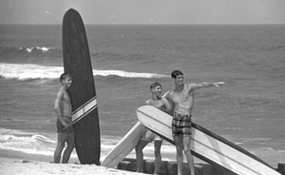
- NO.7-25-1965 Fr30 SurfersFeature .tif  Herman Pritchard.  Reprinted with permission of The News & Observer of Raleigh, N.C.  Courtesy of The North Carolina State Archives. | 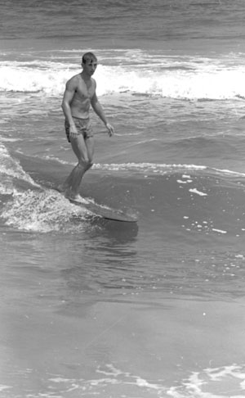
- NO.7-25-1965 Fr29 SurfersFeature .tif  Herman Pritchard.  Reprinted with permission of The News & Observer of Raleigh, N.C.  Courtesy of The North Carolina State Archives. | 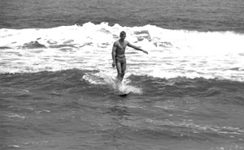
- NO.7-25-1965 Fr28 SurfersFeature .tif  Reprinted with permission of The News & Observer of Raleigh, N.C.  Courtesy of The North Carolina State Archives. | 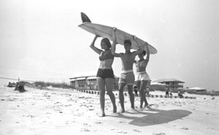
- NO.7-25-1965 Fr27 SurfersFeature .tif  Reprinted with permission of The News & Observer of Raleigh, N.C.  Courtesy of The North Carolina State Archives. | 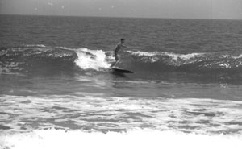
- NO.7-25-1965 Fr26 SurfersFeature .tif  Reprinted with permission of The News & Observer of Raleigh, N.C.  Courtesy of The North Carolina State Archives. | 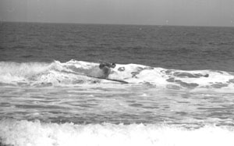
- NO.7-25-1965 Fr21 SurfersFeature .tif  Reprinted with permission of The News & Observer of Raleigh, N.C.  Courtesy of The North Carolina State Archives. | 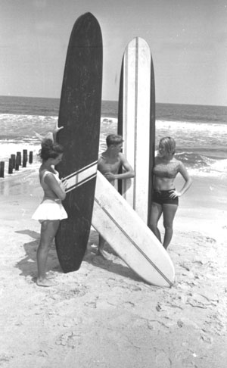
- NO.7-25-1965 Fr20 SurfersFeature.tif  Reprinted with permission of The News & Observer of Raleigh, N.C.  Courtesy of The North Carolina State Archives. | 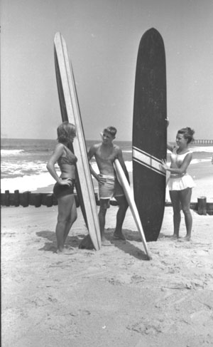
- NO.7-25-1965 Fr13 SurfersFeature.tif  Clarence “Sonny Danner” with drill. Unidentified kneeling.  Reprinted with permission of The News & Observer of Raleigh, N.C.  Courtesy of The North Carolina State Archives. | 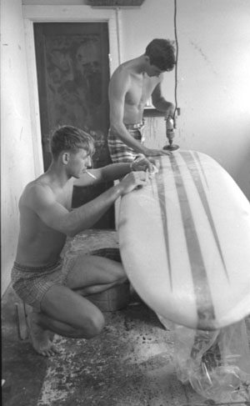
- NO.7-25-1965 Fr11 SurfersFeature.tif  Atlantic Surf Shop in Kure Beach, NC.  Reprinted with permission of The News & Observer of Raleigh, N.C.  Courtesy of The North Carolina State Archives. | 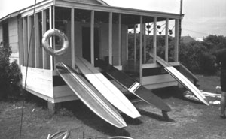
- NO.7-25-1965 Fr10 SurfersFeature.tif  Atlantic Surf Shop in Kure Beach, NC.  Reprinted with permission of The News & Observer of Raleigh, N.C.  Courtesy of The North Carolina State Archives. | 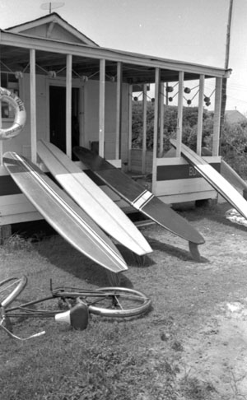
- NO.7-25-1965 Fr9 SurfersFeature.tif  Atlantic Surf Shop in Kure Beach, NC.  Reprinted with permission of The News & Observer of Raleigh, N.C.  Courtesy of The North Carolina State Archives. | 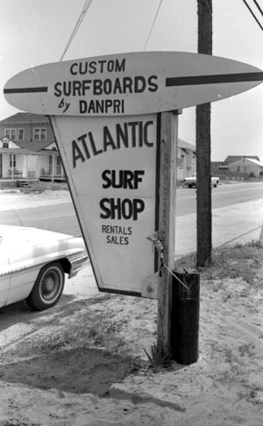
- ConDev.L-153.2 Katherine Meier Wilmington NC c.1937.tif  From the NC State Archives Collection:  North Carolina Conservation and Development Department, Travel and Tourism Division, Photo Files. | 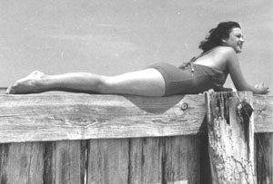
- ConDev.L-153.5 Katherine Meier Wilmington NC c.1937.tif  From the NC State Archives Collection:  North Carolina Conservation and Development Department, Travel and Tourism Division, Photo Files. | 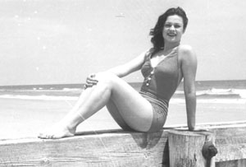
- ConDev.L-153.6 Katherine Meier Wilmington NC c.1937.tif  From the NC State Archives Collection:  North Carolina Conservation and Development Department, Travel and Tourism Division, Photo Files. | 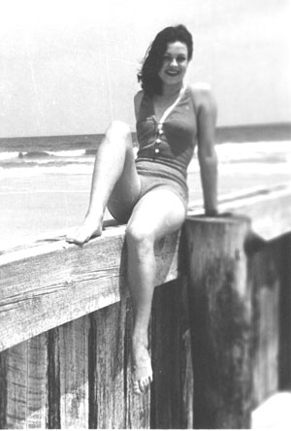
- ConDev.L-153.10 Katherine Meier surfing Wilmington NC c.1937.tif  From the NC State Archives Collection:  North Carolina Conservation and Development Department, Travel and Tourism Division, Photo Files. | 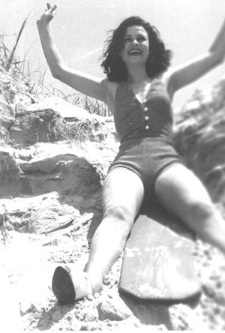
- ConDev.L-153.13 Katherine Meier surfing Wilmington, NC, c.1937.tif  From the NC State Archives Collection:  North Carolina Conservation and Development Department, Travel and Tourism Division, Photo Files. | 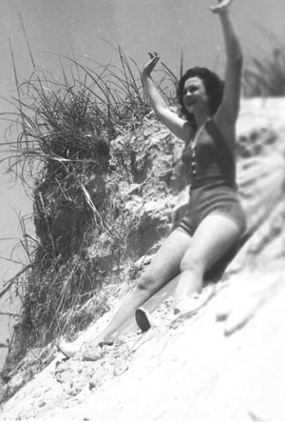
- ConDev.L-153.18 Katherine Meier surfing Wilmington NC 1937.tif  From the NC State Archives Collection:  North Carolina Conservation and Development Department, Travel and Tourism Division, Photo Files. | 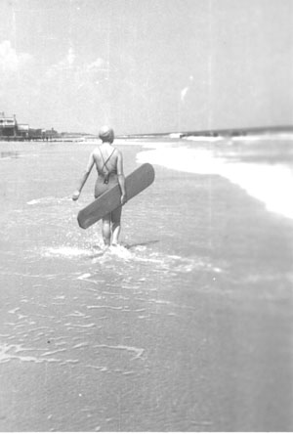
- ConDev.L-153.21 Katherine Meier surfing Wilmington NC c.1937.tif  From the NC State Archives Collection:  North Carolina Conservation and Development Department, Travel and Tourism Division, Photo Files. | 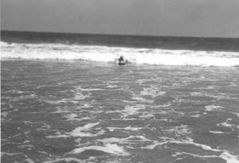
- ConDev.L-153.23 Katherine Meier surfing Wilmington NC c.1937.tif  From the NC State Archives Collection:  North Carolina Conservation and Development Department, Travel and Tourism Division, Photo Files. | 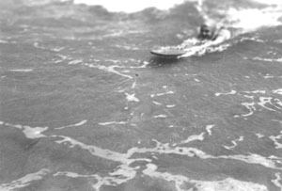
- ConDev.L-153.25 Katherine Meier surfing Wilmington NC c.1937.tif  From the NC State Archives Collection:  North Carolina Conservation and Development Department, Travel and Tourism Division, Photo Files. | 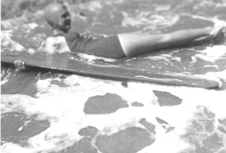
- ConDev.L-153.26 beach scene Wilmington NC 1937.tif  From the NC State Archives Collection:  North Carolina Conservation and Development Department, Travel and Tourism Division, Photo Files. | 