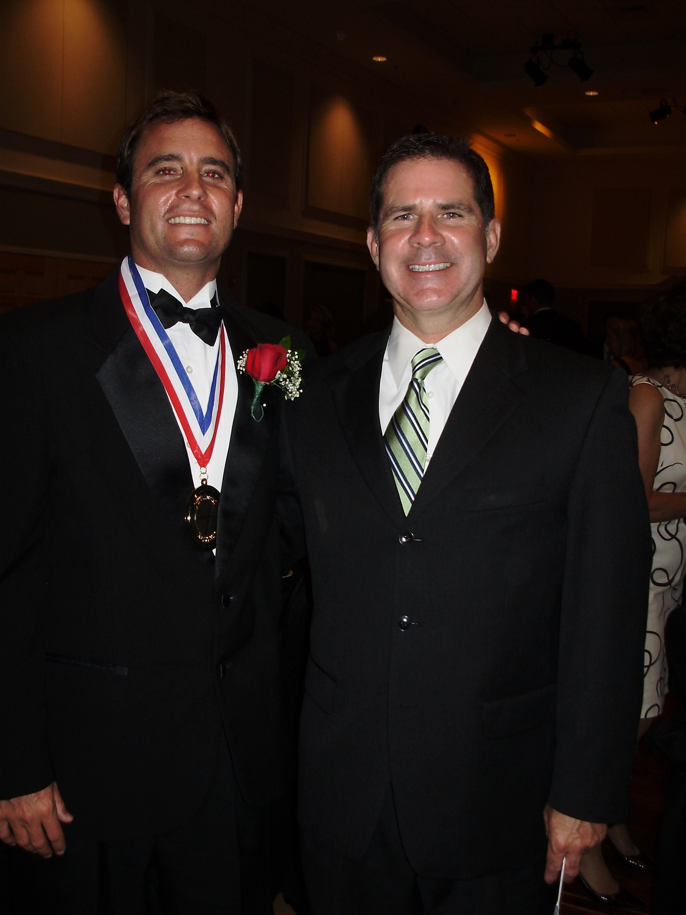

The Surfabout / Record Bar contest series was held at Wrightsville Beach from 1981–1985. Both the ’84 and ’85 events were sanctioned by the Association of Surfing Professionals, the sport’s international governing body. Both of these events featured the world’s top 20 surfers and were watershed moments in local surfing history. It was the first time local surfers had immediate access to the world’s top surfers and the opportunity to see the world’s best surfing their local waves. Courtesy: Robert Dittmer

Ben Bourgeois (left) and his uncle, Brian Tracy, at the Greater Wilmington Sports Hall of Fame induction ceremony, May 2, 2010. Bourgeois was the first local surfer inducted to the Hall, most notably for being the first surfer from North Carolina to compete on the World Championship Tour (WCT) / ASP World Tour, the world’s premier surfing league. Courtesy: Brian Tracy