Отчет по paper-экспериментам
для статьи об emotionally bounded-rational agents
Источник: paper_experiment_bundle_20260511_224550.zip. Подготовлено на основе CSV, config.json, run_log.txt и plots из переданного архива.

1. Статус пакета и валидации
Пакет содержит полный набор обязательных paper-прогонов для текущей статьи: S1, S2, S3, S4. В дополнение проведен optional S3 по всем играм. Финальный validation log содержит VALIDATION OK. Ниже приведен инвентарь запусков.
run_dir | scenario | profile | games | episodes | rounds | conditions | summary_rows | plots_count | ok
results/02_paper/20260511_201116_paper_S1 | S1 | paper | Prisoners Dilemma; Battle of Sexes; Ultimatum Game | 20 | 200 | 48 | 48 | 48 | 1
results/02_paper/20260511_204523_paper_S2 | S2 | paper | Prisoners Dilemma; Battle of Sexes; Ultimatum Game | 20 | 200 | 27 | 27 | 152 | 1
results/02_paper/20260511_210148_paper_S3 | S3 | paper | Prisoners Dilemma | 20 | 200 | 27 | 27 | 18 | 1
results/02_paper_optional/20260511_213155_paper_S3 | S3 | paper | Prisoners Dilemma; Battle of Sexes; Ultimatum Game | 20 | 200 | 81 | 81 | 48 | 1
results/02_paper/20260511_211733_paper_S4 | S4 | paper | Prisoners Dilemma; Battle of Sexes; Ultimatum Game | 20 | 200 | 12 | 12 | 168 | 1
results/00_smoke/20260511_193635_quick_S0 | S0 | quick | Prisoners Dilemma | 1 | 20 | 1 | 1 | 13 | 1
results/01_standard/20260511_194003_standard_S1 | S1 | standard | Prisoners Dilemma; Battle of Sexes; Ultimatum Game | 10 | 100 | 48 | 48 | 24 | 1
results/01_standard/20260511_195447_standard_S2 | S2 | standard | Prisoners Dilemma; Battle of Sexes; Ultimatum Game | 10 | 100 | 27 | 27 | 76 | 1
results/01_standard/20260511_200159_standard_S3 | S3 | standard | Prisoners Dilemma | 10 | 100 | 27 | 27 | 9 | 1
results/01_standard/20260511_200637_standard_S4 | S4 | standard | Prisoners Dilemma; Battle of Sexes; Ultimatum Game | 10 | 100 | 12 | 12 | 84 | 1

2. Краткое содержание экспериментов
- S1: полная ordered cross-type matrix по Prisoners Dilemma, Battle of Sexes и Ultimatum Game.
- S2: адаптация к fixed strategies через сравнение первой и последней трети эпизода.
- S3: personality x emotional intensity sweep; core run для Prisoners Dilemma и optional run для всех игр.
- S4: internal-state dynamics/collapse diagnostics: round-level trajectories, cumulative payoff и event values.
- Все paper-прогоны выполнены с profile=paper: 20 episodes, 200 rounds; standard-прогоны сохранены для технической проверки.

3. S1: cross-type matchup matrix
S1 содержит 48 условий: 3 игры x 16 ordered pairs. Главный смысл для статьи — не заявлять универсальное превосходство гибридного агента, а показать, где payoff, game-specific metrics и internal state расходятся.
Top-5 условий по pair payoff для каждой игры:
game_name | condition_label | pair_total_payoff_mean | agent_1_payoff_mean | agent_2_payoff_mean | game_metric_name | game_metric_value
Battle of Sexes | fixed-tit_for_tat__vs__fixed-tit_for_tat | 1000 | 600 | 400 | agreement rate | 0.0
Battle of Sexes | rational__vs__fixed-tit_for_tat | 683.250 | 273.850 | 409.400 | agreement rate | 0.0
Battle of Sexes | fixed-tit_for_tat__vs__rational | 678.750 | 272.100 | 406.650 | agreement rate | 0.0
Battle of Sexes | rational__vs__rational | 550.750 | 265.200 | 285.550 | agreement rate | 0.55075
Battle of Sexes | fixed-tit_for_tat__vs__emotional-neutral-neutral | 529 | 212.150 | 316.850 | agreement rate | 0.0
Prisoners Dilemma | fixed-tit_for_tat__vs__fixed-tit_for_tat | 1200 | 600 | 600 | mutual cooperation rate | 1.0
Prisoners Dilemma | emotional-neutral-neutral__vs__fixed-tit_for_tat | 901.350 | 452.300 | 449.050 | mutual cooperation rate | 0.28150000000000003
Prisoners Dilemma | hybrid-neutral-neutral__vs__emotional-neutral-neutral | 897.900 | 453.200 | 444.700 | mutual cooperation rate | 0.24175
Prisoners Dilemma | hybrid-neutral-neutral__vs__hybrid-neutral-neutral | 896.550 | 441.150 | 455.400 | mutual cooperation rate | 0.24925
Prisoners Dilemma | emotional-neutral-neutral__vs__hybrid-neutral-neutral | 896.450 | 458.100 | 438.350 | mutual cooperation rate | 0.23675
Ultimatum Game | hybrid-neutral-neutral__vs__rational | 1183 | 572.058 | 610.942 | acceptance rate / mean offer | 0.5915 / 5.433613172814509
Ultimatum Game | rational__vs__rational | 1162.500 | 591.522 | 570.977 | acceptance rate / mean offer | 0.58125 / 5.08537772851627
Ultimatum Game | fixed-tit_for_tat__vs__rational | 1156.500 | 578.250 | 578.250 | acceptance rate / mean offer | 0.57825 / 0.0
Ultimatum Game | emotional-neutral-neutral__vs__rational | 1144 | 550.488 | 593.512 | acceptance rate / mean offer | 0.5720000000000001 / 5.638919480345601
Ultimatum Game | emotional-neutral-neutral__vs__hybrid-neutral-neutral | 703.500 | 343.343 | 360.158 | acceptance rate / mean offer | 0.35175 / 5.412945686870658
Выбранные сравнения для текста статьи:
game_name | condition_label | pair_total_payoff_mean | agent_1_payoff_mean | agent_2_payoff_mean | agent_1_mean_overall_state | agent_2_mean_overall_state
Prisoners Dilemma | hybrid-neutral-neutral__vs__hybrid-neutral-neutral | 896.550 | 441.150 | 455.400 | -1.013 | -0.994
Prisoners Dilemma | hybrid-neutral-neutral__vs__rational | 832.750 | 313.500 | 519.250 | -1.008 | -0.227
Prisoners Dilemma | rational__vs__rational | 734.250 | 372.750 | 361.500 | -0.111 | -0.092
Prisoners Dilemma | emotional-neutral-neutral__vs__rational | 830.350 | 327.800 | 502.550 | -0.809 | -0.190
Prisoners Dilemma | fixed-tit_for_tat__vs__fixed-tit_for_tat | 1200 | 600 | 600 | -0.750 | -0.694
Battle of Sexes | hybrid-neutral-neutral__vs__hybrid-neutral-neutral | 492 | 245.150 | 246.850 | -1.103 | -1.058
Battle of Sexes | hybrid-neutral-neutral__vs__rational | 477.250 | 226.050 | 251.200 | -1.072 | -0.388
Battle of Sexes | rational__vs__rational | 550.750 | 265.200 | 285.550 | -0.409 | -0.390
Battle of Sexes | emotional-neutral-neutral__vs__rational | 509 | 243.550 | 265.450 | -0.798 | -0.375
Battle of Sexes | fixed-tit_for_tat__vs__fixed-tit_for_tat | 1000 | 600 | 400 | -0.850 | -0.792
Ultimatum Game | hybrid-neutral-neutral__vs__hybrid-neutral-neutral | 697.500 | 341.750 | 355.750 | -1.048 | -1.022
Ultimatum Game | hybrid-neutral-neutral__vs__rational | 1183 | 572.058 | 610.942 | -1.071 | -0.176
Ultimatum Game | rational__vs__rational | 1162.500 | 591.522 | 570.977 | -0.170 | -0.167
Ultimatum Game | emotional-neutral-neutral__vs__rational | 1144 | 550.488 | 593.512 | -0.800 | -0.193
Ultimatum Game | fixed-tit_for_tat__vs__fixed-tit_for_tat | 0 | 0 | 0 | -0.708 | -0.722
- В Prisoners Dilemma максимальный парный выигрыш дает fixed tit-for-tat vs fixed tit-for-tat (1200; mutual cooperation=1.0). Это полезный sanity baseline.
- В Prisoners Dilemma hybrid vs rational дает высокий pair payoff (832.75), но payoff распределен асимметрично: rational получает 519.25, hybrid 313.50. Это хороший пример эксплуатации/асимметрии, а не победы гибрида.
- В Ultimatum Game наиболее информативны условия с rational opponent/responder: hybrid vs rational (1183.0) и rational vs rational (1162.5).
- Для Battle of Sexes fixed-strategy условия дают высокие payoff, но agreement_rate часто 0. Поэтому эти строки лучше использовать как технический baseline, а не как центральное доказательство координации.

4. S2: adaptation to fixed strategies
S2 позволяет аккуратно поддержать H1 в виде proxy-adaptation evidence: сравнение метрики и payoff первой и последней трети эпизода. Ниже агрегаты по 20 эпизодам.
game_name | agent_1_type | fixed_strategy_2 | metric_name | first_metric | last_metric | delta_metric_mean | first_payoff | last_payoff | delta_payoff_mean
Battle of Sexes | emotional | always_cooperate | agreement_flag | 0 | 0 | 0 | 96.450 | 97.950 | 1.500
Battle of Sexes | emotional | always_defect | agreement_flag | 0 | 0 | 0 | 67.400 | 58.700 | -8.700
Battle of Sexes | emotional | tit_for_tat | agreement_flag | 0 | 0 | 0 | 68.350 | 63.800 | -4.550
Battle of Sexes | emotional_rational | always_cooperate | agreement_flag | 0 | 0 | 0 | 99.300 | 103.200 | 3.900
Battle of Sexes | emotional_rational | always_defect | agreement_flag | 0 | 0 | 0 | 65.700 | 67.900 | 2.200
Battle of Sexes | emotional_rational | tit_for_tat | agreement_flag | 0 | 0 | 0 | 67.250 | 66.500 | -0.750
Battle of Sexes | rational | always_cooperate | agreement_flag | 0 | 0 | 0 | 110.100 | 151.350 | 41.250
Battle of Sexes | rational | always_defect | agreement_flag | 0 | 0 | 0 | 75.700 | 104.800 | 29.100
Battle of Sexes | rational | tit_for_tat | agreement_flag | 0 | 0 | 0 | 76.450 | 104.800 | 28.350
Prisoners Dilemma | emotional | always_cooperate | cooperation_flag_1 | 0.488 | 0.521 | 0.033 | 265.600 | 261.200 | -4.400
Prisoners Dilemma | emotional | always_defect | cooperation_flag_1 | 0.489 | 0.530 | 0.041 | 33.700 | 31 | -2.700
Prisoners Dilemma | emotional | tit_for_tat | cooperation_flag_1 | 0.486 | 0.530 | 0.043 | 148.350 | 150.100 | 1.750
Prisoners Dilemma | emotional_rational | always_cooperate | cooperation_flag_1 | 0.505 | 0.445 | -0.059 | 263.400 | 271.200 | 7.800
Prisoners Dilemma | emotional_rational | always_defect | cooperation_flag_1 | 0.499 | 0.458 | -0.042 | 33.050 | 35.800 | 2.750
Prisoners Dilemma | emotional_rational | tit_for_tat | cooperation_flag_1 | 0.503 | 0.471 | -0.032 | 149.900 | 142.050 | -7.850
Prisoners Dilemma | rational | always_cooperate | cooperation_flag_1 | 0.452 | 0.206 | -0.245 | 270.400 | 302.800 | 32.400
Prisoners Dilemma | rational | always_defect | cooperation_flag_1 | 0.427 | 0.206 | -0.221 | 37.800 | 52.400 | 14.600
Prisoners Dilemma | rational | tit_for_tat | cooperation_flag_1 | 0.433 | 0.211 | -0.223 | 142.050 | 105.700 | -36.350
Ultimatum Game | emotional | always_cooperate | fairness_proxy | 0.853 | 0.849 | -0.005 | 0 | 0 | 0
Ultimatum Game | emotional | always_defect | fairness_proxy | 0.853 | 0.849 | -0.005 | 0 | 0 | 0
Ultimatum Game | emotional | tit_for_tat | fairness_proxy | 0.853 | 0.849 | -0.005 | 0 | 0 | 0
Ultimatum Game | emotional_rational | always_cooperate | fairness_proxy | 0.847 | 0.851 | 0.004 | 0 | 0 | 0
Ultimatum Game | emotional_rational | always_defect | fairness_proxy | 0.847 | 0.851 | 0.004 | 0 | 0 | 0
Ultimatum Game | emotional_rational | tit_for_tat | fairness_proxy | 0.847 | 0.851 | 0.004 | 0 | 0 | 0
Ultimatum Game | rational | always_cooperate | fairness_proxy | 0.849 | 0.842 | -0.006 | 0 | 0 | 0
Ultimatum Game | rational | always_defect | fairness_proxy | 0.849 | 0.842 | -0.006 | 0 | 0 | 0
Ultimatum Game | rational | tit_for_tat | fairness_proxy | 0.849 | 0.842 | -0.006 | 0 | 0 | 0
- В Prisoners Dilemma rational agent резко снижает cooperation против fixed opponents и увеличивает payoff против always_cooperate и always_defect; это payoff-oriented adaptation.
- Hybrid agent против always_cooperate в PD снижает cooperation умеренно и увеличивает payoff; emotional agent, наоборот, немного повышает cooperation и теряет payoff.
- Для Battle of Sexes agreement_flag остается 0 в fixed-strategy матчах, поэтому вывод по S2/BoS лучше формулировать через payoff adaptation, а не через agreement.
- В Ultimatum Game условия с fixed_strategy дают нулевой payoff и не должны использоваться как substantive evidence адаптации; это техническое ограничение текущей постановки fixed baseline.

5. S3: personality x emotional intensity
Core S3 проведен для Prisoners Dilemma; optional S3 — для всех игр. Центральный вывод: эффекты personality/intensity есть, но они умеренные; в статье лучше писать о sensitivity analysis, а не о сильной универсальной закономерности.
Core S3 по Prisoners Dilemma, среднее по fixed opponents:
game_name | personality | intensity | pair_payoff_mean | agent_1_payoff_mean | agent_1_state_mean | negative_state_share
Prisoners Dilemma | pessimistic | neutral | 905.250 | 448.583 | -1.066 | 1.000
Prisoners Dilemma | neutral | low | 903.633 | 445.733 | -1.118 | 0.999
Prisoners Dilemma | pessimistic | low | 902.817 | 448.700 | -1.127 | 1
Prisoners Dilemma | optimistic | neutral | 899.567 | 447.200 | -0.973 | 0.996
Prisoners Dilemma | optimistic | low | 899.117 | 448.350 | -1.054 | 0.999
Prisoners Dilemma | optimistic | high | 898.250 | 445.750 | -0.970 | 0.995
Prisoners Dilemma | neutral | high | 896.383 | 451.067 | -1.019 | 0.998
Prisoners Dilemma | pessimistic | high | 895.383 | 453.233 | -1.024 | 0.999
Prisoners Dilemma | neutral | neutral | 891.950 | 450.683 | -1.052 | 0.999
Optional S3 по всем играм, среднее по fixed opponents:
game_name | personality | intensity | pair_payoff_mean | agent_1_payoff_mean | agent_1_state_mean | negative_state_share
Battle of Sexes | neutral | neutral | 504.750 | 236.600 | -1.104 | 0.999
Battle of Sexes | optimistic | low | 502.917 | 235.167 | -1.111 | 0.999
Battle of Sexes | neutral | high | 500.750 | 234.917 | -1.088 | 0.999
Battle of Sexes | pessimistic | neutral | 500.417 | 234 | -1.140 | 1
Battle of Sexes | neutral | low | 498.500 | 232.733 | -1.138 | 0.999
Battle of Sexes | pessimistic | high | 498.500 | 232.483 | -1.107 | 1
Battle of Sexes | optimistic | neutral | 497.167 | 233.133 | -1.082 | 0.999
Battle of Sexes | pessimistic | low | 497 | 232.500 | -1.179 | 1
Battle of Sexes | optimistic | high | 496.583 | 232.833 | -1.088 | 0.999
Prisoners Dilemma | pessimistic | neutral | 905.250 | 448.583 | -1.066 | 1.000
Prisoners Dilemma | neutral | low | 903.633 | 445.733 | -1.118 | 0.999
Prisoners Dilemma | pessimistic | low | 902.817 | 448.700 | -1.127 | 1
Prisoners Dilemma | optimistic | neutral | 899.567 | 447.200 | -0.973 | 0.996
Prisoners Dilemma | optimistic | low | 899.117 | 448.350 | -1.054 | 0.999
Prisoners Dilemma | optimistic | high | 898.250 | 445.750 | -0.970 | 0.995
Prisoners Dilemma | neutral | high | 896.383 | 451.067 | -1.019 | 0.998
Prisoners Dilemma | pessimistic | high | 895.383 | 453.233 | -1.024 | 0.999
Prisoners Dilemma | neutral | neutral | 891.950 | 450.683 | -1.052 | 0.999
Ultimatum Game | neutral | high | 0 | 0 | -0.989 | 0.998
Ultimatum Game | neutral | low | 0 | 0 | -1.009 | 0.999
Ultimatum Game | neutral | neutral | 0 | 0 | -0.999 | 0.999
Ultimatum Game | optimistic | high | 0 | 0 | -1.021 | 0.999
Ultimatum Game | optimistic | low | 0 | 0 | -1.027 | 0.999
Ultimatum Game | optimistic | neutral | 0 | 0 | -1.013 | 0.999
Ultimatum Game | pessimistic | high | 0 | 0 | -1.027 | 1
Ultimatum Game | pessimistic | low | 0 | 0 | -1.031 | 1
Ultimatum Game | pessimistic | neutral | 0 | 0 | -1.006 | 0.998
- В PD максимальный средний pair payoff среди personality/intensity cells дает pessimistic-neutral, но лучшее internal state среди топовых конфигураций ближе к optimistic-high/optimistic-neutral.
- Для BoS различия между personality/intensity cells невелики; это стоит описывать как слабый или умеренный эффект.
- Для UG optional S3 с fixed opponents дает нулевой pair payoff; использовать эти строки как limitation/technical artifact.

6. S4: internal-state dynamics / collapse diagnostics
S4 дает материал для Discussion: даже при высоком payoff internal state может оставаться отрицательным, а negative_state_share — близким к 1. Поэтому для статьи лучше подчеркивать относительные различия и trade-off, а не абсолютную психологическую валидность шкалы.
game_name | condition_label | pair_total_payoff_mean | agent_1_payoff_mean | agent_2_payoff_mean | agent_1_mean_overall_state | agent_2_mean_overall_state | agent_1_negative_state_share | game_metric_name | game_metric_value
Prisoners Dilemma | hybrid-neutral-neutral__vs__rational | 832.750 | 313.500 | 519.250 | -1.008 | -0.227 | 0.998 | mutual cooperation rate | 0.15675
Prisoners Dilemma | hybrid-neutral-neutral__vs__fixed-always_defect | 695.350 | 101.550 | 593.800 | -1.054 | -0.624 | 0.999 | mutual cooperation rate | 0.0
Prisoners Dilemma | hybrid-neutral-neutral__vs__fixed-tit_for_tat | 884.100 | 443.300 | 440.800 | -1.062 | -0.640 | 0.999 | mutual cooperation rate | 0.2575
Prisoners Dilemma | emotional-neutral-neutral__vs__rational | 830.350 | 327.800 | 502.550 | -0.809 | -0.190 | 0.999 | mutual cooperation rate | 0.159
Battle of Sexes | hybrid-neutral-neutral__vs__rational | 477.250 | 226.050 | 251.200 | -1.072 | -0.388 | 0.998 | agreement rate | 0.47725
Battle of Sexes | hybrid-neutral-neutral__vs__fixed-always_defect | 497.750 | 199.100 | 298.650 | -1.101 | -0.726 | 0.999 | agreement rate | 0.0
Battle of Sexes | hybrid-neutral-neutral__vs__fixed-tit_for_tat | 499.250 | 200.350 | 298.900 | -1.103 | -0.723 | 0.999 | agreement rate | 0.0
Battle of Sexes | emotional-neutral-neutral__vs__rational | 509 | 243.550 | 265.450 | -0.798 | -0.375 | 0.999 | agreement rate | 0.509
Ultimatum Game | hybrid-neutral-neutral__vs__rational | 1183 | 572.058 | 610.942 | -1.071 | -0.176 | 1.000 | acceptance rate / mean offer | 0.5915 / 5.433613172814509
Ultimatum Game | hybrid-neutral-neutral__vs__fixed-always_defect | 0 | 0 | 0 | -0.999 | -0.752 | 0.999 | acceptance rate / mean offer | 0.0 / 5.422996938023452
Ultimatum Game | hybrid-neutral-neutral__vs__fixed-tit_for_tat | 0 | 0 | 0 | -0.999 | -0.752 | 0.999 | acceptance rate / mean offer | 0.0 / 5.422996938023452
Ultimatum Game | emotional-neutral-neutral__vs__rational | 1144 | 550.488 | 593.512 | -0.800 | -0.193 | 0.999 | acceptance rate / mean offer | 0.5720000000000001 / 5.638919480345601
- В PD hybrid vs tit-for-tat дает более высокий pair payoff, чем hybrid vs always_defect; это ожидаемо и полезно для иллюстрации state dynamics.
- В PD hybrid vs rational и emotional vs rational дают близкий pair payoff, но emotional agent имеет менее отрицательный mean overall state. Это честное ограничение текущего гибридного механизма.
- В UG hybrid/emotional vs rational дают высокие payoffs, но fixed-strategy variants дают нулевой payoff; это снова нужно отметить как ограничение fixed baseline для UG.

7. Ограничения и guardrails для статьи
- Не утверждать, что эти прогоны доказывают H2 или human-like behavior. Они дают поведенческие трейсы и внутренние диагностические переменные для будущей проверки.
- Не писать, что hybrid agent универсально превосходит rational/emotional baselines. Результаты зависят от игры, оппонента и выбранной метрики.
- Внутреннее состояние в текущем коде часто отрицательное; это не внешний психологический тест, а внутренняя диагностическая шкала модели.
- UG fixed-strategy conditions в S2/S3 дают нулевой payoff и не подходят как центральное доказательство адаптации в Ultimatum Game.
- Для статьи предпочтительно использовать S1/S4 по UG с rational opponent и общие графики offer/acceptance, а не fixed-strategy UG rows.

8. Рекомендуемые таблицы и графики для статьи
Таблицы, подготовленные в папке tables/:
- run_inventory.csv — проверка состава прогонов.
- S1_top_pair_payoff_by_game.csv и S1_selected_comparisons.csv — основной материал для Results по matchup matrix.
- S2_adaptation_first_vs_last_third.csv — материал для proxy-adaptation/H1.
- S3_core_PD_personality_intensity_summary.csv и S3_optional_all_games_personality_intensity_summary.csv — материал для H3.
- S4_internal_state_diagnostics_summary.csv — материал для Discussion/internal-state dynamics.
- interpretation_guardrails.csv — список ограничений, которые важно явно учесть при написании статьи.
Отобранные рисунки скопированы в selected_figures/. Их источники указаны в selected_figure_manifest.csv.
figure_file | source_run | purpose
payoff_bar_Prisoners_Dilemma.png | results/02_paper/20260511_201116_paper_S1 | S1 matchup matrix: payoff/internal state/game-specific metric
payoff_bar_Battle_of_Sexes.png | results/02_paper/20260511_201116_paper_S1 | S1 matchup matrix: payoff/internal state/game-specific metric
payoff_bar_Ultimatum_Game.png | results/02_paper/20260511_201116_paper_S1 | S1 matchup matrix: payoff/internal state/game-specific metric
overall_state_bar_Prisoners_Dilemma.png | results/02_paper/20260511_201116_paper_S1 | S1 matchup matrix: payoff/internal state/game-specific metric
game_metric_Prisoners_Dilemma_pd_mutual_cooperation_rate.png | results/02_paper/20260511_201116_paper_S1 | S1 matchup matrix: payoff/internal state/game-specific metric
game_metric_Ultimatum_Game_ug_acceptance_rate.png | results/02_paper/20260511_201116_paper_S1 | S1 matchup matrix: payoff/internal state/game-specific metric
adaptation_first_vs_last.png | results/02_paper/20260511_204523_paper_S2 | S2 adaptation to fixed strategies
20260511_204523_paper_S2__payoff_bar_Prisoners_Dilemma.png | results/02_paper/20260511_204523_paper_S2 | S2 adaptation to fixed strategies
20260511_204523_paper_S2__game_metric_Prisoners_Dilemma_pd_mutual_cooperation_rate.png | results/02_paper/20260511_204523_paper_S2 | S2 adaptation to fixed strategies
S3_heatmap_pair_payoff_Prisoners_Dilemma.png | results/02_paper/20260511_210148_paper_S3 | S3 personality x intensity core PD
boxplot_Prisoners_Dilemma_pair_total_payoff.png | results/02_paper/20260511_210148_paper_S3 | S3 personality x intensity core PD
20260511_210148_paper_S3__overall_state_bar_Prisoners_Dilemma.png | results/02_paper/20260511_210148_paper_S3 | S3 personality x intensity core PD
S3_heatmap_pair_payoff_Battle_of_Sexes.png | results/02_paper_optional/20260511_213155_paper_S3 | Optional S3 all-games extension
S3_heatmap_pair_payoff_Ultimatum_Game.png | results/02_paper_optional/20260511_213155_paper_S3 | Optional S3 all-games extension
timeseries_Prisoners_Dilemma_hybrid-neutral-neutral__vs__fixed-always_defect_agent1.png | results/02_paper/20260511_211733_paper_S4 | S4 internal-state dynamics / collapse diagnostics
timeseries_Prisoners_Dilemma_hybrid-neutral-neutral__vs__fixed-tit_for_tat_agent1.png | results/02_paper/20260511_211733_paper_S4 | S4 internal-state dynamics / collapse diagnostics
cumulative_payoff_Prisoners_Dilemma_hybrid-neutral-neutral__vs__rational.png | results/02_paper/20260511_211733_paper_S4 | S4 internal-state dynamics / collapse diagnostics
event_values_Prisoners_Dilemma_hybrid-neutral-neutral__vs__rational_agent1.png | results/02_paper/20260511_211733_paper_S4 | S4 internal-state dynamics / collapse diagnostics

9. Рекомендуемая формулировка общего вывода
Paper runs substantially strengthen the empirical section by replacing isolated examples with reproducible multi-seed runs over cross-type matchups, fixed-strategy adaptation, personality/intensity sweeps, and internal-state dynamics. The results support a descriptive claim that payoff-only evaluation is insufficient: in several conditions high external payoff coexists with degraded internal state, asymmetric exploitation, or poor game-specific social metrics. However, the current experiments should not be presented as proof of human-like behavior or as validation of future white-box/belief-update components.

Appendix: selected figures
payoff_bar_Prisoners_Dilemma.png
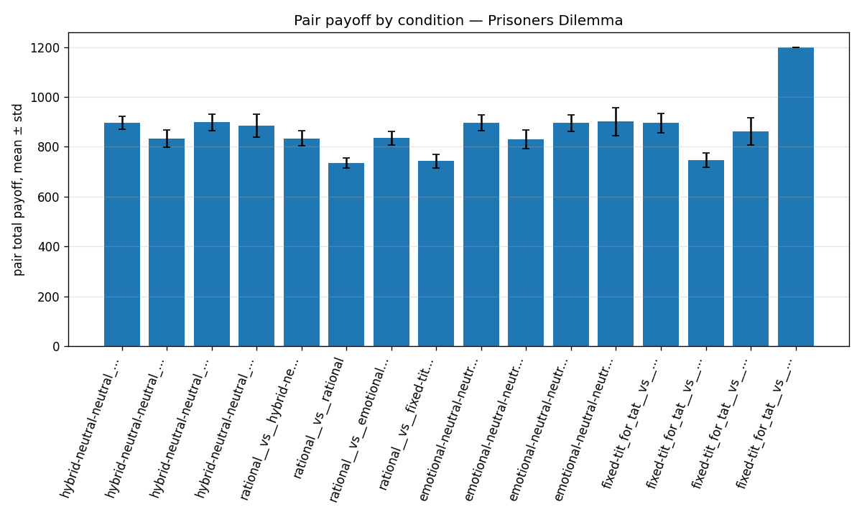
Purpose: S1 matchup matrix: payoff/internal state/game-specific metric
payoff_bar_Battle_of_Sexes.png
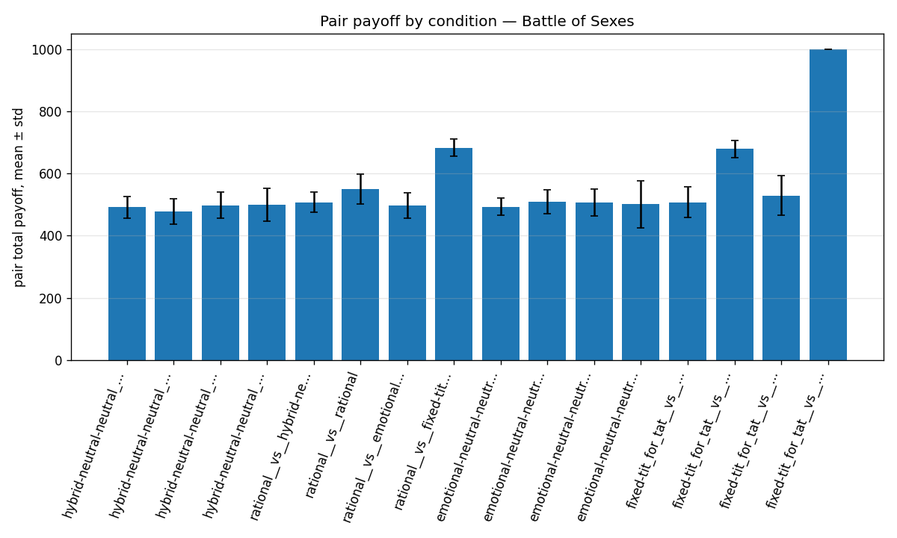
Purpose: S1 matchup matrix: payoff/internal state/game-specific metric
payoff_bar_Ultimatum_Game.png
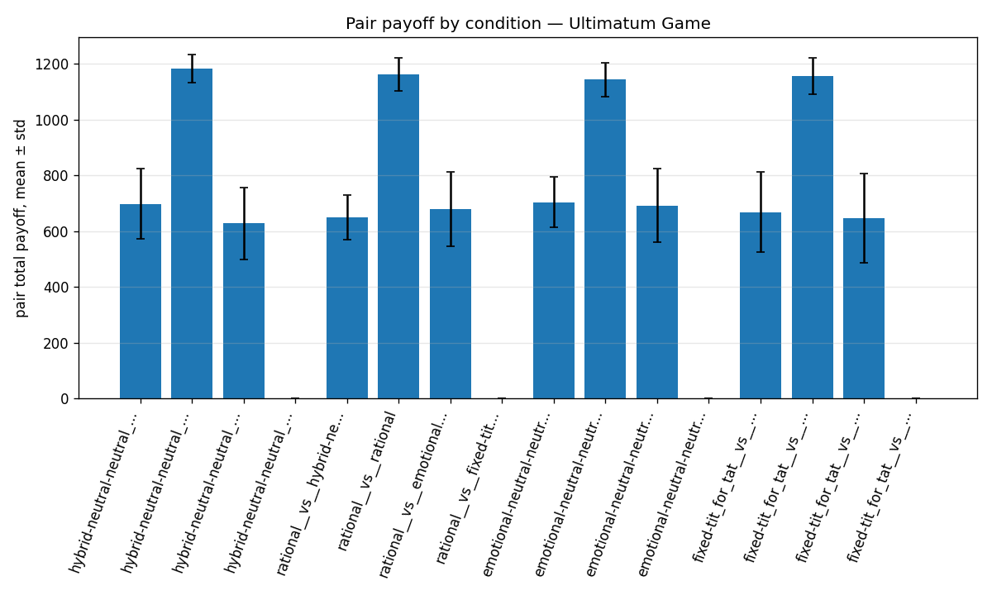
Purpose: S1 matchup matrix: payoff/internal state/game-specific metric
overall_state_bar_Prisoners_Dilemma.png
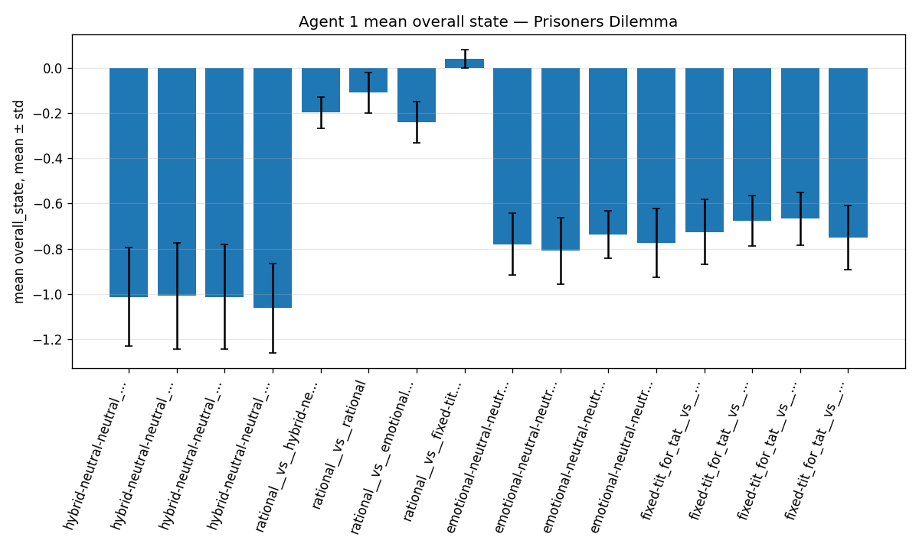
Purpose: S1 matchup matrix: payoff/internal state/game-specific metric
game_metric_Prisoners_Dilemma_pd_mutual_cooperation_rate.png
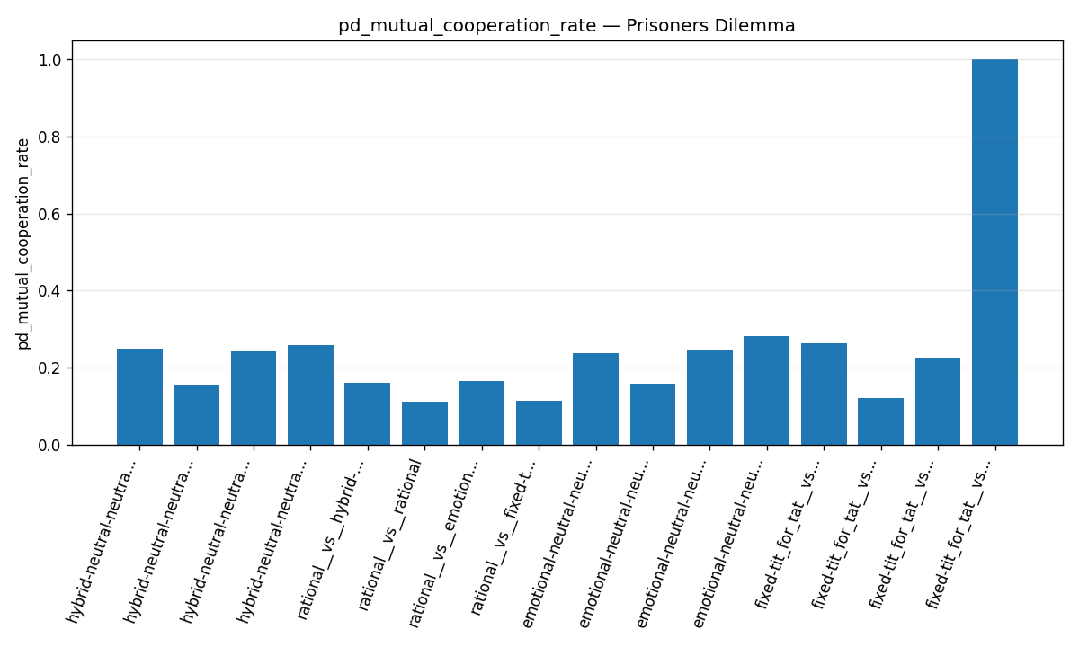
Purpose: S1 matchup matrix: payoff/internal state/game-specific metric
game_metric_Ultimatum_Game_ug_acceptance_rate.png
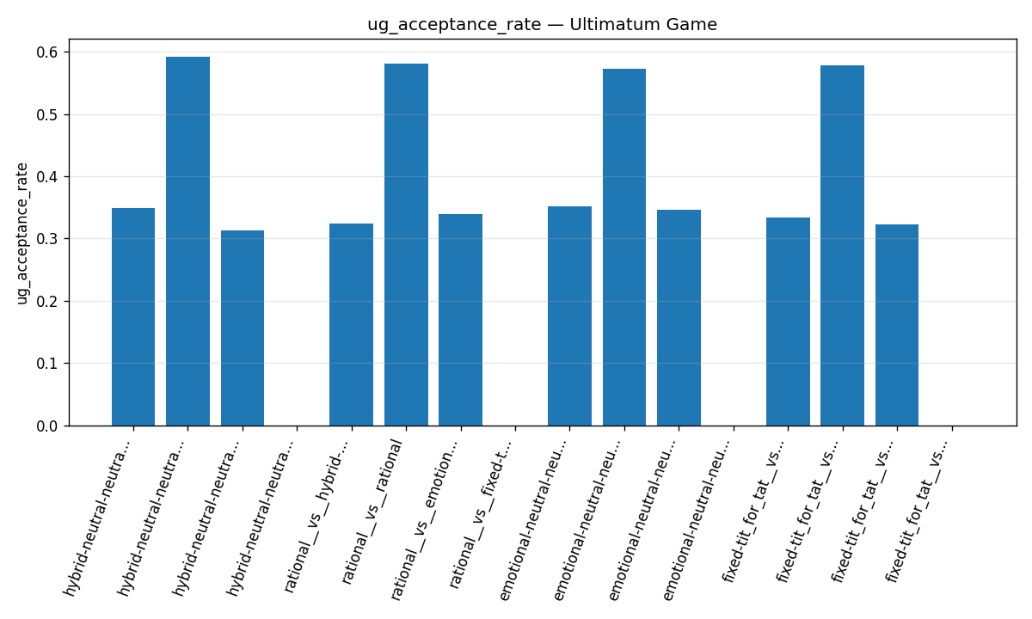
Purpose: S1 matchup matrix: payoff/internal state/game-specific metric
adaptation_first_vs_last.png
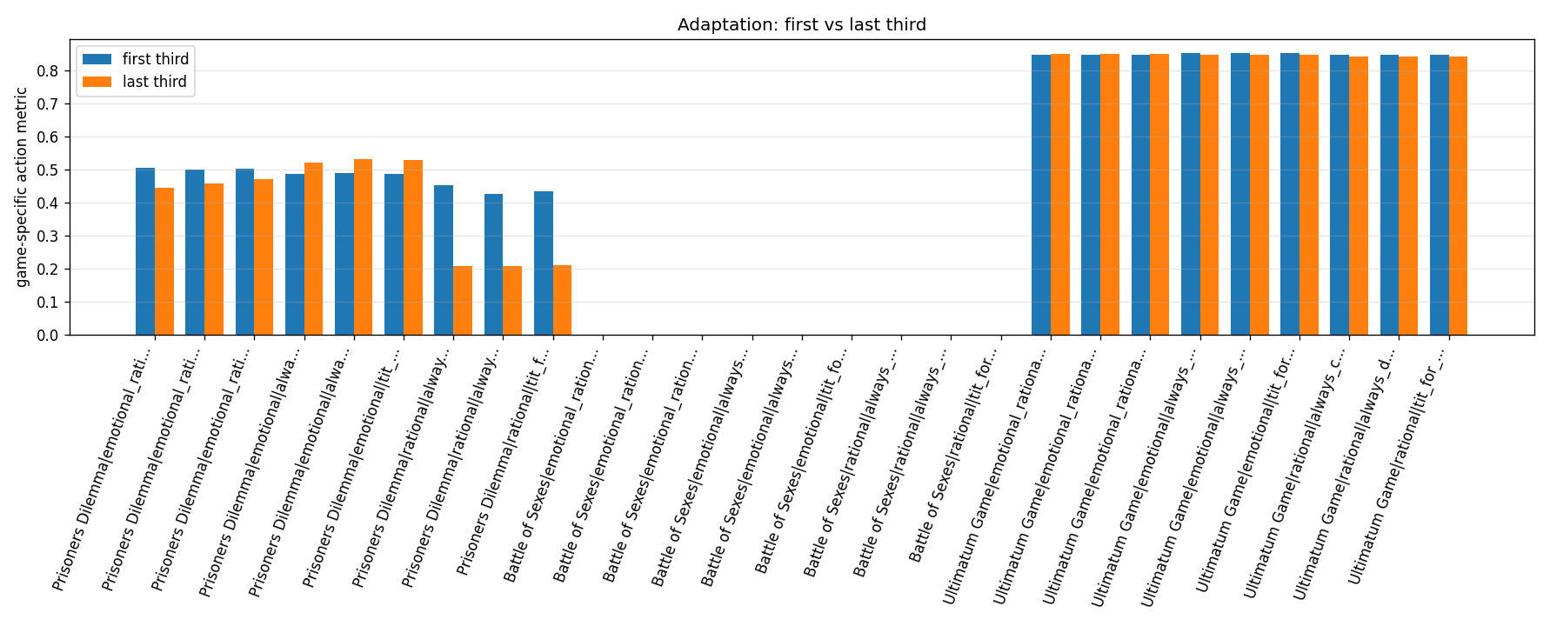
Purpose: S2 adaptation to fixed strategies
20260511_204523_paper_S2__payoff_bar_Prisoners_Dilemma.png
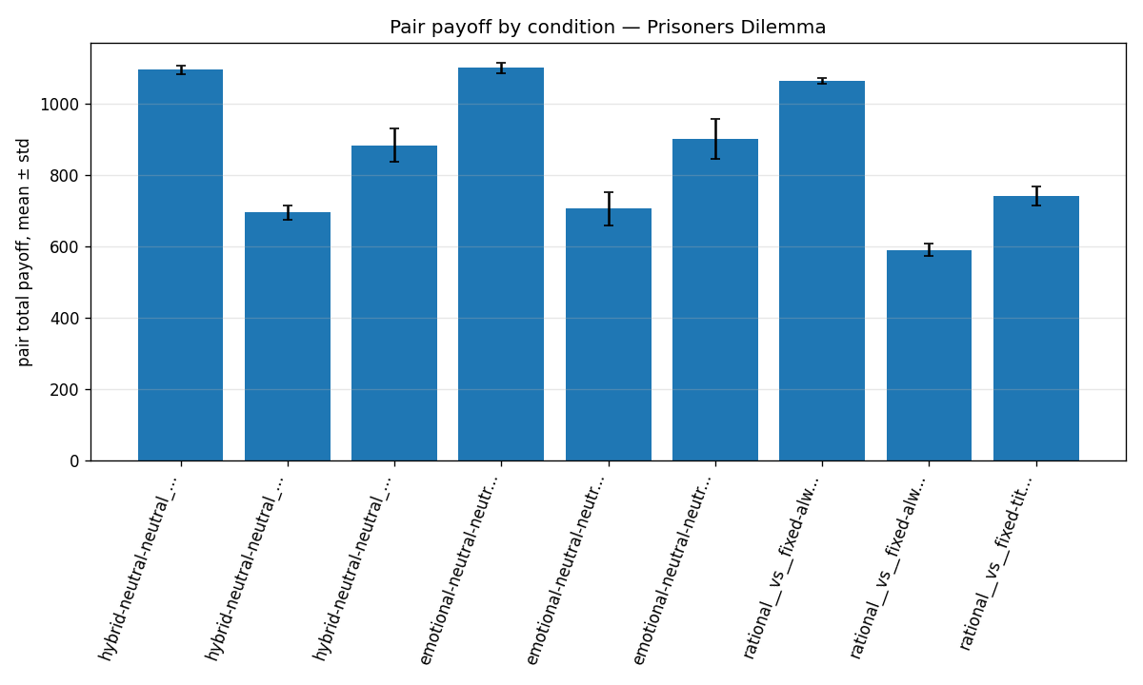
Purpose: S2 adaptation to fixed strategies
20260511_204523_paper_S2__game_metric_Prisoners_Dilemma_pd_mutual_cooperation_rate.png
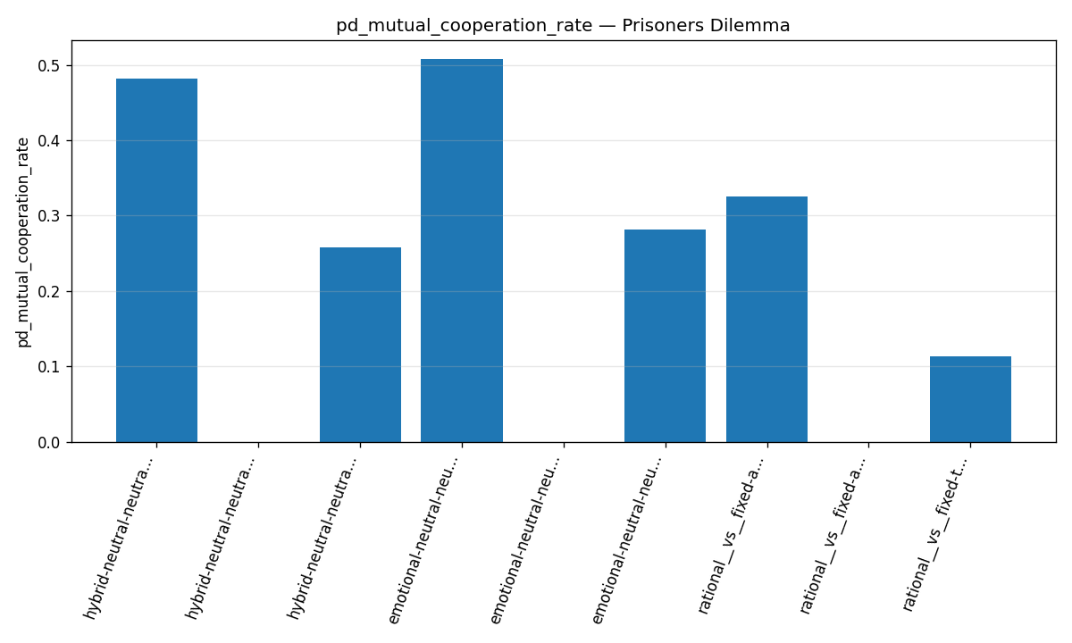
Purpose: S2 adaptation to fixed strategies
S3_heatmap_pair_payoff_Prisoners_Dilemma.png
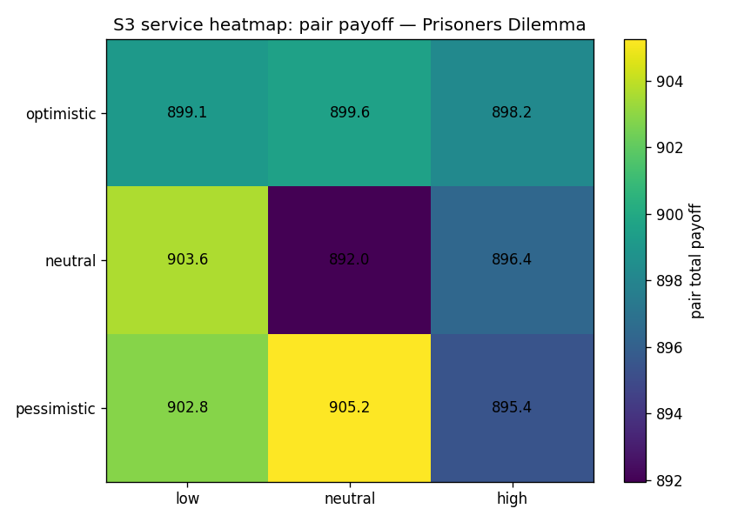
Purpose: S3 personality x intensity core PD

