Assignment 1

1. L1 - Demonstrate the AWS EC2 Ubuntu Instance Creation steps and connect to EC2 Instance using Mobaxterm/putty agent.

* Step 1 - Login aws console.
* Step 2 - Search Ec2 Service and click on Ec2 Instance.
* Step 3 – Click on “Launch Ec2 Insance”.
* Step 4 – Fill all the necessary field
  + Name – Ubuntu
  + Select AMI (ubuntu)
  + Select Instance type (t2.micro)
  + Create a new Key pair .pem file
  + Give storage 8 GiB gp3
  + Network settings
    - Select network
    - Select subnet group
    - Create a new security group
* SSH,HTTP
* Step 5 – Click on “Launch Instance”.

Connecting Instance using putty

* + - Give Host name in Session.
      * Hostname is public IP of the instance.
    - Click “+ SSH”
    - Click on “Auth”
    - On the Right sight Click on “Browser” and select ppk key converted using puttygen

- After that Click on “Open”.

- Give user name as “ubuntu”.

Finally you are connected with your ubuntu instance.

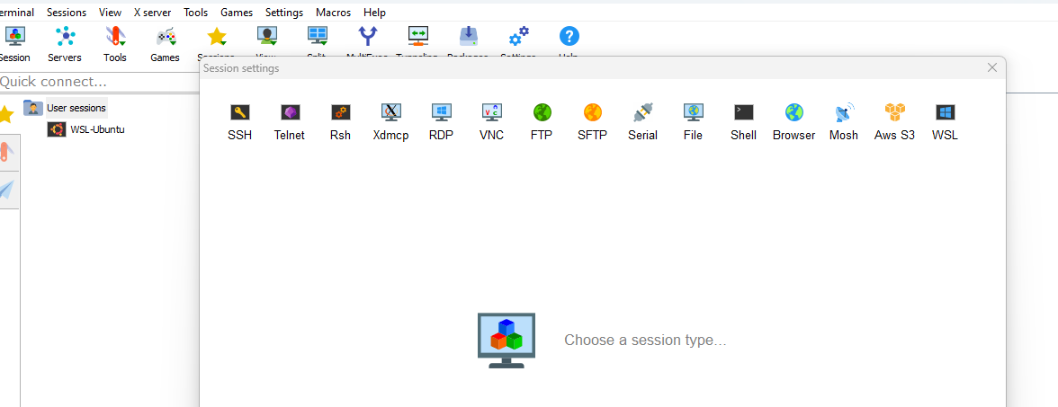

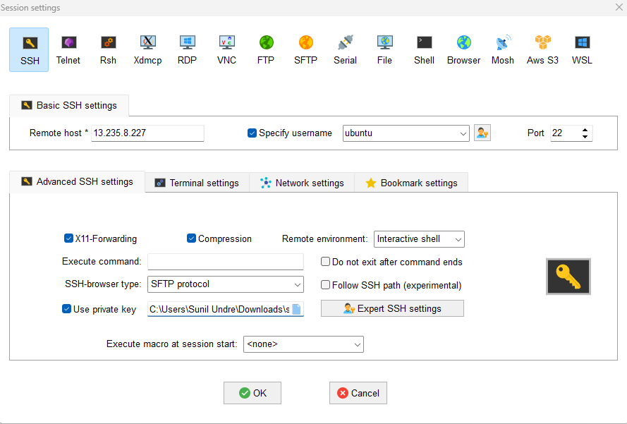

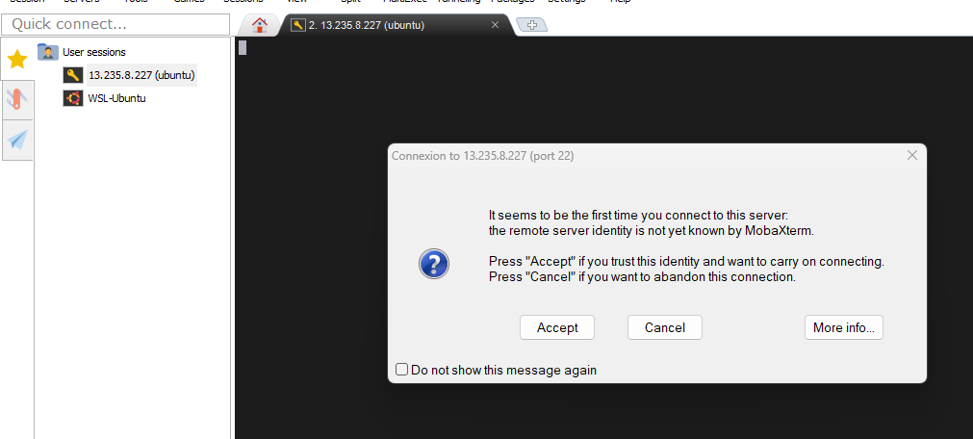

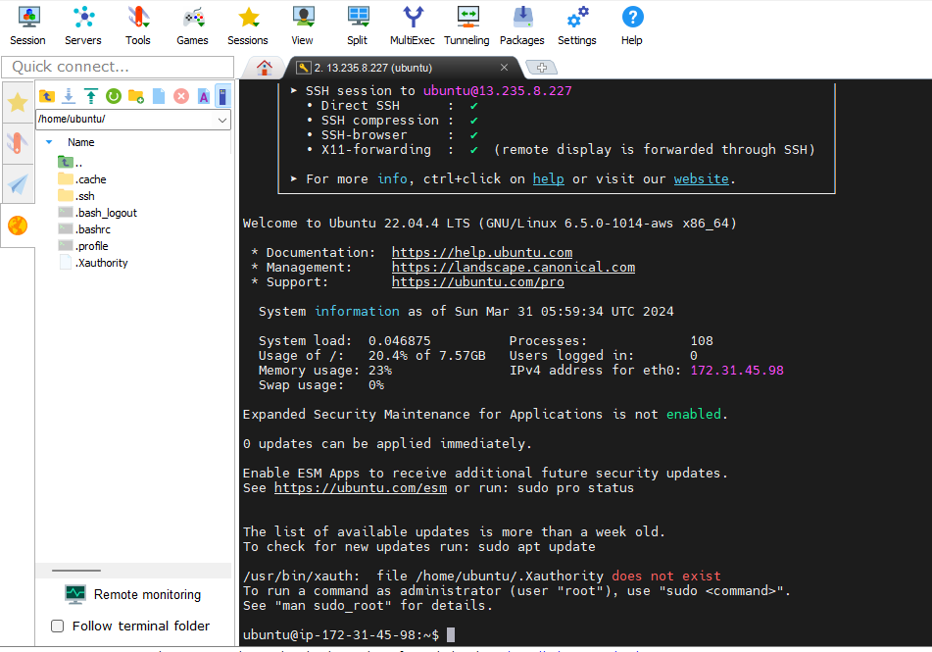

2. L2 - Login to AWS Console and Create IAM User, Role, and Group

In the following image shows dashboard of IAM (Identity Access and Management).

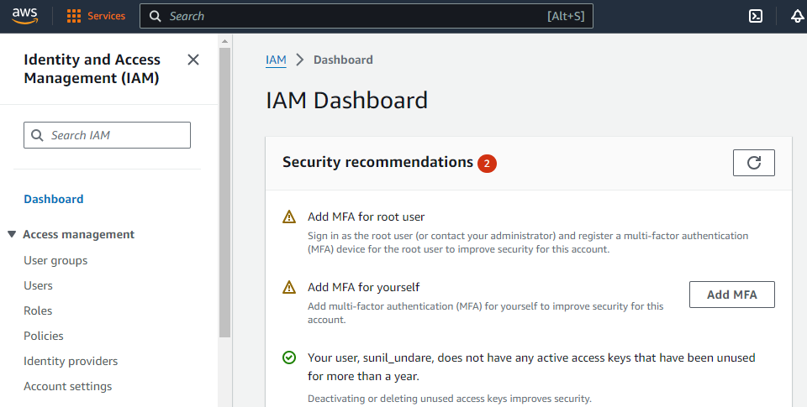

Click on User and create a new IAM User.

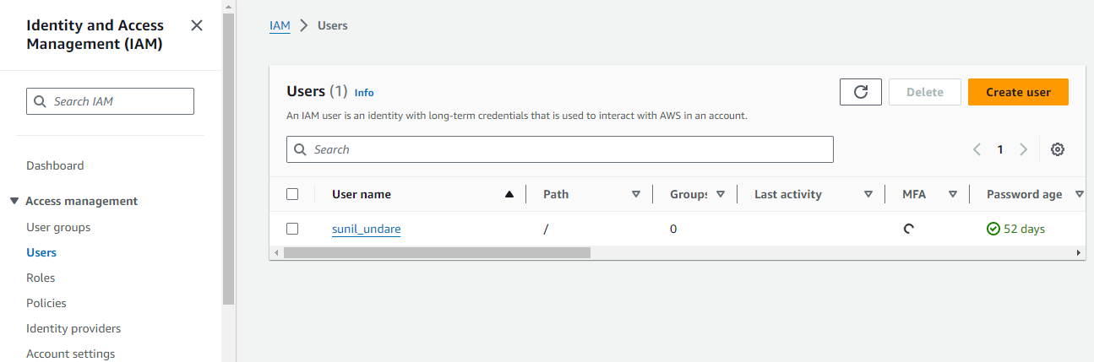

Give us User Name and click on AWS Management console Access, Click on Auto generated password

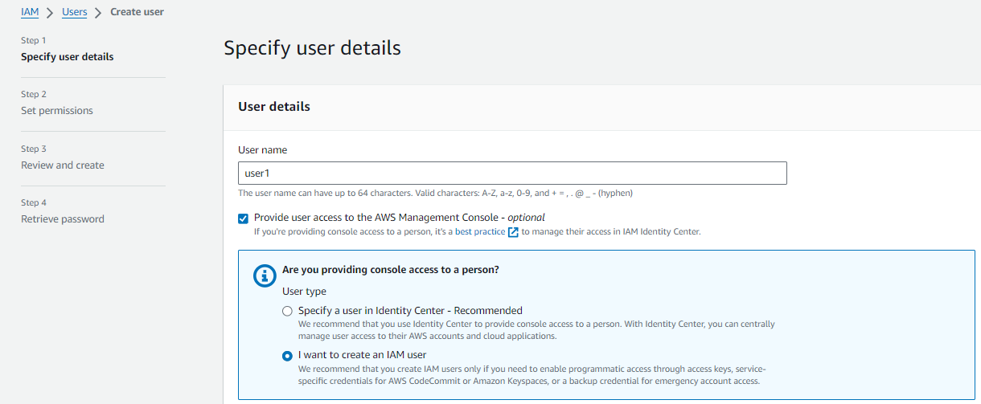

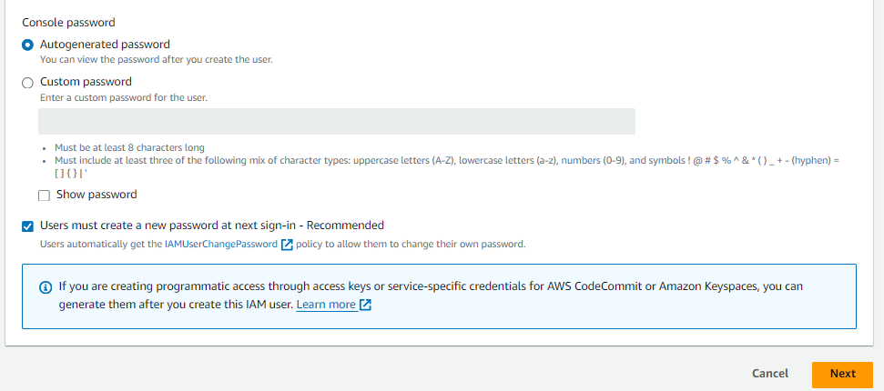

Click on Create User.

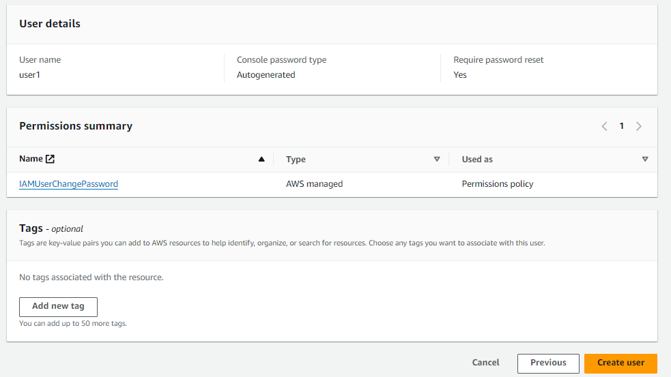

We have seen Console sign-in URL, User Name and Password.

Note: = Must download .csv file, if we are not download file.

Password do not show again.

User is created.

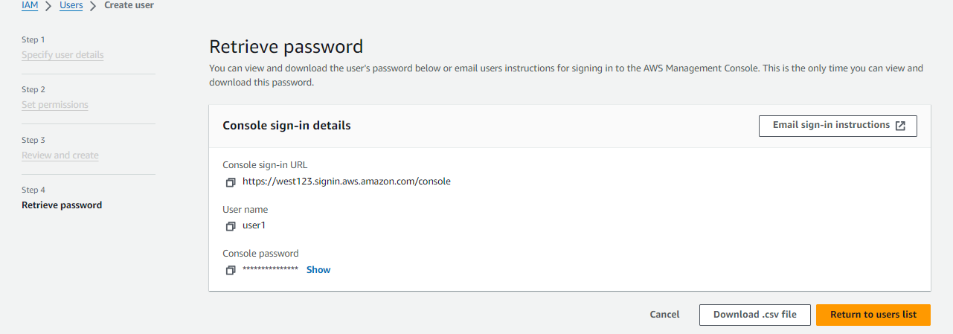

Click on Group, 🡪 click on “Create Group”.

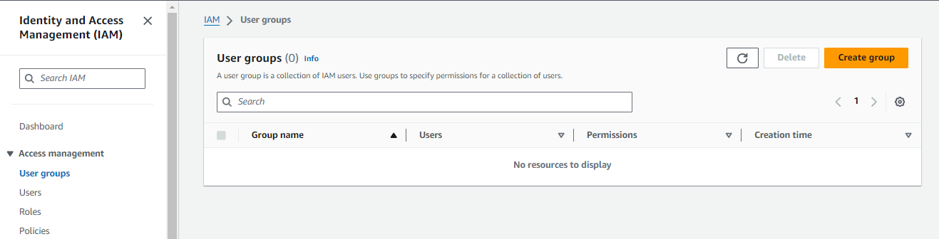

Give it Group Name, Select User which you want to assign in that group.

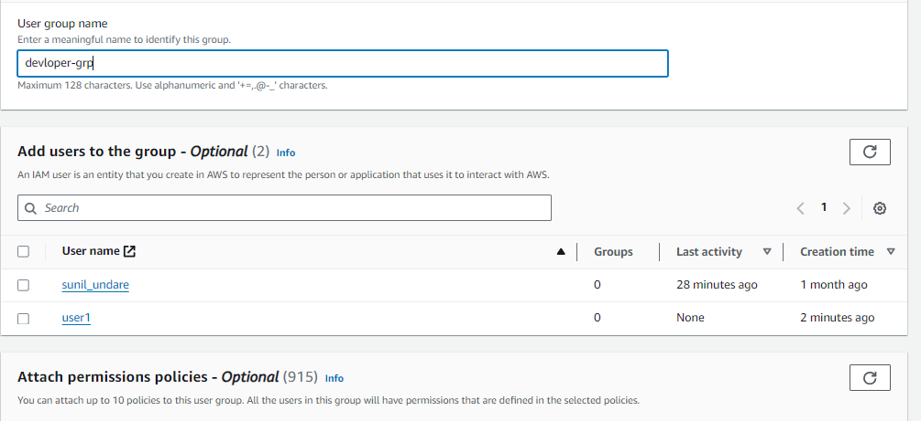

Select policy for the group.

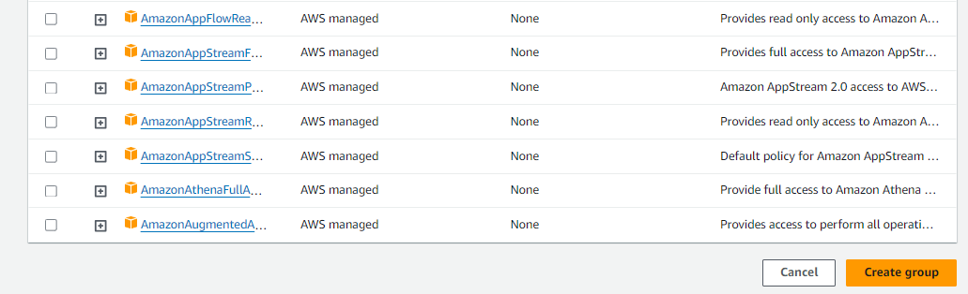

Group is created.

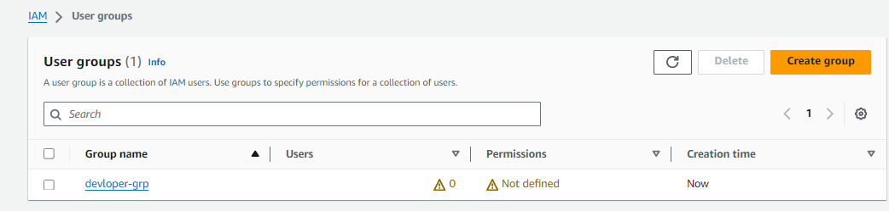

Select User.

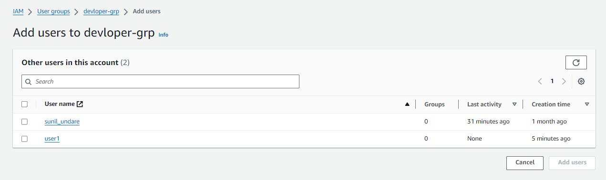

User added.

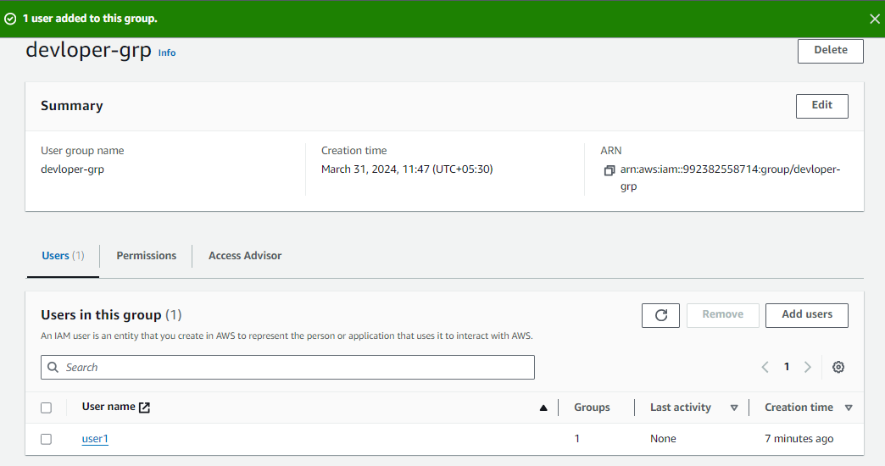

Click on Roles 🡪 Click on “Create role”

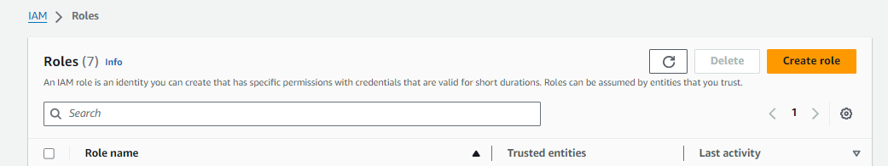

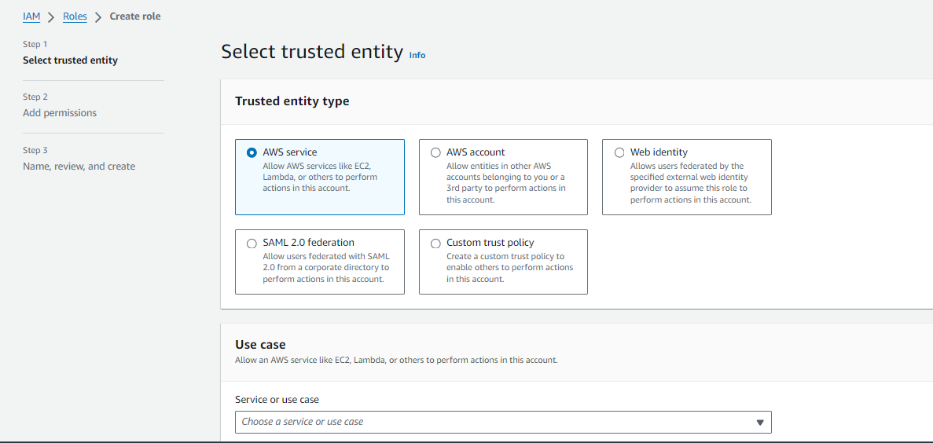

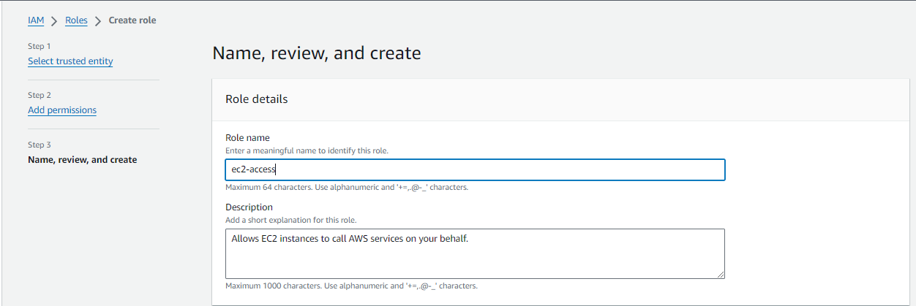

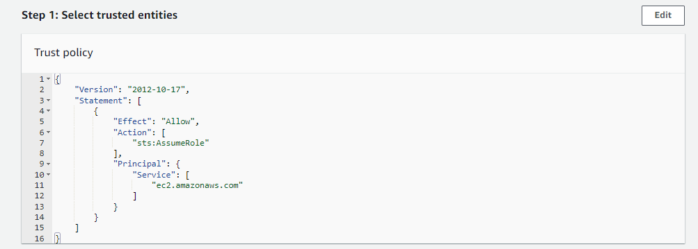

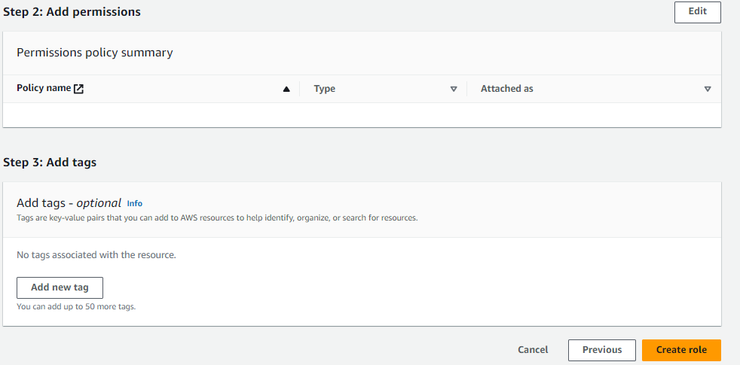

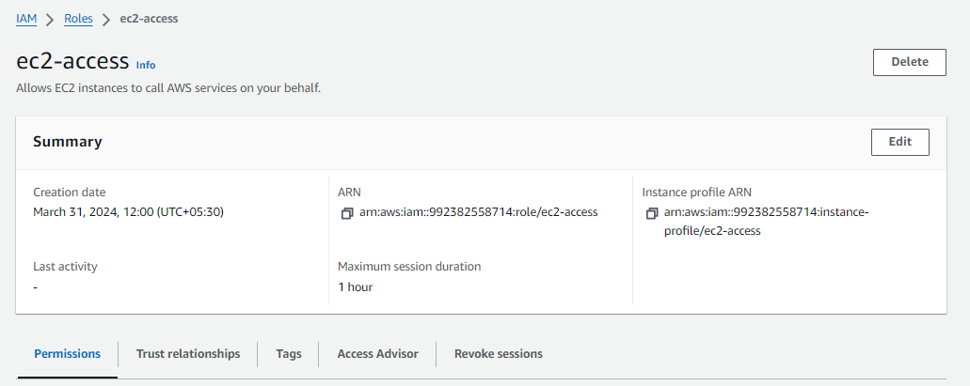

3. L3 - Launch AWS EC2 Ubuntu Instance and configure the Security Group - Inbound Rule:8080.

Justify the usage of Inbound Rules

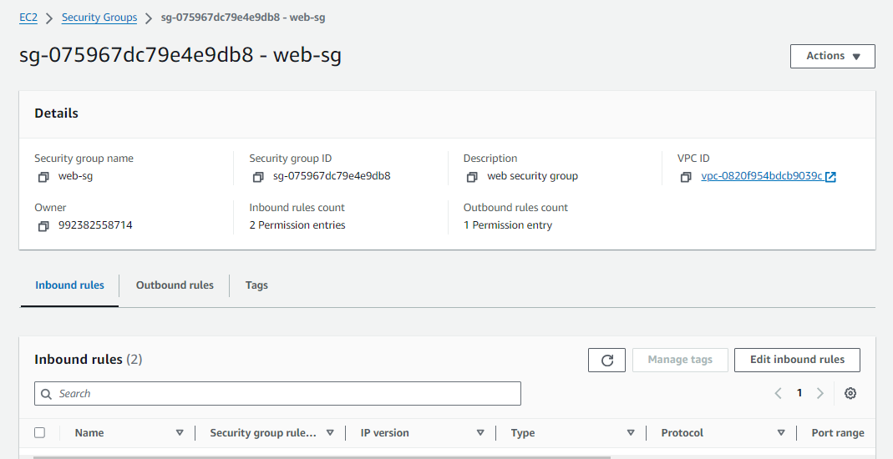

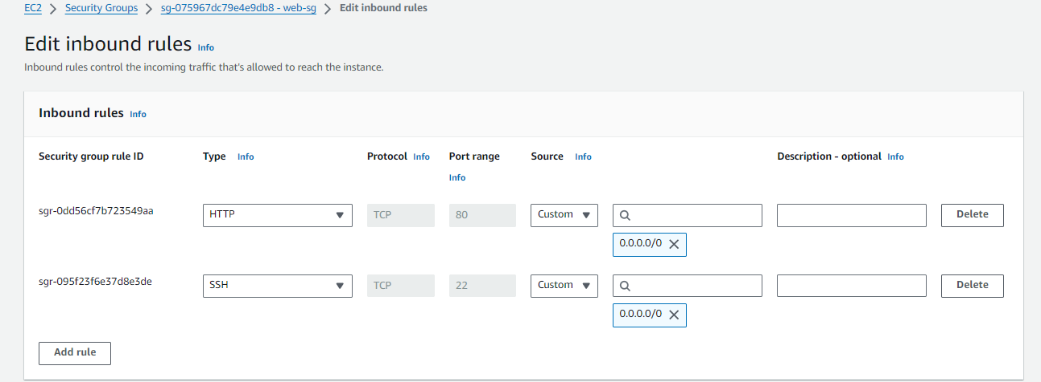

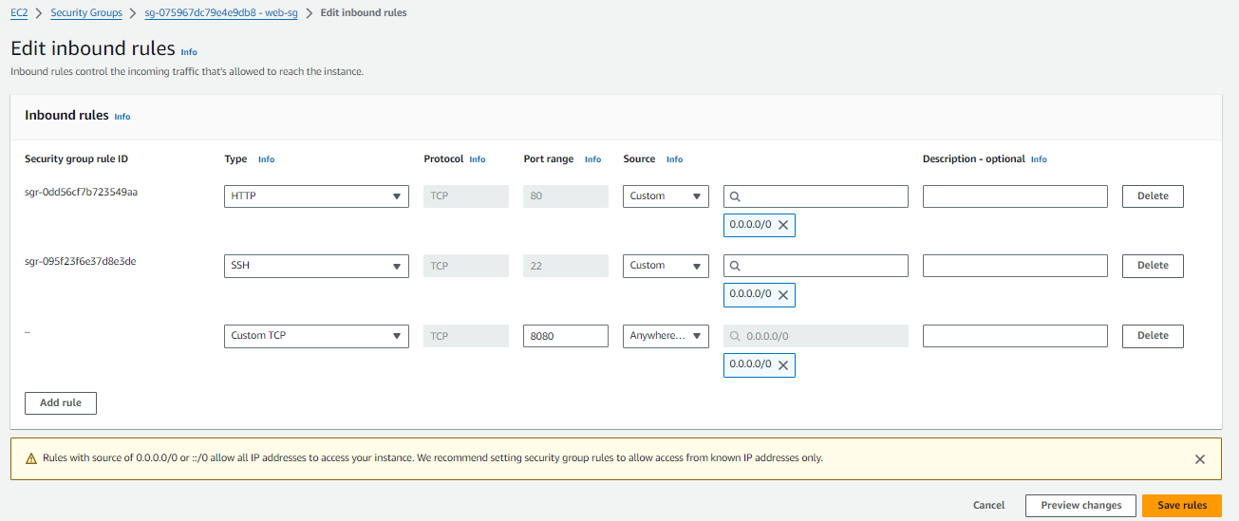

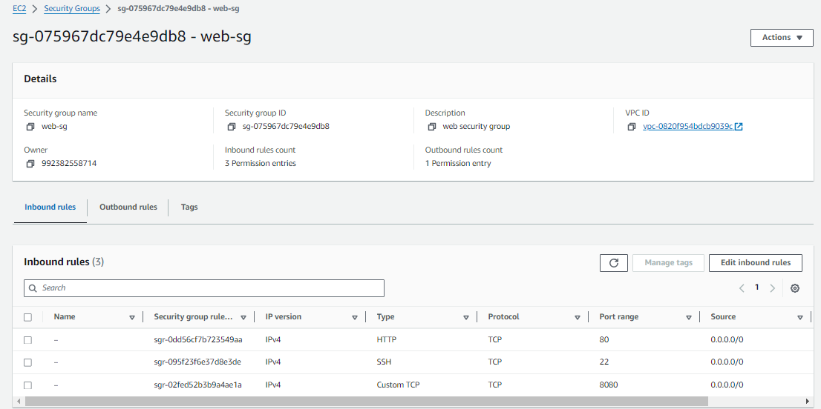

4. L4 - Connect to the AWS EC2 Ubuntu Instance and Update default packages, install JDK, Maven,

Git, and validate the versions

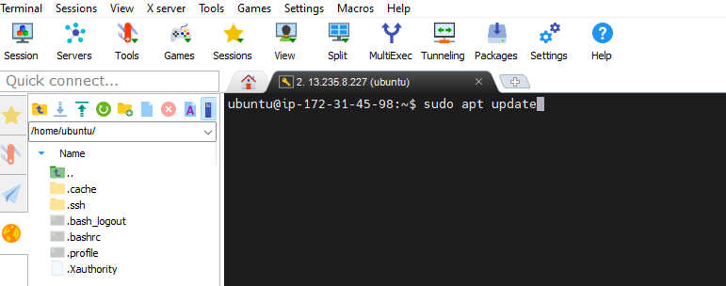

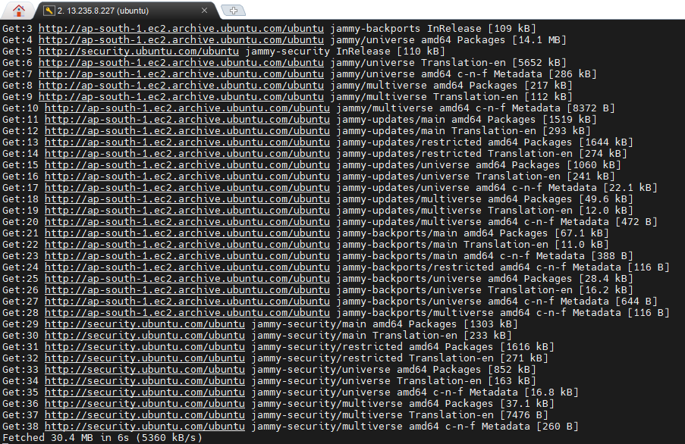

sudo apt install default-jre

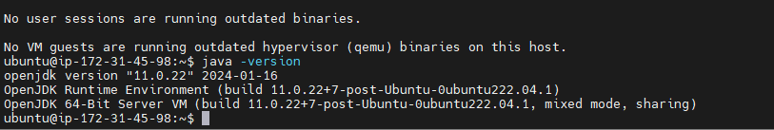

Using this document I have installed java and maven.

Link: = https://www.digitalocean.com/community/tutorials/install-maven-linux-ubuntu#step-3-verify-the-java-installation

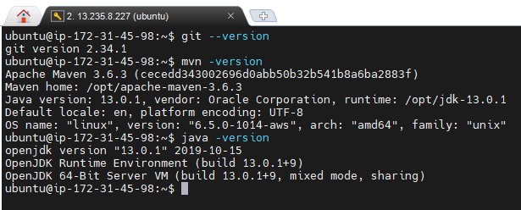

5. L5 - Install Tomcat web application server in AWS EC2 Ubuntu Instance and access Tomcat using a web browser

Using the below link I have install apache tomcat.

Link = <https://www.webhi.com/how-to/how-to-install-tomcat-on-ubuntu/>

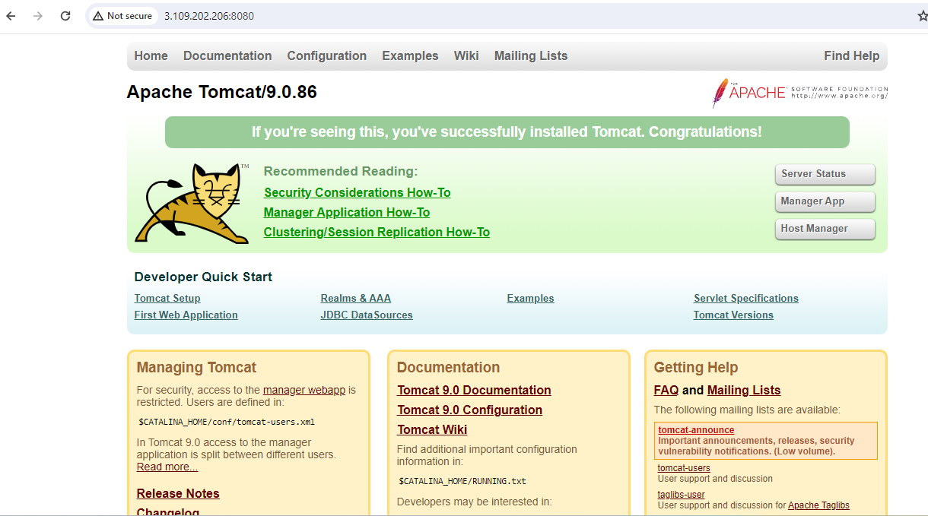

6. L6 - Create S3 Bucket and add folders and files

