**1. Decoding Life Signals Lab Alpha Wave Detection**

1.1 Data analysis tasks

Alpha waves analysis

|  |  |  |  |  |  |
| --- | --- | --- | --- | --- | --- |
| Number | Open/Closed | Time span | App. amplitude | Peak frequency | Relative power of alpha band to other bands |
| 1 | Open | 0:00-0:31 | ~30uV | 7Hz | Similar |
| 2 | Closed | 0:31-0:49 | ~40uV | 11Hz | Peaks an order of magnitude higher |
| 3 | Open | 0:49-1:32 | ~25uV | 5Hz | Similar/slightly lower |
| 4 | Closed | 1:32-2:05 | ~45uV | 11Hz | Similar, but peaks and go above other bands |
| 5 | Open | 2:05-2:23 | ~35uV | 4Hz | Lower |
| 6 | Closed | 2:23-2:31 | ~40uV | 9Hz | Similar/slightly higher |
| 7 | Open | 2:31-2:50 | ~20uV | 6Hz | Lower |
| 8 | Closed | 2:50-3:26 | ~45uV | 10Hz | Higher |

Channel comparison

a) Occipital channel has stronger alpha response than frontal. Right hemisphere has stronger alpha response than left hemisphere.

b) The strongest alpha response is found in occipital channel. It is likely because the occipital lobe is the visual processing brain area.

1.2 Questions to answer

1.2.1 Basic observation questions

a) The approximate frequency of the alpha rhythm is 10Hz. It is not consistent as it fluctuates throughout the recording between 9 and 11 Hz.

b) Alpha activity raises by app. 40% during eyes-closed compared to eyes-open.

c) Alpha rhythm appears and disappears after 1-2s after the transition between the states

d) Yes, I did notice some alpha-blocking events. I think it may be attributed to random events or noise that appears randomly, but I am not sure what those might be.

1.2.2 Signal processing questions

a) After applying the filters, alpha waves became easily distinguishable. With no filters, waves were very scattered.

b) App. Peak frequency in the FFT plot was 12Hz

c) When transitioning from eyes-closed to eyes-open, colors in the alpha band shifted from green/yellow to blue, and vice versa.

d) Eyes-open heights were visibly larger

1.3 Screenshots

1.3.1 Examples of transition between states

Example 1. Open -> Closed

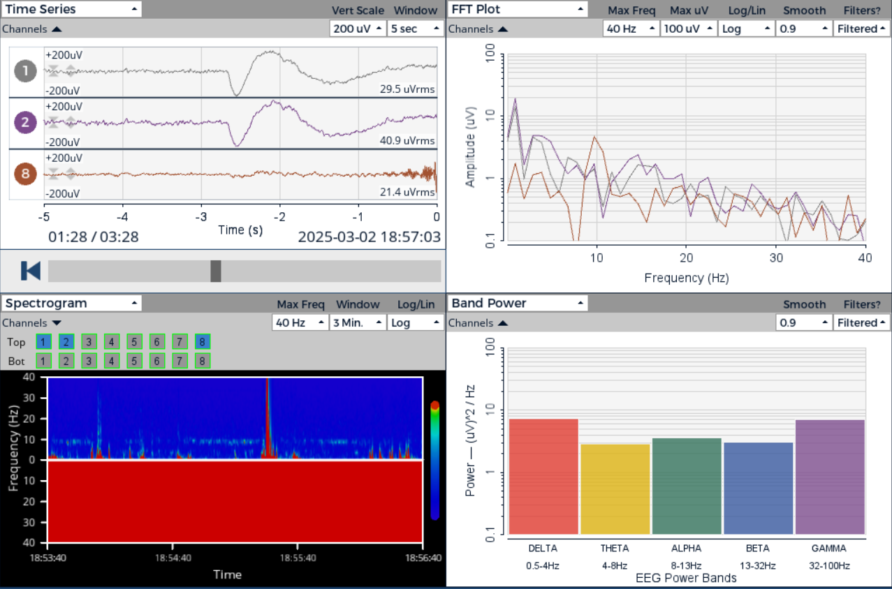

Example 2. Closed -> Open

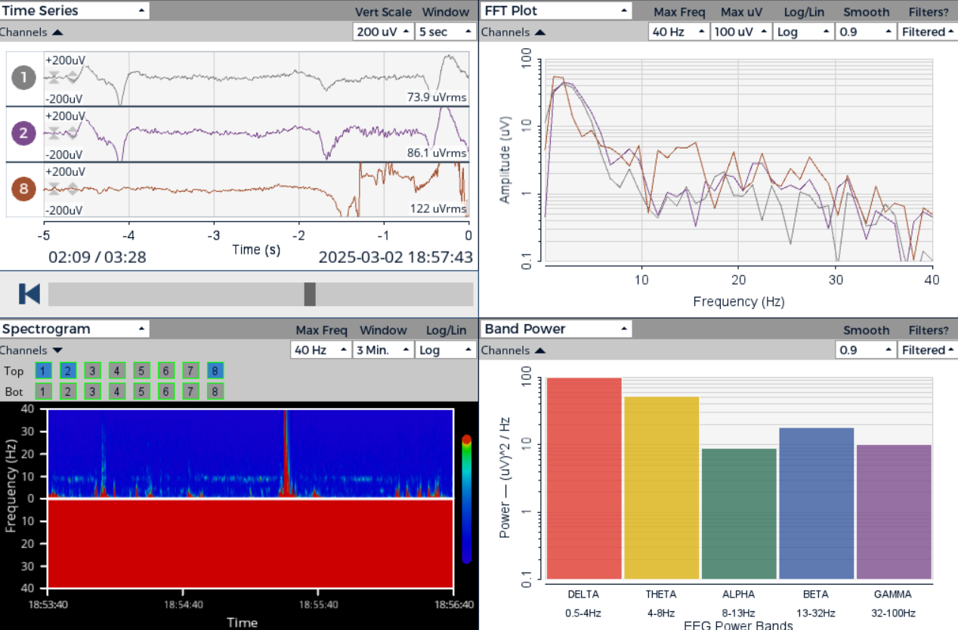

Example 3. Open -> Closed

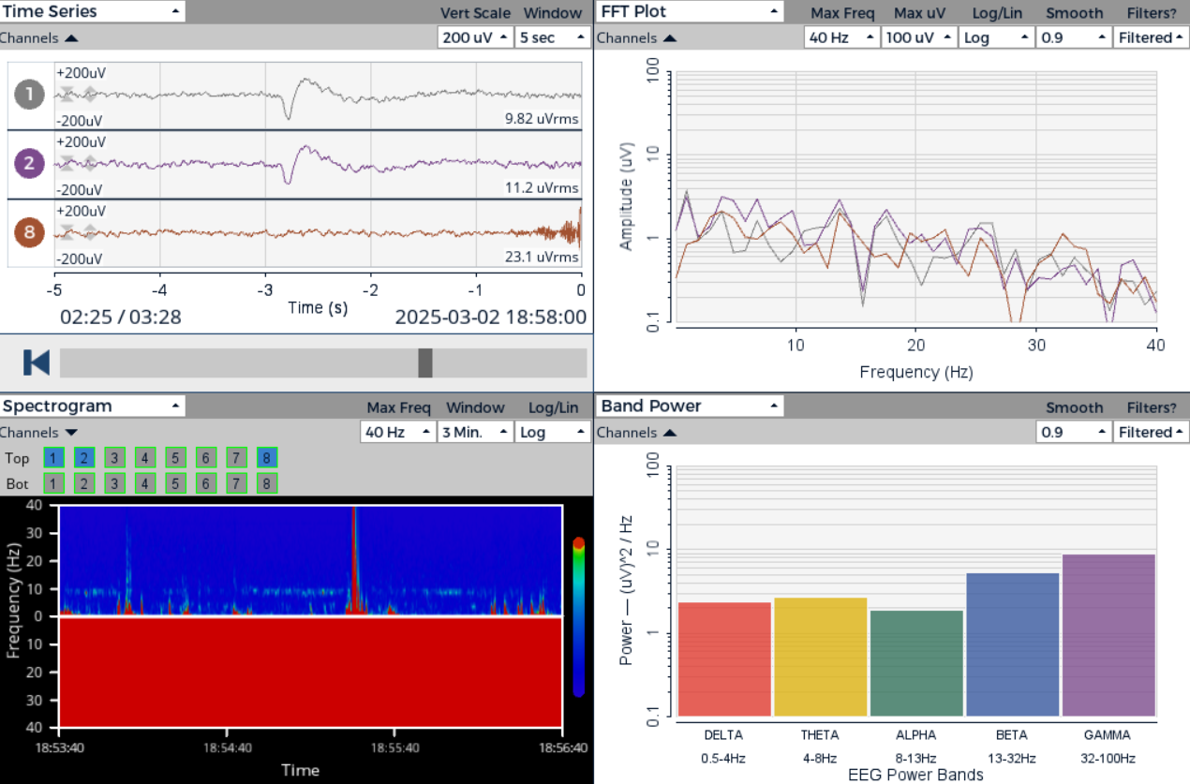

1.3.2 Other screenshots

a) Time Series, alpha waves present

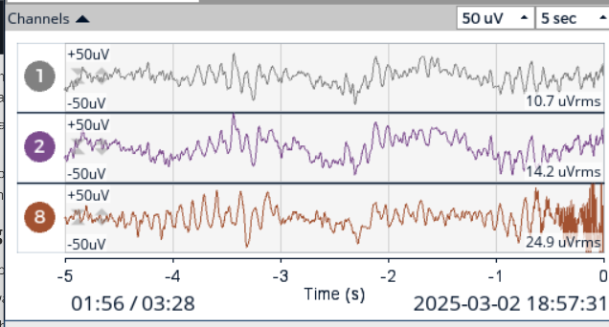

b) Time Series, alpha waves absent

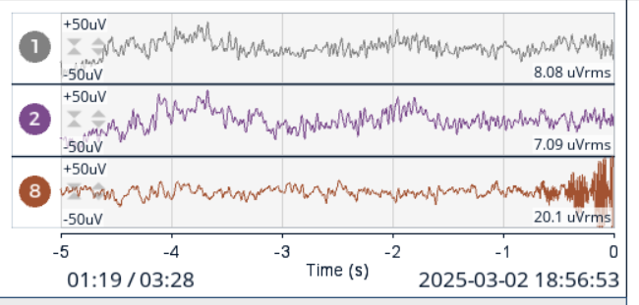

c) FFT Plot, alpha peak

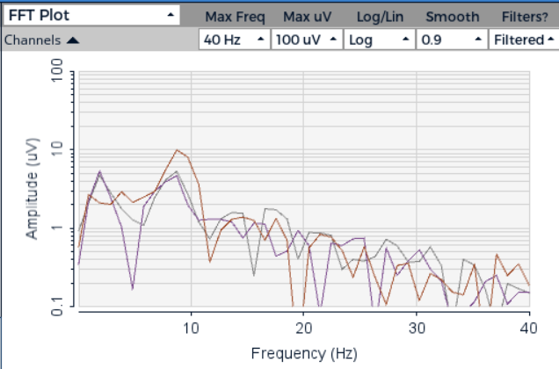

d) Spectrogram, alpha changes (close -> open)

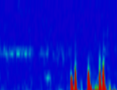

e) Band Power, eyes-open

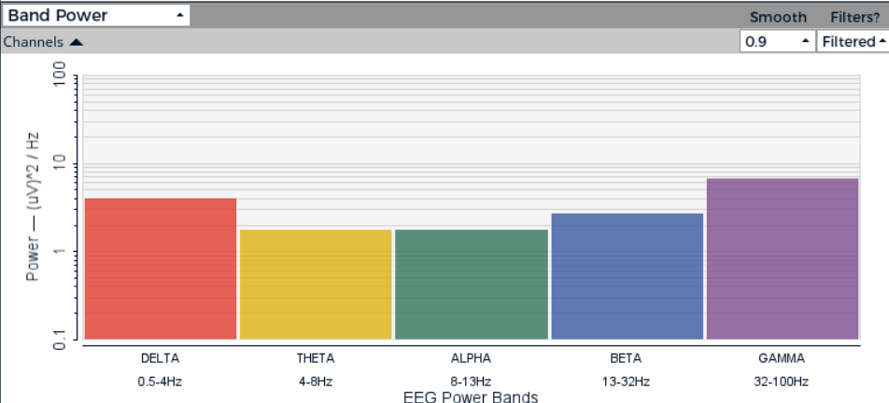

f) Band Power, eyes-closed

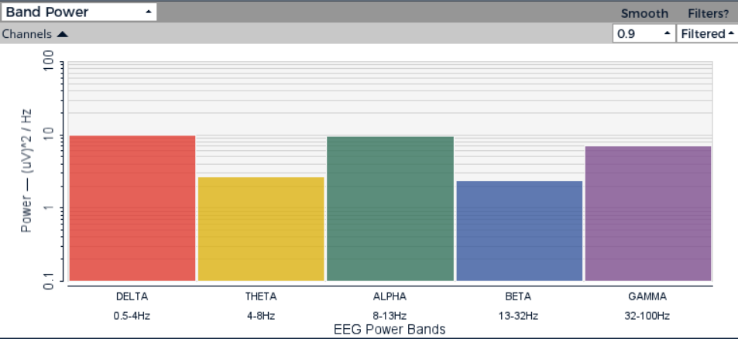

2. **Decoding Life Signals Lab EEG Signal Analysis.pdf**

2.1 Mental states

|  |  |  |  |  |
| --- | --- | --- | --- | --- |
| Mental state | Time stamp | FFT Plot | Spectrogram | Band Power |
| Relaxation | 0:00-1:14 |  |  |  |
| Arithmetic | 1:14-1:28 |  |  |  |
| Reading | 1:28-2:40 |  |  |  |

Alpha/beta ratio:

* Relaxation: alpha raises much above beta, but also goes lower
* Arithmetic: almost 1-1, both are high
* Reading: almost 1-1, both are low

Frequency band that displayed the most significant difference between states was theta.

2.2 Questions to answer

2.2.1 EEG Pattern Analysis

a) metal state: relaxation. Channel: 8

b) For both it was static, but for arithmetic it was much higher

c) Theta was low for relaxation, then it rose for arithmetic, and was fluctuating in reading

d) Fp1 and Fp1 were more susceptible to noise and changes in delta and theta were more visible there. O1 showed changes resulting from different mental states more prominently and the same goes for changes in alpha channel.

2.2.2 Signal characteristics

a) For Fp1 and Fp2 it was 0.5-4Hz. For O1 it was 8-13Hz.

b) There were artifacts, present mainly in Fp1 and Fp2.

c) Spectrogram was the most useful in identifying different states because each mental states left its own distinctive mark, visible in the spectrogram. Moreover, spectrogram showed changes over a long period of time so the transition between mental states was easily traceable.

2.2.3 Morse Code Challenge.

a) EUNICE (. ..- -. .. -.-. .)

b) Short blinks lasted app. 0.5s, while long blinks lasted app. 2s

c) In later part of the recording, I had a problem distinguishing between end of a blink and the start of the next one because they became very long near the end.

Summary: I learned that the more demanding task a person does, the more prominent that brain wave patterns become.

3. **Decoding Life Signals Lab EMG Hidden Message**

2.1 Decoding questions

a) EUNICE (. ..- -. .. -.-. .)

b) Dashes were 2.5-3 times as long

c) Compared to the EEG signal, decoding EMG signal was pretty straightforward. I got it right on the first try.

d) If someone is non-verbal, for whatever reason, it can help them communicate through the means of muscle contractions

2.2 Signal analysis

a) The differences weren't visible, unless I'm mistaken what an EMG envelope is.

b) 38-42Hz and 25-35Hz

c) Muscles contractions causes spikes in frequency that last appropriately longer for long contractions (dashes). Message is easily decodable even in spectrogram. Frequencies range between 50 and 75 Hz.

d) In 10s window, short pauses were visually amplifies (i.e. break between signal, not letters) compared to the length of long pauses and you could see the transition between letters more clearly.

e) Filter weren't needed as the message was easily decodable without them.

4. **Decoding Life Signals Lab ECG Heart Rate Variability Challenge**

4.1 Data analysis

|  |  |  |  |
| --- | --- | --- | --- |
| Breathing pattern | Estimated BPM | Spectrogram | FFT Plot (peak frequency) |
| Normal | 72 | Regular, high red spikes (freq. up to ~22Hz). Green endings (freq. up to ~25Hz) | 7-8Hz |
| Slow | 66 | Groups of red spikes as with normal breathing, but visible gaps between those groups | 7-8Hz |
| Rapid | 84 | Regular spikes of red with green (much more green for lower freq. as compared with normal breathing) | 8-9Hz |
| Hold | 78 | Red color vanishes significantly (visible long gaps) | 8-9Hz |
| Normal 2 | 72 | Similar to the first | 8-9Hz |

4.2 Questions to answer

a) Highest: rapid breathing. Lowest: slow breathing

b) Greatest heart rate variability: slow

c) 5s

d) Slow and rapid: amplitude was jumping up and down like crazy

e) Yes, respiratory influence on heart rate in spectrogram is tangible. This is because the frequencies and their respective power (amount and height of red and green color) changes prominently.