6.0 Design

6.1 Design Strategies

An identified problem is that this as ideal as the current system can get. Not every teacher follows the exact same procedure as the other and may lead to an omission of a step such as a teacher who does not have his/her own electronic database, etc. Consequently, the result is inconsistency in the data. Students claiming they were never absent, the registrar holding different data from the teacher, and so on. These problems are more frequent than what is desirable.

The complete automation of the system in order to eliminate as much error as possible is the goal. Majority of the process will be done by the card reader, the PCs, the school’s network, and the database server(s). The student will manually let his/her ID be scanned.

Finally, the typical problem among students is the case of truancy. In the case of the Integrated School in De La Salle Canlubang, attendance is only checked in the morning by the class advisor. Once the student is marked as absent by the advisor in the morning, he/she is considered absent the whole day. So the mentality is: *might as well be actually absent anyway*; or, once the attendance is finished, there is no one to check whether the student stayed during classes or not.

The process must be repeated *twice*: one for time-in, the other for time-out. It is a way to avoid truancy as well as maintain the integrity of the system for the sake of the parents/guardians.

The time & attendance system may be physically implemented within classrooms, at the buildings’ entrances, or at the gate.

There is currently no centralized database system in DLSU STC LVLC. We propose a database that will centralize time and attendance data. Further expansion of the centralized system will be in the hands of the administration.

The use of a working barcode on the students’ ID or the RFID will automate the process of time and attendance check.

6.2 Data Specifications

6.2.1 Entity-Relationship Diagram*

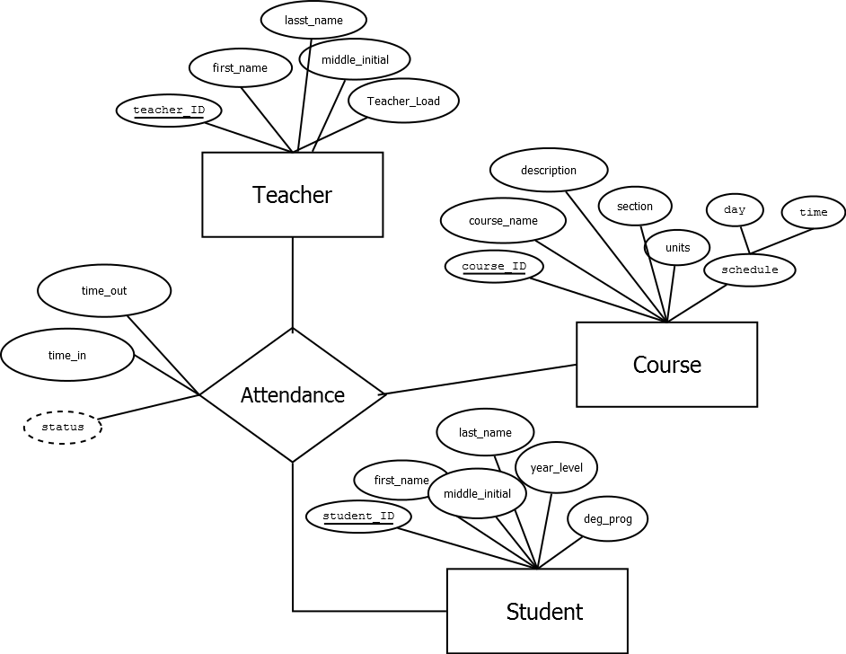

6.2.2 Tables/Files Layout*

|  |  |  |  |  |
| --- | --- | --- | --- | --- |
| ***STUDENT*** |  |  |  |  |
| **Field Name** | **Description** | **Type (Length)** | **Default Value** | **Accepted Values** |
| student_ID | ID# spefically assigned by the school to a single student | char(12) | none | numbers from 0 to 9; an exactly 12-digit number that consists of the following format: [year enrolled/transferred] + 074 + [unique 5-digits] (e.g., 201207408479) |
| first_name | first name of the student | varchar(40) | none | up to 40 characters consisting of only the letters A-Z(also a-z) and period(.) for titles (e.g., Ma., Jr., ...) |
| middle_initial | middle initial/s of the student | varchar(3) | none | up to 3 characters consisting of only the letters from A-Z |
| last_name | surname of the student | varchar(30) | none | up to 40 characters consisting of only the letters A-Z(also a-z) |
| year_level | year level of the student | enum | none | predefined values which are: '1', '2', '3', '4', 'terminal' |
| deg_prog | degree program of the student | enum | none | predefined values which are: 'BSCS', 'BSIS', 'BSBAOM', 'ABCA', 'BSECE', 'BSIE', 'BSCOE' |

|  |  |  |  |  |
| --- | --- | --- | --- | --- |
| ***TEACHER*** |  |  |  |  |
| **Field Name** | **Description** | **Type (Length)** | **Default Value** | **Accepted Values** |
| teacher_ID | ID# spefically assigned by the school to a single teacher | char(12) | none | numbers from 0 to 9; an exactly 12-digit number that consists of the following format: [year enrolled/transferred] + 174 + [unique 5-digits] (e.g., 200207408479) |
| first_name | first name of the teacher | varchar(40) | none | up to 40 characters consisting of only the letters A-Z(also a-z) and period(.) for titles (e.g., Ma., Jr., ...) |
| middle_initial | middle initial/s of the teacher | varchar(3) | none | up to 3 characters consisting of only the letters from A-Z |
| last_name | surname of the teacher | varchar(30) | none | up to 40 characters consisting of only the letters A-Z(also a-z) |
| teacher_load | current load(# of units teaching) of the teacher | varchar(2) | 3 | minimum of 3 units load and maximum of 15 units |

|  |  |  |  |  |
| --- | --- | --- | --- | --- |
| ***COURSE*** |  |  |  |  |
| **Field Name** | **Description** | **Type (Length)** | **Default Value** | **Accepted Values** |
| course_ID | ID# specifically assigned to the course | char(12) | none | numbers from 0 to 9 |
| course_name | name of the course | varchar(40) | none | up to 40 characters consisting of only the letters A-Z(also a-z) and period(.) for titles (e.g., Ma., Jr., ...) |
| description | description of the course | varchar(200) | none | up to 200 characters consisting of alphanumeric characters (A-Z, 0-9) |
| class_section | section number of the course | char(1) | 1 | numbers from 0 to 9 |
| units | units of the course | char(1) | 0 | numbers from 0 to 9 |

|  |  |  |  |  |
| --- | --- | --- | --- | --- |
| ***Attendance*** |  |  |  |  |
| **Field Name** | **Description** | **Type (Length)** | **Default Value** | **Accepted Values** |
| course_ID | ID# specifically assigned to a course | char(12) | none | numbers from 0 to 9 |
| teacher_ID | ID# spefically assigned by the school to a single teacher | char(12) | none | numbers from 0 to 9; an exactly 12-digit number that consists of the following format: [year enrolled/transferred] + 174 + [unique 5-digits] (e.g., 200207408479) |
| student_ID | ID# spefically assigned by the school to a single student | char(12) | none | numbers from 0 to 9; an exactly 12-digit number that consists of the following format: [year enrolled/transferred] + 074 + [unique 5-digits] (e.g., 201207408479) |
| time_in | time the student 'attended' the class | timestamp | none |  |
| status | indicates whether the student is considered absent, late, or present | enum | absent | predefined values which are: 'absent', 'late', 'present' |
| type | indicates whether the class at that given time was a regular, makeup, or alternative class | enum | regular | predefined values which are: 'regular', 'makeup', 'alternative' |

6.2.3 Data Coding Standards

The coding standard in the development of this system utilizes the CamelCase naming convention for objects, functions and variables. In variable naming, we also list what type of JFrame object it is for the GUI.

-lst for Lists

-lbl for Labels that can be changed

-lbl_tag for static Labels

-btn for Buttons

6.3 Screen Specifications

For the system to be optimized, a device with an RFID reader and a screen should be used. The screen should be large enough for the teachers, even the seniors, to read and navigate.

Fonts should be kept simple where the letter “I” and number “1” and other similar characters should be distinct, particularly for the Course Codes.

DLSU-STC logo should be visible but not obstructing the view.

Buttons and other clickable items should have a distinction (underline, different color, and/or borders) to show that they are clickable.

Screens:

*Screen name:* 0.0 Login/Splash page

*File name:*

*Description:* Option to manually type user ID and password or RFID swipe; To be shown when the teacher for that time slot has not logged in.

*Layout:* <2x3 Screenshot>

*Screen name:* 1.0 Attendance

*File name:*

*Description:* Actual attendance sheet for that class for that day; can be sorted; can opt to view previous attendance records; can manually override students’ attendance; swipe RFID of students to get attendance data

*Layout:* <2x3 Screenshot>

*Screen name:* 1.1 Calendar

*File name:*

*Description:* Navigation to view attendance records of previous dates and holidays

*Layout:* <2x3 Screenshot>

6.4 Form Specifications

*Form name:* Attendance

*Description:* Attendance sheet

*Prepared by:* The system

*Used by:* Teachers

*Volume and Frequency:* Class times

*Layout:*

6.5 Report Specifications