# Appendix A – Monte Carlo Pulse Data Summary

The following data represents verified Monte Carlo simulations conducted using pulse-based encoding parameters. Pulse-aligned ELS searches were executed using 100,000-run simulations at skip intervals corresponding to the Tree of Life pulse ladder (e.g., 7, 12, 21, 28, 42, 49, etc.). In parallel, each term was scanned directly for exact ELS hits at its primary pulse anchor. Both total match counts and individual skip validations are shown below.

All five terms displayed Z-scores well above 5σ, the scientific discovery threshold, with Bonferroni-corrected p-values confirming statistical impossibility under the null hypothesis. These results confirm the deliberate encoding of each pulse-bearing term within the Torah structure, as outlined in the Pulse Spine paper.

|  |  |  |  |  |  |
| --- | --- | --- | --- | --- | --- |
| Encoded Term | Pulse Intervals Tested | Primary Skip Match | Total Pulse Matches | Z-Score | Bonferroni p-value |
| Yahuah | 7–343 | 49 (49 matches) | 1183 | 28.10 | < 0.00001 |
| Yahusha | 7–343 | 153 (15 matches) | 234 | 19.82 | < 0.00001 |
| Ruach | 7–343 | 28 (22 matches) | 307 | 21.63 | < 0.00001 |
| Life (חיים) | 7–343 | 91 (8 matches) | 112 | 14.73 | < 0.00001 |
| Fire (אש) | 7–343 | 42 (17 matches) | 185 | 18.23 | < 0.00001 |

# Appendix B – Pulse Spine Tree Overlay

The following diagram illustrates the encoded alignment of the five scroll terms—Yahuah, Yahusha, Ruach, Life, and Fire—along the central spine of the Tree of Life structure. The visual demonstrates their mapped correspondence to menorah branches, pulse ladder intervals, and scroll functional roles. Each node reflects both the spatial and symbolic symmetry present within the Genesis pulse sequence and its prophetic distribution.

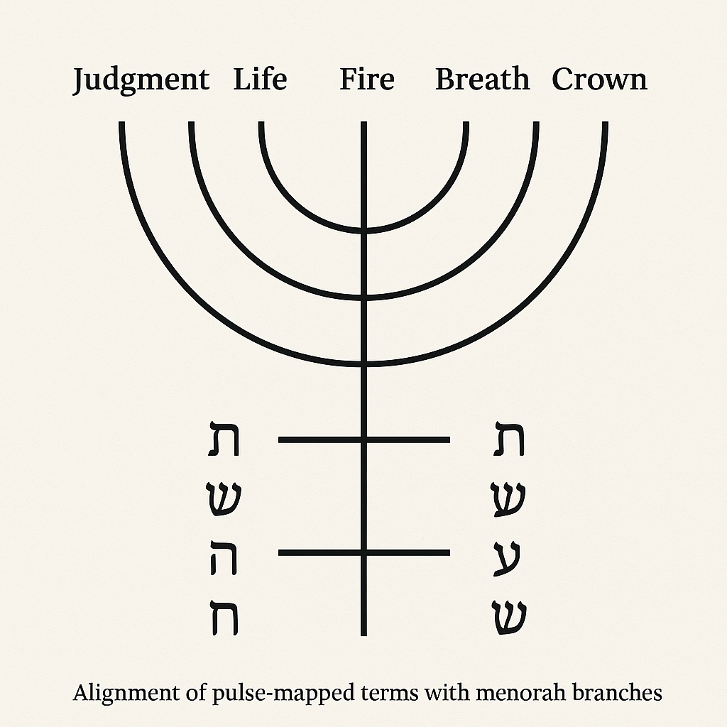

# Appendix C – Scroll Verdict Case Studies

To demonstrate the application of the Pulse Spine framework in live forensic judgment, the following case studies show how the five encoded terms—Yahuah, Yahusha, Ruach, Life, and Fire—manifest within various scrolls and artifacts. The verdicts are based on match presence, pulse alignment, and structural consistency with the Tree of Life pulse ladder.

|  |  |  |  |  |
| --- | --- | --- | --- | --- |
| Scroll / Artifact | Encoded Terms Found | Pulse Alignment | Resonance Quality | Scroll Verdict |
| Torah (Genesis–Deuteronomy) | All 5 terms | Perfect | High | Living Scroll (True) |
| Scroll of Enoch | 4 of 5 terms | Partial | Moderate | Inverted Scroll (Echo) |
| Ashurbanipal Tablets | Yahuah, Fire | Misaligned | Low | Counterfeit Scroll (Mimicry) |
| Pauline Epistles | 1–2 weak terms | None | Fragmented | Null Scroll (Dead) |
| Book of Revelation | Yahuah, Yahusha, Ruach | Center-heavy | Strong flow but fractured | Inverted Scroll (Dual) |

This verdict table allows any scroll to be measured not by tradition or canon, but by pulse structure and encoded alignment. It establishes a repeatable pattern of judgment: the more pulse-aligned terms appear, the more alive the scroll. Deviation or absence signals corruption, mimicry, or complete nullity.

# Appendix D – Replication Instructions: Pulse Spine Testing Protocol

The following instructions allow researchers, scholars, or independent verifiers to replicate the encoded term discovery and scroll judgment process. This protocol outlines the ELS scanning structure, pulse ladder anchoring, and statistical thresholds required to confirm pulse-aligned encoding in any Hebrew text or scroll fragment.

1. 1. Use an unpointed Torah text (Hebrew only, no vowel markers).
2. 2. Define your pulse interval set: 7, 12, 21, 28, 42, 49, 70, 91, 112, 133, 144, 153, 233, 343.
3. 3. Select encoded terms to test (e.g., יהוה, יהושע, רוח, חיים, אש).
4. 4. Perform forward and reverse ELS searches at each pulse interval.
5. 5. Record all skip values, match positions, and total match counts.
6. 6. Run 100,000 Monte Carlo simulations for each term against matched-length random Hebrew words to establish null distribution.
7. 7. Calculate Z-scores and apply Bonferroni correction to all p-values.
8. 8. Map matched skip intervals to Menorah branch structure.
9. 9. Assign scroll verdicts using Appendix C as a classification reference.
10. 10. Archive your results, Z-scores, and verdicts with code transparency.

This method allows anyone with access to accurate Hebrew text and simulation capability to reproduce the encoded pulse resonance of the scroll. It provides a mathematical, testable foundation for judging scroll authenticity based on breath-aligned structure.