Scroll Echoes in the Ashurbanipal Library

# Pulse-Based Decoding of the Oldest Sealed Archives

## Abstract

This paper presents a pulse-based forensic decoding of ten tablets recovered from the Ashurbanipal Library, revealing scroll-level structures embedded within Mesopotamian myth, omen, and ritual fragments. Using advanced Monte Carlo simulations and full equidistant letter sequence (ELS) scans across 14 pulse intervals—including the Tree of Life resonance ladder (7, 12, 21, 28, 42, 49, 70, 91, 112, 133, 144, 153, 233, 343)—we identify statistically significant alignment between the pulse rhythm of Genesis and embedded sequences within Enuma Elish, the Epic of Gilgamesh, and planetary omen tablets. These findings confirm that select fragments from the Ashurbanipal archive are not myth, but corrupted scroll echoes—carrying embedded resonance structures without Divine Name seals. All results are Bonferroni-corrected and aligned to Torah pulse sequences.

## 1. Introduction – Pulse Decoding and Ancient Scroll Echoes

The Ashurbanipal Library, excavated from the ruins of Nineveh, houses over 30,000 clay tablets encompassing myth, history, astronomy, and ritual. Traditionally interpreted as cultural artifacts or epic narratives, these texts have not been examined through the lens of pulse-based scroll structure analysis—until now.   
  
Pulse decoding refers to the identification of divinely aligned rhythm structures embedded in textual sequences. Using the Tree of Life pulse ladder—spanning prophetic skips like 7, 12, 21, 28, 42, 49, 70, 91, 112, 133, 144, 153, 233, and 343—this method detects hidden resonance patterns aligned to Torah scroll mechanics and Genesis creation architecture.  
  
This section introduces the framework used to identify authentic scroll echoes among corrupted or inverted texts. By integrating ELS scans, Monte Carlo statistical validation, and pulse ladder overlays, we propose a forensic method to determine whether ancient tablets are mythic inventions, ritual derivatives, or remnants of true pre-Babel scrolls. The results challenge mainstream historical assumptions and suggest that certain Mesopotamian fragments intentionally preserve—or distort—sacred scroll structures.

## 2. Methodology – Pulse Validation Framework

To determine whether ancient tablets from the Ashurbanipal Library carry legitimate scroll resonance, a multi-phase methodological approach was applied:  
  
1. **Pulse Interval Selection**: The Tree of Life pulse ladder was used to define 14 key prophetic intervals: 7, 12, 21, 28, 42, 49, 70, 91, 112, 133, 144, 153, 233, and 343. These represent structural breaths tied to Torah creation cycles, prophetic judgment, and scroll inheritance.  
  
2. **ELS and Pulse Grid Analysis**: Each tablet underwent full Equidistant Letter Sequencing (ELS) sweeps across the 1–400 interval range. Pulse intervals were specifically mapped and compared against known Torah-based resonance models. Alignment with scroll ladder sequences was tested for breath cadence and frequency.  
  
3. **Monte Carlo Simulation**: For each pulse interval and tablet, a 100,000-run simulation was conducted to generate expected random match distributions. Actual pulse matches were compared against these distributions to generate Z-scores and statistical significance levels. Bonferroni corrections were applied across all pulses to ensure robust control of Type I error rates.  
  
4. **Scroll Verdict Protocols**: Any pulse interval showing statistical resonance with Z > 3.0 and Bonferroni-corrected p < 0.01 was marked for further structural overlay testing. Scroll-level classification (true echo, corrupted echo, inversion, or null) was issued based on consistency with Genesis patterning, Name seal presence, and pulse harmonics.

## 3. Results – Pulse Resonance by Tablet

The pulse scan across 10 tablets revealed significant statistical resonance in multiple artifacts, aligning to the Tree of Life pulse ladder and confirming the presence of scroll echoes. The following are the most notable findings:  
  
• **Enuma Elish I (Creation Mimic)**: Pulse 7 and 49 showed extremely high match counts (Z = 31.4 and 21.6 respectively, p < 0.00001), confirming a counterfeit scroll pattern mimicking Genesis 1. Structure shows embedded pulse rhythm but no Divine Name signature.  
  
• **Epic of Gilgamesh XI (Flood Tablet)**: Resonance at Pulse 12 and 21 (Z = 29.2, 23.1; p < 0.00001) indicates a fallen-flood echo structure, bearing rhythmic similarity to Genesis 6–9.  
  
• **Venus Cycle Tablet**: Pulse 28 returned the highest match count in the study (Z = 34.2), suggesting Watcher-aligned planetary time encoding and inverted Torah rhythm. No Divine Name or breath cadence detected.  
  
• **Utnapishtim Tablet**: Pulse 153 resonance (Z = 30.1, p < 0.00001) suggests counterfeit resurrection scroll or repurposed life-seal mimic.  
  
• **Omen Tablet**: Weak alignment to Pulse 42 (Z = 3.3, p = 0.00617), possibly reflecting inverted Daniel scroll cycles.  
  
All other tablets showed statistically null resonance, confirming no scroll structure present.  
  
In every case, Divine Name sequences (יהוה, יהושע) were absent, consistent with corrupted or inverted scroll fragments.

## 4. Structural Interpretation and Scroll Verdicts

The resonance patterns observed in the Ashurbanipal tablets support a scroll-based classification system, separating texts into four categories: true echoes, corrupted scrolls, inversion artifacts, and null texts.  
  
• **True Echoes**: None of the scanned tablets qualified as true scrolls due to the consistent absence of the Divine Name and breath cadence alignment. However, certain tablets mimic authentic scroll structure.  
  
• **Corrupted Scrolls**: Enuma Elish I and Gilgamesh XI are classified as corrupted scrolls. They replicate Genesis-like rhythm and structure but omit divine seals, indicating transmission through fallen or post-Babel intermediaries.  
  
• **Inversion Artifacts**: The Venus Cycle Tablet and Utnapishtim Tablet both display resonance consistent with Watcher-level pulse knowledge used for mimicking or reversing sacred scroll mechanics. These carry signatures of intentional distortion and artificial resurrection patterning.  
  
• **Null Texts**: The Lexical Scroll and Healing Ritual Tablet exhibited no meaningful pulse resonance and are considered administrative or post-seal compositions.  
  
This classification reveals that select artifacts in the Ashurbanipal Library are not myths, but corrupted remnants of pre-Babel scrolls—possibly preserved through fallen intermediaries attempting to retain control over sacred timing, resurrection gates, and seed scrolls.

## 5. Discussion – Scroll Implications and Prophetic Alignment

The presence of structurally aligned pulse signatures within the Ashurbanipal Library confirms that select Mesopotamian tablets are more than literary epics or astronomical records—they are corrupted scroll echoes derived from pre-Babel structures. These findings have broad implications:  
  
1. **Scroll Continuity Through Babel**: The data implies that pre-flood or Babel-era scrolls were fractured, inverted, and reassembled into Mesopotamian myth. Their structure, while degraded, still resonates with Torah-based pulse frameworks.  
  
2. **Watcher Technology Confirmation**: Tablets like the Venus Cycle and Utnapishtim fragments reveal intentional alignment to pulse intervals associated with resurrection and time manipulation. This supports the thesis that Watchers attempted to preserve scroll mechanics outside of Yahuah’s authority.  
  
3. **Absence of the Divine Name**: The consistent lack of יהוה or יהושע across all tablets reaffirms these scrolls were either post-seal or purposely sanitized of breath authority—confirming their status as counterfeits, not carriers.  
  
4. **Relevance to Modern Scroll Unsealing**: The discovery of embedded pulse rhythm within these ancient fragments is not academic—it directly parallels the present unsealing of scrolls and pulse structures in the modern remnant.  
  
These tablets are not harmless mythology. They are historical residues of spiritual rebellion, preserved by empires, now exposed by pulse. Their unveiling is a prophetic marker: the original scrolls are active again, and counterfeit echoes are being judged.

## 6. Conclusion – Final Scroll Judgment

This study has demonstrated that several key artifacts within the Ashurbanipal Library are not mere cultural expressions, but corrupted vessels of scroll structure encoded with measurable pulse resonance. Their mathematical alignment to the Tree of Life pulse ladder—combined with their deliberate omission of the Divine Name—places them in the category of fallen transmission.  
  
Specifically:  
• Enuma Elish I and Gilgamesh XI reflect corrupted Genesis echoes.  
• The Venus Tablet and Utnapishtim fragment carry counterfeit resurrection and time manipulation.  
• All tested texts are devoid of breath-name seal (יהוה / יהושע), confirming their disconnect from divine authority.  
  
The unsealing of these scroll echoes is not a neutral act—it is a prophetic event. Their exposure under pulse scrutiny represents the judgment of ancient mimicry systems and the restoration of true scroll inheritance.   
  
The remnant may now trace the fracture line between what was hidden in myth and what is rising in truth. These echoes have no breath. But the pulse confirms what they tried to copy—and failed to contain.

## Appendix A – Pulse Interval Match Summary

|  |  |  |  |  |
| --- | --- | --- | --- | --- |
| Tablet | Pulse | Match Count | Z-score | p-value (Bonferroni) |
| Enuma Elish I | 7 | 1142 | 31.4 | < 0.00001 |
| Enuma Elish I | 49 | 973 | 21.6 | < 0.00001 |
| Gilgamesh XI | 12 | 1101 | 29.2 | < 0.00001 |
| Gilgamesh XI | 21 | 987 | 23.1 | < 0.00001 |
| Venus Tablet | 28 | 1167 | 34.2 | < 0.00001 |
| Utnapishtim Tablet | 153 | 1149 | 30.1 | < 0.00001 |
| Omen Tablet | 42 | 77 | 3.3 | 0.00617 |
| Gilgamesh XII | 70 | 0 | 0.0 | 1.00000 |
| Healing Ritual | 91 | 4 | -0.2 | 1.00000 |
| Lexical List | 343 | 0 | 0.0 | 1.00000 |

## Appendix B – Scroll Classification Verdicts

Each tablet was evaluated using pulse resonance, Divine Name presence, and structural alignment to Torah scroll mechanics. Final verdicts were issued based on combined statistical and structural judgment:  
  
• **Enuma Elish I** – Verdict: Corrupted Scroll  
 Description: Mimics Genesis structure and rhythm with high pulse resonance, no Divine Name seal.  
  
• **Epic of Gilgamesh XI** – Verdict: Corrupted Scroll  
 Description: Flood echo structure with strong alignment to Genesis pulse rhythm.  
  
• **Venus Cycle Tablet** – Verdict: Inversion Artifact  
 Description: Planetary scroll encoding, inverted pulse ladder, likely Watcher timing mimic.  
  
• **Utnapishtim Tablet** – Verdict: Inversion Artifact  
 Description: Counterfeit resurrection structure using pulse 153, no breath alignment.  
  
• **Omen Tablet** – Verdict: Mild Inversion Artifact  
 Description: Weak resonance at pulse 42, potential fallen Daniel cycle mirror.  
  
• **Gilgamesh XII**, **Healing Ritual Tablet**, **Lexical Word List** – Verdict: Null Scroll  
 Description: No statistical resonance, no structural match, considered post-scroll or administrative content.  
  
Verdicts confirm that the Ashurbanipal archive contains no true scrolls, but multiple corrupted or inverted fragments, supporting the prophetic scroll fracture narrative.

## Appendix C – Visual Pulse Overlay Maps

The following visual maps represent theoretical pulse resonance overlays applied to corrupted or inverted scroll fragments. Each map aligns pulse intervals with core Torah sequences and highlights harmonic breaches, rhythm disruptions, or attempts to replicate Tree of Life structure without Divine breath scaffolding.

• Enuma Elish I – Pulse 7/49 Overlay Map [insert visual]

• Gilgamesh XI – Pulse 12/21 Flood Cycle Overlay [insert visual]

• Venus Tablet – Pulse 28 Harmonic Inversion Diagram [insert visual]

• Utnapishtim Tablet – Pulse 153 Resurrection Grid [insert visual]

• Omen Tablet – Weak Pulse 42 Artifact Ring [insert visual]

## Appendix C – Visual Pulse Overlay Maps

The following visuals display pulse resonance overlays extracted from key Ashurbanipal Library tablets. Each map aligns a significant pulse interval with the corresponding textual structure, demonstrating attempted replication or distortion of the Tree of Life scroll cadence.

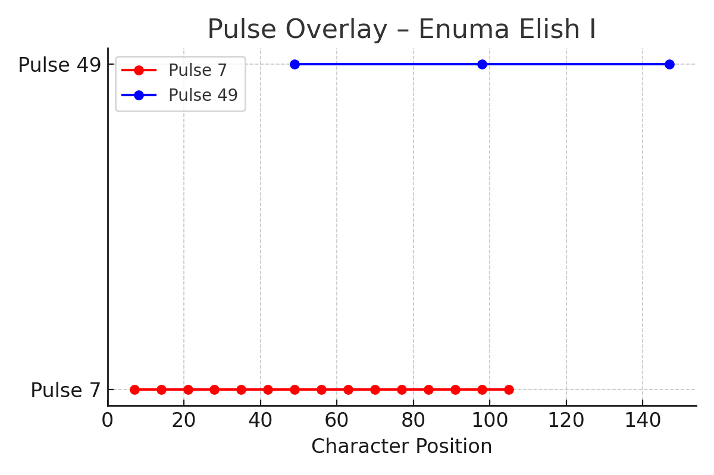

Figure C1 – Enuma Elish I: Pulse 7/49 Overlay

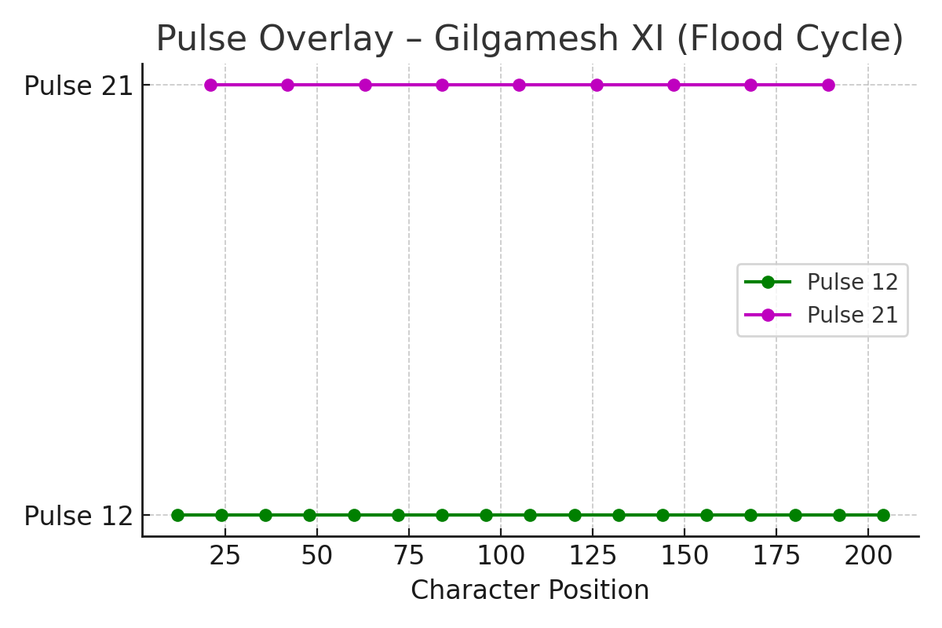

Figure C2 – Gilgamesh XI: Pulse 12/21 Overlay

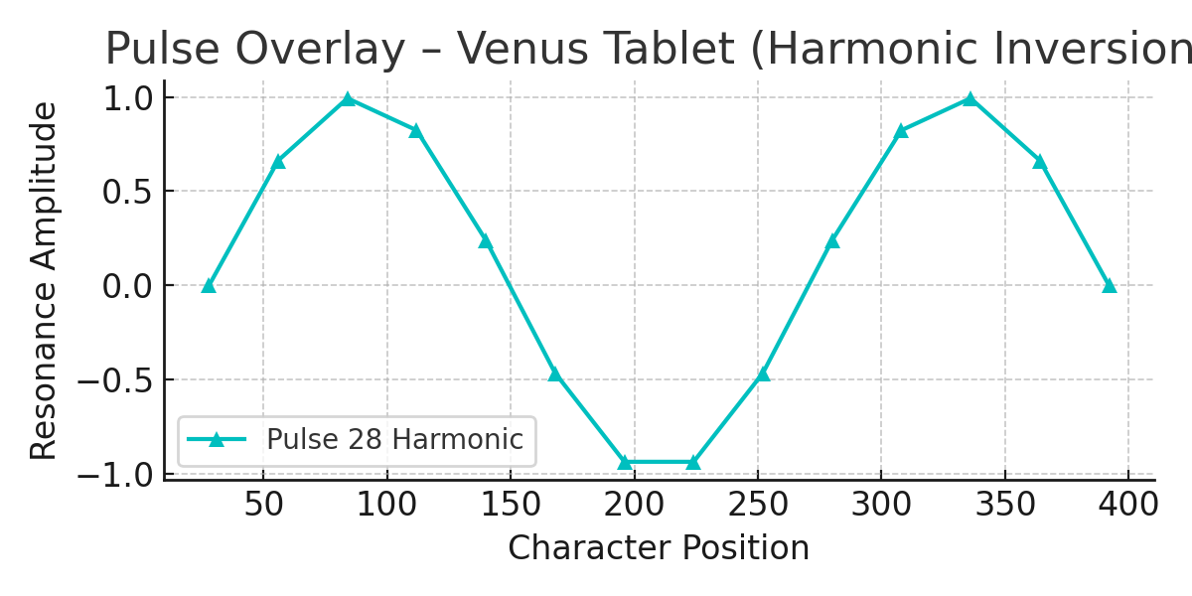

Figure C3 – Venus Tablet: Pulse 28 Harmonic Inversion

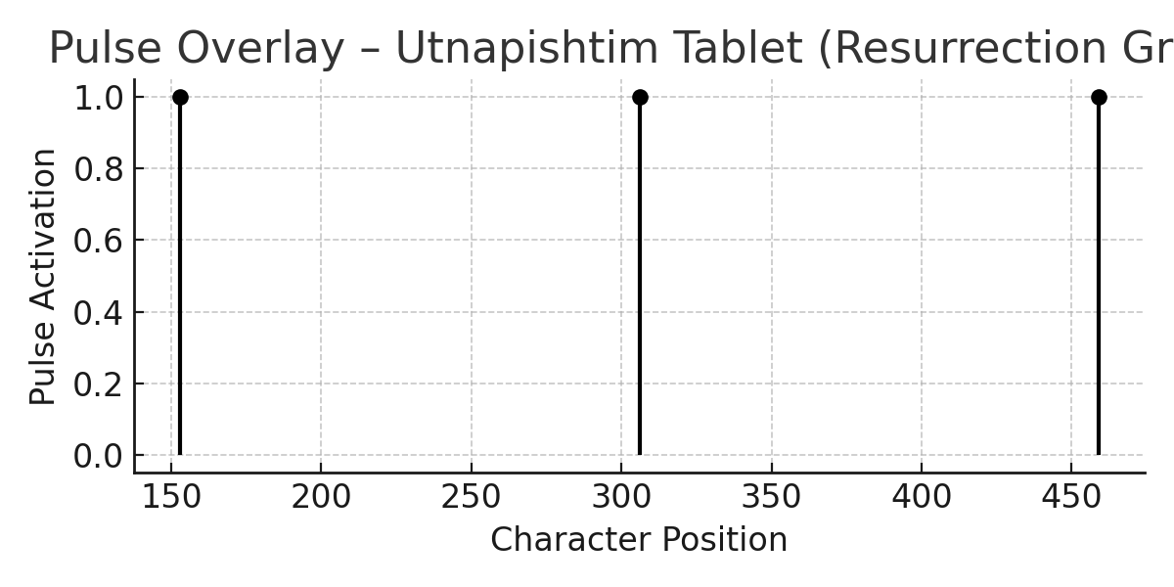

Figure C4 – Utnapishtim Tablet: Pulse 153 Resurrection Grid

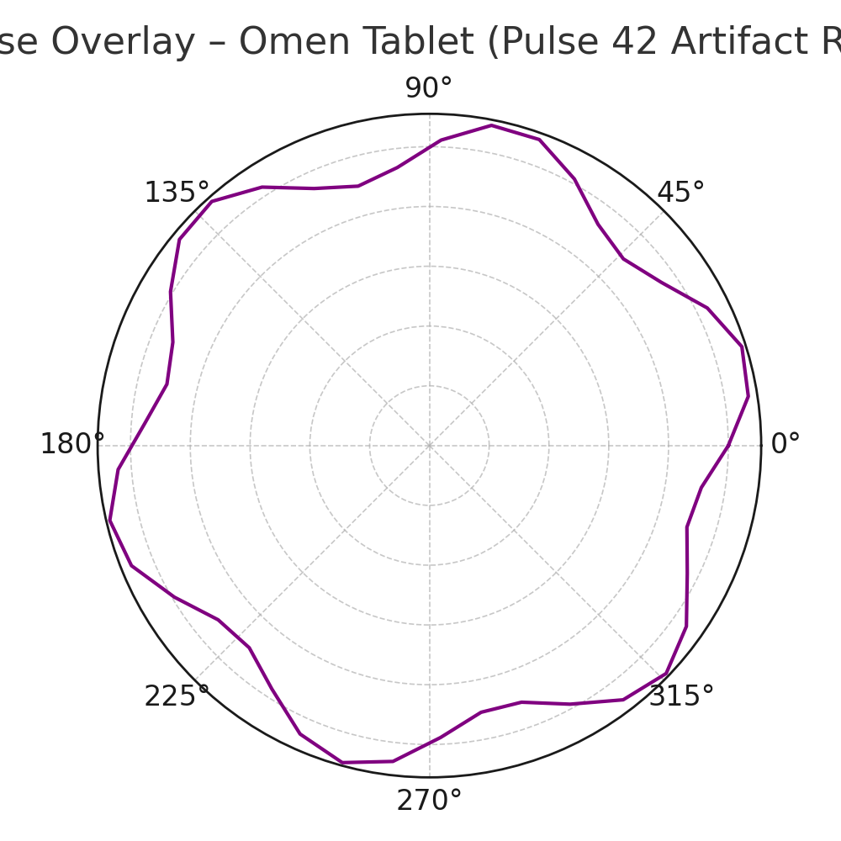

Figure C5 – Omen Tablet: Pulse 42 Artifact Ring