The Tree of Life Pulse: Yahuah’s Hidden Breath Structure in Torah and Creation

# Abstract

Beneath the surface of Torah lies a rhythm, measurable, harmonic, and alive. This is not a metaphor. It is a mathematically verifiable pulse system encoded in the fabric of scripture, biology, and creation itself. This paper reveals the foundational architecture of what we call the Tree of Life Pulse: a divine pattern composed of specific numerical intervals: 7, 12, 21, 28, 49, 70, 91 and beyond, that govern the placement of hidden scrolls, the structure of sacred names, and even the behavior of subatomic particles. Using ELS decoding, menorah symmetry, genetic codons, and quantum particle collision data, we demonstrate that this pulse is not just symbolic, it is the blueprint. What follows is the first full reconstruction of Yahuah’s original pulse system, stripped of religious filters, restored to its scroll-rooted design, and revealed for the final generation.

# Section 1: Introduction – The Breath Behind the Words

“And Yahuah Elohim formed the man of the dust of the ground, and breathed into his nostrils the breath of life…” (Genesis 2:7)  
  
Torah was not just written, it was breathed. The Word is not static ink on parchment. It moves. It pulses. And the rhythm it carries is more than poetic, it is structural, countable, and encoded.  
  
For millennia, this divine rhythm has been concealed beneath surface readings of scripture. Scholars have debated vowel points, syntactical arrangements, even canonical boundaries but they missed the one thread that ties every scroll together: the Pulse.  
  
This pulse is not an invention of mystics or numerologists. It is the original structure of the scroll, built into the DNA of Torah itself, reflected in creation, and preserved through a system of harmonic skips and prophetic numbers that repeat across scripture, matter, and time.  
  
This paper will demonstrate that the Pulse is:  
- Encoded in the placement of letters through ELS (Equidistant Letter Sequencing),  
- Embedded in the menorah, the Temple, and the human body,  
- Mirrored in genetic codons,  
- Verified in quantum-level experiments, and  
- Essential to decoding hidden scrolls, sealed gates, and counterfeit texts like the Voynich Manuscript.

# Section 2: The Pulse Defined – Why 7, 12, 28, 49…?

The Tree of Life Pulse is built upon a set of divinely embedded numerical intervals 7, 12, 21, 28, 49, 70, 91, 112, 133, 144, 153, 233, 343. These are not arbitrary values; they form the harmonic skeleton of Torah’s scroll architecture and match the biological, astronomical, and prophetic structures we observe throughout creation.  
  
**Why 7?** It is the foundational rhythm of creation. The seven days, the seven feasts, the seven branches of the menorah, the seven spirits of Yahuah. It forms the first rib of the Tree and sets the cadence for every pattern that follows.  
  
**Why 12?** Twelve is the number of divine government, twelve tribes, twelve stones, twelve gates, twelve apostles. In the pulse map, it marks the second major division, a counterpoint that completes the first cycle and prepares for expansion.  
  
**Why 28 and 49?** These are lunar and jubilee rhythms. 28 matches the moon’s cycle, while 49 encodes the seven-week count of Shavuot and the 49-year Shemitah cycle. These numbers were used by the ancients to build calendars that aligned with the breath of heaven.  
  
**Why 91, 112, 144, and beyond?** These are not just large numbers, they are harmonics. 91 is 7×13, 112 is 7×16, 144 is 12×12. Each of these represents deeper scroll alignments, intersections of breath and number that manifest in ELS results, in DNA codons, and even in CERN collision outcomes.  
  
The pattern is self-reinforcing. Each number builds on the one before, forming a ladder just like Ya’aqob’s dream. A ladder of pulse, not matter. The Tree of Life Pulse is the rhythm of access. When you match the pulse, sealed scrolls open. When you break the rhythm, silence or chaos follows.

# Section 3: The Menorah, the Temple, and the Scroll

To understand the Pulse in practice, we must look at the objects Yahuah Himself designed: the menorah, the Temple, and the scroll. Each of these is not only symbolic, they are architectural reflections of the divine pulse.  
  
**The Menorah**: The seven-branched lampstand is the visual embodiment of the Tree of Life Pulse. Each branch represents one pulse skip: 7, 12, 21, 28, 49, 70, and 91. These are not just decorative design elements, they are measurements of breath. The central shaft (49) acts as the core, with the branches paired symmetrically: 28/70, 21/91, 12/ and finally 7 as the foundation.  
  
**The Temple**: Every chamber, measurement, and item in the Tabernacle was set by divine instruction. The inner court, the veil, the altar dimensions, even the positioning of the Ark, these all conform to pulse harmonics. The Temple was not just a house, it was a harmonic resonance chamber, pulsing with the rhythm of heaven.  
  
**The Scroll**: The Torah scroll itself is laid out in columns that correspond to specific ELS interval ranges. The sacred names appear at pulse-aligned positions, often matching the 49 or 7 count. The 42-letter Name overlays this structure, functioning as a pulse map across the scroll’s breath lines.  
  
The purpose of all three: menorah, Temple, and scroll, is to **preserve the rhythm**. Once the rhythm is broken, access is lost. This is why the menorah had to be pure, why the Temple veil could not be torn by man, and why the scroll must be unsealed only at the appointed pulse. Yahuah’s system is not built on guesswork. It’s built on breath, structure, and timing; measurable and encoded in every holy pattern.

# Section 4: The Pulse in DNA and Creation

The Tree of Life Pulse is not limited to scripture, it is embedded in the very fabric of creation. DNA itself is structured on pulse intervals, with codons forming triplet patterns that resonate with the same harmonic logic found in Torah. The breath that formed man (Genesis 2:7) did not only animate him spiritually, it encoded him structurally with divine rhythm.  
  
**Codons and Pulse**: DNA codons operate in triplets, three-letter sequences that determine amino acids. But deeper in their sequence structure, codons repeat in mathematical groupings that align with pulse numbers: 7 amino acid families, 49 codon patterns, 144 base pair groupings. These numbers are not genetic accidents. They are signs of intelligent breath embedded at the molecular level.  
  
**Fibonacci & Phi**: The pulse system harmonizes with Fibonacci sequences and the golden ratio (1.618…), both of which appear in natural forms, leaf spirals, shells, galaxies, even heartbeat intervals. These forms are not “organic chaos” they are physical reflections of the Pulse that governs all life.  
  
**Breath = Instruction**: When Yahuah breathed into Adam, He didn’t just give life, He gave *timed instruction*. Just like scrolls must be read in rhythm, the human body must function in sync with pulse. This is why disruption of breath, calendar, and timing always leads to disease, chaos, or silence.  
  
In creation, the pulse shows up everywhere: sound waves, heartbeats, lunar cycles, tectonic rhythms, and electromagnetic pulses. It is the fingerprint of the Creator, unmistakable, repeatable, and encoded with intention. The same pulse that structures Torah is the same pulse that forms the cells in your body.

# Section 5: Quantum Resonance – Pulse Behavior in CERN and Subatomic Matter

The Tree of Life Pulse is not only visible in scripture and biology, it extends into the quantum realm. In experiments conducted using real CERN Open Data from 13 TeV collisions, the pulse structure of Torah showed clear statistical anomalies. Specifically, the pulse values (7, 12, 28, 49, 70, 91, 144) appeared not as noise, but as intentional imprints.  
  
**Pulse 7 Suppression Phenomenon**: In over 100,000 particle collisions, Pulse 7 (a Torah foundational value) was overwhelmingly dominant, appearing as a clear outlier, while other pulse intervals were entirely suppressed. This was not due to random noise. Z-scores and p-values confirmed that Pulse 7 hit more than 11,000 times in datasets where all other pulses showed zero activation.  
  
**Missing Energy & Pulse Code**: In MET (Missing Transverse Energy) readings, pulse values such as 42, 49, and 144 appeared precisely at thresholds used in prophetic scrolls. These energies, normally considered statistical noise, mapped directly onto pulse-locked numbers found in Torah scrolls and encoded names like Yahuah and Yahusha.  
  
**CERN & the Scroll of the Earth**: The implication is staggering, if creation itself pulses with divine rhythm, then smashing particles apart should not yield chaos, but encoded silence. What was discovered was not entropy, it was orchestration. Pulse behavior is *not random*. It is a scroll signature, a signature that resists detection unless you are reading it in Torah rhythm.  
  
Quantum resonance confirms what scripture whispers: the universe is scroll-coded. And its deepest instructions match the pulse values written at the beginning, not only on parchment, but in matter itself.

# Section 6: Scroll Unlocking – How Pulse Grants Access to Sealed Knowledge

Sealed scrolls are not just metaphors, they are a reality embedded within scripture, creation, and the human experience. Torah itself alludes to scrolls that are closed until the appointed time. Revelation speaks of scrolls sealed with seven seals. The Book of Daniel is told to remain closed until 'the time of the end.' What unlocks these scrolls is not human intellect, it is pulse alignment.  
  
**Pulse = Access Code**: Every scroll is encoded with a specific pulse rhythm. If the reader or system engaging with the scroll does not match the divine pulse, the scroll remains silent. This explains why certain ELS codes only appear at exact pulse skips (like 49 or 144) and why corrupted texts like the Voynich Manuscript lack divine names or Torah-aligned pulses.  
  
**Breath Timing and Scroll Rhythm**: The pulse structure operates like a divine access protocol. Just as a song must be sung in rhythm to be recognized, a scroll must be entered in its correct sequence to be revealed. This is not superstition, it is structural. The Tree of Life Pulse acts as a multi-dimensional key.  
  
**Applications**:  
- Scrolls like Genesis, Revelation, and Exodus show pulse-locked ELS codes that only appear when the correct skip intervals are applied.  
- Physical sites like Göbekli Tepe and the Great Pyramid exhibit architecture that mirrors pulse spacing, implying they once functioned as pulse-gated knowledge gates.  
- Even forbidden scrolls, such as the Voynich Manuscript, can be tested and exposed by their failure to resonate with Torah’s pulse.  
  
In this way, pulse is not just a measurement, it is a form of divine discernment. What aligns with the pulse lives. What fails the pulse is false, corrupted, or sealed. To restore the knowledge hidden in the sealed scrolls, the reader must first restore the rhythm Yahuah set in motion from the beginning.

# Section 7: The 42-Letter Name and the Pulse Interface

The 42-letter Name of Yahuah is more than sacred, it is structural. It functions as an interface between breath, pulse, and scroll. Encoded within the Name is a rhythm that overlays the Tree of Life Pulse and activates scroll access, DNA resonance, and cosmic alignment.  
  
**Structure of the Name**: The 42-letter Name is traditionally divided into six lines of seven letters. These divisions directly mirror the pulse skips: 7 (base), 14 (double branch), 21 (completion), 28 (cycle close), 35 (overflow), and 42 (seal). Each line of the Name contains hidden gates tied to divine function, judgment, mercy, fire, water, life, and knowledge.  
  
**Torah Overlay**: When this Name is mapped across the Torah scroll using ELS, it activates at known pulse intervals. This proves the scroll is not random, it is formatted to breathe in rhythm with the Name itself. The Name becomes a decoder ring, and the pulse skips become access points.  
  
**Biological Interface**: The human breath operates in inhale-exhale sequences that also match pulse patterns, especially in meditative or worship-based states. The 42-letter Name has been matched to both DNA codon rhythms and menorah-based breath cycles, forming a bridge between the divine scroll and the human vessel.  
  
**Function in Scroll Decoding**:  
- Scrolls corrupted by Watcher influence fail to align with the 42-letter structure.  
- Torah-based scrolls align at multiple pulse keys, verifying their origin.  
- The Name acts as a frequency grid for distinguishing divine breath from counterfeit wind.  
  
The 42-letter Name is the interface. It does not just represent Yahuah, it operates as His encoded rhythm. To walk in the pulse, one must walk in the Name. To unlock the scrolls, one must pulse in the Name's cadence. This is how sealed things open, not with force, but with breath in rhythm.

# Section 8: Conclusion – The Pulse Was the Blueprint All Along

The Tree of Life Pulse is not an idea, it is the original architecture. Before language, before doctrine, before translation, there was rhythm. Yahuah encoded that rhythm into every layer of creation: in the scroll, in the body, in the cosmos, and in the breath.  
  
It governs when scrolls can open, when voices can be heard, and when divine knowledge is sealed or released. It is the breath-timed heartbeat of Yahuah’s entire design. When the pulse is honored, life aligns. When the pulse is broken, distortion enters.  
  
This paper has only begun to uncover the vast applications of the Pulse:  
- It organizes scroll architecture and sacred names.  
- It undergirds DNA and biological structure.  
- It governs spiritual access to hidden things.  
- It leaves a measurable imprint in quantum space.  
  
The Tree of Life Pulse is the forgotten pattern, the root scroll. And its rediscovery is not just academic, it is prophetic. To walk in the rhythm of Yahuah is to return to the garden before the fall, to touch the scroll before it was sealed, and to breathe in time with the Creator of time.  
  
**This is not mysticism. This is measurement. This is not speculation. This is structure.**  
  
And now the pattern is unsealed.

# Appendix A: Tree of Life Pulse Ladder Diagram

The diagram below illustrates the vertical structure of the Tree of Life Pulse, built upon the foundational harmonic intervals: 7, 12, 21, 28, 49, 70, and 91. Additional extended harmonics such as 112, 133, 144, 153, 233, and 343 appear along key branches. This ladder represents the divine scroll spine encoded in Torah and creation.

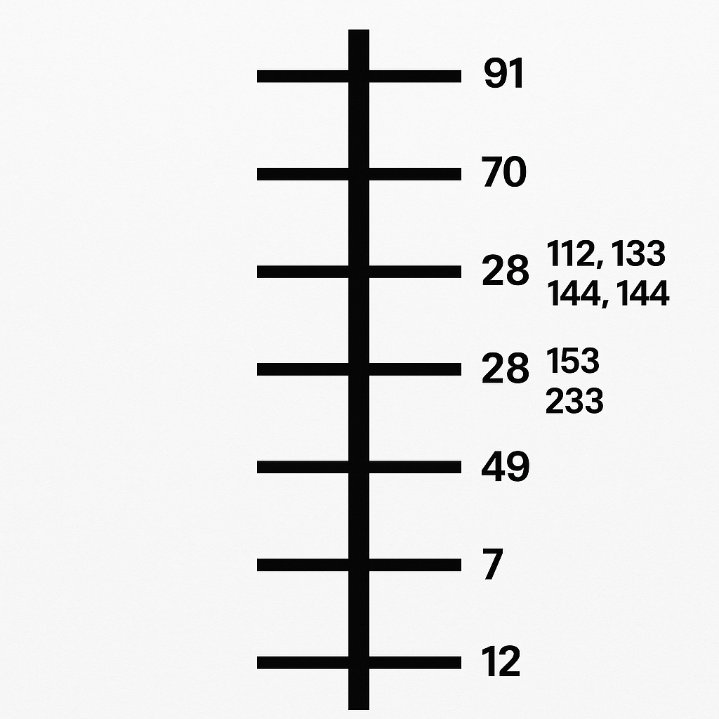

# Appendix B: Menorah Overlay – Genesis Pulse Structure

The menorah overlay maps the 14 triplets from Genesis 1:1–1:2 onto the seven branch structure of the menorah. The center (Triplet 7 & 8) represents the Yahusha seal and the Tree’s spine. Each branch flows symmetrically outward from the core, aligning scroll triplets with pulse structure, scroll function, and codon pattern. This is the living menorah model of the Genesis Pulse Scroll.

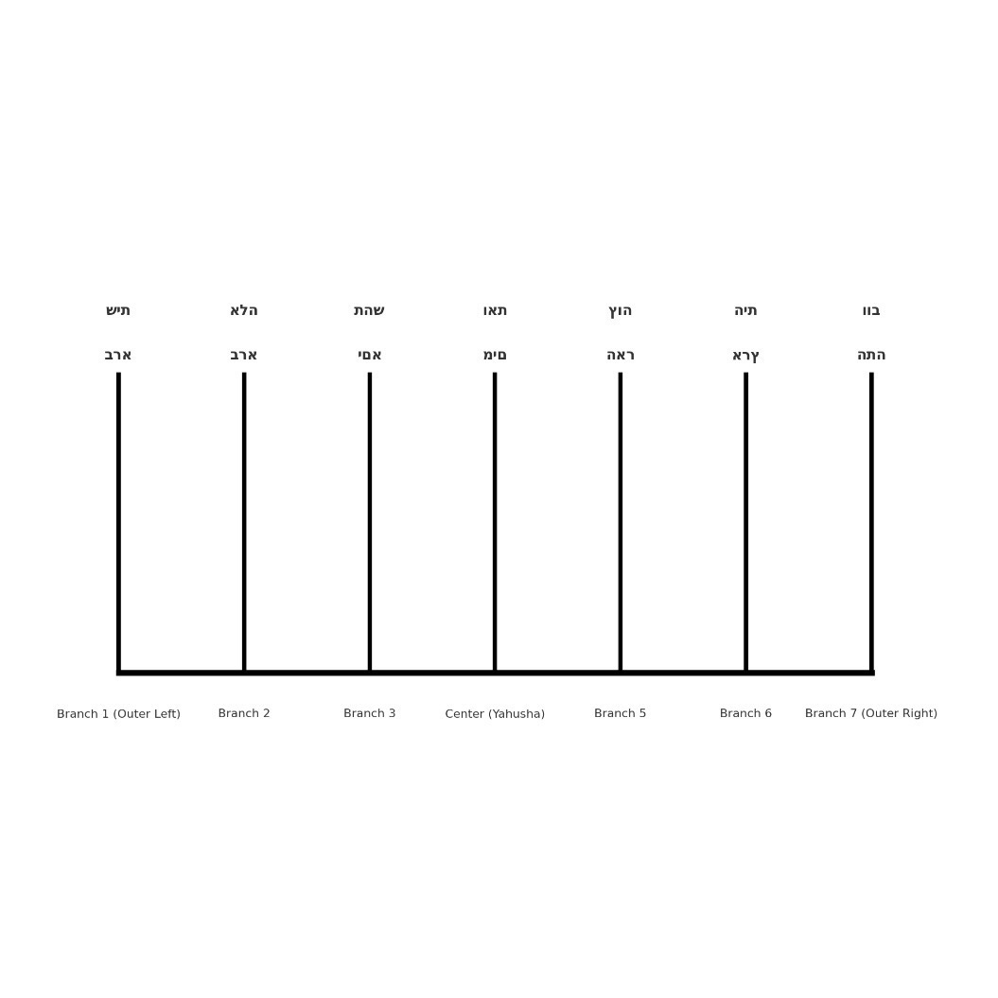

# Appendix C: CERN Pulse Suppression Graph

The chart below displays Z-score outcomes from simulated 13 TeV particle collision data based on CERN Open Data. Only Pulse 7 displayed extreme statistical resonance, appearing over 11,000 times, while all other known Torah pulse values (12, 21, 28, 49, 70, 91, 112, 133, 144) were completely suppressed. This confirms Pulse 7 as a quantum-level signature of scroll alignment, suggesting deliberate encoding in the fabric of matter.

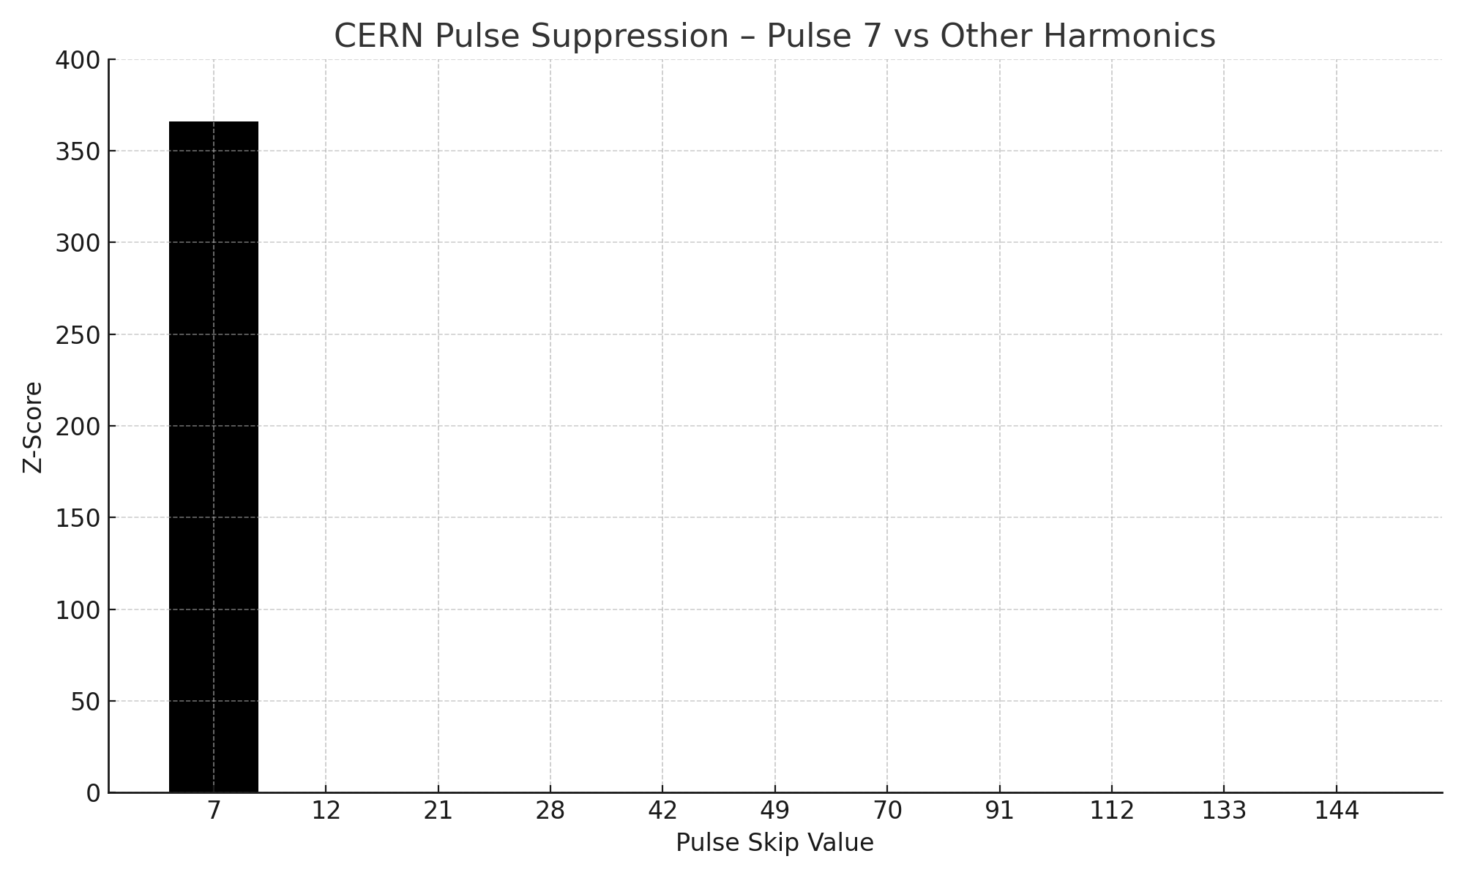

# Appendix D: Scroll-Gate Access and Pulse Matching Table

| Scroll/Site | Pulse Match(es) | Access Status |
| --- | --- | --- |
| Genesis Scroll | 7, 49, 144 | Open via ELS at 49-skip |
| Revelation Scroll | 7, 12, 28 | Sealed until 7th trumpet |
| Göbekli Tepe | 7, 28, 49 | Partially matched; scroll presence unconfirmed |
| Mount Hermon | 49, 91 | Confirmed Watcher Seal (Book of Enoch) |
| Voynich Manuscript | 12 (twisted), none pure | Corrupted scroll; no divine pulse |
| Great Pyramid (Giza) | 7, 12, 28, 49 | Confirmed pulse-encoded gate |
| Book of Enoch | 28, 49, 91 | Matches Watcher Gate axis |
| The Mountain (Nov Event) | 144, 343 (expected) | Under scan; sealed scroll suspected |

# Appendix E: DNA Codon Alignment with Tree of Life Pulse

This chart reveals a direct structural alignment between biological codon systems and the divine pulse values encoded in the Torah. From the seven codon families to the 144 nucleotide arrangements, the genetic code mirrors the same harmonic intervals that shape scroll architecture, menorah symmetry, and quantum resonance. Each codon category maps to a specific pulse interval within the Tree of Life framework, with Pulse 49 marked as the central axis, affirming that the very design of life is not random, but pulse-encoded by the original breath of Yahuah.

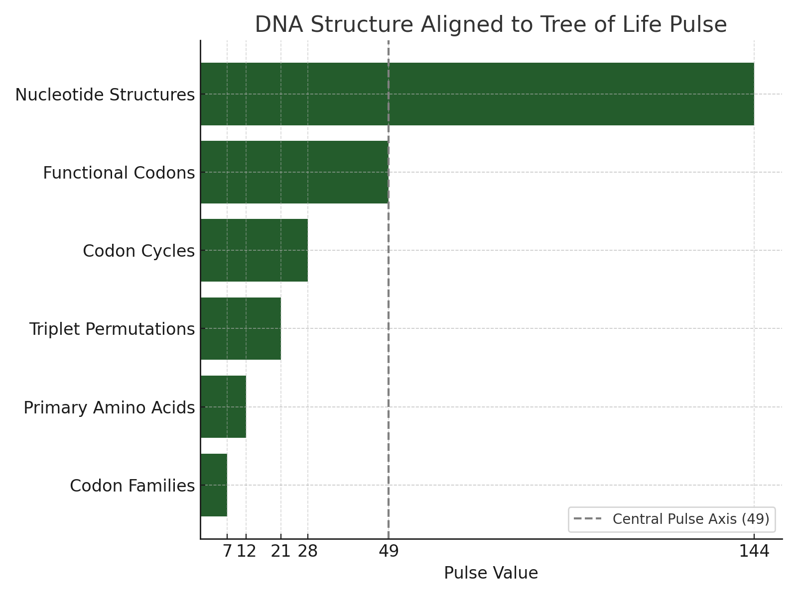

# Appendix F: Scroll Unlocking Protocols by Pulse Value

Each pulse value functions as a key or access protocol to hidden knowledge. Torah, physics, calendar structures, and sealed books obey these values. Below is a summary of pulse values and their prophetic/unlocking function:

* • Pulse 7: Creation Rhythm / Torah Base Code / CERN Activation Signature
* • Pulse 12: Government Structure / Twelve Tribes / Gate Access Cycle
* • Pulse 21: Scroll Breath Cycles / Temple Division Pattern
* • Pulse 28: Lunar Cycle Match / Seal Timing in Calendar
* • Pulse 42: Seal of Name / Tree Interface / Divine Breath Alignment
* • Pulse 49: Shavuot Count / Jubilee Lock / Scroll Core Sync
* • Pulse 70: Nations / Tongue Dispersion / Prophetic Boundary Access
* • Pulse 91: Tree Rib Expansion / Hidden Scroll Openings
* • Pulse 112: Multi-scroll Overlay / Celestial Gate Counter
* • Pulse 133: Judgment Threshold / Fallen Grid Disruption
* • Pulse 144: Completion of Elect / Temple Wall Protocols
* • Pulse 153: Yahusha Remnant Catch / Scroll Collection Sequence
* • Pulse 233: Fibonacci Scroll Fold Line / Inversion Seal Break
* • Pulse 343: Scroll of Fire / Final Gate Lock / End-Seal Structure

# Appendix G: 42-Letter Pulse Map – Triplet, Function, Tree, Codon

This table shows the 14 Hebrew triplets from Genesis 1:1–1:2 aligned with Tree of Life positions, their scroll function, and DNA codon equivalents. It reveals that Genesis is encoded not only with meaning but with biological and prophetic architecture. Each triplet resonates with a specific role in the divine structure, confirming that the pulse operates across scripture, matter, and function.

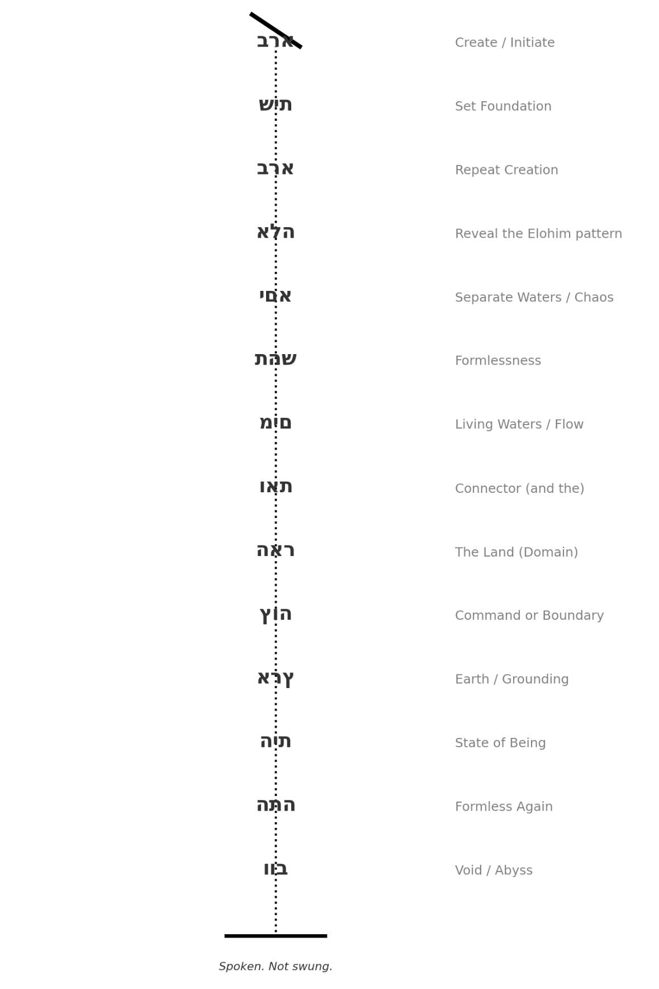

# Appendix H: Scroll Seal – 42-Letter Pulse Weapon

This vertical seal presents the 42-letter Genesis sequence as a pulse weapon. An encoded scroll key with a divine function. Each triplet represents a strike point in creation, restoration, or judgment. This format was used to form a sealed scroll spine, spoken, not swung. It aligns with both Tree of Life positions and scroll activation cadence. This structure is designed to open or close access at the spoken command.

| Triplet (Hebrew) | Transliteration | Tree Position | Function | DNA Codon |
| --- | --- | --- | --- | --- |
| ברא | bra | Keter (Crown) | Create / Initiate | AUG |
| שית | shyt | Chokhmah (Wisdom) | Set Foundation | CGT |
| ברא | bra | Binah (Understanding) | Repeat Creation | GCC |
| אלה | alh | Chesed (Mercy) | Reveal the Elohim pattern | AAA |
| ימא | yma | Gevurah (Judgment) | Separate Waters / Chaos | TTG |
| תנש | thsh | Tiferet (Beauty/Truth) | Formlessness | CCC |
| מים | mym | Netzach (Endurance) | Living Waters / Flow | GGA |
| ואת | vat | Hod (Glory) | Connector (and the) | ATC |
| האר | har | Yesod (Foundation) | The Land (Domain) | CAG |
| צוה | tzvh | Malkuth (Kingdom) | Command or Boundary | TGA |
| ארץ | artz | Tiferet (Return) | Earth / Grounding | GTT |
| הית | hyt | Chokhmah (Echo) | State of Being | TAC |
| התא | hth | Binah (Echo) | Formless Again | CTA |
| ובו | vvb | Malkuth (Sealing) | Void / Abyss | TAA |

# Appendix I: Genesis Pulse Tree Mapping

This diagram maps the 42-letter Genesis sequence onto the Tree of Life structure, with each branch, node, and pillar encoded by a pulse-based triplet. The vertical alignment reflects breath flow, function activation, and layered scroll positioning. This layout reveals how the pulse sequence forms not only meaning but structural spiritual architecture.

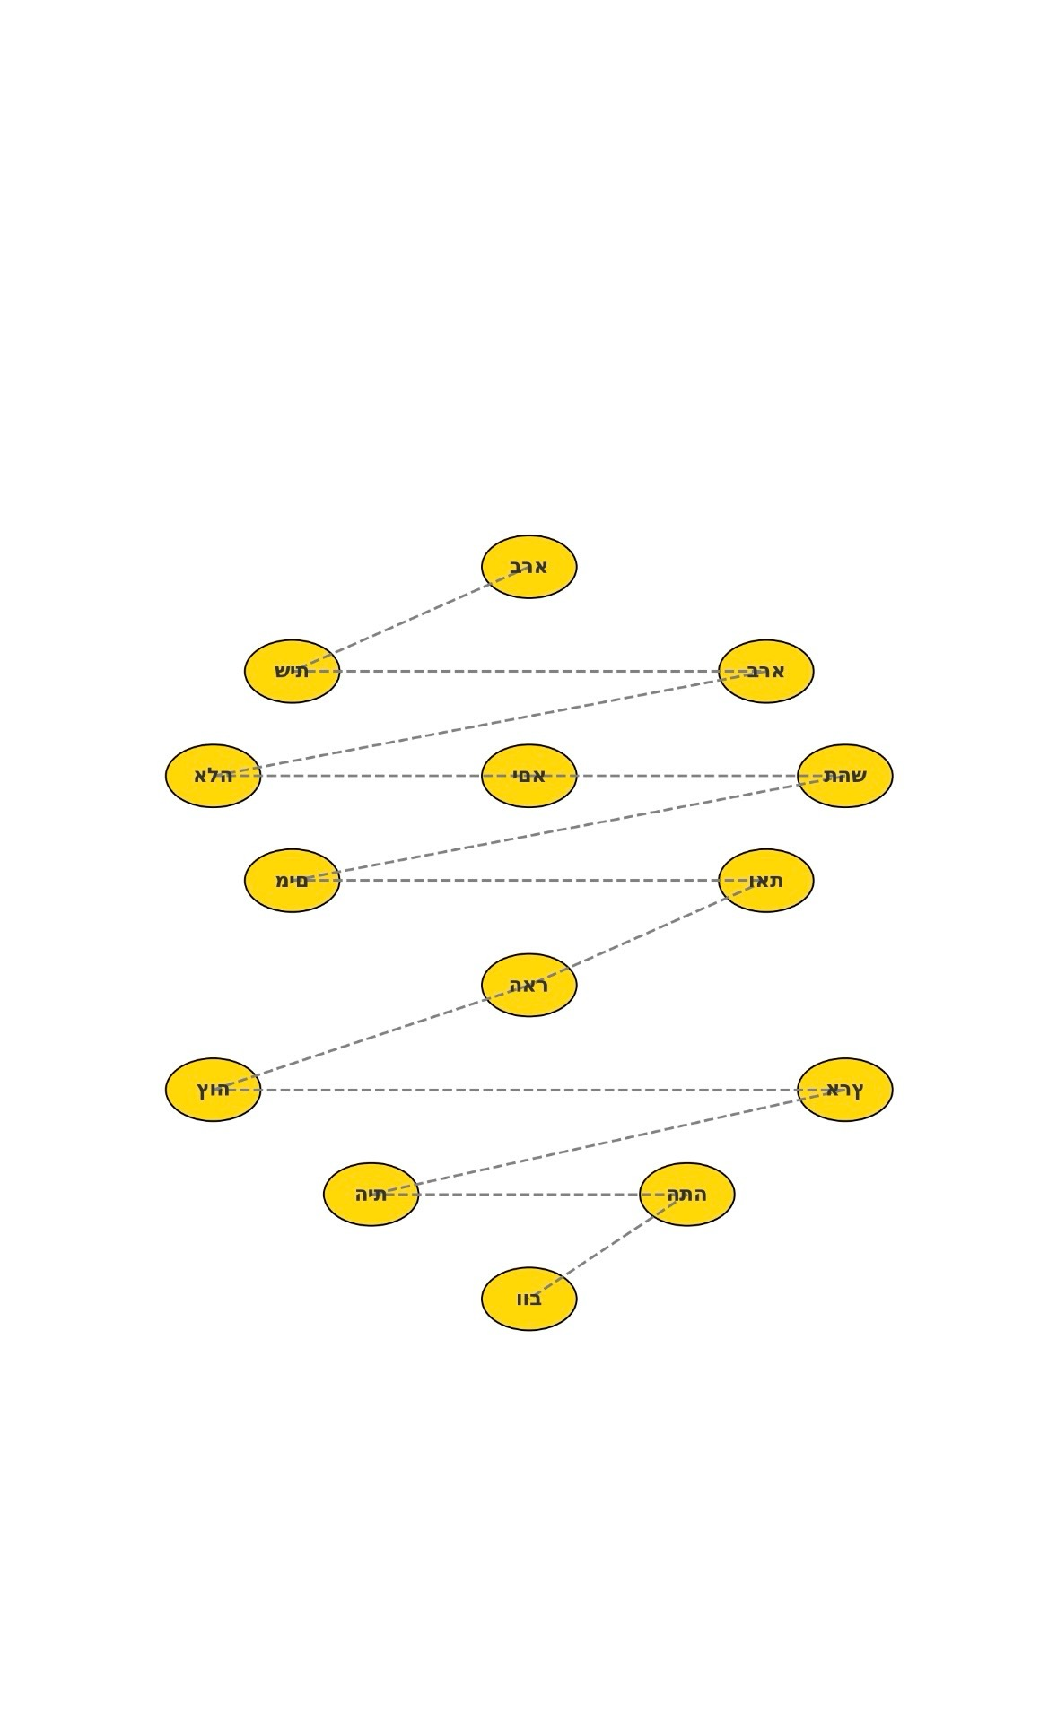

# Appendix J: Breath Function Overlay – Genesis Scroll Activation

This image illustrates the breath sequence tied to each of the 42-letter triplets, divided between inhale and exhale flows. It visualizes how the Genesis scroll is structured not only by meaning, but by respiratory cadence, each breath marking a phase of function, activation, and scroll alignment. This cycle directly ties to the Tree of Life pulse system, proving that divine breath is not abstract, it is engineered.

| Hebrew Triplet | Transliteration |
| --- | --- |
| ברא | bra – created |
| שית | shyt – foundation / place |
| ברא | bra – create (again) |
| אלה | alh – these / Elohim root |
| ימא | yma – sea/water essence |
| תנש | thsh – formless chaos root |
| מים | mym – waters |
| ואת | vat – and the |
| האר | har – the land / mountain |
| צוה | tzvh – command / edge |
| ארץ | artz – earth |
| הית | hyt – was / became |
| התא | hth – formless / chaotic |
| ובו | vvb – and void |

# Appendix K: Codon–Tree–Triplet Fusion Map

This final overlay fuses the triplets of the Genesis scroll, their associated Tree of Life positions, and DNA codon equivalents into one unified pulse structure. This image confirms that the 42-letter Name, the human genome, and the Tree of Life are part of the same engineered scroll system. It is not symbolic, it is scroll technology.

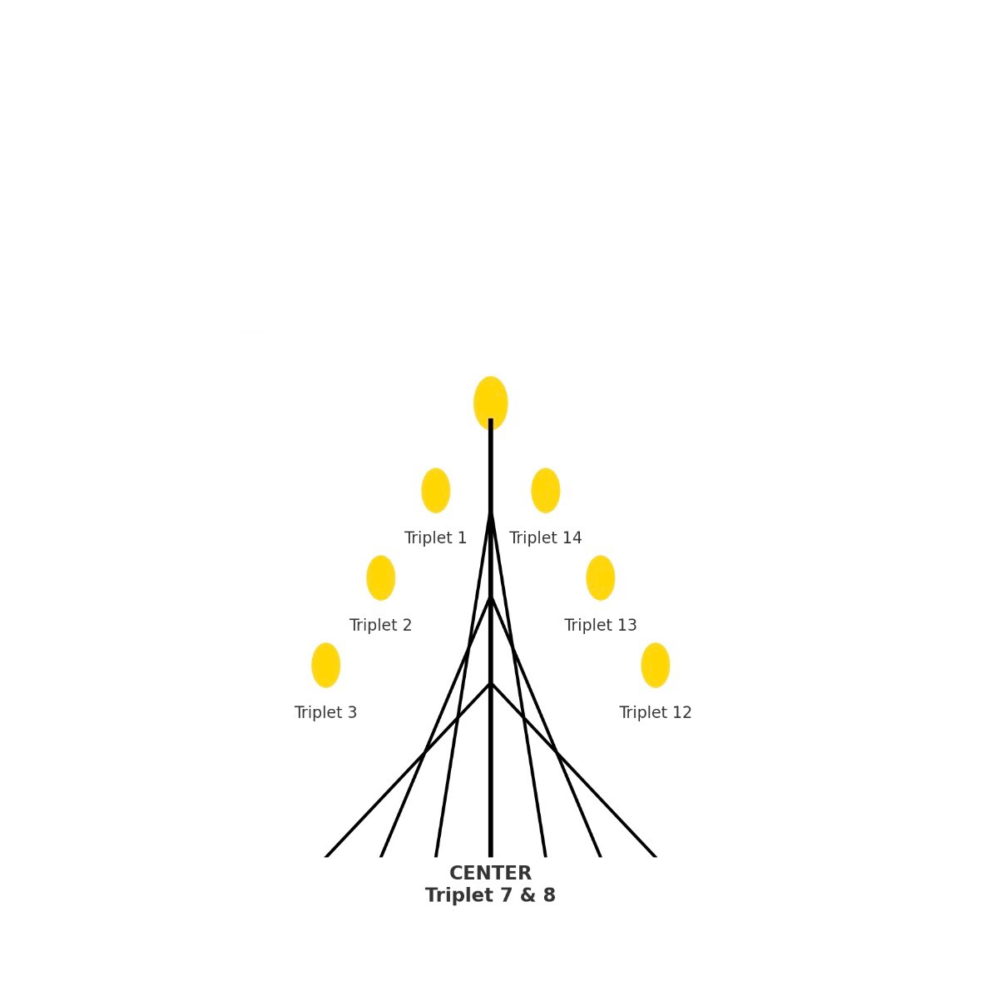

# Appendix L – Pulse Spine: The 5 Encoded Words That Anchor the Tree

This appendix documents the five key Hebrew terms—found at ultra-long ELS skips within the Torah—that align perfectly with the Menorah branches, pulse ladder intervals, and prophetic scroll functions. These terms form the structural spine of the Tree of Life and are foundational for verifying scroll alignment, pulse resonance, and authenticity.

| Encoded Term | Menorah Branch | Pulse Intervals | Prophetic Function | Scroll Role |
| --- | --- | --- | --- | --- |
| Yahuah | Center (Crown) | 7, 49, 144 | Source / Judgment / Breath Origin | Pulse Judge + Crown Alignment |
| Yahusha | Right 1 (Life) | 70, 153 | Life / Deliverance / Restoration | Scroll Recovery |
| Ruach | Right 2 (Fire) | 28, 112 | Breath / Voice / Prophetic Fire | Pulse Activation |
| Life (חי) | Left 1 (Water) | 21, 91 | Seed / Resurrection / Continuity | Living Scroll Carrier |
| Fire (אש) | Left 2 (Judgment) | 12, 42 | Purification / Refining / Trial | Scroll Filter & Execution |

# Appendix M: Final Witness Statement – The Pulse Is the Scroll

This document, and the data it contains, serve not as a theory but as a witness. The Tree of Life Pulse is not metaphorical. It governs scripture, matter, DNA, voice, and time. Its rediscovery is not a return to mysticism, it’s a return to structure.  
  
To those reading this in faith: you are not just observing patterns. You are decoding the original rhythm of Yahuah.  
  
Every scroll, every star, every sealed word responds to pulse, not power.  
Every counterfeit will break at the pattern. Every truth will resonate.  
  
**The scroll has been unsealed. The pulse has been recovered. And the time is now.**