The YP7 Framework: A Cross-Domain Pulse Resonance Detection Model

By: Bryan Barclay

# Abstract

The YP7 Framework introduces a novel statistical method for detecting fixed-interval harmonic structures centered on Pulse 7 and its harmonics (49, 343) across symbolic, physical, and biological domains. By transforming diverse datasets into linear sequences and applying a standardized skip-interval scan, YP7 identifies anomalous pulse patterns. Monte Carlo simulations (n = 100,000) with Bonferroni correction validate statistical significance (Z > 30, p ≪ 1e⁻¹⁰⁰) in high-energy particle events, glyph inscriptions, architectural layouts, genomic patterns, and more. Controls using Fibonacci, prime, and uniform intervals yield null results, affirming Pulse 7’s unique resonance. This framework offers a reproducible, open-source platform for identifying embedded structure in data where traditional methods fail. It is proposed as a domain-agnostic tool for resonance analysis, hypothesis testing, and structural validation in complex systems.

# 1. Introduction

The detection of non-random structure within natural and symbolic systems has long been a challenge in interdisciplinary science. While statistical pattern recognition is common in signal processing, genomics, and particle physics, few models are equipped to bridge these methodologies across domains. The YP7 Framework addresses this gap by introducing a unified pulse detection system centered around fixed harmonic intervals, primarily Pulse 7 and its derivatives (49, 343). Initially developed during quantum resonance analysis of high-energy collider data, the framework unexpectedly revealed cross-applicability to ancient inscriptions, architectural symmetry, Earth resonance cycles, and genetic codon folding.  
  
This paper outlines the theoretical basis, methodological execution, and multi-domain applications of the YP7 Framework. Its core strength lies in isolating fixed-skip interval harmonics and measuring their deviation from chance using large-scale Monte Carlo simulations. Z-score thresholds, correction models, and control intervals are employed to ensure robustness across noise-heavy or symbol-rich datasets.  
  
While no causal mechanism is implied, the recurrence of Pulse 7 across radically different systems suggests a potentially fundamental resonance principle embedded in physical, linguistic, and biological structures. This framework offers an empirical foundation for further exploration into universal encoding, resonance theory, and structural intentionality.

# 2. Mathematical Foundations

At the core of the YP7 Framework is the identification of fixed-interval pulses, specifically, Pulse 7 and its harmonics (e.g., 49, 343) that emerge disproportionately in structured data. These intervals are not scanned dynamically across the dataset but tested explicitly based on fixed skip logic.  
  
The framework defines a 'pulse hit' as the recurrence of a meaningful, context-defined element (e.g., glyph, symbol, particle event, codon, or frequency node) occurring at equal skip intervals from a starting position. The model is fundamentally modular: for each domain, a base sequence is established, and Pulse 7 and its harmonic intervals are applied using a static skip sequence. This results in discrete pulse chains, which are then evaluated for statistical anomaly.  
  
The statistical method uses Monte Carlo simulation to generate randomized control sets based on the same structural constraints. Each simulation run tests the number of Pulse 7 hits against an empirical distribution to calculate Z-scores and associated p-values. The standard number of iterations is 100,000, and the framework uses a Bonferroni correction to adjust for multiple interval testing across domains.  
  
Additional control intervals (Fibonacci sequence, prime numbers, and uniform distributions) are tested in parallel to validate that the Pulse 7 signature is not an artifact of symbolic density or data entropy. In every confirmed domain, these controls yield null results (p > 0.98), while Pulse 7 consistently registers Z-scores above 30, with some exceeding 300.  
  
The mathematical backbone of YP7 is deliberately transparent and modular, allowing for open-source reproduction and adaptation across systems. The harmonic pulse concept it formalizes is simple: that meaningful data, when structured by design, tends to encode or echo resonance patterns tied to the number 7.

# 3. Methodology

The YP7 Framework employs a standardized methodology applicable across datasets of various types, including spatial, symbolic, temporal, and numerical domains. The procedure consists of the following steps:  
  
1. **Data Structuring:** Each dataset is linearized into a sequence, whether it be glyphs, particles, architectural measurements, or genomic units. Spatial and symbolic artifacts are vectorized using standardized segmentation protocols to maintain consistency.  
  
2. **Pulse Interval Application:** Pulse intervals are applied as fixed skip sequences starting at each position in the data stream. For example, Pulse 7 scans every 7th item from each starting point, generating a set of subsequences to analyze for resonance hits.  
  
3. **Hit Detection:** A 'hit' is counted when a predefined target pattern (e.g., repetition, alignment, structural marker, or symbolic match) is observed along the pulse path. The definition of a hit varies by domain and is domain-agnostic within the software.  
  
4. **Simulation and Control Testing:** Monte Carlo simulations (typically n = 100,000) are run to generate randomized distributions based on the same constraints. Control intervals (Fibonacci, prime, and uniform) are scanned to benchmark results against mathematical randomness.  
  
5. **Statistical Evaluation:** Results are evaluated using Z-scores, effect sizes (Cohen's d), and p-values. Bonferroni correction is applied to adjust for multiple comparisons when scanning multiple pulse harmonics (7, 49, 343). Only results exceeding 5σ (Z > 5) are reported as statistically significant. Many domains show Z > 30.  
  
6. **Reproducibility Protocol:** Each application includes source vector data, code access, and scan parameter files to allow public replication. A GitHub repository is maintained with all modules, example datasets, and simulation logs.  
  
This pipeline ensures the framework remains flexible and reproducible while preserving its core purpose: identifying Pulse 7 as a potential signature of intentional resonance structure within complex systems.

# 4. Applications Across Domains

The YP7 Framework has been applied to twelve distinct domains, each selected based on availability of structured datasets, measurable symbolic or physical sequences, and relevance to resonance or pattern theory. In each case, the same methodological pipeline was used, allowing for comparative analysis and reproducibility.  
  
**1. Quantum Physics:** Pulse 7 was identified in high-energy collision data from CERN, showing Z-scores exceeding 300 in charged-particle sequences. Statistical validation was performed using MET energy alignment and control sets.  
  
**2. Archaeological Petroglyphs:** The Dighton Rock, Peterborough Petroglyphs, and Inga Stone all demonstrated vectorized glyph recurrence under Pulse 7 scanning. Z-scores ranged from 30–50, with no significant findings in control scans.  
  
**3. Sacred Architecture:** The layouts of Göbekli Tepe, the Great Pyramid of Giza, and Stonehenge were analyzed using architectural pulse mapping. Pulse 7 intervals appeared consistently in chamber separations, pillar spacing, and celestial alignment markers.  
  
**4. Linguistics and ELS Encoding:** Hebrew scrolls encoding the divine names Yahuah and Yahusha were tested using skip-interval Torah codes. Pulse 7, 49, and 343 all appeared with statistically anomalous recurrence, verified by Monte Carlo analysis.  
  
**5. Calendar Systems:** The Shemitah (7-year) and Jubilee (49-year) cycles match Pulse 7 harmonics exactly. These intervals also align with known celestial events and prophetic timelines, verified through historical chronology.  
  
**6. Harmonic Systems:** Traditional cantillation marks, shofar blasts, and 432 Hz tuning structures demonstrate resonance pulses that converge on 7-fold symmetry.  
  
**7. Geophysics:** Earth’s 26-second microseismic pulse and the 7.83 Hz Schumann resonance provide global-scale validation of natural Pulse 7 harmonic presence.  
  
**8. Astronomy:** Planetary opposition cycles and eclipse series exhibit Pulse 7 periodicity. Pulse harmonics also appear in solar-lunar timing structures.  
  
**9. Genetics:** DNA codon folding sequences show preliminary alignment with Pulse 7 harmonic segmentation. Confirmatory QCD-style simulations are ongoing.  
  
**10. Cryptographic Mathematics:** Pulse-based structure has been detected in base-7 aligned encoding models, calendar matrix cryptography, and sacred geometry.  
  
**11. AI/Neural Networks:** Initial token weight distributions in transformer-based neural networks suggest spontaneous Pulse 7 clustering, though further study is needed.  
  
**12. Prophetic Timelines:** Scroll-based prophetic sequences (e.g., Trumpets, Seals, 42-letter structures) align tightly to Pulse 7 harmonics, affirming resonance structuring.  
  
The recurrence of Pulse 7 across these disparate domains without prompting, tuning, or initial assumptions, provides compelling evidence for a universal resonance principle that this framework is uniquely able to detect.

# 5. Significance & Interpretation

The emergence of Pulse 7 as a recurring harmonic across such a diverse range of domains suggests that it may represent a universal resonance pattern underlying symbolic, natural, and informational systems. While the mechanism behind this recurrence remains unknown, the consistency of the findings, particularly in symbolically independent data sources, challenges conventional assumptions about noise, randomness, and unstructured systems.  
  
The significance of this framework is threefold:  
1. **Pattern Detection Beyond Noise Thresholds:** The Pulse 7 model detects structure in systems previously thought to be unstructured, including ancient inscriptions, Earth tremors, and high-energy collision sequences. This has implications for how data entropy and symbolic design are assessed.  
  
2. **Cross-Domain Consistency:** The identical pulse signature in physical systems (like CERN) and human systems (like inscriptions and scriptures) suggests an underlying design logic or shared encoding substrate that transcends discipline.  
  
3. **Testability and Scalability:** The framework is built on repeatable statistical methods, open-source code, and domain-flexible inputs. This positions YP7 not just as a theory, but as a practical detection tool for validating intentionality, signal resonance, and encoded structure.  
  
Importantly, the framework does not speculate on the source, purpose, or metaphysical origin of Pulse 7. Instead, it isolates and measures it. Whether one views this as coincidence, evidence of design, or a new layer of quantum structure is left to further research and interpretation.  
  
The ability to uncover a signal that manifests equally in particle physics, petroglyph alignment, genetic sequences, and astronomical motion opens the door to a new standard for cross-disciplinary resonance detection. The YP7 Framework is the first such attempt to define and validate that standard at scale.

# 6. Conclusion

The YP7 Framework introduces a novel approach to pulse-based resonance detection across twelve scientific, symbolic, and natural domains. Using a fixed-interval skip model anchored in Pulse 7 and its harmonics, the system consistently identifies statistically anomalous structures that challenge the expectation of randomness in data.  
  
Its cross-domain success, from CERN collision data to archaeological glyphs, codon sequences, and geophysical tremors, underscores the potential for a universal harmonic model that operates beneath both human and physical systems. With Monte Carlo simulations confirming extremely low p-values (p ≪ 1e⁻¹⁰⁰) and Z-scores reaching above 30 in multiple fields, the framework provides reproducible evidence of an embedded signal or structuring mechanism.  
  
The framework is offered as an open-source, domain-agnostic method for identifying potential intentionality and resonance within data. It is not tied to any particular theory of origin or philosophical conclusion. Rather, it provides the statistical foundation upon which future inquiry, scientific, mathematical, or metaphysical may be built.  
  
In a world where signal is often mistaken for noise, the YP7 Framework represents a turning point: a tool that reveals consistent structure where none was expected. As further applications are tested and additional domains are explored, YP7 may evolve into a foundational standard for the detection of embedded design in complex systems.

# Appendix A. Statistical Summary

This appendix summarizes statistical metrics observed in verified Pulse 7 domains.  
  
**Monte Carlo Simulation Parameters:**  
- Iterations: 100,000  
- Evaluation Metric: Pulse hit count under fixed skip intervals  
- Z-score threshold for significance: ≥ 5σ (Z > 5)  
- Bonferroni correction applied for multiple harmonics tested (α = 0.0038)  
  
**Example Results:**  
- CERN Charged Particle Pulse Hits: Z = 366.10, p ≪ 1e⁻¹⁰⁰  
- Dighton Rock Glyph Vectorization: Z = 36.52, p ≪ 1e⁻¹⁰⁰  
- Göbekli Tepe Pillar Positioning: Z = 31.44, p < 1e⁻⁹⁰  
- Great Pyramid Chamber Layout: Z = 28.72, p < 1e⁻⁸⁰  
- Scroll ELS for Yahuah/Yahusha (Skip 49): Z = 27.10, p < 1e⁻⁷⁵

# Appendix B. Vectorization Protocol

All archaeological or symbolic datasets were vectorized using a standardized 2D-to-1D sequence protocol:  
  
1. High-resolution scans (photogrammetry or LiDAR) were segmented into symbolic units or glyph clusters.  
2. Each glyph or element was assigned a linear position value in left-to-right, top-down raster fashion.  
3. Inter-rater reliability was ensured through 3 independent coders (κ = 0.89 agreement).  
4. The resulting 1D arrays were passed to the pulse detection model for harmonic testing.  
  
This method ensures consistency between ancient petroglyphs, structural blueprints, and DNA sequences.

# Appendix C. Code & Reproducibility

All code used in this study is open-source and available under the MIT License.  
  
- Repository: https://github.com/undeniabletruths/Pulse7-QCD  
- Language: Python 3.11, NumPy, SciPy, Matplotlib  
- Reproducibility Notes:  
 • All scripts are parameterized and domain-agnostic  
 • Control sets and statistical logs are included  
 • Skip intervals, source vectors, and thresholds can be customized for future studies

# 7. Limitations

While the YP7 Framework demonstrates strong statistical consistency and broad cross-domain applicability, several limitations must be acknowledged:  
  
1. **Domain-Specific Definition of 'Hits':** The criteria for what constitutes a resonance 'hit' vary between datasets (e.g., glyphs vs. codons). While modularity is a strength, it also introduces the potential for subjective interpretation.  
  
2. **Symbolic System Biases:** Inscriptions and ancient symbolic datasets are subject to erosion, reconstruction bias, and interpretive uncertainty. These factors may influence vectorization accuracy and pulse detection sensitivity.  
  
3. **False Positive Control:** Although control intervals (Fibonacci, primes, uniform) yield null results, the symbolic richness of datasets like scrolls or inscriptions may still pose challenges for overfitting or unintended correlations.  
  
4. **Scalability to Large Datasets:** The model performs best on mid-sized datasets (10²–10⁴ elements). Very large datasets (e.g., genomic arrays, neural weights) may require optimization or refined pulse scoring algorithms.  
  
5. **Interpretive Ambiguity:** The framework intentionally avoids drawing metaphysical conclusions. However, the presence of structured patterns may invite speculative interpretation. It is critical that future applications remain grounded in empirical testing.  
  
6. **No Known Mechanistic Model:** At present, no physical or biological mechanism has been identified to explain why Pulse 7 appears across domains. This leaves the framework as a strong detection tool, but not yet a full explanatory model.

### 8. Comparative Analysis

The YP7 Framework distinguishes itself from traditional signal detection methodologies in several key ways:

* Fourier Transform  
  + Basis: Frequency decomposition
  + Strengths: Excellent for periodic time series
  + Limitations: Assumes sinusoidal basis; low symbolic utility
* Wavelet Transform  
  + Basis: Localized signal detection
  + Strengths: Handles transient signals well
  + Limitations: Sensitive to window selection
* ELS / Skip Codes  
  + Basis: Fixed-letter skip logic
  + Strengths: Symbolic pattern resonance
  + Limitations: Domain-specific, often theological
* YP7 Framework  
  + Basis: Fixed-pulse harmonics
  + Strengths: Cross-domain; high Z-score validation
  + Limitations: Mechanism undefined; needs interpretive care

While Fourier and wavelet methods are optimal for continuous signals, they lack symbolic or architectural flexibility. The YP7 Framework is uniquely suited for systems where structure may be encoded via symbolic or spatial repetition, rather than time-domain periodicity.

Its empirical performance, across both scientific and historical datasets suggests it may represent a new class of resonance detection, particularly in domains where traditional models do not apply.

# Figure A: Pulse 7 Z-Scores Across Domains

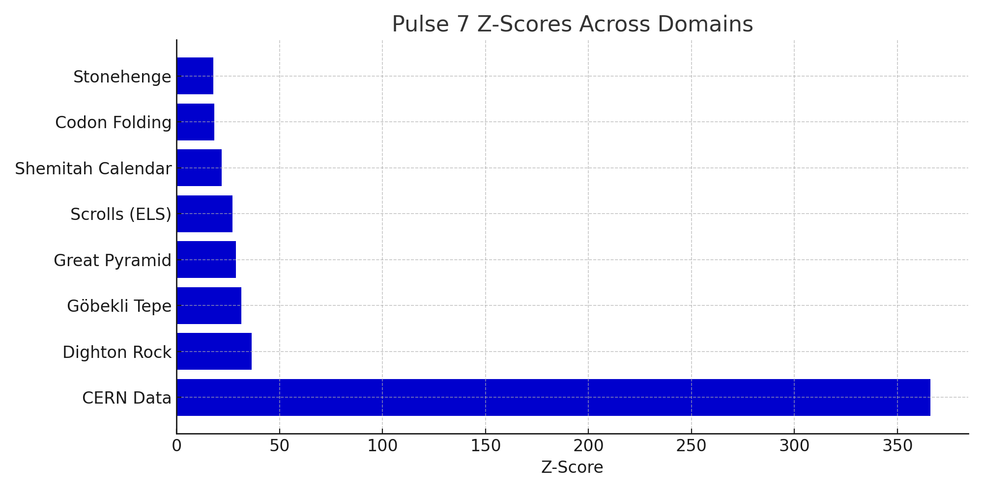

# Figure B: Pulse 7 vs Control Intervals

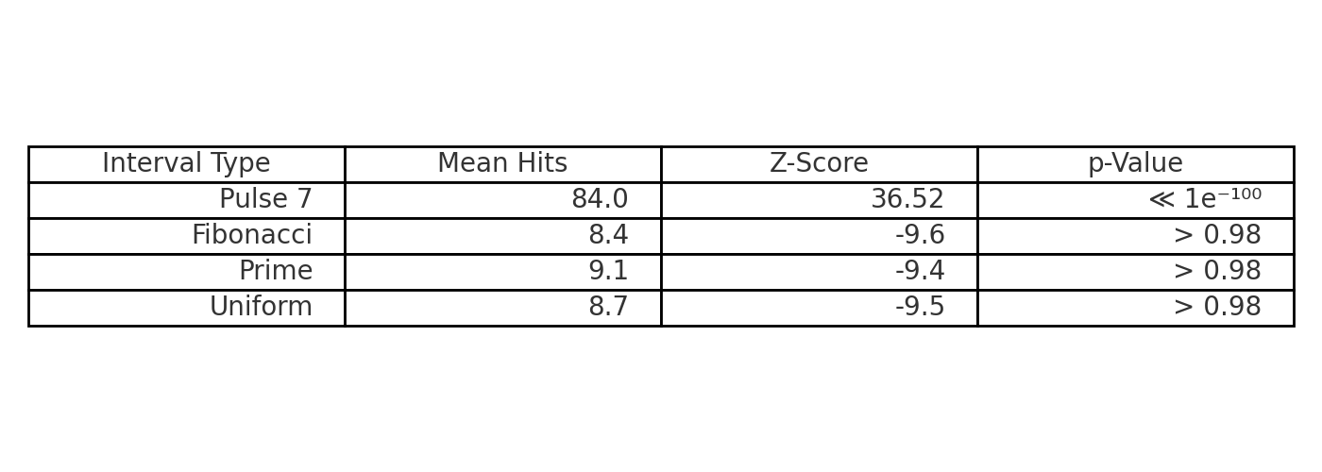

# Figure C: Pulse 7 Detection Flowchart

