Latest Firmware version issued on 21st, May, 2020, please check carefully before updating, please check the modifications in blue color

Following two are for the version of 10.000 contacts only
RT90(GPS-REC)-S16.13.bin for GPS version
RT90(REC)-D16.13.bin for common version

Following two are for the version of 100.000 contacts
RT90(CSV-GPS)-P16.13.bin for GPS version
RT90(CSV)-V16.13.bin for common version

Hardware: change PLL IC, and this modifications make firmware version cannot be compatible with previous one, so please check serial number, which is from 2006T00001 and 2006U00001
Software: Address the issue that some radio will ask for password after update

And some users also found that the radio will show enter password even you didn’t set the password after upgrading, please set password=0 in the programming software into password=password
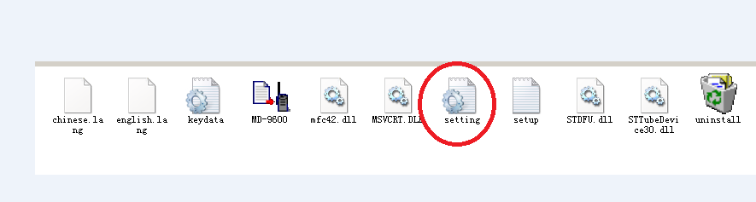
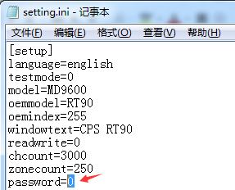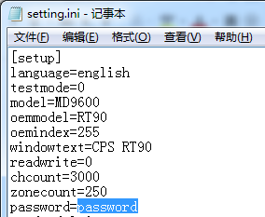

The radio enters the firmware upgrade state:
Press P1 and Emergency key to connect the power supply
user programming

