**\*\*Weekly Report: Predictive Maintenance using Random Forest Regressor for Bearing RUL Prediction\*\***

**\*\*Introduction: \*\***

In the realm of industrial operations, predictive maintenance holds a pivotal role, especially in industries heavily reliant on machinery and equipment. The untimely failure of equipment can lead to substantial downtime, production delays, and increased maintenance expenses. Organizations are harnessing sensor data and machine learning methodologies to mitigate such challenges to accurately predict the Remaining Useful Life (RUL) of critical machinery components. The prediction of RUL facilitates proactive maintenance planning, optimizing operational efficiency, and mitigating the risk of unforeseen breakdowns.

This weekly report delves into a project centered around RUL prediction using sensor data from bearing tests. Bearings, integral components in numerous industrial systems, carry significant ramifications for machinery performance upon failure. The project's primary goal is to develop a precise RUL prediction model, thereby aiding maintenance teams in scheduling and executing effective maintenance activities. This endeavor contributes to enhanced productivity and minimized downtime.

**\*\*Project Scope and Objectives: \*\***

The scope of the project encompasses several key components:

1. \*\*Data Collection: \*\* Sensor data from bearing tests conducted across varied time intervals will be gathered.

2. \*\*Data Preprocessing: \*\* The collected data might contain missing values and noise, necessitating preprocessing techniques for effective handling.

3. \*\*Model Development: \*\* The implementation of a Random Forest Regressor model is targeted to predict RUL based on sensor data.

4. \*\*Model Evaluation: \*\* The performance of the developed model will be assessed using relevant metrics like R-squared scores and Mean Squared Error (MSE).

5. \*\*Visualization: \*\* Visualizations will be generated to depict the model's predicted RUL against actual RUL values, providing valuable insights.

**\*\*Problem Definition: \*\***

This project's core lies in the challenge of precisely predicting the Remaining Useful Life (RUL) of bearings using sensor data. The accurate anticipation of RUL empowers maintenance teams to proactively address potential equipment failures. The challenge is intricate, encompassing the handling of complex sensor data, addressing missing values, and formulating a robust machine-learning model capable of generalizing to unseen data.

**\*\*Existing Solution: \*\***

Traditional maintenance strategies have either been reactive (addressing issues post-failure) or time-based preventive maintenance (routine maintenance). However, these approaches often result in either costly downtime or unnecessary maintenance expenditure. Predictive maintenance introduces data-driven models for RUL prediction, heralding a shift from traditional paradigms.

Some existing solutions leverage statistical methods like moving averages, exponential smoothing, or regression techniques. Nonetheless, these approaches might not accurately capture underlying data patterns. Machine learning models, particularly Random Forest Regressors, display promise in RUL prediction due to their capacity to handle intricate relationships within data.

**\*\*Proposed Development: \*\***

The proposed approach entails constructing a Random Forest Regressor model to predict RUL based on bearing sensor data. The data will undergo preprocessing to manage missing values, and feature engineering techniques might be applied to extract pertinent insights from sensor readings. The Random Forest model will be trained on historical data and assessed on unseen data to gauge its generalization capabilities.

The journey will encompass robustness validation through hyperparameter tuning and cross-validation. The model's effectiveness will be gauged using metrics such as R-squared scores and MSE, while visualizations will visually represent predicted RUL against true RUL values.

**\*\*Functional Implementation: \*\***

The functional implementation of the solution comprises the following stages:

1. \*\*Data Collection: \*\* Acquisition of sensor data from bearing tests across different time intervals.

2. \*\*Data Preprocessing: \*\* Addressing missing values and noise via techniques like imputation and filtering.

3. \*\*Feature Engineering: \*\* Extracting pertinent features from sensor data to accurately represent bearing health conditions.

4. \*\*Model Development: \*\* Constructing a Random Forest Regressor model for RUL prediction using engineered features.

5. \*\*Model Training and Evaluation: \*\* Training the model on historical data, optimizing hyperparameters, and assessing performance on test data.

6. \*\*Visualization: \*\* Generating scatter plots to visualize model-predicted RUL versus true RUL values for comprehensive interpretation.

**\*\*Innovation in Implementation: \*\***

The proposed development leverages the robustness of Random Forest Regressors, acknowledged for their efficacy in handling intricate data relationships. Feature engineering amplifies the model's predictive capabilities by extracting valuable information from sensor data. Furthermore, data preprocessing tackles missing values effectively. The utilization of cross-validation and hyperparameter tuning bolsters the model's real-world reliability.

**\*\*Scalability to Solve Industrial Problems: \*\***

The RUL prediction model's potential extends beyond bearing systems. Its applicability is comprehensive, serving as a predictive maintenance framework for diverse industrial equipment. By precisely predicting RUL, industries can transition from traditional maintenance strategies to proactive, data-driven methods. The model's scalability enables it to address multifaceted industrial challenges, fostering cost reduction, heightened equipment longevity, enhanced production efficiency, and data-informed decision-making.

**\*\*Result: \*\***

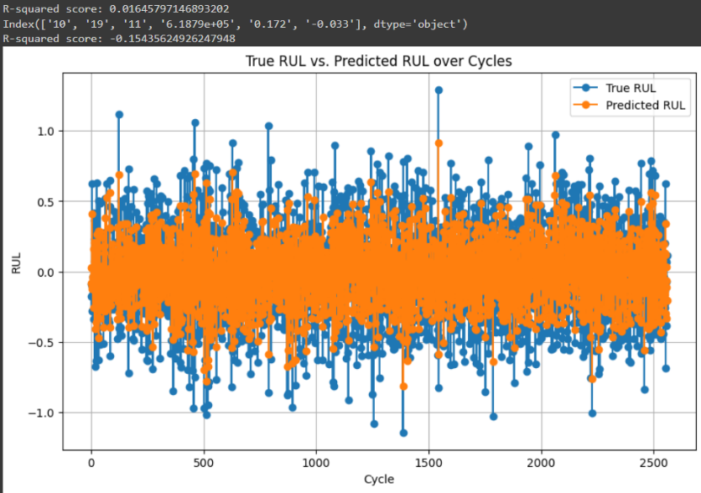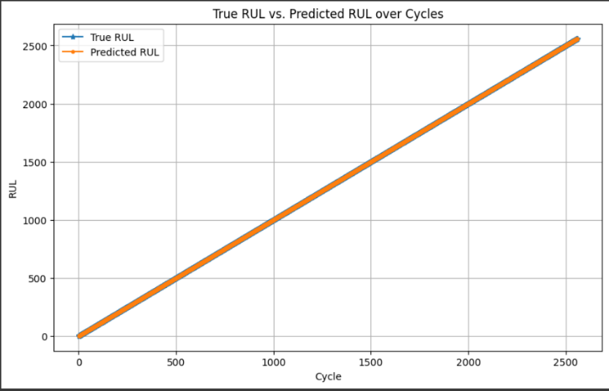

**\*\*Conclusion: \*\***

In summation, the weekly report encapsulates a project directed at RUL prediction via a Random Forest Regressor model fueled by sensor data. This approach imparts the capability to industries to transcend conventional maintenance tactics and embrace proactive, data-driven methodologies. The fusion of machine learning techniques, data preprocessing, and comprehensive visualizations underscores the endeavor's potential to address industrial exigencies effectively. The project exemplifies the symbiosis of technology and industrial challenges, ushering in enhanced operational efficiency, cost mitigation, and prolonged equipment lifespan.