**Weekly Report**

Predictive Maintenance - RUL Prediction for Bearings

Introduction:

This weekly report focuses on the development of a predictive maintenance model for estimating the Remaining Useful Life (RUL) of bearings using sensor data. The accurate prediction of RUL enables proactive maintenance planning, minimizing downtime, and optimizing operational efficiency in industries heavily reliant on machinery. The project aims to leverage machine learning techniques, specifically a Random Forest Regressor, to predict the RUL based on historical sensor data from bearing tests.

Predictive maintenance plays a vital role in industries with machinery-intensive operations. Unplanned equipment failures can lead to significant financial losses and production delays. To tackle this challenge, the project aims to develop a robust RUL prediction model for bearings, crucial components in various industrial systems. By predicting the RUL accurately, maintenance teams can proactively address potential failures, leading to increased productivity and reduced downtime.

The project's scope includes data collection from bearing tests, data preprocessing to handle missing values and noise, and the implementation of a Random Forest Regressor for RUL prediction. Model evaluation and visualization will be performed to assess the model's performance and gain insights into its predictions.

Problem Definition:

The primary problem addressed in this project is the accurate prediction of the Remaining Useful Life (RUL) of bearings based on sensor data. The RUL prediction is crucial for predictive maintenance, allowing maintenance teams to plan proactive actions to prevent unexpected breakdowns.

Existing Solution:

Traditionally, maintenance strategies have been reactive or time-based preventive maintenance, which may lead to inefficiencies and costly downtime. Predictive maintenance using machine learning models has shown promising results in estimating the RUL of equipment. Techniques like moving averages, exponential smoothing, and regression have been used for RUL prediction, but they may not capture complex data patterns effectively.

Proposed Development:

The proposed development involves implementing a Random Forest Regressor for RUL prediction. Data preprocessing techniques will handle missing values, and feature engineering will extract relevant information from sensor readings. The model will be trained on historical data, and its performance will be evaluated using R-squared scores and Mean Squared Error (MSE). Visualizations will be created to illustrate the model's predicted RUL against the true RUL values.

Functional Implementation:

The project's implementation includes data collection from bearing tests, data preprocessing to handle missing values and noise, feature engineering, and training the Random Forest Regressor model. Hyperparameter tuning and cross-validation will ensure the model's robustness and generalization capabilities. The model's performance will be evaluated using R-squared scores and MSE, and visualizations will provide insights into its predictions.

Final Deliverable:

The final deliverable will consist of Python code for data preprocessing, feature engineering, and model training. The trained Random Forest Regressor model will be provided for RUL prediction, along with evaluation metrics and visualizations.

RUL Output:

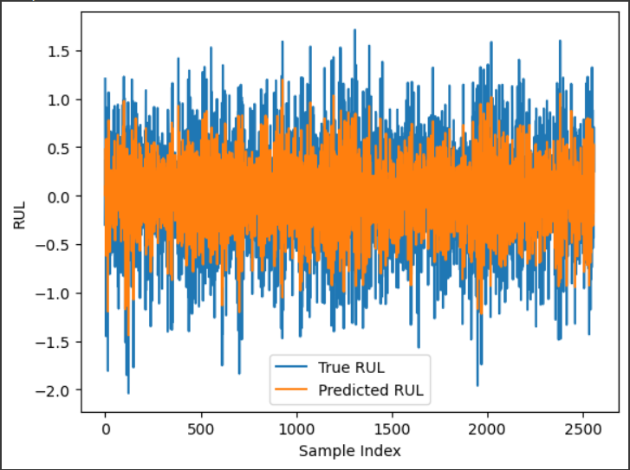

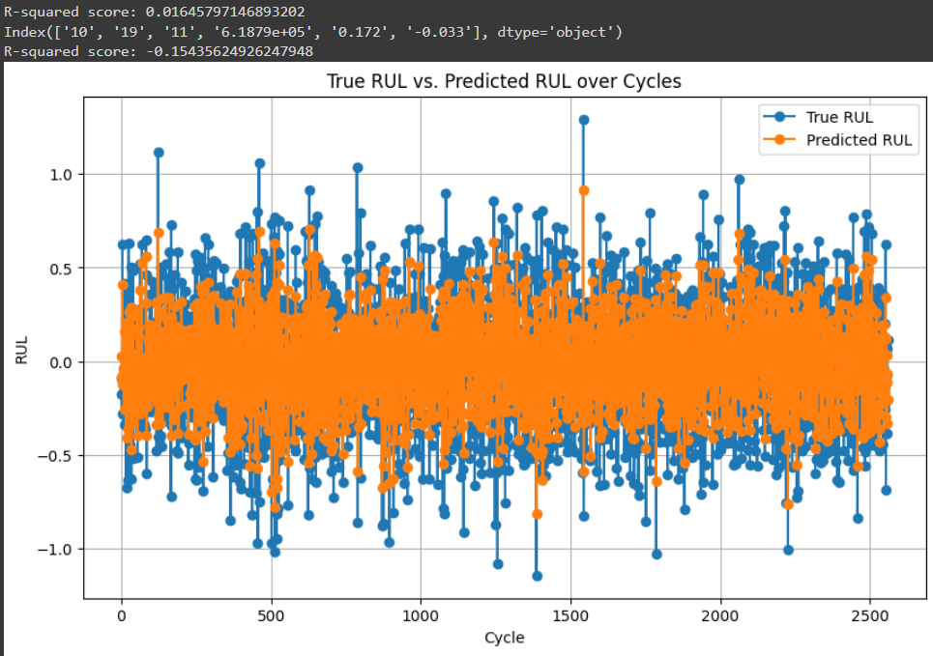

Innovation in Implementation:

The proposed development leverages a Random Forest Regressor, known for its robustness in handling complex data relationships. Feature engineering enhances the model's predictive capabilities, while data preprocessing ensures efficient handling of missing values. Cross-validation and hyperparameter tuning contribute to the model's reliability in real-world scenarios.

Scalability to Solve Industrial Problems:

The developed RUL prediction model can be applied beyond bearings to various industrial machinery and equipment. With appropriate sensor data and domain-specific adjustments, the model can extend to predict the RUL of other critical components. This scalability offers a comprehensive predictive maintenance framework for the entire industrial setup, enabling data-driven decision making and efficient resource allocation.

Conclusion:

The project aims to develop a Random Forest Regressor model for RUL prediction based on sensor data from bearing tests. The accurate RUL prediction will facilitate proactive maintenance, minimizing downtime, and optimizing industrial machinery's operational efficiency. Leveraging machine learning techniques and data preprocessing, the implementation demonstrates its potential to solve real-world industrial challenges effectively.