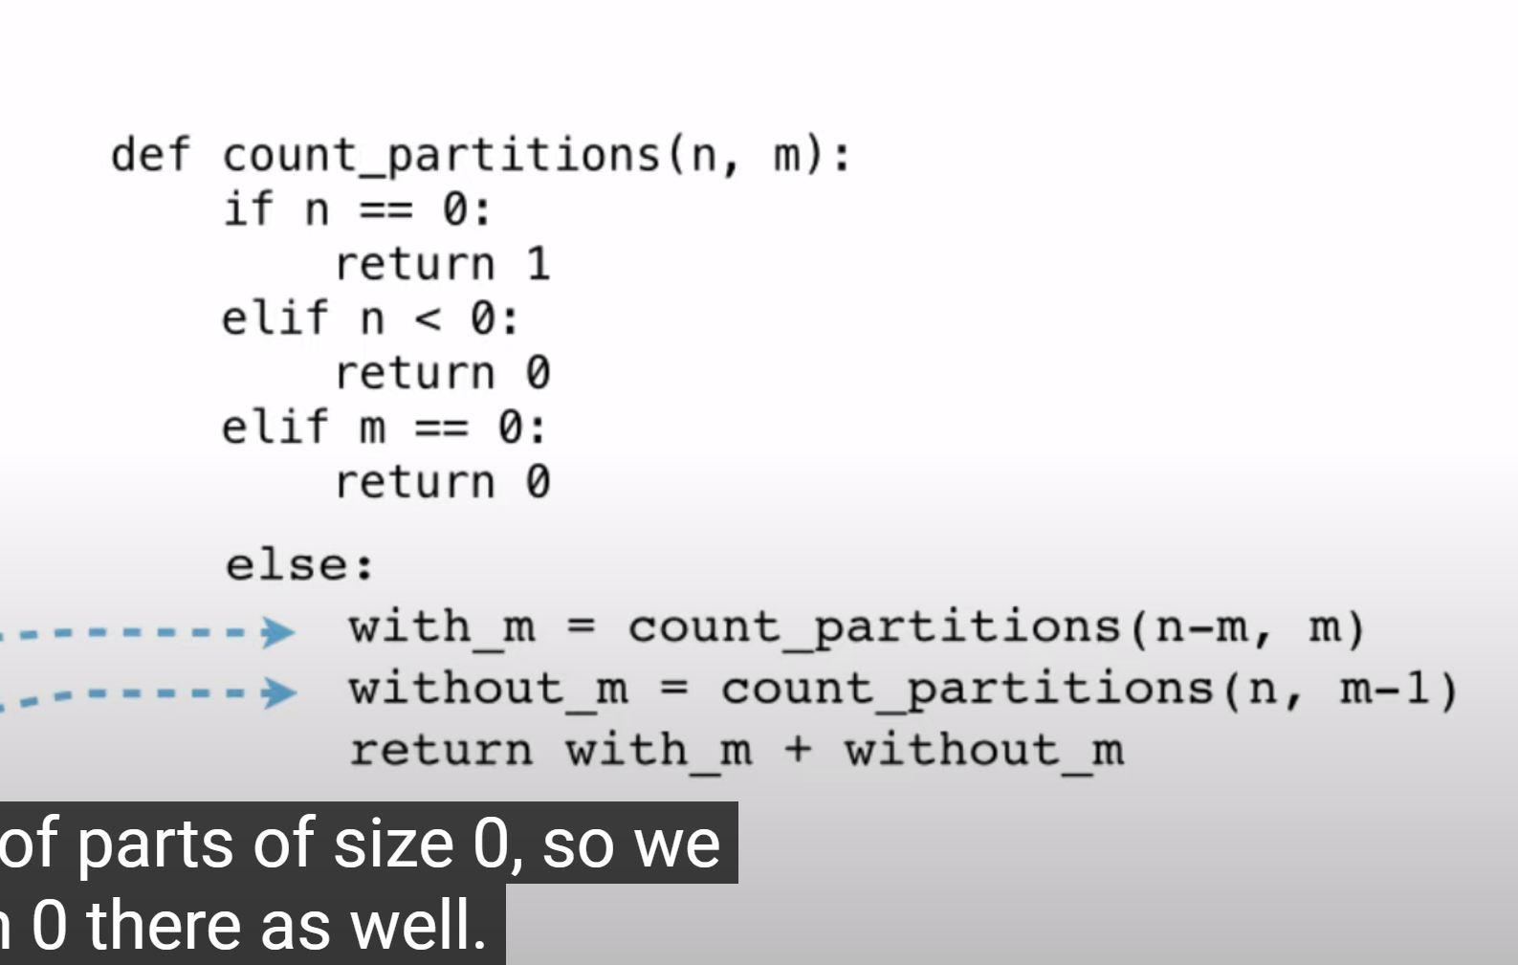

Next,iter会移动指针，导致循环只能进行一遍

seq[:i] + seq[i+1:]

Damaging a bee may cause it to be removed from its place. If you iterate over a list, but change the contents of that list at the same time, you [may not visit all the elements](https://docs.python.org/3/tutorial/controlflow.html#for-statements). This can be prevented by making a copy of the list. You can either use a list slice, or use the built-in list function to make sure we do not affect the original list.

>>> lst = [1,2,3,4]

>>> lst[:]

[1, 2, 3, 4]

>>> list(lst)

[1, 2, 3, 4]

>>> lst[:] **is** **not** lst **and** list(lst) **is** **not** lst

True