Irradiance Batch Script

The script works by taking very large volumes and then creating a grid of boxes wherever there is a floor under this grid. You can then select boxes within this grid and then use a hotkey to convert them into an irradiance volume. This script works well in most situations where the map is flat, but if you have multiple levels I suggest detaching the floor into levels and then doing stairs or dropdowns manually.

Installation
To install this script you can go under M:\tools\maxscripts\Tools\Lib
and drag irradiancebatch.mcr into max
You can add buttons, hotkeys in customize UI under the MC4 category.
You'll need the lightingzone and irradiancebatch commands.

Usage
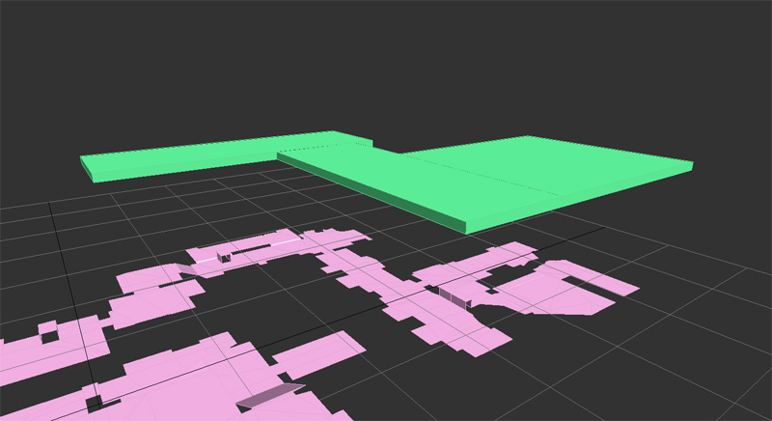
To use this script create a large box called lighting_zone and place it above your floor. Use whole number values and snap any volumes together for the best results. Your scene could look something like this:

Run the "lightingzone" command and then click on the target floor when the volumes are converted. Your scene should look something like this after:
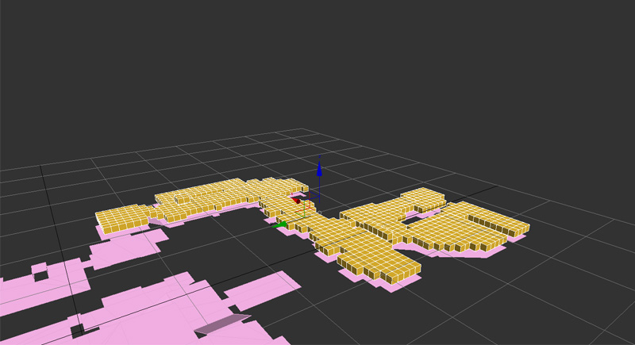
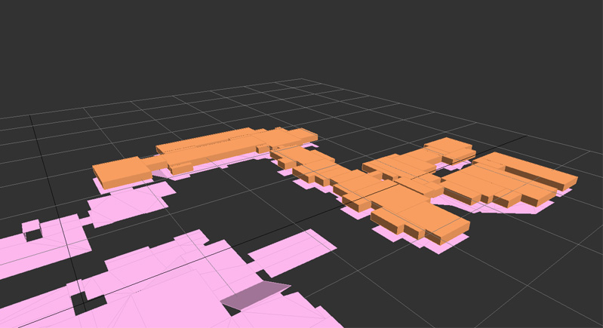
The grid volumes are snapped to the floor and moved up by 1M. All that needs to be done is to group them by making a marquee selection and run the irradiancebatch command (probably hotkey it). Try to make perfectly square selections in this process. I highly recommend that you freeze the floor to prevent selecting that object. Additionally after you run the irradiancebatch command the irradiance volumes are frozen as well.
After batching my volumes together they look something like this:
All that needs to be done is rename them correctly. This can be done with the Tools>Rename objects, and you can simply name them irradiance_volume_ and check the numbered steps. It should be done at the end so that there are no number conflicts.
It's a pretty cool script and can save a ton of time on maps with complex layouts. Let me know if you have any questions or issues.

