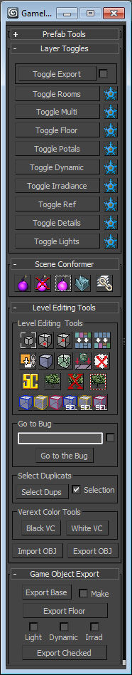
Gameloft Tools
Gameloft tools – is an extremely powerful set of tools developed internatly and specifically for the technology we use here at Gameloft. They are disgned to make you experience with out software and naming conventions as streamlined as possbile and help you cut the rough edges and save time.
The tools are separated into 5 sections. Lets take it from the top:

Prefab Tools
Prefab tools are just an easier way to create groups without the hassle of managing the groups. User has to run Scene Conformer before exporting or destroying all prefabs. Game Exporter doesn't like groups.
Layer Toggles
Layer toggles section contains a number of buttons that allow you display or hide all kind of objects possible with our engine, provided you adhere to correct naming conventions.

Toggle Export – toggle visibility as if you were to export the scene without the Portals
Toggle Check – Toggle the portals on or off.
Toggle Rooms – toggle visibility of all "room_##" objects and every object linked to them.
Toggle Multi - toggle visibility of all "multi_##" objects and every object linked to them.
Toggle Floor – toggle visibility of the "floor" (navigation) mesh
Toggle Portals – toggle visibility of all "portal_##" objects.
Toggle Dynamic – toggle visibility of all "dynamic_##" objects.
Toggle Irradiance – toggle visibility of all irradience objects.
Toggle Ref – toggle visibility of all objects that are not named in any way that the engine will recognize and will be consider helper, reference objects.
Toggle Details
Toggle Lights – toggle visibility of all light objects.
Freeze Buttons - freeze the corresponding layer

Scene Conformer
Scene Conformer is the magic wand for organazing and naming the objects in your level. With a click of a button you'll getall your objects analyzed and placed into corresponding layers.

Make multi – select an object(s), press this button, select the rooms from the menu that pops up and you'll get a new correctly named multi object with your selected meshes linked to it. You can also specify the offset of the utility object to bury it below the floor far from the players eyes.
Super Linker – No more shooting in the dark trying to get that wireframe line that represents your room object with the link tool. Just select your object, push the button, select the room and voila! All your objects corretly linked and automatically placed in the selected rooms layer.
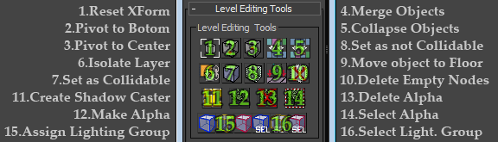
Level Editing Tools

1.Reset Xfrom – self explanatory. Also hotkeyable from Custom UI menu.
2.Pivot to Bottom - move pivot straight down to the lowest Z value of the bounding box.
3.Pivot to Center – self explanatory. The tool also works in subobject mode. The tool will move the pivot to that average position of the selection. Works with edge, verts and faces.
4.Merge Objects – attach object to each other keeping the name of the first object selected.
5.Collapse Objects – detach objects naming them "CurrentObjectName_##".
6.Isolate Layer - hide all the layers except the ones containing selected objects. Helps to figure out what the object belongs to visually. Quicker that isolating the layer/room currently being worked on.
7.Set as Collidable – add "col_" prefix to the name of the object to enable ingame collision.
8.Set as not Collidable – remove "col_" prefix from the name of the object to disable ingame collision.
9.Move object to Floor - move object straight down to where it's pivot point meets the floor mesh.
10.Delete empty nodes – Deletes objects that have no polygons in it. Engine will complain with empty mesh objects. It is also included in the scene conformer. This one is just faster.
11.Create Shadow Caster – A button that converts selected faces to a Shadowcaster and puts it in to the BakeMesh layer.
12.Make Alpha – add prefix "alpha_" to objects name.
13.Delete Alpha – remove prefix "alpha_" from objects name.
14.Select Alpha – select every object with "alpha_" prefix.
15.Assign Lighting Group – assign one of the three lighting groups: LightMap, Vertex and Unlit. Works with Lightmapper tool by adding user defined properties in the object porperties. Selecting colored objects is faster than parsing string prorperty of each object. – it's just a little something to help you keep those separated and easily within reach.
16.Select Lighting Group – select one of the three lighting groups.

Go to Bug Tools - Users can copy game camera and paste in the text box and the viewport camera will change accordingly when Go to Bug button is pressed. If the check box is checked the tool will isolate the room the bug belongs to aswell.

Game Object Export
Game Object Export allows you to export the level you're working with out having to go into Utilites tab and choosing the export script. Managing the layers by unhiding and returning back to the original working place Important to know is that if you choose to "make" upon export as well you will not be able to see an error report, should you have one and run the game. (still needs polish)
Also Exporting from Gameloft Tools takes into account all the correctly named objects in the scene, even the hidden ones.

