Lightmap Tool
Lightmap tool does not only provide you with great efficiency in producing lighting for our engine, but also gently nudges you in the direction of a more efficient lighting workflow. Especially if you're new to this.
The tool allows you to control render settings, unwrapping and baking.
Settings
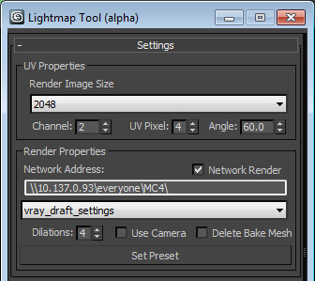
UV Properties:
This section allows you to set you rendered texture size, UV channel, UVPixel and your Flatten Mapping Angle.
Render Properties:
This section allows you to take advantage of our automatically set up distributed rendering, should you chose to check "Network Render".
You can also choose from a bunch of premade "Vray settings" in case you're not that familiar with the intricacies of Vray controls.
"Dilations" control the amount of pixels your baked UV island bleed in order to avoid Miping artifacts at lower resolutions.
"Use Camera" allows you to choose to use Vray Camera that works in conjunction with Vray Sunlight system to ensure proper exposure. More on it in the lighting guide that can be found here:
M:\doc\art\ART-PIPELINE.ppt
"Delete Bake Mesh" is pretty much self explanatory.

Render Preview
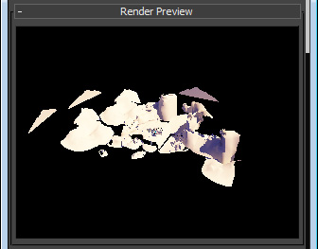
This little window does a preview render of your scene upon clicking.(using distributed rendering if checked above)
Unwrap Tools
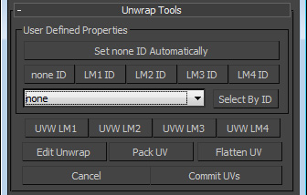
User Defined properties section allows you to assign and edit objects UV by Lighting Groups.
For example you might need 3 lightmaps for the whole level, or you want to vertex light some objects so they shouldn't really be present on the main lightmap sheet. That's were these groups come in.
With this hefty tool set you have easy access to all the LM groups in your level as well as the most necessary UV tools for unwrapping huge chunks or even the whole level at once.
Worth noting that this section uses inputs from Setting UV Properties section.(Angle)
Also worth noting that Gameloft Tools, you use to build your levels, also offer similar functionality in assigning LM groups and these properties are picked up by the Lightmap Tool and are made to work in conjunction with it.

Don't forget to commit your UVs after you're done editing, to make shure that the changes you've made actually get applied to your objects.

Bake Tools
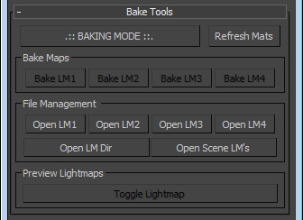
Make maps section is made specifically for baking out lightmaps for your Lightmap Groups.
When you go into Baking Mode the tool replaces your materials with bake specific ones and reverts them upon exit.

File Management section allows to open up your ligthmaps or their containing folder directly from 3ds Max.

