A Java CGM Library
Yun-Tung Lau
June 1999

Introduction
Computer Graphics Metafile (CGM) is an international standard for graphic display. The decoding of a CGM is typically tied to the type of display or low level graphic library being used (eg., X-window/Motif). Thus existing CGM libraries are not platform independent. Specific support is required for each type of window display. This problem is solved by developing a pure Java CGM class library, which translate CGM’s into Java objects and vice versa.
This document describes the concepts used in the Java CGM Library and its implementation for the NITF 2.0-CGM, which is a subset of the more general CGM standard.

Java Glyph Objects
A “glyph” is a small graphic object that encapsulates all its attributes in its data fields. It can be a simple drawing (eg. a circle), an inset pixel image, or a more complex drawing. It also carries methods for drawing, manipulating, intersecting, translating to CGM, etc.
The class Glyph defines all the glyph recognized by the CGM library. Some of the protected fields in Glyph are: color, lineWidth, X[ ], Y[ ], etc. (Figure 1). Details can be found in the file Glyph.java.
Glyph
X[ ], Y[ ] coordinates
color
lineWidth
text

draw()
drawBound()
shift()
intersect()
toCGM()

Figure 1. A simplified Glyph class.
When interpreting a CGM, the elements (circles, lines, etc.) are read and new glyph objects are created. These objects exist in an array or a vector of glyphs and are displayed when the display canvas calls their draw methods (Figure 2). On the other hand, a user can use the mouse to create a glyph object (say, a circle), which is translated into CGM only when saving to a file.
Figure 2. The abstract glyph objects allow us to translate
the CGM in a platform independent way.

Finally, a glyph can be extended to include composite graphics. An example is a north arrow, which consists of an arrow (a polygon) and the letter “N”.

The CGM Class Library
The CGM class deals with conversion to and from CGM. Its main interfaces are its constructor and the “get” methods. Examples of usage are shown below (more details can be found in Cgm.java):

From glyphs to cgm -
1) Cgm cgm = new Cgm(glyphs); // create and initialize cgm
- // note: may do cgm.add(glyph); before write or getBuf.

- cgm.write(“test.cgm”); // write to a CGM file
// conversion is invoked implicitly
or
buffer = cgm.getBuf(); // retrieve the cgm buffer
// conversion is invoked implicitly

2) Cgm cgm = new Cgm(); // create and initialize cgm
cgm.add(glyphs); // adds a vector of glyphs
buffer = cgm.getBuf(); // retrieve the cgm buffer
Here “glyphs” is a vector containing multiple glyphs, which is created by :
Vector glyphs = new Vector();

From cgm to glyphs -
Here cgm_buffer is an array of bytes (byte [ ]) containing cgm codes.
1) Cgm cgm = new Cgm(cgm_buffer);
glyphs = cgm.getGlyphs(); // get glyphs as a vector

2) Cgm cgm = new Cgm(); // create and initialize cgm
cgm.read(“test.cgm”); // read from file and set cgm_buffer
- // it automatically calls the CGM
// interpretor, which creates the
// corresponding glyphs.
glyphs = cgm.getGlyphs(); // get glyphs

3) Cgm cgm = new Cgm(); // create and initialize cgm
cgm.setBuf(cgm_buffer); // set cgm_buffer & add to glyphs
glyphs = cgm.getGlyphs(); // get glyphs

A more elaborate example of the Glyph-CGM interaction is shown in Figure 3 (from the Whiteboard application). There the DrawCanvas class acts as a driver to the Cgm class, which in turn uses the servant class CgmTool. A user of the Java CGM class library only needs to deal with Cgm.java.
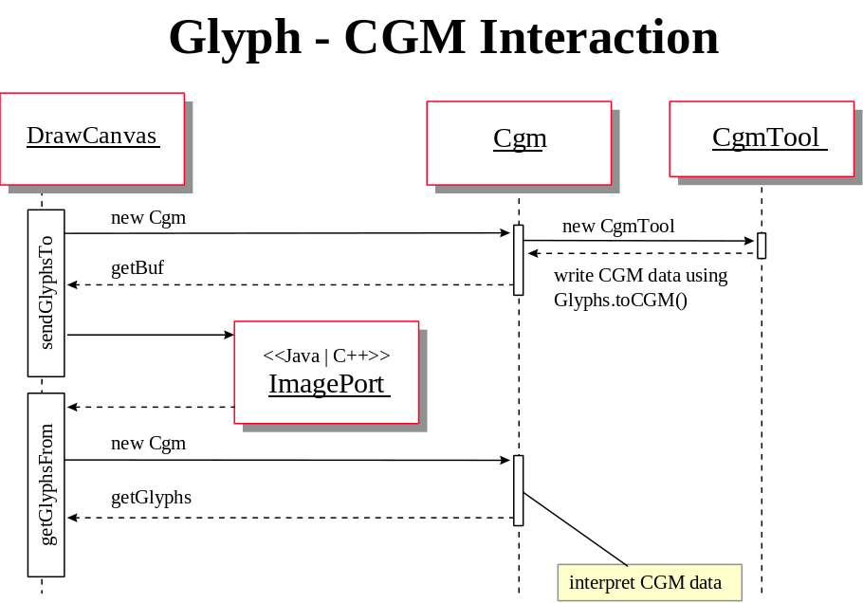
Figure 3. Glyph-CGM interaction.

Hierachical Group
NITF uses Display Level and Attachment Level to indicate the hierachical order of its elements. The level numbers basically set up a linked list for the elements. The scheme is simple to implement but in an interactive graphic display environment like the Whiteboard, it can result in very slow searching. To see this, suppose we want to move element 2 along with its subordinates. If ten elements are found to link to element 2, we need to keep searching down each of the ten links and all of the sublinks in order to find all subordinate elements.
An alternative solution is to implement a hierarchical group structure. Each element in the hierarchy has a “key”, which is used to quickly locate the subgroup to which the element belongs. This scheme is described in detail below.

Hierarchical Group Key
The key is an integer partitioned into several parts. For example, with a 4-byte integer, we may have:
Byte 3

1
Byte 2

255
Byte 1

2
Byte 4

20

which can be represented as 20.1.255.2 (like an IP address). Each unique key represents a group of glyphs. They key 0.0.0.0 represents the base image or other ungrouped glyphs. Note that multiple glyphs can have the same key. Each positive key code (key > 0) represents a unique group of glyphs. This grouping key allows us to manipulate multiple glyphs simultaneously (like moving them together).

From Level to Key
First, let’s look at translation from NITF Display Level (DL) and Attachment Level (AL) to the hierarchical group “key”.
DL | AL | key | Comment
0 | 0 | 0.0.0.0 | Base image or ungrouped glyphs
1 | 0 | 0.0.0.1 | First group of CGM. All glyphs in group have same key
2 | 0 | 0.0.0.2 | Second group of CGM
3 | 1 | 0.0.1.1 | Subgroup attached to 0.0.0.1
4 | 0 | 0.0.0.3 | Third group of CGM
5 | 4 | 0.0.1.3 | Subgroup attached to 0.0.1.3
6 | 1 | 0.0.2.1 | Second subgroup attached to 0.0.0.1
7 | 6 | 0.1.2.1 | Subgroup attached to 0.0.2.1
8 | 7 | 1.1.2.1 | Subgroup attached to 0.1.2.1
9 | 8 | 2.1.2.1 | Reach bottom of hierarchy – see text

The last row in this table indicates that the bottom of the hierarchy has been reached. Instead of starting a new subgroup, we simply set display element 9 to be in the same hierarchy as element 8 (but different group). If four levels of subgrouping is not enough, one can use a long integer key, which has 8 bytes, or eight levels of subgrouping. In an interactive display environment, such as the Whiteboard, it is unlikely that we need to track more than eight levels of subgrouping (although NITF does allow unlimited levels of links).

Glyph Management
Next we discuss the manipulation of glyphs using their keys. The glyphs are displayed according to their order in a vector containing all glyphs (similar to the Display Level in NITF). The management of groups of glyphs is shown in the table below.

Key | Glyph Management
0.0.0.0 | Base image - operation (eg. moving, resizing) affects all other glyphs of all groups.  Glyphs with this key are considered ungrouped glyphs. Their manipulation is independent of other any other glyphs.  Ungrouped glyphs can be grouped and assigned the next available key value 0.0.0.k.
0.0.0.1 | First group of glyphs. Its operation affects all subgroups with keys of the form i.j.k.1 (for i,j,k > 0).
0.0.0.2 | Second group of glyphs. Its operation affects all subgroups with keys of the form i.j.k.2 but not other groups of the same hierarchy (like 0.0.0.1)
0.0.1.2 | First subgroup attached to 0.0.0.2. Its operation will not affect group 0.0.2.2.
0.0.2.2 | Second subgroup attached to 0.0.0.2. Its operation will not affect group 0.0.1.2.

Glyph Selection
When selecting a glyph, if it has value 0, then it is independent and only that glyph is selected.

If the key value > 0, then other glyphs are searched and all glyphs of the same key value is selected (group selection). Furthermore, all subgroups are selected too. For example, if the selected glyph has key 0.0.1.2, then all glyphs with keys of the form *.*.1.2 are selected. The search is done in a single for loop by matching the code of the first two hierarchies. This is much faster than the linked list searching with the original NITF scheme.

From key to Level
To translate the hierarchical group key into Display Level (DL) and Attachment Level (AL), we do the following.
- The base image (key = 0.0.0.0) has DL = AL = 0.
- Each group with key > 0 will produce one CGM. The Display Level is determined as follows. For each group with key > 0, find the minimal index in the vector glyphs (that index determines the display order of the glyphs). Use that index to order the groups. The Display Level is the same as the order.
- The Attachment Level is simply determined by the subgroup association. For example, 0.m.2.1 is attached to 0.0.2.1 and n.1.3.1 to 0.1.3.1 (for m, n > 0).

Other key partitions
Finally, in the above example, we have used one byte (8 bits) per partition for the key. This gives a maximum of 255 elements (not counting the value 0) in each level. However, NITF standards require 1000 elements. This can be achieved by using a 10-bit partition. So if we use a 64-bit integer (long int), we can have up to 6 levels of subgrouping.

