# Introduction to HTML, CSS, & JavaScript

## Overview

Hypertext Markup Language (HTML) is an annotation system for text, also called a *markup language*, that is used to define Web pages. Web browsers retrieve HTML files from Web servers and create visual representations of them to the user. To understand how to create Web applications, you need to understand HTML.

Reading and References  
The following are some recommendations, but you are free to use whatever resource or online article you find to complete this assignment (No seriously, I only care that you can complete the assignment. Use whatever resource you like to get this done. I have provided a few links to help.) The only exception is please look over the diveintohtml5 article below.

References:

<http://computer.howstuffworks.com/web-page1.htm>

<http://www.w3schools.com/html/default.asp>

<http://www.htmlgoodies.com/primers/html/article.php/3478141>

<http://www.w3schools.com/css/>

<http://www.htmldog.com/guides/css/beginner/>

<http://www.cssbasics.com/>

Training Courses:

<https://www.khanacademy.org/computing/computer-programming/html-css>

<http://www.microsoftvirtualacademy.com/training-courses/adding-style-with-css>

Glance over this:

<http://diveintohtml5.info/>

## Example

Here is a simple HTML file.

<html>  
 <head>  
 <title>Hello, World.</title>  
 </head>  
 <body>  
 <h1>Hello, World.</h1>  
 </body>  
</html>

Deliverables

When this assignment is complete, you will have created a folder called assignment1 containing the following files. This html folder and its contents will be zipped up and you should ftp the site to altervista.com.

* index.html
* elements.html
* inline_styles.html
* internal_styles.html
* external_styles.html, styles.css
* form.html
* entities.html

## Instructions

## Part 1: HTML

Create a folder called *part1*.

Create the following files (using notepad or any other text editor for HTML) in folder *part1* and test them by opening them in a web browser directly from your file system.

**NOTE: You should create the HTML content for these pages.**

|  |  |
| --- | --- |
| index.html | Contains relative links to all other pages in this assignment. (These links are relative, so they work correctly when the files are copied to a new location in the file system.) |
| elements.html | Contains examples of the following elements: html, head, title, body, p, h1, h2, pre, img, table, ul, li. |
| inline_styles.html | Contains style attributes for the following tags (inline style approach): body, p, h1, h2, pre. |
| internal_styles.html | Contains style attributes for the following tags using the internal stylesheet approach: body, p, h1, h2, pre.  See: <http://www.w3schools.com/html/html_css.asp> |
| external_styles.html  styles.css | Contains style attributes for the following tags using the external stylesheet approach: body, p, h1, h2, pre.  See: <http://www.w3schools.com/html/html_css.asp> |
| form.html | Contains an example of a form element containing the following controls: text box, text area, check boxes, radio buttons, submit button, drop-down selection list. |
| entities.html | Contains examples of 5 different HTML entities, such as &amp; and &lt; |

You should be able to navigate to the website and between each of these files.

## Part 2: CSS

**References:**

* <http://www.w3schools.com/css/>
* <http://www.barelyfitz.com/screencast/html-training/css/positioning/>

CSS (Cascading Style Sheets) is a method of apply style, design, and layout to webpages. Some things to think about as you go through this assignment… what are some methods of including css on webpages? ...what can CSS really be used for? ...is CSS used by a programmer?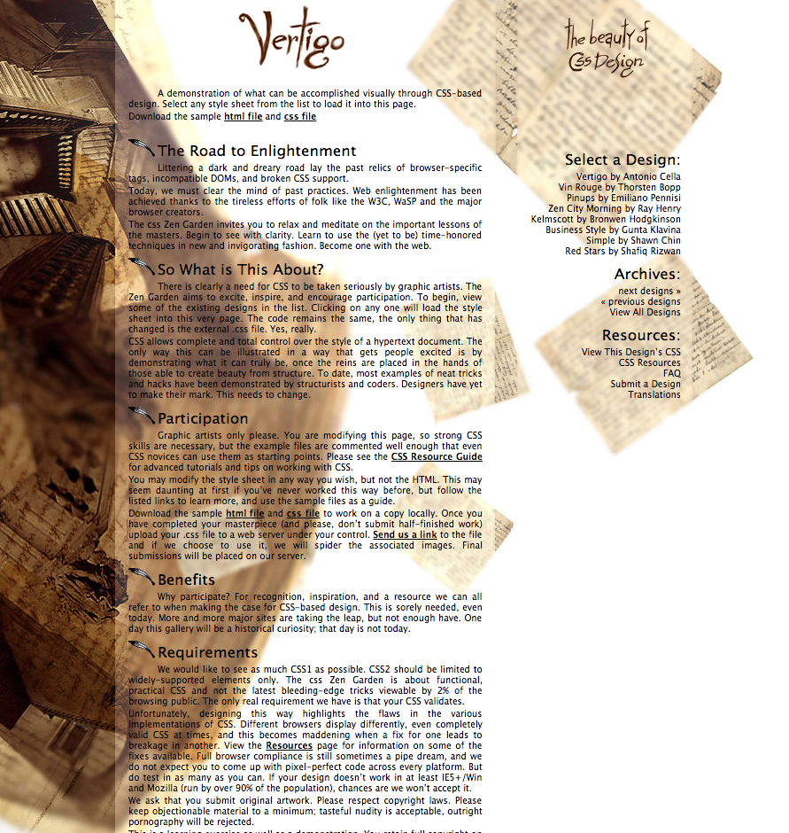

Create a folder called *part2*..

Create the layout on the following page using CSS. You should attempt to make your page look as close as possible. The source html can be found here: <http://www.csszengarden.com>

***(Yes, you can find the design below. I want you to try to create this on your own. You are welcome to look at any of the other layouts to get ideas, but please make this work your own. I will check to see if it’s the same file.)***

Image Resources:

* <http://www.csszengarden.com/180/bck.jpg>
* <http://www.csszengarden.com/180/bck2.jpg>

Resources:

<http://www.csszengarden.com/180/title2.jpg>

<http://www.csszengarden.com/180/svirgolata.gif>

<http://www.csszengarden.com/180/bck.jpg>

<http://www.csszengarden.com/180/bck2.jpg>

## Part 3: JavaScript

Javascript is perhaps the only truly web programming language. While there are exceptions, JavaScript for the most part runs in your browser. It doesn’t typically run on a server. Each browser implements it’s own JS Scripting Engine. Because of this each browser will often have difference that can make JS painful. Therefore, libraries like Dojo, jQuery, and prototype have arisen.

This is a simple JavaScript file that copies one field to another:

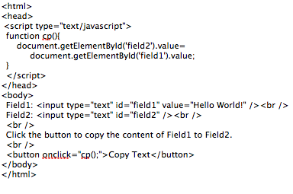

**Part 3A: Site**

Place all your files in a folder called part3.

In this assignment, you will create a simple website to provide a simple online calculator that you will write. Using the The site should have the following structure:

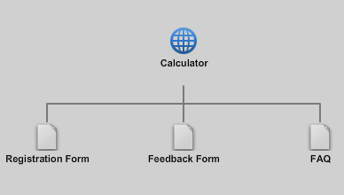

So there are four pages total. You should be able to navigate easily from all the pages. Before you get started, work through these:

<http://www.codecademy.com/courses/javascript-intro>

<http://www.microsoftvirtualacademy.com/training-courses/javascript-fundamentals-for-absolute-beginners>

<http://learn.appendto.com/>

<http://javascript.info/tutorial/introduction-browser-events>

**All Pages:** Should use a common css file where appropriate (if there is a page that has it’s own either create a second css file or use a script block. All pages should navigate well between each other.

**Part 3B: Calculator**: Develop a HTML/Javascript calculator site.

Reading:

<http://kalyan-city.blogspot.com/2009/11/simple-javascript-calculator-code.html>

*Note: this guy uses document.calculator.number1.value to get access to values. document.getElementById is a better approach. Try using this approach instead. http://www.tizag.com/javascriptT/javascript-getelementbyid.php

<http://jsmadeeasy.com/javascripts/Calculators/Basic%20Calculator/index.htm>

Here is another basic calculator. This guy uses the eval() method. What does it do?

You customer tells you he likes the way this looks:

<http://learnjavafx.typepad.com/.a/6a00e54f133d698834010536422a08970b-800wi>

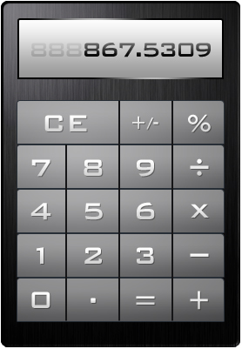

**Part C: Feedback form:** The feedback form is for people to send feeback. It should collect email and comment. Email must be a validate email address and comment must not be empty. On this one, I want you to validate using document.getElementById() only approach.

*\*NOTE: You don’t have to worry about actually sending it someplace. Just validate the input when you click the button to submit.*

## Turning it in

FTP and publish your site to altervista. You should have three folders published to altervista.org. Create an index.html page at the root of the site to link to all three. Turn in the link to blackboard.

***Use either your ftp client, the file browser on altervista.org, or cyberduck from this link*** [***https://cyberduck.io***](https://cyberduck.io)***. Do NOT use filezilla is full of malware.***

**References:**

* <http://howstuffworks2012.blogspot.com/2012/03/whats-ftp-how-do-i-use-it.html>
* <https://wiki.filezilla-project.org/FileZilla_Client_Tutorial_%28en%29>
* <http://www.coffeecup.com/help/articles/absolute-vs-relative-pathslinks/>

Create an account at altervista.org. *These screenshots are from last year. They may have been changed.

**Step 1:**

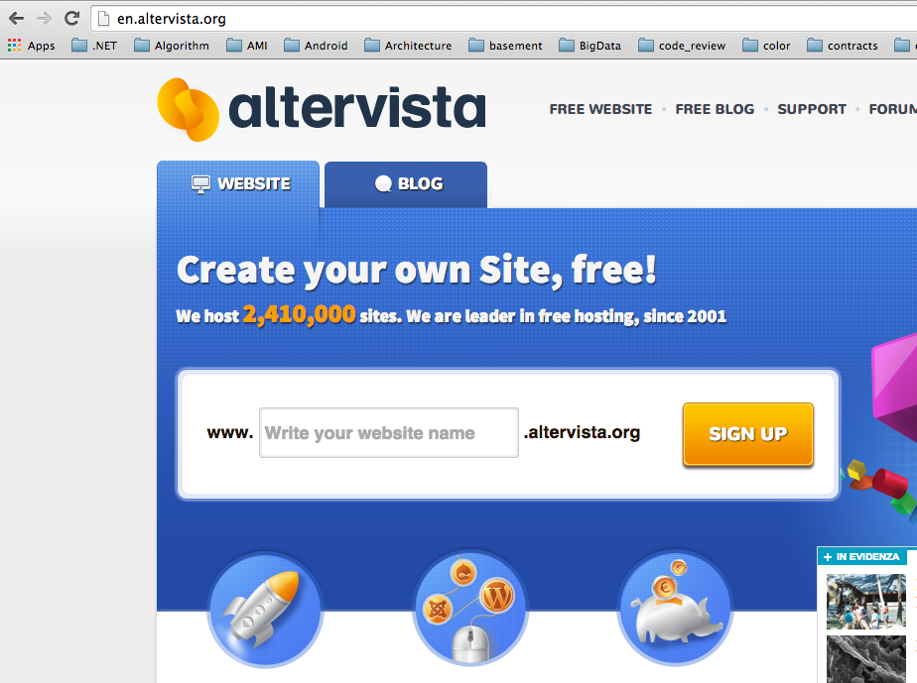

**Step 2:**Dismiss the quick start splash page. Play around in the dashboard. See what’s available. Make sure to visit the template site that was created for you by clicking on the Go to Your Site.

|  |  |
| --- | --- |
|  |  |

**Step 3:**

Go to the dashboard and click FTP.

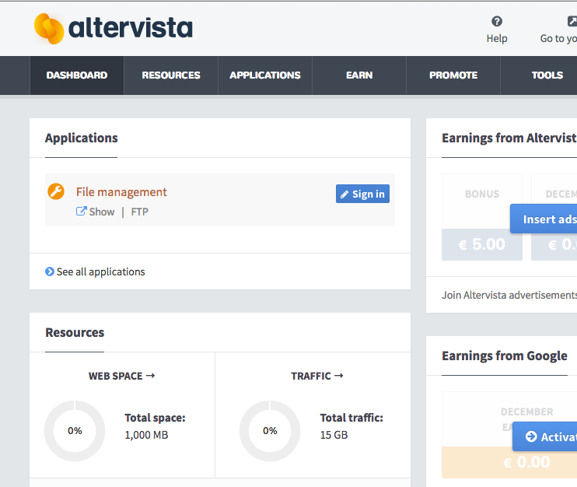

**Step 4**

Record your credentials

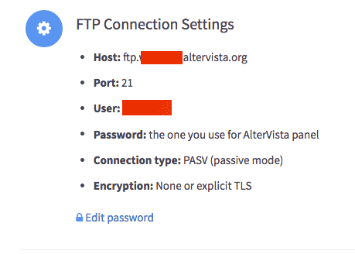

**Step 5**

Use an FTP client to connect (I will demo one called filezilla… you can find it on the web along with quickstart tutorials) and download your sample page.

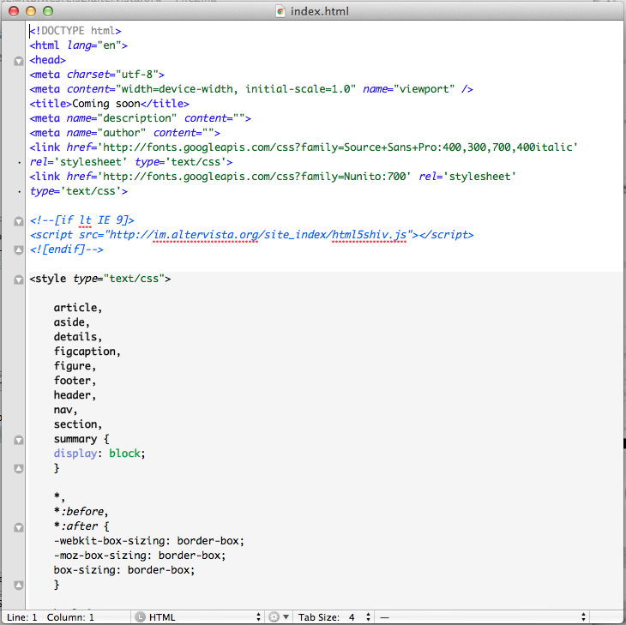

**Step 6**

Using this page as a template and any of your new found skills from part 1-2, redesign a homepage for you. It must link to part1, part2, and part3.

**\*NOTE: make sure you use relative links to your resources (don’t use file system links… anything with c:/Documents and Settings will not work when you upload. They should all be images/wes.png if the document referencing it is in the same directory as the image folder. If this doesn’t make sense to you, google relative links html pages.**

**Step 7**

When you are done, use your ftp client and upload your pages. Post the link to your site on blackboard. (See Cyberduck above)