Homework 3: JQuery and JQuery Plugins

**Reading:**

* <http://learn.jquery.com/>
* <http://www.microsoftvirtualacademy.com/training-courses/introduction-to-jquery>
* <http://www.w3schools.com/jquery/jquery_intro.asp>

**Purpose:** Develop a tic tac toe game. In case you forgot, here are the basics:

- Players alternate

- One player is X the other is 0

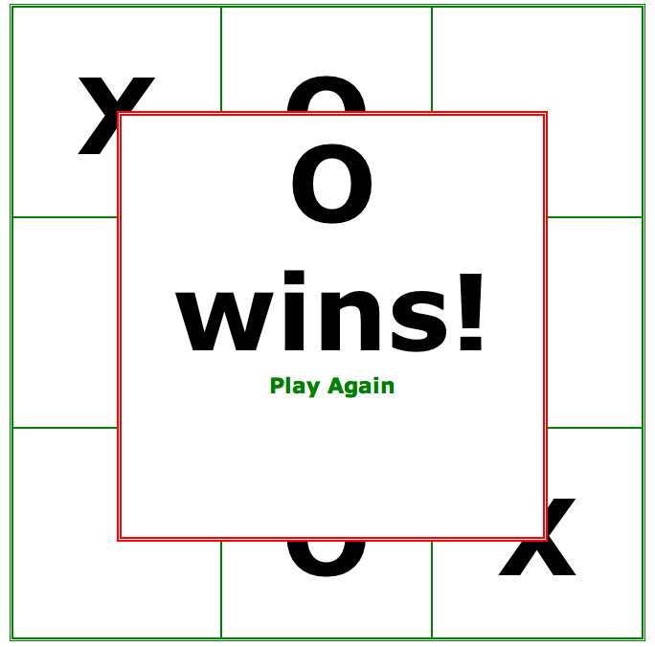

This game should be your standard tic tac toe game using javascript event handlers and jQuery. In this game, you have the license to make it look like whatever you want. Please make it professional looking.

Also I want you to develop this into a simple website. The website should have a 3 field contact us (use ***jquery validation*** with this), 5 field registration form (use ***jquery validation*** with this), 20 question filterable and sortable faq (use ***jquery datatable*** plugin for this), and the actual tictactoe game. All of the site should be HTML, CSS, and JQuery.

So one of the questions you will likely have about now is: how do I get jquery validation and jquery datatable. Try out this link: <http://lmgtfy.com/?q=how+do+I+get+jquery+validation>

:)

I want you to do your own research for this project. Use the web. Google javascript jquery tic tac toe. Read and understand the blogs you find. If your code is a straight copy of what you find, I will not accept it. I want you to read through the code you find and make it your own. I also want you to use jQuery tables and jQuery validation plugins for the site. Make sure you give yourself enough time.

***I’m not going to give you articles to use this time. Do your own research.***

This should be posted to your altervista site and link submitted to blackboard

Here is the sitemap I would like you model.

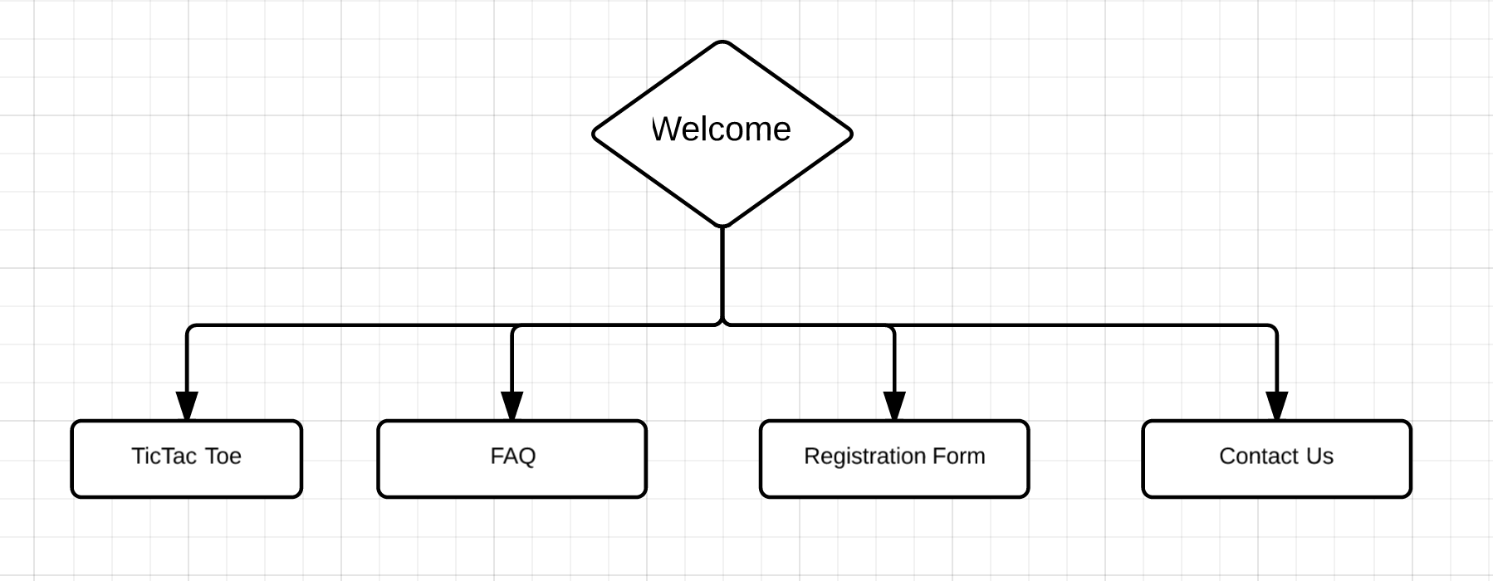

**Part B: Working with Git**

References:

* https://www.atlassian.com/git/tutorials

**I would like you to complete the following walkthrough:** [**http://www.mutuallyhuman.com/blog/2012/06/22/a-git-walkthrough**](http://www.mutuallyhuman.com/blog/2012/06/22/a-git-walkthrough)

For installing Git, use this Github Desktop (<https://desktop.github.com/>). Make sure the commandline tools are installed (<http://stackoverflow.com/questions/32261198/how-do-you-configure-github-desktop-to-run-from-the-command-line-in-osx>). Then I want you to work through the walkthrough above. Anytime, you see a git command, I want you to execute it. For example, in the following part of the tutorial:

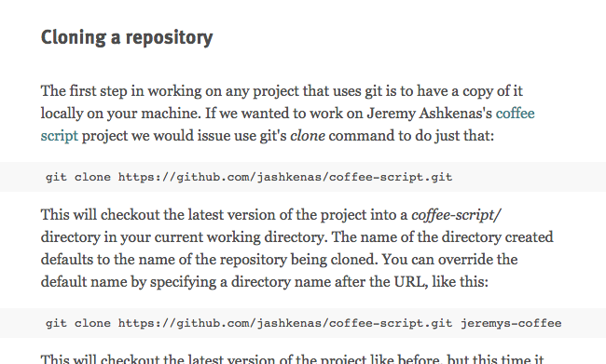

You should git clone the provided url. Notice, he wants you to do another clone specifying a name of the repo this time. I want you to execute both commands.

**You should so all of these commands in a git-bash window. Let me say this again, use git bash. If you do not, you will have issues.**

When you have completed the complete walkthrough, I want you to execute the following:

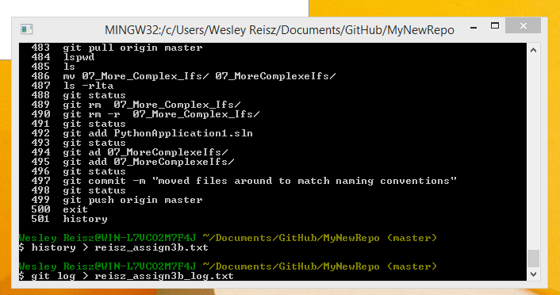

Submit the link to part A and the two files for part B on blackboard.