|  |
| --- |
| **[Undisciplining the Victorian Classroom logo](https://undiscipliningvc.org/)Peer-Reviewed Assessment**  **Peer Reviewer:** Vani Kannan  **Date:** 2023  **License:** [CC BY-NC 4.0](https://creativecommons.org/licenses/by-nc/4.0/) |

**Intro to Archival Research Handout**

Katherine Judith Anderson

Western Washington University

katherine.anderson@wwu.edu

**What is an archive?**

* An [**archive**](https://www.merriam-webster.com/dictionary/archive)is "a place in which public records or historical materials (such as documents) are preserved." **Archives** contain [**archival materials**](https://vangarderen.net/posts/archival-materials-a-practical-definition.html), which "are information objects that serve as evidence of past events." Although some institutions might have more distinct meanings for the two terms, "special collections" is often synonymous with "archives."
* Since the eighteenth century, **archive** has been used metaphorically as a title for academic, historical, and scientific **periodicals.** A periodical is a journal or magazine that is issued periodically: 4 times a year, once a month, once a week, etc.
* University libraries often house archives or special collections. For example, at my graduate institution, the Lilly Library is a designated rare books, manuscripts, and special collections library, housing a vast array of cultural texts and objects, including a Gutenberg Bible printed in 1455 (only 48 copies of this Bible still exist in the world), an Oscar award, handwritten letters from serial killer John Wayne Gacy, and Sylvia Plath’s hair. Researchers travel to see and then write about all these things. On the same campus, the Kinsey Institute houses an archive relating to human sexuality that includes items from more than 2,000 years of history.

A pair of simple wooden clogs against a grey background.


Figure 1. Tippu Tip. “Inscribed Clogs Gifted to Herbert Ward.” c.1890. [*One More Voice*](https://onemorevoice.org/html/transcriptions/liv_021097_ART.html).

* University libraries (and public libraries of the caliber of the New York Public Library, museums, etc.) often collect documents and objects related to a specific person, writer, or group of writers. They will buy these items from private collectors, other institutions, or sometimes family members of the individual in question, or the items will be donated to the library collection. Researchers will travel from all over the world to visit that archive, read the material, photograph, and take notes as needed, and then write their analyses in relation to the individual or group who make up the subject of that collection. There are also national archives, which serve as a repository for the historical documents of a nation.
* A **digital archive**is similar in purpose to a physical archive, but the historical documents and objects that provide evidence of the past have been digitized (often by scanning or photography, unless a document was created digitally in the first place) and made available online. Digital archives are created to preserve historical texts and objects and to make them widely accessible, especially to researchers who cannot afford to travel or take time off to visit the physical archives.
* All archives play a part in knowledge production, collective memory, and identity construction; thus, they reveal political commitments. For every record saved in an archive, countless others are not. Traditionally, Anglo-European archives have tended to preserve and produce knowledge of the past in ways that maintain inequitable and imperialist hierarchies of race, class, and gender. While this in no way means that we should burn all archives to the ground and refuse to engage with history or historical records, it does require us to think carefully and critically about how power is distributed in the archives. What is deemed worth preserving and why? How can we as archival researchers decenter, destabilize, and displace imperialist archival epistemologies (ways of knowing)?
* Displacing imperialist archival epistemologies is the primary [mission](https://onemorevoice.org/html/documents/mission_statement.html) of *One More Voice*. One of the ways the project achieves this mission is by refusing the term “archive” in the way scholars usually understand it, instead calling itself a “digital humanities recovery project**.”** It seeks to provide “recourse to voices [that promise] to transform common critical understanding of global history and literatures – particularly critical understanding rooted in Anglo-European intellectual traditions – while foregrounding perspectives that scholarship coming from such traditions has hitherto overlooked or silenced.”

It’s important for us to remember, as *One More Voice* says, that:

* + This recovery work “will always be incomplete due to the biased and fragmentary nature of imperial and colonial archives.”
  + “Recovered voices will not necessarily be completely authentic records of the original creators.” There is a lot of mediation (as we saw with Thomas Pringle’s editing of *The History of Mary Prince*).
  + “All the voices from these archives must be read and understood as *already* embedded in a wider, intercultural, documentary context.”

*One More Voice* therefore stresses the need for “highly-considerate critical practices when working with these voices,” and I ask that you remain mindful of this in your own research and writing.

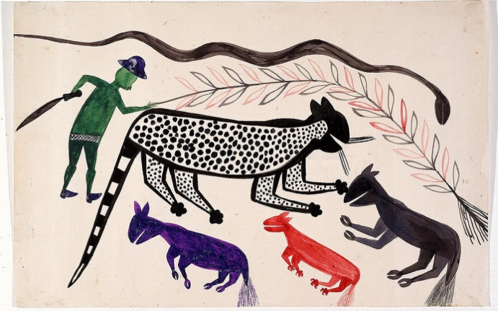

Figure 2. Djilatendo (Tshyela Ntendu). “Les Animaux.” c.1930. [*One More Voice*](https://onemorevoice.org/html/transcriptions/liv_021042_ART.html).

**What counts as an “archival text”?**

A **primary source** is the text or cultural object that you analyze/make your argument about. It is the focus of your essay and argument. In our class, primary sources are nineteenth-century texts (and sometimes, relevant adaptations that represent those texts).

A **secondary source** is a critical/scholarly article or essay that has concepts or ideas you can use to help you analyze the primary source. These kinds of sources are secondary to 1) your primary source and 2) your own argument. Think of them as your background singers who are there to support you, or in this case, your argument. In our class, secondary sources are the scholarly articles we read alongside our nineteenth-century texts.

Archival texts are primary sources which we can analyze just as we do any literary texts because they too are cultural representations: in our case, cultural representations from the nineteenth century.

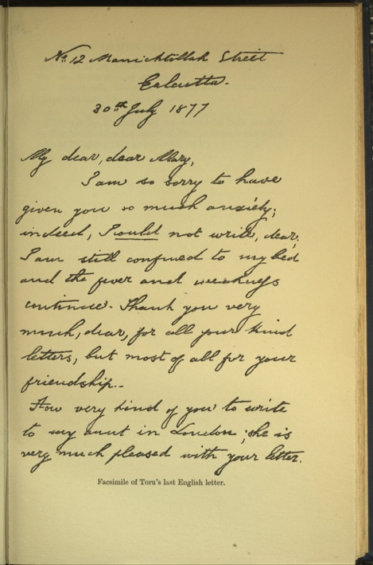

Figure 3. Dutt, Toru. “Facsimile of Toru’s Last English Letter” [Letter to Mary E.R. Martin]. 30 July 1877; 1921. [*One More Voice*](https://onemorevoice.org/html/transcriptions/liv_021109_ART.html).

* Originally, the term “archival text” referred to primary texts that hadn’t been published: personal photographs, diaries or journals, letters, unpublished manuscripts, government documents, etc.

* As noted above, it can also refer to published primary materials such as articles in the periodical press, images or illustrations, or material objects of various kinds.
* For our purposes, we’ll research unpublished or published texts and/or images from the nineteenth century, including some fiction (like short stories that were published in periodicals).

**Archival Essay**

Katherine Judith Anderson

Western Washington University

katherine.anderson@wwu.edu

# Length: 3-4 pages, double spaced, plus separate works cited page

**Objectives:**

* Research and familiarize yourself with nineteenth-century primary materials, taking ownership of your knowledge and the research choices you make
* Understand and think critically about what archives are and how they produce knowledge, as well as best practices for using them as a scholar
* Critically engage with the voices of racialized creators in British imperial and colonial archives
* Connect literature to its cultural and historical moment through primary research
* Critically analyze nineteenth-century literature and writing, attending to the significance of textual details and cultural contexts
* Construct a scholarly argument featuring critical and independent thinking
* Effectively express interpretation through writing
* Hone your scholarly voice and writing style

If you wish, this archival essay can serve as the initial base on which to build your final research essay, with additional editing and the expansion of your ideas.

# Sources:

# (Some of the language below and on the “Intro to Archival Research” handout is adapted directly from the *One More Voice* website, particularly the [Mission Statement](https://onemorevoice.org/mission_statement.html)*.*)

|  |  |
| --- | --- |
| You will conduct your archival research in [*One More Voice*](https://onemorevoice.org/), a freely accessible project of digital humanities scholarship that focuses on identifying, documenting, and critically engaging with the voices of racialized creators in British imperial and colonial archives. | A black woman sits outside and looks off into the distance. She is centered in the frame and is wearing a white head covering, black shawl, and light dress.  Figure 1. Jones, Neville. “Semane Khama.” Early twentieth century. [One More Voice](https://onemorevoice.org/html/transcriptions/liv_021022_ART.html). |

The name *One More Voice* “reflects the fact that there is always *one more voice* to recover from the archives. The voices take multiple forms and appear in multiple genres, including travel narratives, autobiographies, letters, diaries, testimonies, interviews, court records, treaties, maps, oral histories, genealogies, and vocabularies. *One More Voice* seeks to introduce these rich and diverse materials to broad academic and public audiences, but also acknowledges the impossibility of amassing the materials in a single place because of their dispersal across the archives.”

**Instructions for the Essay:**

You will choose one (1) primary text from this database to analyze in your archival essay. The text you choose can be written or visual, and it is entirely up to you.

If you wish, you can write a comparative essay, placing the primary text you chose in conversation with one of our course texts.

Above all, the important thing to note is that archival texts are cultural representations, and therefore, *you must close read/analyze them just as you’ve analyzed our course texts.* Even if your archival text is an illustration or an article rather than a piece of fiction, interpreting the specific details is still your main goal. All cultural representations require analysis. With that in mind, here are some options for how to go about approaching and organizing your essay:

* Choose a text from *One More Voice* and provide a close reading of that text, making an argument about what you think it shows us about (British) imperialism or colonialism, anticolonialism, the creator’s life and position in relation to the imperial archive, or any of the themes and topics we’ve discussed thus far in class, paying explicit attention to form as well as content.
* Choose a text from *One More Voice*, then do a comparative analysis of it with a primary text from our course in relation to some shared, specific topic, cultural issue, or theme, paying explicit attention to form as well as content. If you go this route, close readings of both texts will inform your essay.
* Choose a text from *One More Voice* and attempt a critical fabulation, like Saidiya Hartman does in the essay “Venus in Two Acts,” to honor the creator’s voice and life. [Though you should still ground such an attempt in close reading of the textual details in front of you and with some attention to form – it’s tricky, as we’ve discussed. If you choose this option, I can help you develop a plan. You will also have the option to do a critical fabulation for your final research essay, building on the work you’ve done in this archival essay and bringing in scholarship.]

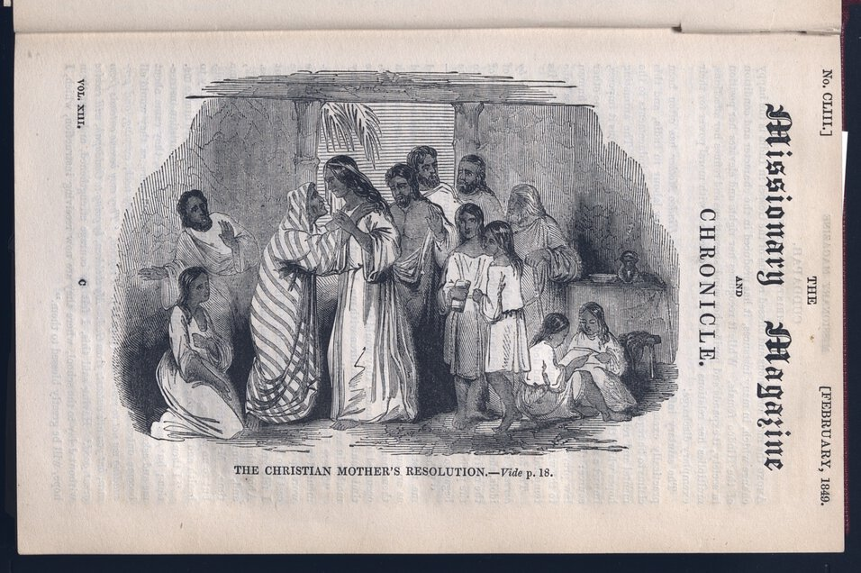

Ultimately, the choice of what to do with this essay will be yours, so long as you adhere to these broad guidelines. No matter which option you choose, the length requirements and rubric criteria will remain the same to ensure class equity.

Figure 2. Anonymous. “The Christian Mother’s Resolution,” Missionary Magazine and Chronicle 13, no. 153 (February 1849): 1, also see 18. CWML G455. University of London. School of Oriental and African Studies, London. Public domain.

**Tip:** Pay attention to the scholarly articles we read before you write your essay, especially the way they introduce and analyze their archival and primary texts. You can gain valuable writing tips by noticing *how* scholars write and what methods seem to work or don’t, not just what they’re arguing.

I’m happy to discuss your ideas with you, and/or talk structure and writing style. If you aren’t sure how you tend to write, or how to organize your essay, I can help you think through the basic logistics of writing, and you can start figuring out your own personal style: what it is now, and what you might want it to be. Just come by office hours or shoot me an email!

# Rubric Criteria for Archival Essay Evaluation:

* **Thesis/Argument:** Specific, focused, and unobvious argument about the archival text (and course text, if you use one) that demonstrates your critical and independent thinking.
* **Archival Research:** Intentional, productive research and analysis of one item from the *One More Voice* digital recovery project.
* **Textual Analysis:** Consistent and smoothly integrated textual analysis throughout the body of the essay, which proves and develops your argument about the archival text (and the course text, if you use one) and is grounded in a careful close reading of specific, cited textual evidence.
* **Structure and Writing Style:** A clear essay structure, including: a focused introduction with a clear and unobvious thesis that drives the rest of the essay, concise body paragraphs with strong topic sentences, smooth, logical transitions between paragraphs, and a meaningful conclusion gesturing toward the larger cultural implications of your argument.
* **Mechanics:** Essay conforms to assignment length and formatting guidelines, including MLA citation, spelling, grammar, and punctuation. Consult the “How to Cite MLA Style” Canvas Page if you need help with your citations, and please ask me if you have additional citation questions.

|  |
| --- |
| **Notes for UVC readers**  The assessment guidelines outlined above are introduced in class in Week 3 (with reference to the archival texts relating to the Indian Uprising of 1857) and are available to students for the duration of the course. The related “Intro to Archival Research” handout is then distributed to students and discussed in class during Weeks 4-5, when we practice researching in *One More Voice* and analyzing our example archival texts from Malabari and Hossain.  The length requirement and evaluation criteria remain the same for each of the three options, which are all written options, to ensure parity in assessment. For me, parity is much more difficult to achieve in assessment when some students submit multimodal work and some submit formal essays, and in this class, we do not have time to model multimodal work effectively. While I strongly believe there is a place for multimodal assessment and offer it as an option in many of my classes, this specific class curriculum aims to train majors in the skills they need to write formal academic essays with confidence. My students also frequently affirm their desire to learn this skill set, and I believe it’s empowering for them to do so. Therefore, I deliberately limited the options to formal writing ones that can be similarly evaluated. For the less structured critical fabulation option, Hartman provides our model of how to balance formal writing conventions with the deliberate revision of scholarly form. However, I want to affirm that in other class contexts, offering multimodal options for this archival essay assessment is a productive variation to encourage student innovation and critical thinking.  The comparative option gives many of my students a boost of necessary confidence for working with a new assignment, skill set, and text, because they use it to integrate the new knowledge with work they’ve already done in the class. For many students, comparison feels like an organic approach. For example, they see more analytical potential in a nineteenth-century letter from a new author if they can connect it to the themes and contexts of a novel we’ve already discussed, and over which they feel a confident sense of ownership as a literary critic. The act of comparison often generates and strengthens analytical claims as well. In my experience with writing assessments, so many students asked if they could do a comparative option when one was not listed that I now offer it as a regular choice to honor their intellectual interests and keep assessments student-centered. |