|  |
| --- |
| **[Undisciplining the Victorian Classroom logo](https://undiscipliningvc.org/)Peer-Reviewed Syllabus**  **Peer Reviewer:** Charles LaPorte  **Date:** 2024  **License:** [CC BY-NC 4.0](https://creativecommons.org/licenses/by-nc/4.0/) |

# Empire of Religion

**Sebastian Lecourt**

[**sjlecour@central.uh.edu**](mailto:sjlecour@central.uh.edu)

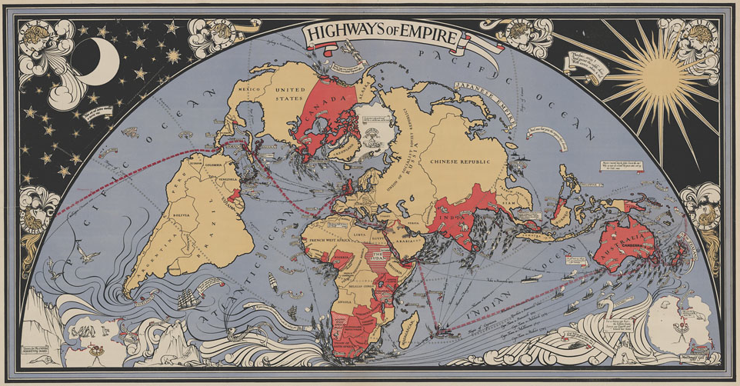

Religion has long been recognized as an important component of British imperialism. Postcolonial criticism, however, has often treated the religiosity of empire as a one-way street by focusing primarily on the role that British religious actors played in driving the colonial enterprise. The reality is that the media networks of the British Empire facilitated a more multidirectional set of religious exchanges. The heteroglot environment of Calcutta, for instance, enabled the formation of new syncretic sects like the Brahmo Samaj, which blended elements of high-caste Hinduism, Islam, and Unitarianism. Buddhist activists from Ceylon to Japan advocated for national independence in books and tracts printed on British printing presses. And evangelical converts in Africa and the West Indies repurposed the rhetoric of John Bunyan’s *Pilgrim’s Progress* (1678) to tell their own stories of political and spiritual independence.

This course explores the complex exchange of religious texts, ideas, and practices facilitated by the British Empire. How did imperialism provoke the formation of new religiosities, both cosmopolitan and local? How did it reinvent the concept of religion itself as a cross-cultural category, as well as produce the notion of the secular as a universal, neutral backdrop?

## Requirements

* 15-20 page critical essay
* 1-page paper prospectus
* 1 discussion question about each week’s reading, posted to Blackboard each Wednesday by 12:00 noon; and 1 response to a classmate’s question, posted any time during the week

## Required Texts

* Edwin Arnold, *The Light of Asia and the Indian Song of Songs* (Crest)
* Thomas Carlyle, *On Heroes, Hero-Worship, and the Heroic in History* (Yale)
* Michael Madhusudan Dutt, *The Poem of the Killing of Meghnād (Meghnādbadh kābya)*, trans. William Radice(Penguin)
* Rudyard Kipling, *Kim* (Oxford World’s Classics)
* All other readings will be made available as PDFs

## Course Schedule

### Week 1: The Invention of World Religions

* Talal Asad, *Genealogies of Religion* (1993), 27-54
* Tomoko Masuzawa, *The Invention of World Religions* (2005), 1-33
* David Chidester, *Empire of Religion* (2015), 1-23
* Kathryn Gin Lum, *Heathen* (2022), 1-20
* Max Müller, “Semitic Monotheism” (1860); “Lecture on the Vedas” (1865); “The Science of Religion: Lecture One” (1870)
* John Henry Barrows, from *The World’s Parliament of Religions* (Chicago: Parliament, 1893)

### Weeks 2-3: World Religions, World Literatures

* Johann Peter Eckermann, from *Conversations with Goethe* (1836)
* William Jones, “Third Anniversary Discourse” (1786)
* Friedrich von Schlegel, *On the Language and Wisdom of the Indians* (1808), 496-526
* Max Müller, “Forgotten Bibles” (1884), “Preface” to *The Sacred Books of the East* (1879)
* F. D. Maurice, *The Religions of the World and Their Relations to Christianity* (1847), 1-33, 130-61
* David Damrosch, *What Is World Literature?* (2003), 1-36
* J. J. Clarke, *Oriental Enlightenment* (1997), 54-70
* Michael Allan, *In the Shadow of World Literature* (2016), 1-38
* J. Daniel Elam, *World Literature for the Wretched of the Earth* (2020), 1-18
* Siraj Ahmed, *Archaeology of Babel: The Colonial Foundation of the Humanities* (2017), 1-49
* Aamir R. Mufti, *Forget English! Orientalisms and World Literatures* (2016), 1-97

### Weeks 4-6: Bengali “Renaissance”

* Charles Wilkins, T*he Bhagvat-Geeta* (1785)
* Poems by Kashiprasad Ghosh, Henry Derozio, Toru Dutt (1820s-90s), from Mary Ellis Gibson, ed., *Anglophone Poetry in Colonial India, 1780-1913* (2011)
* Michael Madhusudan Dutt, *The Poem of the Killing of Meghnād* (1867; trans. William Radice)
* Romesh Chunder Dutt, *Ramayana: The Epic of Rama* (1899)
* Rammohun Roy, “Translation of an Abridgment of the Vedant” (1816), “The Brahmunical Magazine, or the Missionary and the Brahmun” (1821-23), “Translation of a Conference between and Advocate for, and an Opponent of, the Practice of Burning Widows Alive” (1818), “An Autobiographical Sketch” (1832), “Address to Lord William Bentinck” (1830), “Anti-Suttee Petition to the House of Commons” (1832)
* Alfred Tennyson, “Akbar’s Dream” (1892)
* David Kopf, *British Orientalism and the Bengal Renaissance* (1969), 65-126
* Simon Dentith, *Epic and Empire in Nineteenth-Century Britain* (2006), 175-80
* Rosinka Chaudhuri, *Gentlemen Poets in Colonial Bengal* (2002), 2-22
* G. S. Sahota, *Late Colonial Sublime: Neo-Epics and the End of Romanticism* (2018), 3-26
* Srinivas Aravamudan, *Guru English: Asian Religion in a Cosmopolitan Language* (2006), 1-62

### Weeks 7-9: Buddhism and *Bildung*

* Edwin Arnold, *The Light of Asia* (1879)
* Anagarika Dharmapala, “The World’s Debt to Buddha” (1893), “The Spread of Buddhism” (1894), “Buddha Gaya and Its Surroundings” (1891) OR “The History of the Maha-Bodhi Temple at Buddha Gaya” (1900), “Memories of an Interpreter of Buddhism to the Present-Day World” (1927), “Reminiscences of My Early Life” (1933)
* Rudyard Kipling, *Kim* (1901)
* Philip C. Almond, *The British Discovery of Buddhism* (1988), 7-79
* Tobias Boes, from *Formative Fictions: Nationalism, Cosmopolitanism, and the* Bildungsroman(2012), 1-42
* Jed Esty, *Unseasonable Youth: Modernism, Colonialism, and the Fiction of Development* (2011), 1-38
* Richard Gombrich and Gananath Obeyesekere, from *Buddhism Transformed* (1989), 202-40
* H. L. Seneviratne, from *The Work of Kings: The New Buddhism in Sri Lanka* (1999), 1-55
* Anne Blackburn, from *Locations of Buddhism* (2010), 197-217

### Weeks 10-11: The World Religions Anthology

* William Rounseville Alger, from *The Poetry of the East* (1856)
* Edward Fitzgerald, from *Rubaiyat of Omar Khayyam* (1857)
* Moncure Conway, from *The Sacred Anthology: A Book of Ethnical Scriptures* (1871)
* Edwin Arnold, from *The Indian Song of Songs* (1875)
* W. A. Clouston, from *Arabian Poetry for English Readers* (1881)
* Charles Mills,from *Pebbles, Pearls and Gems of the Orient* (1882)
* Herbert Giles, from *Gems of Chinese Literature* (1884)
* Alexander Bubb, *Asian Classics on the Victorian Bookshelf* (2023), 89-117
* Annmarie Drury, *Translation as Transformation in Victorian Poetry* (2015), 147-91
* General Introduction to *The Norton Anthology of World Religions* (2011)

### Weeks 12-13: World Heroics

* Thomas Carlyle, *On Heroes, Hero-Worship, and the Heroic in History* (1841)
* Marcus Dods, from *Mohammed, Buddha, and Christ* (1877)
* W. Quartermaine East, from *The Last Days of Great Men: Cromwell, Napoleon, Mahomet* (1903)
* Kecia Ali, *The Lives of Muhammad* (2014), 6-40
* Philip C. Almond, *Heretic and Hero: Muhammad and the Victorians* (1989), 3-32
* Alex Woloch, *The One vs. the Many: Minor Characters and the Space of the Protagonist in the Novel* (Princeton, 2003), 12-42

### Coda: Secular Criticism

* Edward Said, “Secular Criticism” (1983)
* Matthew Arnold, from *Literature and Dogma* (1873)
* Michael Kaufman, “The Religious, the Secular, and Literary Studies” (2007)
* Wendy Brown, *Regulating Aversion: Tolerance in the Age of Identity and Empire* (2006), 25-47
* Talal Asad, *Formations of the Secular* (2003), 1-66