|  |
| --- |
| **[Undisciplining the Victorian Classroom logo](https://undiscipliningvc.org/)Peer-Reviewed Syllabus**  **Peer Reviewer:** Amy Wong  **Date:** 2025  **License:** [CC BY-NC 4.0](https://creativecommons.org/licenses/by-nc/4.0/) |

**ENGL 2030 Encountering Intercultural Literature**

**Other Lives: Women of the Nineteenth Century**

Dr. Yangjung Lee (She) [ylee13@seattleu.edu](mailto:ylee13@seattleu.edu)

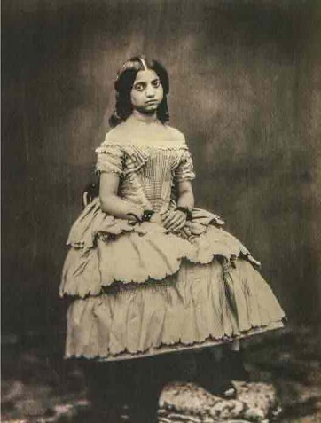What kinds of lives did women of the nineteenth century lead in the age of empire? In “Other Lives” we will encounter how women in various parts of the nineteenth-century world—England, the US, the Caribbean, and South and East Asia—experienced, reinforced, resisted, and reimagined imperial projects through their writing. Who was considered to be human, let alone a woman? How did women represent themselves and how were they seen by others? What role did women play in the consolidation, proliferation, and decline of empires? What do intersections of race, gender, and sexuality offer us in understanding imperialism, often considered to be monolithic? We will interrogate these questions as we read texts by diverse women who wrote in the nineteenth century and whose writing offers complex views about gender, race, imperialism that are grounded in their own cultural contexts. We will examine three aspects of their lives: education, love and marriage, and work. Through our readings and discussions, we will critically reflect on the construction of “self/other” in a world where it was not neatly binary, to meaningfully encounter other lives.

Figure 1. Victorian Gouramma (1854)

**Required Texts**

The following books are available through the Campus Store, online bookstores, and local bookshops such as Elliott Bay. Please get the editions listed below.

* Anonymous, *The Woman of Colour* (Broadview)
* Charlotte Bronte, *Jane Eyre* (Penguin)
* Mary Prince, *The History of Mary Prince* (Penguin)

The following texts will be provided as pdfs on Canvas.

* Hariette Shelton Dover, selections from *Tulalip, From My Heart*
* Toru Dutt, selected poems
* Frances E.W. Harper, selected poems and essays
* Lady Hyegyŏng, selections from *The Memoirs of Lady Hyegyŏng*
* 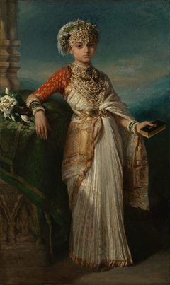Rokeya Sakhawat Hossain, “Sultana’s Dream”

Figure 2. Princess Victoria Gouramma (1852) by Franz Xaver Winterhalter

* Krupabai Satthianadhan, *Saguna*

**Course Goals**

This course is designed to help you develop the following:

* an understanding of literatures that engage cultural boundaries and the issue of communicating across social and cultural differences;
* an ability to close read and interpret a variety of literary texts in multiple genres;
* an awareness of how intersections of race, class, gender, sexuality, and national history shape literary studies;
* your ability to write and speak effectively for different audiences and purposes.

Upon successful completion of this course:

* You will be more practiced at close reading, using textual details to support critical arguments while understanding the difference between latent and projected textual meaning.
* You will develop a historical sensitivity to textual, contextual, and intertextual literary production.
* You will become familiar with a variety of literary genres—learning to read form as a mode of conveying meaning.
* You will learn to use MLA citation conventions correctly in your writing.

**Course Requirements** Detailed assignment descriptions are on Canvas

|  |  |
| --- | --- |
| **Requirements** | **Due Date** |
| **In-Class and Homework Activities (30%)**  These low-stakes activities are designed to help you in your understanding of the texts, critical thinking skills, the writing process, and the papers you will be completing. Participation in discussion is included in in-class activities. | On Going |
| **Close Readings (30%)**  Three 3-page close reading papers, worth 10% each, on one of the texts we cover for each unit. You may write on *Jane Eyre* only once. Specific prompts will be distributed for each paper that will ask you to be very careful readers of a specific textual moment (attending at certain points to literary language) and considering how the particular textual moment produces its meaning. | #1: 4/12  #2: 5/3  #3: 6/3 |
| **Discussion Leader (15%)**  Each Friday during Weeks 3-9 students will sign up to become discussion leaders, preparing a “lesson” for our class. You will submit Talking Points (1 page) prior to the class and a reflection (1-2 pages) afterwards. | Sign up Week 1  Talking points: 5%  Discussion: 5%  Reflections: 5% |
| **Archival Project and Presentation (25%)**  3–4-page paper on 1-2 primary sources from a digital archive such as *One More Voice*, *Colonial Caribbean*, *Empire Online*, or *India Raj and Empire* (see Canvas for links). 5-minute presentation of the research on Week 10. | Paper (20%): 6/3  Presentation (5%): Week 10 |

**Reading Schedule**

*Please read the assignments in preparation for the day they are listed*. The schedule is subject to revision depending on our progress this quarter.

|  |  |  |
| --- | --- | --- |
| **Week** | **Date** | **Assigned Materials and Deadlines** |
| WEEK ONE | M  3/25 | Course Introduction |
|  |  | **Women’s Education** |
| WEEK ONE | W  3/27 | *Readings*  Indian Boarding Schools in the Pacific Northwest  Introduction to archives: [Carlisle Indian School Digital Resource Center](https://carlisleindian.dickinson.edu/) |
|  | F  3/29 | *Readings*  “Foreward,” “Introduction,” “Prologue” from *Tulalip, From My Heart*  Richard Pratt, excerpts from “The Advantages of Mingling Indians with Whites” |
| WEEK TWO | M  4/1 | *Readings*  “Tulalip Indian School” and “The Tulalip Indian School Schedule” from *Tulalip, From My Heart* |
|  | W  4/3 | *Readings*  *Jane Eyre* Ch 1-9 |
|  | F  4/5 | *Readings*  *Jane Eyre* Ch 10-15 |
| WEEK THREE | M  4/8 | *Readings*  Selections from *Memoirs of Lady Hyegyŏng*  Haboush’s introduction to the *Memoirs* |
|  | W  4/10 | *Synthesis Day* |
|  | F  4/12 | *Student-led Discussions* |

|  |  |  |
| --- | --- | --- |
|  |  | **Women’s Love and Marriage** |
| WEEK FOUR | M  4/15 | *Reading*  *The History of Mary Prince* |
|  | W  4/17 | *Readings*  *The History of Mary Prince* |
|  | F  4/19 | *Readings*  *The Woman of Colour*, vol. 1  Student-led Discussion |
| WEEK FIVE | M  4/22 | *Readings*  *The Woman of Colour,* vol. 2 |
|  | W  4/24 | *Readings*  *Jane Eyre* Ch. 16-20 |
|  | F  4/26 | *Student-led Discussions* |
| WEEK SIX | M  4/29 | *Readings*  *Jane Eyre* Ch. 21-26  Harper, “The Two Offers” |
|  | W  5/1 | *Synthesis Day* |
|  | F  5/3 | *Student-led Discussion* |
|  |  | **Women’s Work: Professionalization/Civilization** |
| WEEK SEVEN | M  5/6 | *Readings*  *Jane Eyre* Ch. 27-32 |
|  | W  5/8 | *Readings*  *Jane Eyre* Ch. 33-38 |
|  | F  5/10 | Student-led Discussion |
| WEEK EIGHT | M  5/13 | *Readings*  Harper, “Bible Defense of Slavery” and “Christianity”  Selectionsfrom *Memoirs of Lady Hyegyŏng* |
|  | W  5/15 | *Readings*  Toru Dutt, select poems  Govin Dutt, “Prefatory Memoir” |
|  | F  5/17 | *Student-led Discussions* |
| WEEK NINE | M  5/20 | *Readings*  Krupabai Satthianadhan, *Saguna* 1-5 (19-86) |
|  | W  5/22 | *Readings*  Krupabai Satthianadhan, *Saguna* 6-9 (87-164)  John Murdoch, “Mrs. S. Satthianadhan” from *Sketches of Indian Christians* |
|  | F  5/24 | *Student-led Discussions* |
| WEEK TEN | M  5/27 | *Readings*  Rokeya Sakhawat Hossain, “Sultana’s Dream”  Chitra Ganesh, Illustrations to “Sultana’s Dream” |
|  | W  5/29 | *Readings*  Harper “We Are All Bound Up Together”  *Synthesis Day* |
|  | F  5/31 | *Final Project Presentations* |