|  |
| --- |
| [Undisciplining the Victorian Classroom logo](https://undiscipliningvc.org/)**Peer-Reviewed Syllabus**  **Peer Reviewer:** Charles LaPorte  **Date:** 2024  **License:** [CC BY-NC 4.0](https://creativecommons.org/licenses/by-nc/4.0/) |

**Religion and the Transimperial: Literatures of Faith, Conquest, and Resistance**

Padma Rangarajan

[padma.rangarajan@ucr.edu](mailto:padma.rangarajan@ucr.edu)

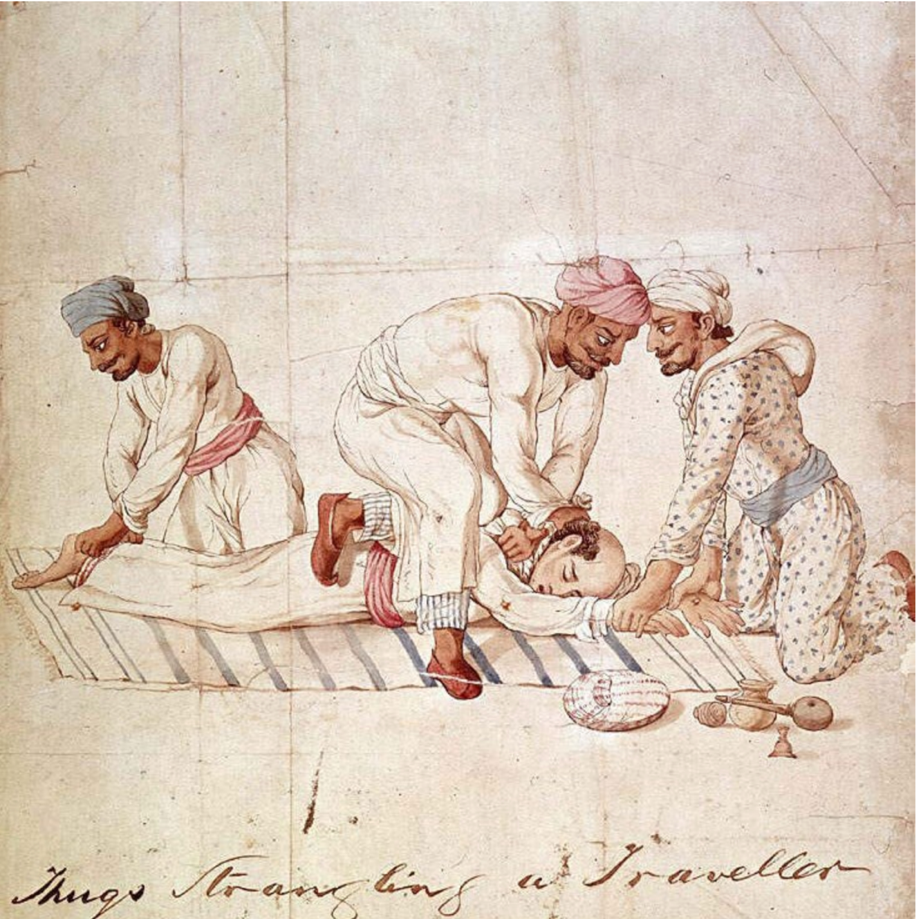

Anonymous Indian artist. *A group of Thugs strangling a traveller on a highway in India in the early 19th century. One member of the group is gripping the traveller’s feet, another his hands, while a third member is tightening the ligature around the traveller’s neck*. 1829–40, <https://en.m.wikipedia.org/wiki/File:Thugs_Strangling_Traveller.jpg>.

**Course Description**

What happens when different religious traditions meet each other in asymmetrical relations of power? How is religion used to justify, protest, and conceptualize colonial conquest? What is the relationship between religious faith and modernity? Late-nineteenth-century literature grapples with these questions. The nineteenth century has generally been associated with a triumphal imperialism and with the erosion of religious faith in the face of an irresistible move toward the secular. In contrast, this course argues that colonial contact led to the sharing and fusing of different religious concepts and ideologies and explores how this fusion was represented in the literature of Britain and its most important imperial holding, India. We’ll examine how imperial expansion and societal change enabled diverse and new expressions of faith and spirituality. We’ll also consider how religion was a powerful, if unstable, tool for both colonial conquest and anticolonial resistance. Crucially, we will explore how different genres of literature responded to and were shaped by this discourse of religion and empire. We’ll consider how and why certain genres, like the oriental tale, were overtaken by the realist novel, and we will study how Indian authors mingled European poetic forms with native ones. Although the class focuses primarily on India, we will also consider literary representations of Africa and the Middle East as important points of comparison.

**Course Assignments**

Biweekly reading responses

Final Project: 6-8 page paper plus collaborative concept map

**Required Texts**

Eliot, *Adam Bede*

Haggard, *She*

Course Reader

**Syllabus**

Week 1

*Locating the Divine*

Tu Introduction, Hopkins, “God’s Grandeur”; Dutt, “The Tree of Life”

Th Rossetti, “A Better Resurrection”; Kipling, “Recessional”; Vivekananda, “Kali the Mother”

Week 2

*Realism and Religion*

Tu Eliot, *Adam Bede*

Th Eliot, *Adam Bede*

Week 3

Tu Eliot, *Adam Bede*

Th Eliot, *Adam Bede*

Week 4

*Empire and the Occult*

Tu Haggard, *She*

Th Haggard, *She*

Week 5

*Faith and Duty*

Tu Livingstone “Cambridge Lecture 1”; Tilak, “The Bharata Dharma Mahamandala”

Th Newbolt, “Vitai Lampada”; Hughes, “The Short Cut”

Week 6

Tu Hughes, from *Tom Brown’s Schooldays*

Th Barathi, “Bharata Desam”; “Sri Krishna and Despotic Rule”

Week 7

*Religion and Resistance*

Tu Moore, “The Fire Worshippers”

Th Kipling, “The Undertakers”

Week 8

Tu Chattopadhyay, from *Anandamath*

*Comparative Religion*

Th Hegel, from *The Philosophy of History*

Week 9

Tu Aurobindo, “A Vision of Science,” “Lines of Ireland”; Dutt, “Baugmaree”

Th Müller, *The Science of Religion: Lecture One*

Week 10

Tu Rossetti, “By the Sea”; Dutt, “Our Casuarina Tree,” “Sonnet--The Lotus”

Th Conclusion