BabyShopHub
System Design Document
Aptech eProject Submission
Version 1.0
Table of Contents
1. Purpose of this document 2
2. Architecture overview 3
2.1 Why this structure 5
3. Technology choices 6
4. Data model 7
4.1 Tables at a glance 7
4.2 Two deliberate modelling decisions 9
4.3 Referential integrity 9
5. State management 10
5.1 Routing at the root 10
6. Security design 11
6.1 Password storage 11
6.2 Access control 11
6.3 What the dummy payment stores 11
7. Order lifecycle (state machine) 12
8. Support ticket lifecycle 13
9. Screen map 14
10. How the design meets the non-functional requirements 15

1. Purpose of this document
This document explains how BabyShopHub is built, where the SRS explains what it does. It describes the architecture, the data model, the way the app holds state, the security design, and the two state machines that govern orders and support tickets. It is written so that a developer can understand the shape of the system before opening the code, and so that a reviewer can see that the design meets the non-functional requirements.

2. Architecture overview
BabyShopHub uses a layered architecture. Each layer only talks to the layer directly below it, which keeps responsibilities separate and makes the system easy to reason about and to extend.
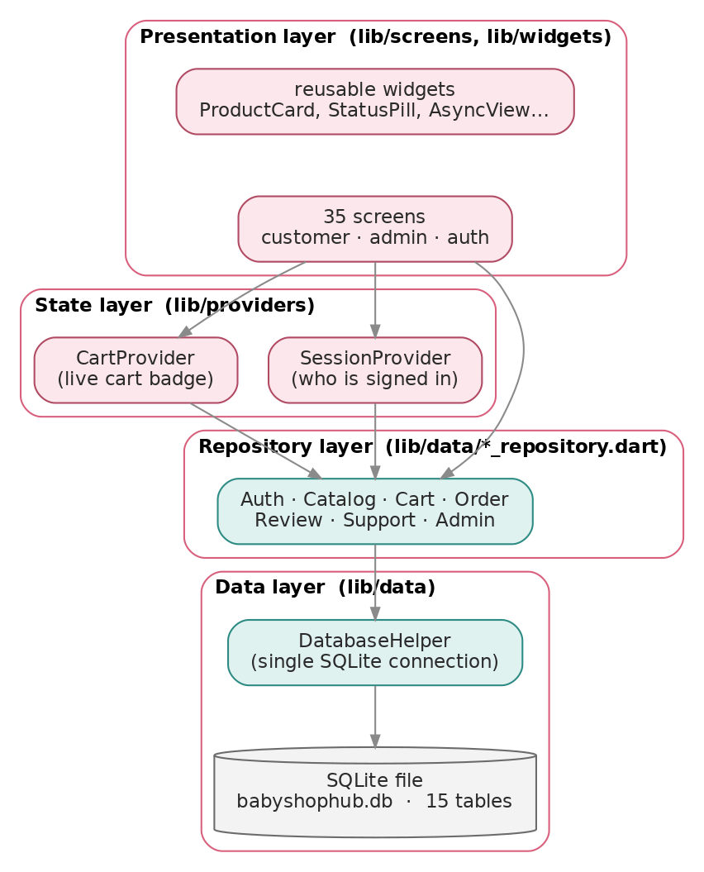
Architecture layers
Presentation layer (lib/screens, lib/widgets). The 35 screens and the reusable widgets. Screens never touch the database directly; they call a repository or read a provider. Common UI — product cards, status pills, loading/empty states — is factored into shared widgets so every screen looks and behaves consistently.
State layer (lib/providers). Two ChangeNotifier providers hold the small amount of state that is shared across screens: SessionProvider (who is signed in, and therefore what the app is allowed to show) and CartProvider (the live cart, so the cart badge and totals update the instant an item is added anywhere).
Repository layer (lib/data/*_repository.dart). Every data operation the app can perform is a method on a repository — AuthRepository.login, OrderRepository.placeOrder, AdminRepository.setUserActive, and so on. Repositories translate between database rows and the typed model objects the UI uses. Write methods return a String?: null on success, or a human-readable message on failure, which is what lets every screen show a clear error instead of crashing.
Data layer (lib/data). A single DatabaseHelper owns the one SQLite connection and the schema. It is the only class that knows what the storage looks like. Because everything is local, this layer never makes a network call.

2.1 Why this structure
This separation is what delivers several of the non-functional requirements at once. Responsiveness (NFR-1) follows from all data being local and read through indexed queries. Maintainability (NFR-7) follows from each concern living in one layer, with single sources of truth for pricing, statuses, and theme. Scalability (NFR-6) follows from being able to add a screen or a repository method without disturbing the others.

3. Technology choices
Concern | Choice | Why
UI framework | Flutter (Material 3) | One codebase for Android, iOS, and desktop; a mature widget set.
Language | Dart | Flutter’s language; sound null safety catches whole classes of error at compile time.
Database | SQLite via sqflite | A real relational store, embedded in the app, no server needed.
Desktop database | sqflite_common_ffi + sqlite3_flutter_libs | The same code runs on Windows/Linux for demonstration.
State management | provider | Lightweight, official, and enough for this app’s shared state.
Password hashing | crypto (SHA-256) | Standard, well-tested hashing for salted password digests.
Path handling | path | Builds the database file path correctly on every platform.
The dependency list is deliberately short. Every package is widely used and actively maintained, which keeps the project easy to build and to trust.

4. Data model
All persistent data lives in one SQLite database, babyshophub.db, created on first launch. The schema has 15 tables. Foreign keys are enforced (PRAGMA foreign_keys = ON), and every column the app filters or joins by is indexed (15 indexes in total).
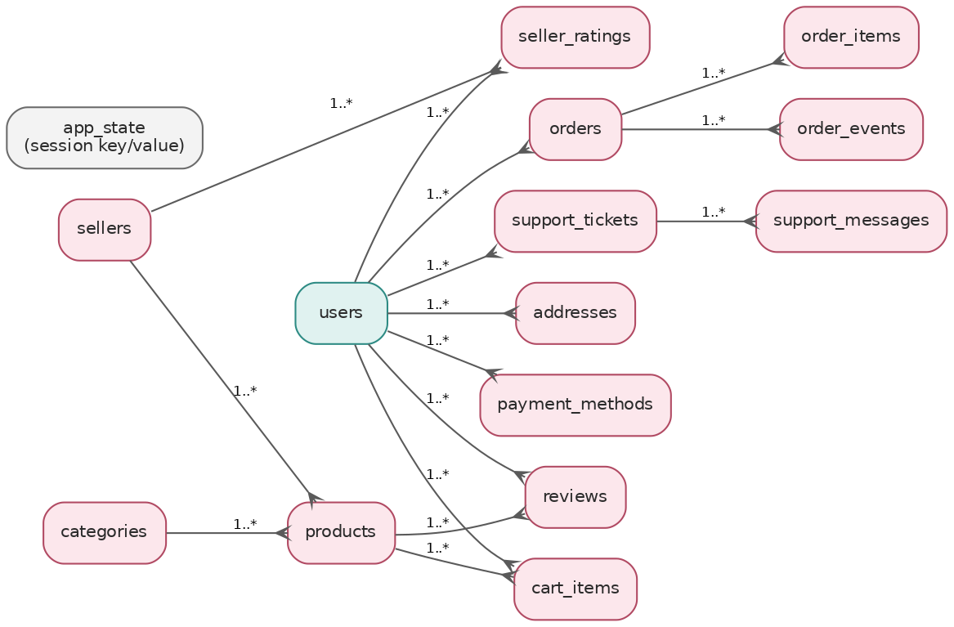
Entity relationships

4.1 Tables at a glance
Table | Holds | Key relationships
users | Accounts: name, email, salted password hash, role, active flag | Parent of most tables
app_state | A key/value store; holds the signed-in user id for session persistence | —
addresses | Saved delivery addresses | belongs to users (cascade)
payment_methods | Saved cards — brand and last four digits only | belongs to users (cascade)
categories | Product categories with an icon and sort order | parent of products
sellers | Sellers, with recomputed rating totals | parent of products
products | Catalogue: price, stock, image, rating totals, active flag | references categories, sellers
cart_items | The live cart; unique per (user, product) | references users, products
orders | Placed orders with a copied shipping address and price breakdown | belongs to users
order_items | Line items, with product details copied at checkout | belongs to orders (cascade)
order_events | The tracking timeline — one row per status reached | belongs to orders (cascade)
reviews | Product star ratings and comments; unique per (product, user) | references products, users
seller_ratings | Seller star ratings; unique per (seller, user) | references sellers, users
support_tickets | Support conversations with a status | belongs to users
support_messages | Messages within a ticket, tagged by sender role | belongs to support_tickets (cascade)

4.2 Two deliberate modelling decisions
Order data is copied, not referenced. When an order is placed, the product name, brand, image, and unit price are copied into order_items, and the delivery address is copied onto the orders row. order_items intentionally carries no foreign key to products. This means an administrator can later edit the price of a product or delete a discontinued one without ever changing or corrupting a past receipt. A historical order is a complete, immutable record of what was bought and where it was sent.
Rating totals are recomputed, never incremented. Each product and seller stores a rating_sum and rating_count. Rather than adjusting these by hand on each new review, the app recomputes them directly from the rating rows after any change (add, edit, delete, or hide). This guarantees the displayed average can never drift away from the reviews a shopper can actually read — a hidden review, for instance, is excluded automatically.

4.3 Referential integrity
Foreign keys use two different delete rules by design:
- CASCADE on data that belongs to a parent and has no meaning without it: a user’s addresses, cards, cart, reviews, and support tickets; an order’s items and events; a ticket’s messages. Removing the parent cleanly removes these.
- NO ACTION on references that must not trigger silent deletion: products.category_id, products.seller_id, and orders.user_id. Deleting a category must not wipe its products, so the admin screens check for dependants first and refuse (or offer to deactivate) instead.

5. State management
The app keeps shared state deliberately small. Most screens simply load what they need from a repository when they open. Only two pieces of state are truly cross-cutting, and each has its own provider:
SessionProvider holds the currently signed-in AppUser, or null. It is restored on launch by reading the saved user id from the app_state table, so a returning user is taken straight to the right home screen. Signing in or out updates this provider, and the root of the app listens to it to decide which screen to show.
CartProvider holds the current user’s cart. It is bound to the signed-in user, exposes the item count and totals, and notifies listeners whenever the cart changes — so the cart badge, the cart screen, and the checkout button all stay in step without passing data between screens manually.

5.1 Routing at the root
A small gate at the root of the app (_RootGate in main.dart) watches SessionProvider and chooses the screen:
- still restoring the saved session → the splash screen;
- not signed in → the login screen;
- signed in as an administrator → the admin shell;
- signed in as a customer → the customer shell.
This single decision point is where the security rule “only registered users can reach customer features, only administrators can reach the admin panel” is enforced structurally: an unauthenticated or customer session simply never has the admin shell built for it.

6. Security design
Security is a stated requirement (NFR-5), and the design addresses it on two fronts: credentials and access.

6.1 Password storage
Passwords are never stored, logged, or compared in plain text. When an account is created, the app generates a random salt unique to that account, and stores the SHA-256 hash of the salt combined with the password. At login, the app hashes the entered password with the stored salt and compares digests. Two users with the same password therefore have completely different stored hashes, and the stored value cannot be reversed to reveal the password.

6.2 Access control
Access is controlled by the role on the account (customer or admin) and the is_active flag:
- The root gate (Section 5.1) routes each role to its own area and never builds the admin panel for a customer session.
- Administrative operations live behind the admin shell, which is only reachable by an admin session.
- A suspended account (is_active = 0) is refused at login.
- The system refuses to suspend or demote the last active administrator, so the shop can never lock itself out of management.

6.3 What the dummy payment stores
The checkout validates card input for format only and processes no real payment. Only the card brand and the last four digits are ever saved; the full number is used to derive those and then discarded, and no security code is ever collected. This keeps the demonstration realistic without holding sensitive data.

7. Order lifecycle (state machine)
An order moves through a deliberately linear flow. The customer’s tracking screen draws this as a timeline; the admin order screen offers only the permitted next transitions from the current state.
Pending → Confirmed → Packed → Shipped → Out for delivery → Delivered
▲
Cancelled ←──────────┘ (only reachable before Shipped)
The rules, enforced in OrderStatus.nextOptions:
- From any state on the happy path, the only forward move is to the next state in the sequence — statuses cannot be skipped.
- Cancelled is offered only while the order has not yet reached Shipped; once a parcel is with the courier it can no longer be cancelled in-app.
- Delivered and Cancelled are final — an order in either state offers no further transitions.
Every transition writes a row into order_events with a timestamp and a friendly note, which is exactly what the customer sees as their tracking history.

8. Support ticket lifecycle
Support tickets have four states: Open, In progress, Resolved, and Closed. A new ticket starts Open. When the administrator replies, the ticket moves to In progress. The administrator can mark it Resolved or Closed when the issue is handled, and can reopen a closed ticket back to Open if the customer comes back. Each message is tagged with its sender role (customer or support), which is what lets both sides of the conversation be laid out correctly on each person’s screen.

9. Screen map
The 35 screens divide into four groups.
Entry (3): splash (restores the session), login, register.
Customer storefront (19): the customer shell (bottom navigation) hosting home, categories, product list (with search), product detail, cart, checkout, payment form, order confirmation, orders list, order detail (tracking), write review, account, edit profile, address list and form, payment methods and form, and the support list, support detail, new-ticket, and FAQ screens.
Admin panel (11): the admin shell (bottom navigation + a “More” tab) hosting the dashboard, orders and order detail, products and product form, categories, users, reviews, and support and support detail.
Shared: reusable widgets used across all of the above.
Each screen maps to one or more requirements in the SRS traceability matrix (SRS Section 5).

10. How the design meets the non-functional requirements
Requirement | How the design meets it
NFR-1 Responsiveness | All data is local; queries hit indexed columns; no network wait.
NFR-2 Usability | One theme, shared widgets, empty-state guidance, confirmation dialogs.
NFR-3 Accessibility | Legible type, adequate contrast and tap targets, labelled controls.
NFR-4 Error handling | Repository writes return a message on failure; input is validated first.
NFR-5 Security | Salted SHA-256 hashes; role-based routing; suspended-account and last-admin guards.
NFR-6 Scalability | Normalised, indexed schema; layered code that extends without churn.
NFR-7 Maintainability | Single sources of truth for pricing, statuses, and theme.
NFR-8 Portability | Same code on mobile and desktop; the data layer adapts per platform.
The Developer Guide expands Sections 2–5 into a working orientation of the codebase; the Test Plan verifies the behaviours designed here.

