ICT365 MAJOR ASSIGNMENT
CHECK LIST

Surname (Family Name): _Amin______________________________________________________

Given Names: __Riaz_______________________________________________________________

Student Number: _33686825__________________________________________________________

Tutor’s Name: ___________________________________________________________________

Assignment Due Date: __2/11/2020_____________ Date Submitted: _2/11/2020________________

Your assignment should meet the following requirements. Please confirm this (by ticking boxes) before submitting your assignment.

- All details above are complete.
- I acknowledge and agree that the assessor of this assignment may, for the purpose of assessing this assignment, reproduce this assignment and provide a copy to another academic staff member.
- I am aware of Murdoch University’s assessment policy 8.1.8 that states that “Unit Coordinators have the right to submit any assignment to the University’s plagiarism detection software if they suspect plagiarism.”
- I have read and understood the requirements for submission of assignments specified in the Unit Information and Learning Guide.
- I have read and understood the requirements for documenting and submitting this assignment that are specified in the assignment question sheet of this assignment.
- I understand that the archive file should be submitted to ICT365 Unit LMS.
- I have kept a copy of this assignment, including the archive file.

Extension
ii. No extension was been granted, and the submission date was extended to 2 November for all students.

iii. The assignment required to develop a system that pushes messages to collaborators subscribed to an individual with cognitive impairment using social media streams.

Self-diagnosis, evaluation and declaration
iv. The fully implemented features of the system are as follow:
- Collaborators can enter their level of support using the sign-up form. The collaborator will enter the required information as part of the sign-up process to be eligible to help users with cognitive impairment.
- The UI displays text and images in each of the forms
- The system can successfully push messages for collaborators to see through Discord and Instagram.
- No unit tests were done as most of the methods were private
Some features that were not fully implemented in the system include:
- The system is unable to pull or retrieve messages from the social media streams. The API used for Instagram did not support retrieving direct messages from a user’s inbox. The Discord API to retrieve webhooks was not functioning properly in the system and was not implemented.
- Users cannot post images, videos or embed webhooks in Instagram and Discord respectively being restricted to text messages only. The Instagram API returned a SystemNullException error when attempting to implement send videos or images directly to a collaborator’s inbox.

Description of Solution
The platform chosen to implement the solution was WPF and XAML UI. The choice to use XAML for the solution is firstly because the code is short and succinct to interpret. Secondly, the logic of the UI and XAML are separate of each other which makes implementation of the GUI and logic easy to develop and keep track of. The roles of the developer and designer are separated this way.
The system is divided into three different forms each responsible for a certain aspect of the solution. The first part is the application form which is the starting point of the system. When the solution is executed, the application form is displayed first. The form displays a welcome message to the user who either can be a collaborator or an individual user. For collaborators wanting to help individuals with cognitive impairment, they must sign up to be eligible to do so. Collaborators can sign up by clicking the sign-up button. This will lead to the second part of the solution which is a sign-up form. The form will require the collaborator to enter information that are their names, state, location, email address, mobile number, the maximum distance to help an individual and Instagram username. The information was stored in an array of collaborator objects with a size of 50. This means that only up to 50 collaborators can sign up. The size can be increased further if required. Individual users that want to push messages to collaborator(s) to see can do so using Discord or Instagram. The application form gives users the option to choose between Discord or Instagram to use for pushing out messages to subscribed collaborators. Clicking on one of these options is the third part of the solution that displays sub forms. A separate form is displayed for each social media platform. For the Instagram form, the username of the collaborator and the message to be sent is required which will send a direct message to the collaborator’s inbox. The Discord form follows the similar format except the message will be sent to the general channel of the Cognitive Safety Server for all collaborators to see. The username will be the name of the user in this instance.
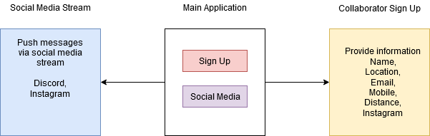

The diagram shows a visual representation of the structure of the solution. As shown, the main application calls the lower level forms to perform a particular function that is an example of the dependency inversion principle being followed.
The API used for Instagram was the InstagramApiSharp that provided most of the functions needed for the system.

Evidence of Solution

The main application form that is displayed first when the system is executed.
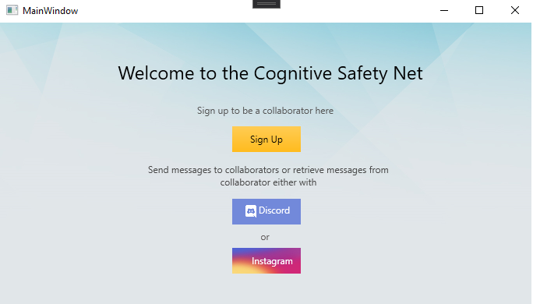

The sign-up form for collaborator is shown below when the Sign Up button is clicked. The form below shows sample data entered as input. The information includes first and last name, state, location, email address, mobile number, maximum distance and Instagram username.
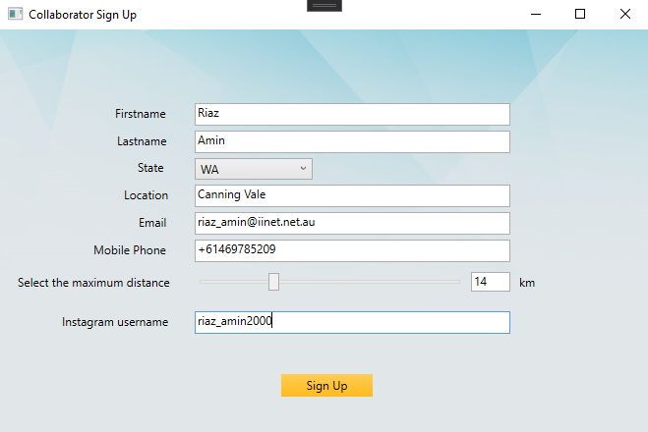

After the Sign Up button is clicked, a message box is displayed notifying the user that the sign-up was successful. The system has recorded the collaborator details.

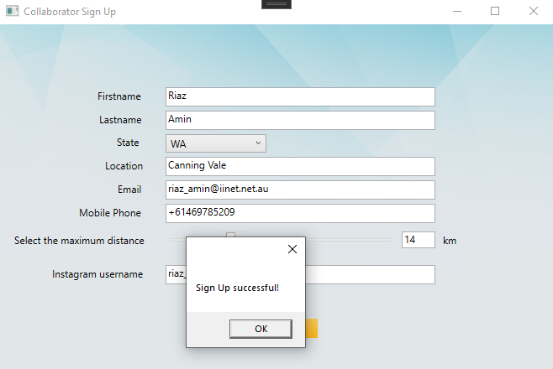
Below is the discord message form that will send a webhook to the discord sever with the username and message.
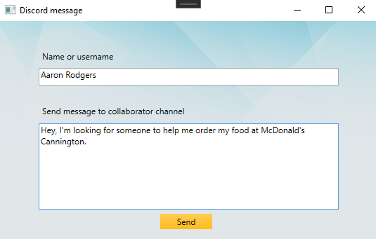

The messages and username is shown in the Discord server below has been sent in the general channel and all collaborators can see.
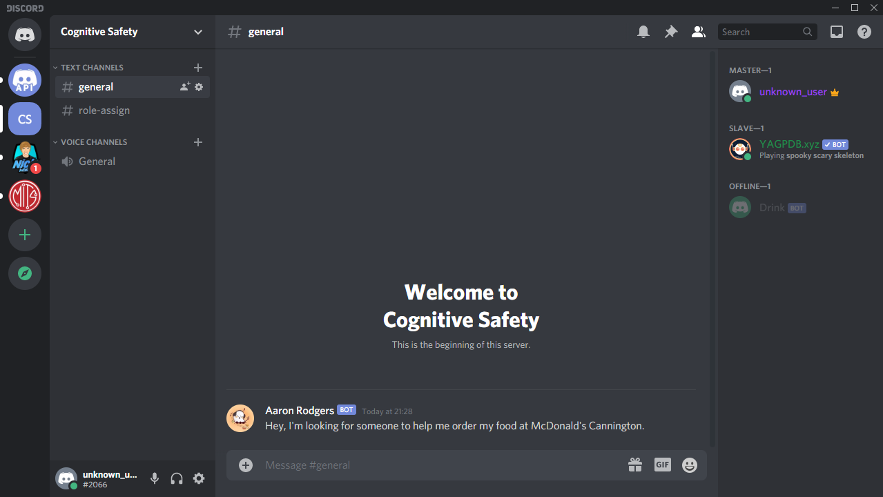

Below is the Instagram form, the username and message is entered.
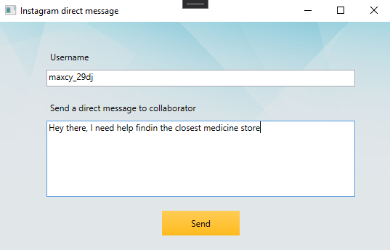

The message has been sent to the inbox of the user on Instagram as shown below.
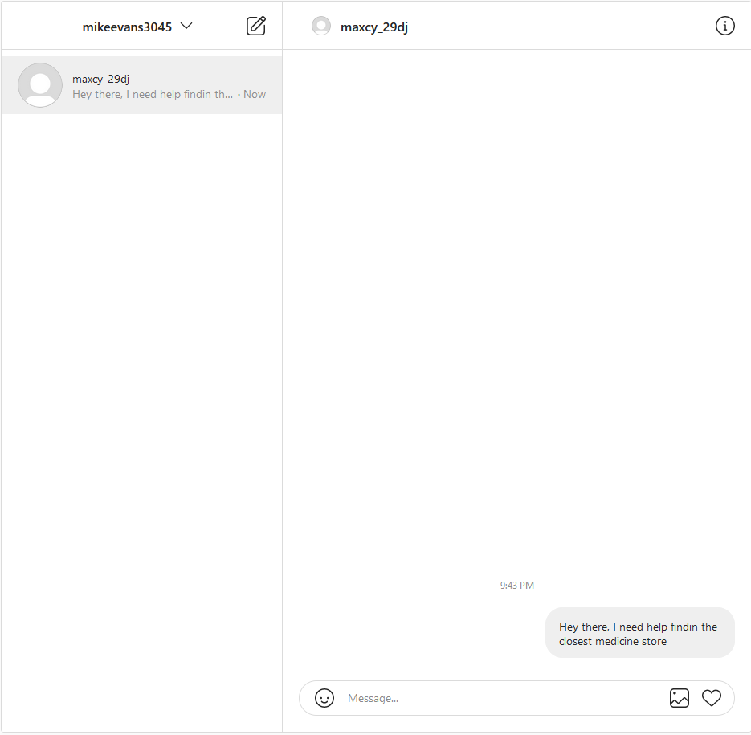

Design principles and Refactoring
The solution implemented followed the single-responsibility and open-close principles. Each event method for the XAML UI performed a single task. This allowed for the code of each method to be short and not need to refactor as much. Most of the event methods were button_click methods that were executed when a particular button was pressed. Each method is also able to be extended for new features without modifying the code. An example would be for the SingUp_Click method in SignUp.xaml.cs where a Clear() method was added. This method was added as an extension that clears all the fields of the form after the user has signed up as a collaborator. The method was added without having to modifying any existing code and just make a simple method to execute it.

One instance in the XAML UI where refactoring was used was for creating a style for the button. The style was created in the App.xaml file so it could be used throughout the whole application. The style is called ButtonStyle which sets the background colour of the button as a linear gradient and removes the border. This style was used for the Sign Up and Send buttons in the forms. As show below, the button style was refactored so it can be called instead of being coded again for several buttons used in the form.

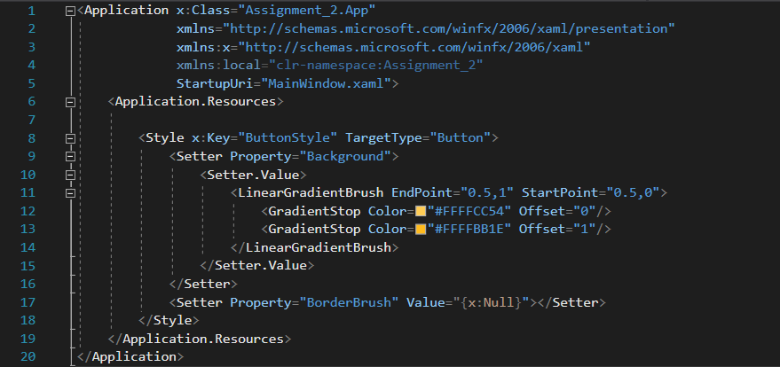

Comparison and Reflection
The solution could have been developed using alternative technologies Xamarin for mobile applications and ASP.net for web applications.

ASP.NET applications can be created using Web Forms that is similar to WPF for XAML UI. The components of the forms are both shared such as button controls, text boxes and labels, check boxes and radio buttons, list controls and many others. These shared components make it easy to create forms using different technologies. The only difference would be the syntax. The ASP.NET Web form would follow the XHTML format whereas the WPF would follow the XAML format. Both are mark up languages and almost similar but with small differences in the syntax. The different format will refer to different namespaces and styles (i.e. xmlns). In XAML the xmlns will refer to a different namespace compared to XHTML for the formatting.

The code-behind file for ASP.NET, Xamarin and XAML can use any programming language because of CLR feature. In this case, C# was used, and the event handlers and methods all follow the same syntax since it is in the same language.

The effort required to convert the application written in XAML to Xamarin or ASP.NET would require not much effort. Most of the code-behind files can remain since each technology supports C# in this case. So all the C# files would not have to be touched at all. Also, the system can be created on Visual Studio.NET and so there is no need to use a separate IDE to develop the application. The XAML files would need to be changed into to HTML and CSS files when using ASP.NET. This would create an .aspx file rather than a .xaml file. However, the code-behind files can remain the same and would just need to be called to in the ASP.NET files.

