An I-band Period–Luminosity Distance to the Globular Cluster Kestrel-7 from 42 RR Lyrae Stars
Bianca Azartash
University of Oklahoma Libraries, Norman, OK, USA
Draft of 30 October 2026
DRAFT PREPRINT — MOCK RESEARCH PROJECT. All data are synthetic and Kestrel-7 is a fictional cluster. Cited works marked as fictional in references.bib do not exist.

Abstract
We present V- and I-band time-series photometry of 42 RR Lyrae stars in the recently discovered globular cluster Kestrel-7 (Haddad et al. 2021). Using Lomb–Scargle periodograms and fourth-order Fourier fits, we identify 28 fundamental-mode (RRab) and 14 first-overtone (RRc) pulsators. The mean RRab period, ⟨P_{ab}⟩ = 0.593 d, places Kestrel-7 in the Oosterhoff gap. A free fit to the I-band period–luminosity relation gives a slope of −1.23 ± 0.09, consistent with recent calibrations. Adopting the parallax-based calibration of Okafor & Lindqvist (2023) and a reddening of E(B−V) = 0.08 (Chen & Abara 2024), we derive a true distance modulus of μ₀ = 15.11 ± 0.01 (stat) ± 0.07 (sys) mag, corresponding to 10.5 ± 0.3 kpc.

1. Introduction
RR Lyrae stars are low-mass, core-helium-burning pulsators that trace old stellar populations. Although their V-band absolute magnitudes depend only weakly on period, a well-defined period–luminosity (PL) relation appears at redder wavelengths, where the relation is also less sensitive to metallicity and interstellar extinction (Okafor & Lindqvist 2023). This makes I-band RR Lyrae photometry an efficient distance indicator for globular clusters.
Kestrel-7 was identified as a compact overdensity behind the southern Galactic bulge, with a horizontal-branch distance of 11 ± 2 kpc (Haddad et al. 2021). Variability among horizontal-branch stars in the discovery data motivated the dedicated time-series campaign presented here. Our goals are to (i) build a clean RR Lyrae census, (ii) determine the cluster's Oosterhoff type, and (iii) measure a precise PL distance.

2. Observations and Data Reduction
We obtained 62 epochs in each of V and I over a 118-day baseline. Point-spread-function photometry was performed on all frames and calibrated to a standard system. Each light curve was inspected and epochs flagged by the reduction pipeline (cosmic rays, bad columns; 25 of 5208 measurements) were removed. The resulting photometry is provided in data/raw/kestrel7_photometry.csv. Typical uncertainties are 0.01–0.02 mag.

3. Analysis
Periods were determined from the V-band data with a Lomb–Scargle periodogram (Lomb 1976; Scargle 1982) over 0.2–1.0 d. We inspected folded light curves at the strongest peaks to rule out daily aliases, a common failure mode for nightly sampling (Petrov 2019). Phased light curves in each band were fit with a fourth-order Fourier series, and mean magnitudes were computed by intensity-averaging the fitted model (Petrov 2019). Example light curves are shown in Figure 3.
Stars with P < 0.43 d and sinusoidal light curves were classified as RRc. Their periods were fundamentalized with log P_{F} = log P + 0.127. The resulting period–amplitude (Bailey) diagram (Figure 2) shows two clean sequences with no ambiguous objects.
We fit ⟨I⟩ = a log P_{F} + b by least squares, and separately derived μ₀ by fixing the slope and zero point to the calibration M_{I} = −1.13 log P_{F} + 0.47 (Okafor & Lindqvist 2023), correcting for A_{I} = 0.15 mag. Statistical uncertainties were estimated with 2000 bootstrap resamples. The analysis code is src/rrlyrae_pl.py, and a step-by-step record is in notebooks/kestrel7_analysis.ipynb.
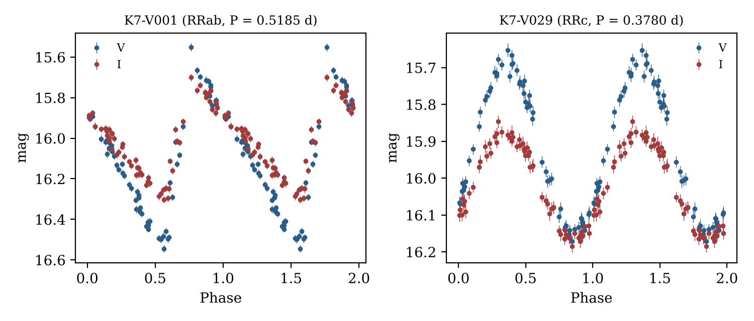
Figure 3. Example phased V- and I-band light curves for one RRab and one RRc star, plotted over two cycles.
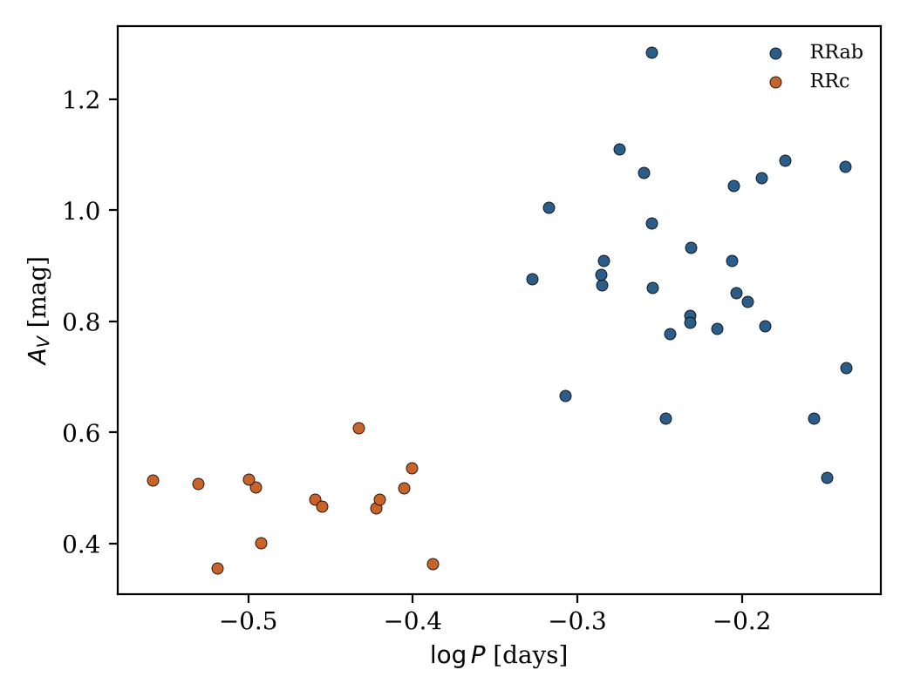
Figure 2. Bailey (period–amplitude) diagram. RRab and RRc stars form two distinct sequences.

4. Results
Our final catalog contains 28 RRab and 14 RRc stars (Table 1). The mean RRab period is ⟨P_{ab}⟩ = 0.593 d and the mean RRc period is ⟨P_{c}⟩ = 0.347 d, with an RRc fraction of 0.33.
The free-slope PL fit (Figure 1) gives a = −1.23 ± 0.09 and b = 15.70 ± 0.03 with an rms scatter of 0.043 mag, consistent with the intrinsic scatter of the calibrating relation. With the slope fixed to the calibration, we find μ₀ = 15.11 ± 0.01 (stat) ± 0.07 (sys) mag, or d = 10.5 ± 0.3 kpc.
Table 1. Summary of derived properties of Kestrel-7.
Quantity | Value
RRab / RRc | 28 / 14
⟨P_{ab}⟩ | 0.593 d
⟨P_{c}⟩ | 0.347 d
PL slope (free) | -1.23 ± 0.09
PL rms scatter | 0.043 mag
A_{I} | 0.15 mag
μ₀ | 15.11 ± 0.01 (stat) ± 0.07 (sys)
Distance | 10.5 ± 0.3 kpc
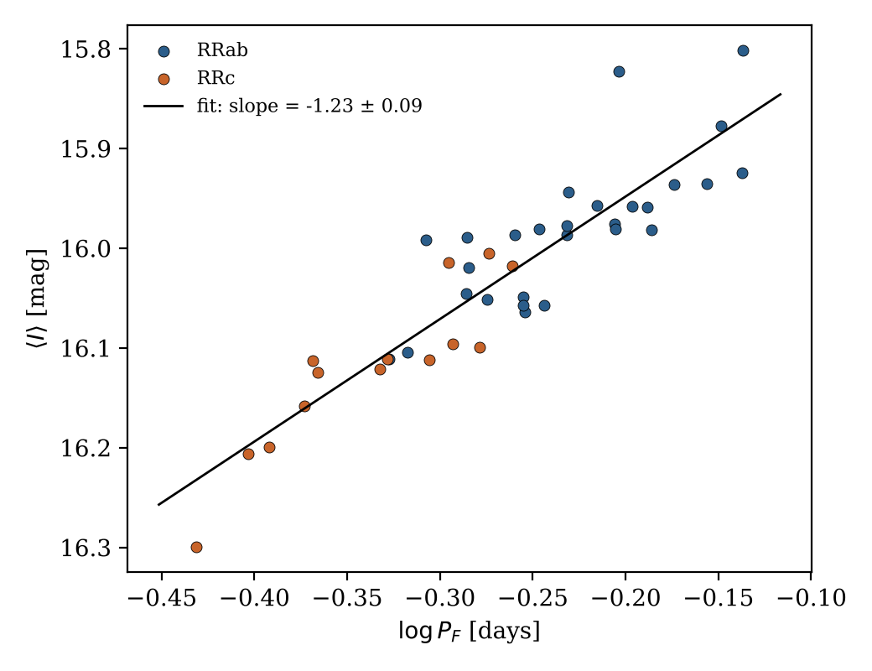
Figure 1. I-band period–luminosity relation for Kestrel-7. RRc periods are fundamentalized. The line shows the free least-squares fit.

5. Discussion
Our distance agrees with, and is roughly six times more precise than, the horizontal-branch estimate of Haddad et al. (2021). The error budget is dominated by the systematic terms: the calibration zero point (0.05 mag) and the reddening (0.02 mag in E(B−V), or about 0.04 mag in A_{I}).
With ⟨P_{ab}⟩ = 0.593 d, Kestrel-7 falls in the 0.58–0.62 d range that is sparsely populated among Galactic halo clusters (Moreau et al. 2022). Its RRc fraction (0.33) is also intermediate between typical Oosterhoff I and II values. Oosterhoff-intermediate clusters are often associated with accreted systems, which makes Kestrel-7 a promising target for spectroscopic metallicity and kinematic follow-up.

6. Conclusions
We have identified 42 RR Lyrae stars in Kestrel-7 and used their I-band PL relation to measure a distance of 10.5 ± 0.3 kpc. The cluster is Oosterhoff-intermediate. Planned future work includes spectroscopic metallicities, which will allow us to apply a metallicity-dependent PL calibration.

Acknowledgments
This draft is part of a mock research project created for teaching and documentation exercises. No real telescope time was used.

References
Chen, L., & Abara, D. 2024, Journal of Synthetic Astrophysics, 13, 412 [fictional]
Haddad, R., Tanaka, S., & Ruiz, M. 2021, Proceedings of the Mock Astronomical Society, 48, 233 [fictional]
Lomb, N. R. 1976, Astrophysics and Space Science, 39, 447
Moreau, J., Adeyemi, K., & Sørensen, P. 2022, Journal of Synthetic Astrophysics, 11, 57 [fictional]
Okafor, N., & Lindqvist, E. 2023, Journal of Synthetic Astrophysics, 12, 101 [fictional]
Petrov, A. 2019, Monthly Notes of Synthetic Photometry, 7, 22 [fictional]
Scargle, J. D. 1982, The Astrophysical Journal, 263, 835

