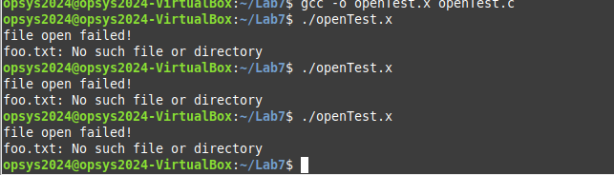

openTest.x file failure

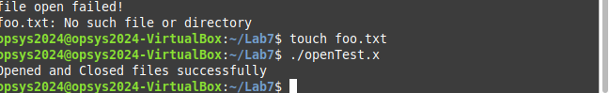

openTest.x file success

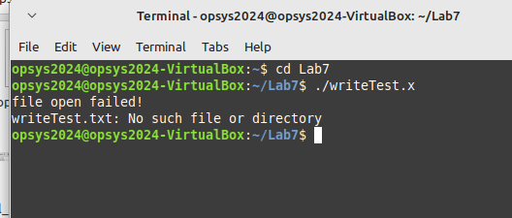

writeTest.x failure

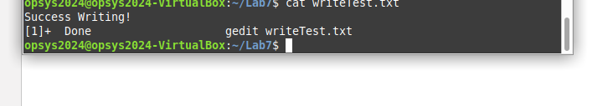

writeTest.x success

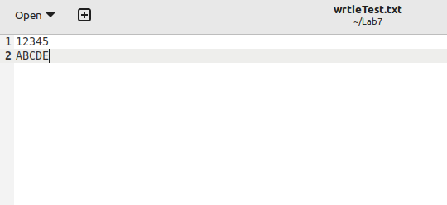

initial content of writeTest.txt

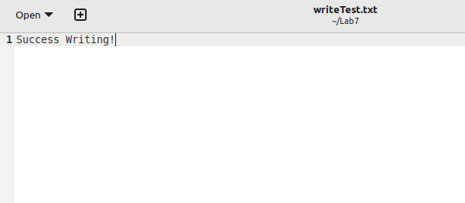

The writeTest.txt file has changed its content to Success Writing!.

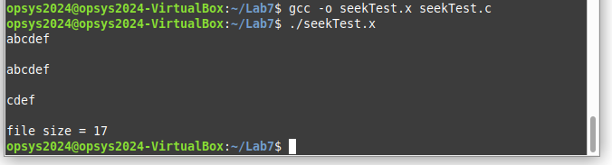

seekTest.x succuss