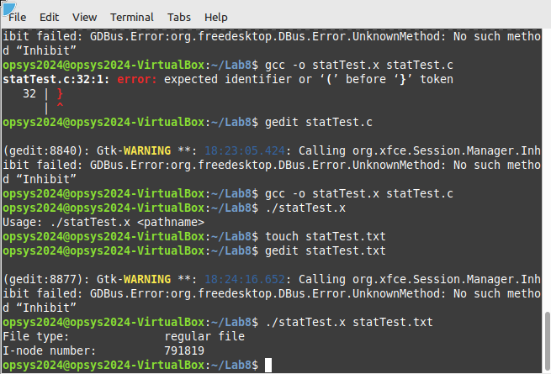

This is file showing I node number and file type of chosen file.

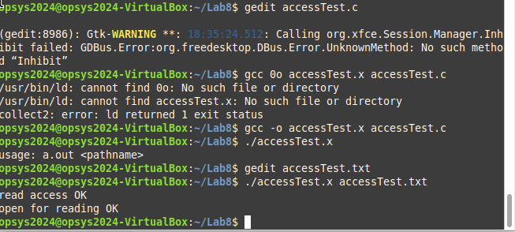

testing whether file is accessible in reading and read only.

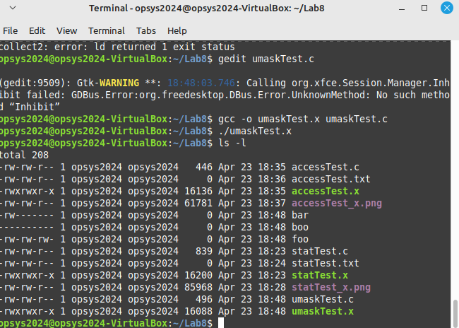

ls –l is showing in different access of the file to user group and other. in here we have used unmaskTest in txt file which is giving rwxrwxr-x access.

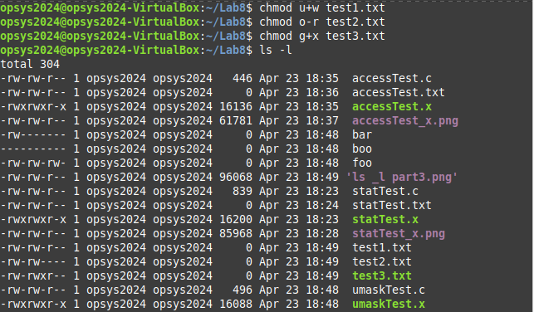

Changed the access of txt1,2,3 file. txt file1 didn’t changed since it already had write access of user.